Calling CNG via VMware vRealize Orchestrator (vRO)

Adding CNG to vRO is fairly straightforward. Follow the steps below to add a CNG instance to VRO. The workflow example below will be able to provision a custom name that can then be used in other workflows or used in external processes. This example only uses the createName operation but similar steps can be followed to add the queryByName operation as well as the deleteByName operation.
Note: This document is not meant as an introduction to vRO, some vRO experience is assumed.

- Add the CNG server as a REST endpoint.
  - Navigate to Library/HTTP-REST/Configuration
  - Run the “Add a REST host” workflow
    - Fill in the required fields (see example below)
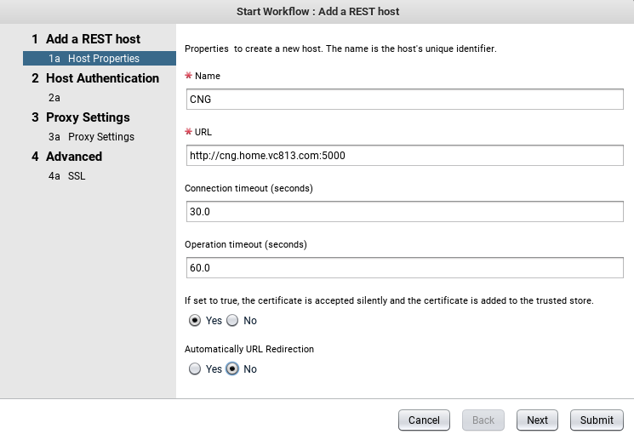
    - Click Next
    - Set authentication type dropdown to NONE
    - Click Next
    - Leave the “Use Proxy” radio button on “No”
    - Click Next
    - Leave the SSL options on the default values
    - Click Submit
- Add a REST operation for creating a name
  - Navigate to Library/HTTP-REST/Configuration
  - Run the “Add a REST operation” workflow
    - Select the parent host that was created in the previous step
    - Set the Name box to “createName”
    - Set Template URL to: /cng/api/v0.1/createName
    - Set the HTTP Method dropdown to POST
    - Set Content Type to “application/json”
    - Click Submit
- Create a workflow to request a name
  - Navigate to Library/HTTP-REST
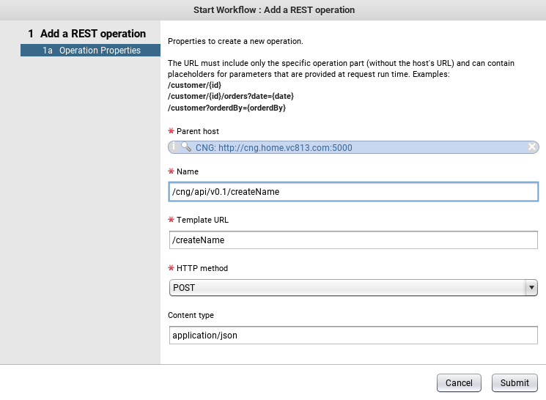
  - Run the “Generate a new workflow from a REST operation” workflow
  - In the Operation tab, select the REST operation that was created in the previous step
  - Set Content Type to “application/json”
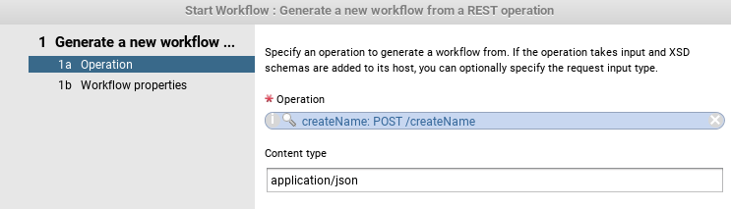
  - Click Next
  - In the Name field, enter a name for the new workflow
  - Select the folder you’d like the workflow to be placed
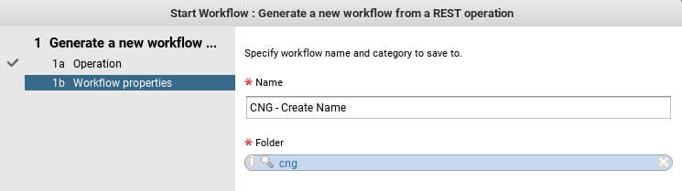
  - Click Submit
- Test the new workflow
  - Navigate to the workflow folder selected in the previous step (cng in this example)
  - Run the Workflow that was created (CNG – Create Name in this example)
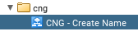
  - Start the workflow
  - Click Next
  - Provide the JSON content required to create a name
    - this will depend on the name fields you have set as required in the docker run command
    - My example uses the following:
{
"name_fields":{
"hLoc":"LAB",
"hType":"VM",
"hApp":"DOCKER"
}
}
    - Click Submit
    - If all goes as expected, you should see a green check next to the workflow run
    - The Variables tab will show the “Content as String” variable containing the name returned from CNG. This can then be passed to other workflows for machine provisioning or use elsewhere.
