Aula Passada
Games to study
  - Dwarf Fortress (https://en.wikipedia.org/wiki/Dwarf_Fortress)
  - Sim City (https://en.wikipedia.org/wiki/SimCity)
  - Noita (https://en.wikipedia.org/wiki/Noita_(video_game))
  - Rain World (https://en.wikipedia.org/wiki/Rain_World)
  - The Sims (https://en.wikipedia.org/wiki/The_Sims)
Spore (https://en.wikipedia.org/wiki/Spore)
Esta aula
- Formal grammars
- L-Systems
- Implicit grammars
- Loot systems
- Games to study
  - Speedtree (https://en.wikipedia.org/wiki/SpeedTree)
  - Nethack (https://en.wikipedia.org/wiki/NetHack)
  - Diablo (https://en.wikipedia.org/wiki/Diablo)
  - Dwarf Fortress (https://en.wikipedia.org/wiki/Dwarf_Fortress)
  - Caves of Qud (https://en.wikipedia.org/wiki/Caves_of_Qud)

Grammars

What Is a Grammar?
grammars are systems that generate structures through rules.
Key points:
- Alphabet (symbols)
- Production rules
- Start symbol
- Derivation
- Language generated by the grammar
Example:
S → AB
A → aA | a
B → bB | b

In the arts, grammars let you formalize rules for creation, enabling structured improvisation, generative art, and algorithmic creativity, similar to how linguistic grammar formalizes sentence generation.
Conceptual framing:
Grammar = rules for generating complexity from simple elements
Applications:
- Language
- Music
- Architecture
- Biology
- Games
- AI systems

Art Grammars

Music
- In music, a “grammar” can define how notes, chords, and rhythms are combined.
- Symbols:
- Notes: C, D, E, F, G, A, B
- Chords: Cmaj, G7, Am
- Rhythm patterns: quarter, half, whole
- Production rules:
- Melody → Note Melody | Note (a melody is a note followed by another melody or ends with a note)
- ChordProgression → Chord ChordProgression | Chord
Example:
- Start symbol: Song
- Rules generate a sequence like C D E F G A B or chord progression Cmaj Am G7 Cmaj.
- This approach is used in algorithmic composition, like in the works of Iannis Xenakis.

Visual
Artists can define a “visual grammar” to generate or analyze artwork.
- Symbols:
- Basic shapes: circle, square, triangle
- Colors: red, blue, green
- Layout elements: line, curve
- Production rules:
- Artwork → Element Artwork | Element
- Element → Shape | Shape + Color | Group
- (Element, Element)
Example:
A rule could produce: Red circle next to blue square, then expand recursively to create complex patterns or generative art.

Formal Grammars
Formal grammars are explicit rule-based systems that generate structures by repeatedly applying production rules.
They come from theoretical computer science and linguistics, especially the work of Noam Chomsky on grammar systems.
Basic Idea
A grammar contains:

Symbols
Symbols are divided into two types:
- Terminal symbols – actual characters in the final output
Example:
a, b
- Non-terminal symbols – placeholders used during generation
Example:
S

Production Rules
Rules describe how symbols can be replaced.
Example rules:
S → aS
S → b
These rules mean:
- S can become aS
- S can become b

Starting Symbol
The process always begins from the start symbol:
Start: S

Rules replace symbols with other symbols until a final structure appears.
How Strings Are Generated
Start with S and repeatedly apply rules.
Example 1
S
→ b
Generated string:
b
Example 2
S
→ aS
→ ab
Generated string:
ab
Example 3
S
→ aS
→ aaS
→ aab
Generated string:
aab

Language generated by this grammar:
b
ab
aab
aaab
aaaab
mathematical notation:
L = { aⁿb | n ≥ 0 }

simple sentence grammar, similar to what Noam Chomsky introduced in his studies of English syntax.

1. Symbols
Non-terminal symbols (placeholders):
- S – Sentence
- NP – Noun Phrase
- VP – Verb Phrase
- Det – Determiner
- N – Noun
- V – Verb
Terminal symbols (actual words):
- Determiners: the, a
- Nouns: cat, dog
- Verbs: chases, sleeps

2. Production Rules
S → NP VP
NP → Det N
VP → V NP | V
Det → the | a
N → cat | dog
V → chases | sleeps

3. Starting Symbol
Start: S

4. Example Sentence Generation
Step 1: Start with S
S
→ NP VP
Step 2: Expand NP
NP → Det N
S → Det N VP
Step 3: Expand VP
VP → V NP
S → Det N V NP
Step 4: Replace terminals
Det → the
N → cat
V → chases
Det → a
N → dog
Resulting sentence:
The cat chases a dog

Another Example
Using VP → V instead:
S → NP VP
NP → a dog
VP → sleeps
Resulting sentence:
A dog sleeps

S
/ \
NP VP
/ \ / \
Det N V NP
| | | / \
the cat chases Det N
| |
a dog

Example (simple dungeon generator)
Start symbol:
S
Rules:
S → Room Corridor Room
Room → TreasureRoom | MonsterRoom | EmptyRoom
Corridor → Straight | Turn
Generated result might be:
TreasureRoom – Straight – MonsterRoom

Uses in PCG
Formal grammars are commonly used for:
- Level generation
- Mission structures
- Architecture
- Story structures
Example:
Many roguelike dungeon generators rely on grammar-like rules to guarantee playability.
Advantages
✔ Clear structure
✔ Easy to control design constraints
✔ Reproducible generation
Disadvantages
✘ Can feel repetitive
✘ Requires careful rule design

A formal grammar is a set of production rules for rewriting strings which means turning 1 string into another
each rule is of the form symbol(s) Another symbol(s)
Example
1) A AB
2) B b

Using a grammar is as simple as going through string and each time a symbol or sequence of symbols that occurs in the left hand side (LHS) alpha rule is found those symbols are replaced by the right hand side (RHS) of that rule.

Formal grammars were originally introduced in 1950 by the linguist Noam Chomsky as the way to model natural language. However they found a widespread application in computer science.

Deterministic vs Non-Deterministic Grammars

Deterministic grammar
exactly one rule that applies to each symbol or sequence of symbols
completely unambiguous
One rule applies at each step.
Example:
A → AB
B → A

Nondeterministic grammars
Multiple choices possible.

several rules could apply to a given string
The grammar might even include probabilities for choosing each rule
another way is to use parameters for deciding which way to expand the grammar.
Example:
A → AB | BA | AA
Key idea:
Non-determinism introduces variation and emergence.
Connect to:
- generative art
- procedural content

L systems 1
the other distinction of interest here is in which order the rewriting is done.

Sequential writing
goes through the string from left to right and rewrites the string as it is reading it
If a production rule is applied to symbol the result of that rule is written into the very same string before the next symbol is considered

parallel rewriting
all the rewriting is done at the same time
this is implemented as the insertion of a new string at the separate memory location containing all the efects of applying the rules, While the original string is left unchanged.

L systems 2
are a class of grammars whose defining feature is parallel rewriting.
Biologist aristid lindenmayer in 1968
model the growth of organic systems such as plants and algae
model yeast growth

Example
1) A AB
2) B A
A
AB
ABA
ABAAB
ABAABABA
ABAABABAABAAB
ABAABABAABAABABAABABA
ABAABABAABAABABAABABAABAABABAABAAB
Fibonacci 1,2,3,5,8,13,21,34,55,89
Outcome of N=n+ ( n-1) + (n-2)

Turtle graphics
one way of using the power of health systems is to implement instructions as a set of turtle graphics
think of the turtle as moving across a plane holding a pencil and simply drawing a line that traces its path

KOCH CURVE
The Koch curve rules:
- Axiom: F
- Rule: F → F+F−F-F +F
- Angle: 60°
F = move forward (a certain distance) and draw
+ = turn left
- = turn right

Bracketed L systems 1
interpreting all systems as a turtle allows us to enter into the fractal dimension

however many interesting shapes cannot be drawn this way
plants for example are branching
require you to finish drawing a branch before returning to the stem to draw the next line

bracketed L systems
have two extra symbols [ and ]
They act as push and pop commands to a stack (FiLo)
[ - Saves the current position and orientation of the turtle onto the stack
] - Retrieves the last saved position from the stack and reset the turtle to that position
- The turtle jumps back to a position it has previously been at

FF[-F]F[+F][F]
30º

Plant Generation Example
Classic rule set:
F → F[-F]F[+F][F]

Uses in Games
Vegetation systems in games like:
- No Man’s Sky
- The Elder Scrolls V: Skyrim
use similar procedural techniques for large ecosystems.

1. Shape Grammars (Architecture / Design)
Shape grammars are similar to formal grammars but operate on visual shapes instead of symbols.
They were originally introduced by George Stiny and James Gips for architectural design.
Instead of:
S → A B
you have rules like:
Square → Square + Door
Square → Square + Window
Square → Two smaller Squares
These rules transform geometric shapes.

Example: Procedural Building Generation
Start with:
Base cube
Rules:
- Split cube vertically → floors
- Add windows every X meters
- Add roof variation
This approach is used in many city generation systems and research tools like CityEngine.

Why Shape Grammars Are Useful
They allow:
- architectural style control
- consistent building patterns
- scalable cities
Example pipeline:
city layout → block → building → windows → decorations

Games using similar techniques include
Assassin’s Creed Unity and SimCity.
.
Assassin’s Creed Unity – Paris Architecture
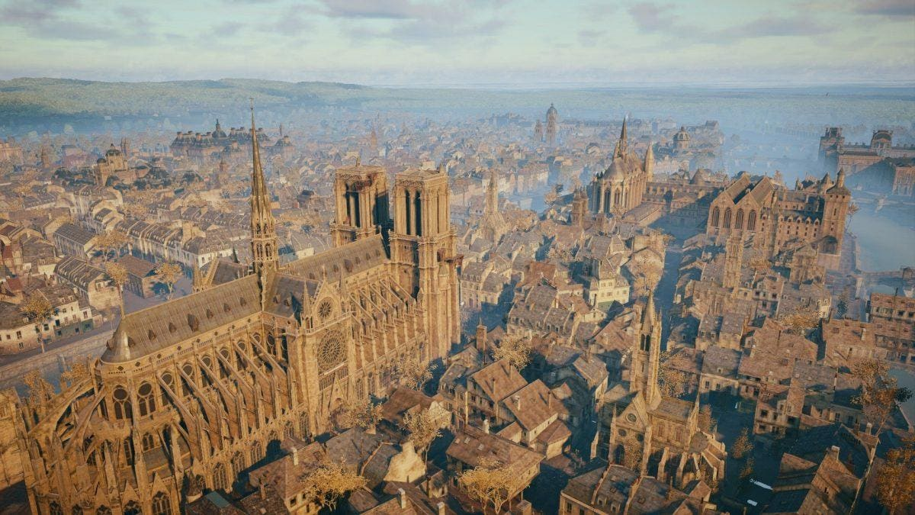
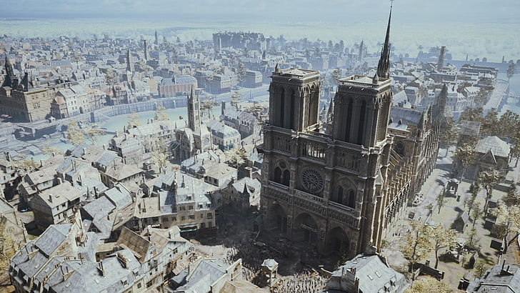
- Façade repetition: Parisian buildings have repeating windows, balconies, and roof shapes that can be generated by rules (e.g., floor → window pattern → balcony).
- Modular blocks: Many buildings follow Haussmann-style rules (height limits, roof slope, window alignment).
- Hierarchical rules:
Example grammar structure:
  - City → blocks
  - Block → building parcels
  - Building → floors
  - Floor → windows + balcony + wall modules
Games like Assassin’s Creed often combine historical references with procedural rules to quickly populate large cities while maintaining architectural consistency.

2. SimCity – Procedural City Layout
How shape grammars appear here:
- Grid-based street rules:
Roads generate city blocks following zoning rules.
- Zoning grammar:
  - Residential → low / medium / high density building forms
  - Commercial → towers with repeated façade modules
- Growth rules:
Buildings expand vertically when population and land value increase.

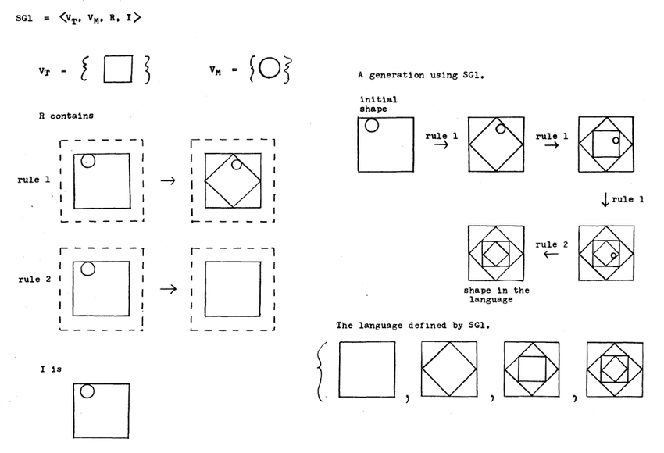
https://www.researchgate.net/figure/A-shape-grammar-for-Inscribed-squares-Source-Stiny-1977_fig3_328383333
Haussmann-style buildings
Building → Floors
Floor → Window Modules
Window Module → Window + Wall
Top Floor → Balcony + Windows
Ground Floor → Door + Shopfront

Step 1 — Initial Mass
+----------------------+
| Building |
| Mass |
+----------------------+
↓ Rule 1
Split Vertically
Step 2 — Floors
+----------------------+
| Roof |
+----------------------+
| Floor 4 |
+----------------------+
| Floor 3 |
+----------------------+
| Floor 2 |
+----------------------+
| Ground Floor |
+----------------------+
↓ Rule 2
Subdivide Floors
Step 3 — Window Modules
+----------------------+
| [] [] [] [] |
|----------------------|
| [] [] [] [] |
|----------------------|
| [] [] [] [] |
+----------------------+
↓ Rule 3
Add Architectural Elements
Step 4 — Final Façade
+----------------------+
| /\ Roof Detail |
|----------------------|
| [] [] [] [] Balcony |
|----------------------|
| [] [] [] [] Windows |
|----------------------|
| Door Shop Windows |
+----------------------+

City Layout (w/ shape grammars)

Shape Grammar for Procedural Cities (SimCity-Style)
Rules Example
City → Road Network
Road Network → Blocks
Block → Parcels
Parcel → Zone Type
Zone Type → Building Type
Building → Floors → Façade Modules

Level 1 — Terrain
+------------------------+
| Map Area |
+------------------------+
↓ Rule 1
Generate Roads
Level 2 — Road Network
──────┬──────
│
──────┼──────
│
↓ Rule 2
Create Blocks
Level 3 — City Blocks
+-----+-----+-----+
| | | |
+-----+-----+-----+
↓ Rule 3
Subdivide Lots
Level 4 — Building Parcels
+--+--+--+--+
| | | | |
+--+--+--+--+
↓ Rule 4
Generate Buildings
Level 5 — Buildings
🏢 🏠 🏬 🏢
A city layout is generated by recursively applying a shape grammar that subdivides space from city → blocks → parcels → buildings, assigning land uses at the smallest scale.
1. Conceptual Shape Grammar
The city is generated by repeatedly applying production rules:
City → Block
Block → Block Block
Block → StreetBlock
StreetBlock → Parcel
Parcel → Building
Building → Residential | Commercial | Park
Interpretation:
- A city begins as a large rectangular region.
- Blocks may subdivide into smaller blocks.
- When blocks become sufficiently small they become street blocks.
- Street blocks subdivide into parcels.
- Parcels become buildings, which may be residential, commercial, or parks.
Thus the grammar progressively refines urban structure from large scale to small scale.

2. Pseudocode Procedure
City generation
procedure GenerateCity(depth):
create root node representing the entire city
recursively generate structure:
GenerateNode(root, depth)

Recursive generation
procedure GenerateNode(node, depth):
if depth == 0:
node becomes Building
assign random type (res, com, park)
stop recursion
apply grammar rule depending on node type
if node was split:
for each child node
GenerateNode(child, depth - 1)

Applying grammar rules
procedure ApplyRule(node):
if node is City
split into two Blocks using an Avenue
if node is Block
with high probability:
split into two Blocks using a Street
otherwise:
convert to StreetBlock
if node is StreetBlock
if block is large enough
split into Parcels
otherwise
convert to Building
if node is Building
randomly choose type:
Residential
Commercial
Park

Splitting geometry
procedure Split(node):
choose random orientation:
horizontal or vertical
choose random split position within bounds
create two child rectangles
assign them as child nodes

3. Rendering Procedure
After the grammar tree is generated:
procedure Draw(node):
if node has children
recursively draw each child
draw street boundary around node
else if node is Building
shrink rectangle slightly
if type == Park
draw green area
else
draw building footprint

4. Conceptual Interpretation
The algorithm implements a hierarchical urban model:
- City scale – major subdivision (avenues)
- Block scale – smaller subdivision (streets)
- Parcel scale – building lots
- Building scale – land use assignment
This approach is typical of procedural urban modeling systems, such as those used in tools like CityEngine.
The key idea is that simple rewriting rules applied recursively can generate complex spatial structures.

Graph grammars
Generative grammars typically Operate on strings
however they can be used to generate graphs tile maps two or three-dimensional shapes and so on
Graphs are more useful than strings to represent missions and spaces for games

For RPG dungeons and other explorative adventure games
you would want missions to contain lock and key puzzles famous objectives and possibly multiple paths

graph grammars work quite similarly to string grammars
they also have a left hand part that identifies a particular graph construction that can be replaced by one of the constructions in the right hand of the rule
it is important to identify each node on the left hand part individually
and to match them with individual nodes in each right hand part

Loot Sytem
A loot system in video games is the mechanism for generating, dropping, and distributing items—such as weapons, armor, or currency—that players collect to increase their power, customize characters, or progress. It acts as a reward loop, often utilizing rarity tiers and randomization (random number generators) to provide excitement and engagement

The program first generates the spatial structure of a city using a recursive shape grammar.
After the shape grammar generates the city structure:
City → Blocks → Parcels → Buildings
Once buildings are created, a loot table system assigns probabilistic rewards to some of them.
some buildings become loot containers.
Items such as swords are further generated using attribute rules, producing variations like damage ranges and elemental effects.

Each container generates items using a loot table, which is a probabilistic list of rewards.
Typical rewards:
- Gold
- Potions
- Weapons
- Weapons with modifiers
Example item:
Sword
+15–25 damage
+5% critical chance
+10% fire damage

LootTable
A loot table defines probabilities of item types.
Gold → 40%
Potion → 30%
Sword → 20%
RareItem → 10%

Weapons may receive random modifiers.
Sword → BaseSword + Modifier*
Modifier →
+Damage
+CriticalChance
+ElementalDamage
Possible attributes:
+15–25 damage
+5% critical chance
+10% fire damage
+8% ice damage

procedure GenerateLoot()
roll random number
if roll < 0.40
return Gold
if roll < 0.70
return Potion
if roll < 0.90
return GenerateSword()
else
return RareItem

procedure GenerateSword()
sword.damage = random(15,25)
if random chance
sword.critChance = 5%
If random chance
sword.element = fire or ice
sword.elementDamage = 10%
return sword

Integrating Loot With the City
When the grammar produces a building, we attach loot generation.
Building generation step
Building → Residential | Commercial | Park
Extend the rule:
Building → Residential + Loot?
Building → Commercial + Loot?
Building → Park
Where:
Loot? = optional loot container

Pseudocode Integration
During building creation:
if node.level == Building
assign building type
if building is not Park
with probability 30%
node.loot = GenerateLoot()
- Shape grammar generates the city structure
- Loot tables generate game rewards
- Attribute grammars generate item properties

So the full generative pipeline becomes:
City Grammar
↓
Buildings
↓
Loot Table
↓
Item Attribute Generation

Implicit Grammars
An implicit grammar is a generative rule system that is expressed through an algorithm rather than a formal rule list.
The grammar exists in the program logic instead of written production rules.

There is no explicit rule list, but the algorithm still behaves like a grammar.
if node is city
split region into two blocks
if node is block
with probability 0.9 split again
otherwise convert to streetblock
if node is streetblock
if region is small
create building

We are using Partly implicit
Block → Block Block (90%)
Block → StreetBlock (10%)
Translated as:
if self.level == "block":
if random.random() < 0.9:
self.split("street")
else:
self.level = "streetblock"

