# Multi-Projection Plugin for Unity

### Introduction:

Edge blending is the dark art of stitching together the output of two or more overlapping projectors and making one seamless screen out of them.

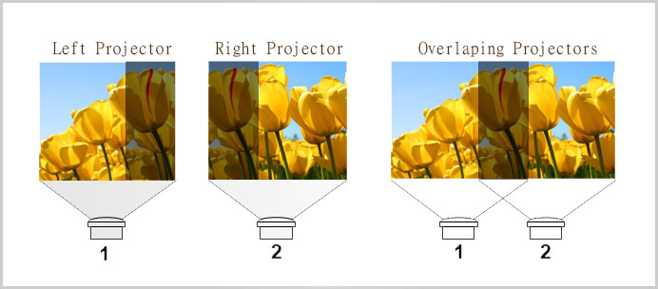

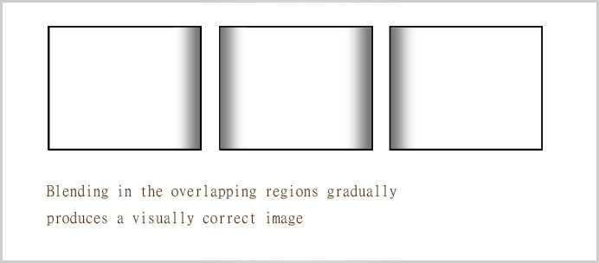

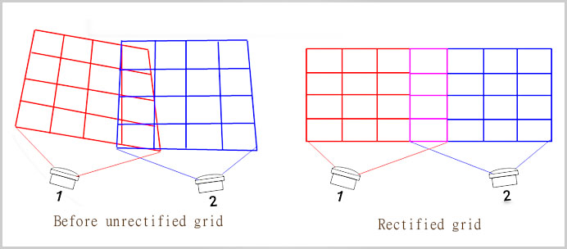

### WebGL Demo

**<https://hardybbs.itch.io/multiporjection>**

### How to Use

**In Unity Developing**

1 import MultiProjection.unitypackage into your project

2 Drag /MultiProjection/prefabs "MP_MappingCamera" into your scene

3 Change screen layout or blend count , try shortcut.

4 finish.

**Hardware Requirement**

You need a high performance PC ,

CPU I3 + VGA card (for two projectors).

CPU I5 + VGA card(GTX 750) (for 3 or 4 projectors).

CPU I7 + VGA card*2 (for 5 or 8 projectors).

You need install win7 or win8 or win10, and make sure your VGA card can connect all projectors.

*if you need blend 3 or more projectors , maybe you need two or more VGA card.

* be care of Unity max support 8 monitors

**Tutorial 1: How to build two projector blending**

* If you want to build a 2048 *768 projection, first connect two projectors and

Below picture is setting from windows 7 , first active your two projector, and layout as below 2*1.

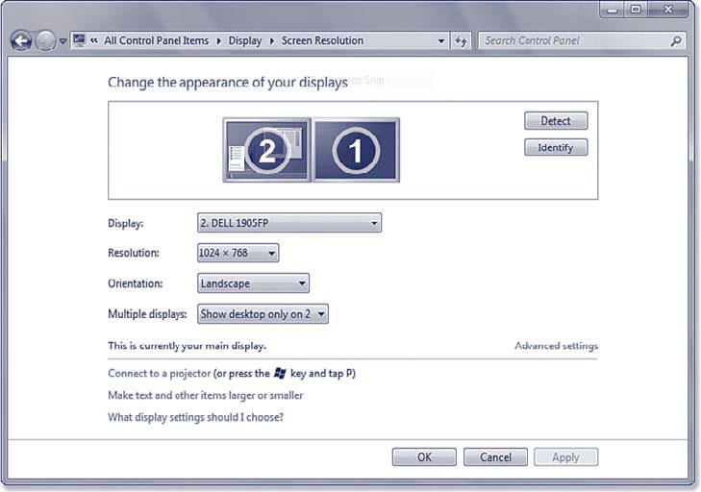

* Go to your unity project and set layout to L_2*1 , and set blend_count base your overlapping.

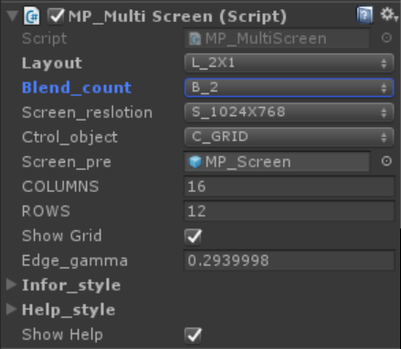

* Build a execute , and run it. Use shortcut change grid .
* Adjust grid one by one

First use grid FOUR_CONNER change all grid to match some good,

Next use grid single move, to match more accurate points.

After got perfect matching.

Press R,G,B key + Up/Down to made two projectors color same.

Press key 1 or 2 open blend edge.

Press -,= adjust blend edge gamma.

All finished, Press F5 save. If you want to rest all Press F8 key.

After your release your app, you need set showHelp and showGrid into false.

* Shortcut List:

F1: show help or not

  F2:Open color GUI

H: hide grid or not

W/S/A/D : choose control point

Up/Left/Down/Right : move control point

(Press Shift to speed up and Alt to slow)

M: change grid move way

R/G/B: change screen color, Up/Down change color value

num 1-num4: open blend area(left/right/top/bottom)

-,=: adjust blend area gamma.

Mouse click: choose screen

Tab: switch screen

T: testing screen

F5: save all data

F8: load default grid

ESC: exit

**Tips**

**1 how to view multi-monitor in Unity editor ?**

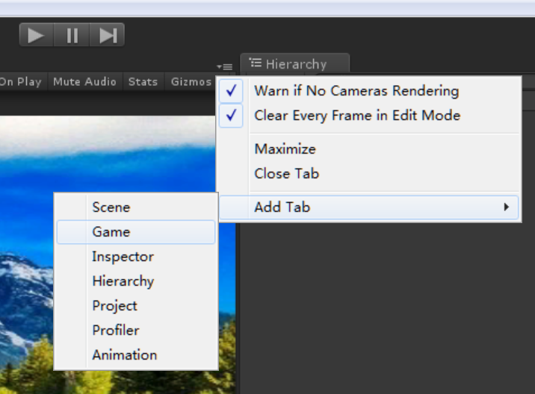

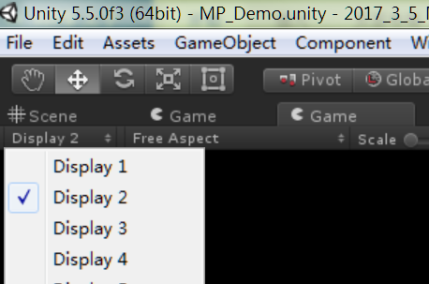

Add a Game Tab and change game display

**2 how to made full screen show inside my previous camera ?**

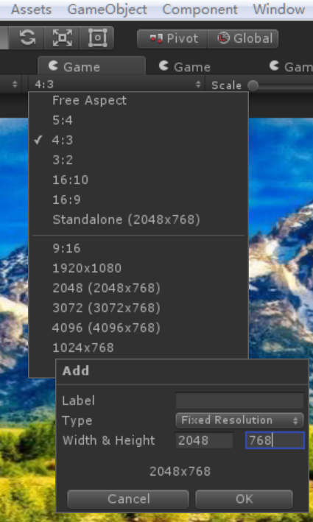

You can add your own resolution, and check your origin camera is work good.

**Key Features**

**\* Support 1*1 (very useful for 3d mapping)**

**\* Support 1*2,1*3,1*4**

**\* Support 2*1,2*2,2*3,2*4 (in processing ,not finished)**

**\* Dynamic Mesh, low CPU and GPU overload**

**\* Full keyboard control**

**\* Full source code , create your own blending software**

* **Links**  
  [Website](http://vvvision.net/zblog/post/MultiProjectionUnity.html): http://vvvision.net/zblog/post/MultiProjectionUnity.html  
  WebGL Demo <https://hardybbs.itch.io/multiporjection>  
  [Asset Store](https://www.assetstore.unity3d.com/en/" \l "!/content/76410" \t "https://forum.unity3d.com/threads/released-dynamic-decals.450820/_blank) https://www.assetstore.unity3d.com/#!/content/85466

Video Tutorials **https://youtu.be/kCgO-ok8zek**

**Change Log**

1.0.1

**Contact us**  
mail: hardyfish@163.com  
web： www.vvvision.net