Maria Gorshunova
mrgorshunova@edu.hse.ru

Sales planning and evaluation
Staff graded assignment

Оглавление
Task No1. Access settings 2
Task No2. Product2 & country2 materialized views 3
Commands to set necessary permissions: 3
Task No3. Loading data into the company table 3
Task No4. Company classification by annual amount of orders 4
Task No5. Finding quarterly sales amount by company, and product category 6
Task No6. Initial data preparation 7
Line with function call to populate the plan_data and plan_status tables: 8
Plan_data screenshot: 8
Plan_status screenshot: 8
Task No7. Changing the plan data 9
A screenshot of v_plan_edit contents (logged in as kirill, show the changed data before executing the remove_lock function ): 10
Task No8. Plan data approval 11
A function call as kirill and sophie: 12
A screenshot of rows in the v_plan (logging in as sophie): 12
Task No9. Data preparation for plan-fact analysis in Q1 2014 13
Approach: Calculate actual data using salesorderheader and ordersalesdetail tables without using company_sales. 13
A screenshot of data in mv_plan_fact_2014_q1 view: 14

Task No1. Access settings

create role planadmin;
create user ivan with password '123';
grant planadmin to ivan;
grant usage on schema public to planadmin;
grant select on all tables in schema public to planadmin;
grant select, update, insert, delete on plan_data to planadmin;
grant select, update, insert, delete on plan_status to planadmin;
grant select, update, insert, delete on country_managers to planadmin;
grant select on company to planadmin;
grant select on company_sales to planadmin;

create role planmanager;
create user sophie with password '123';
create user kirill with password '123';
grant planmanager to sophie;
grant planmanager to kirill;
grant select on all tables in schema public to planmanager;
grant usage on schema public to planmanager;
grant select, update, insert, delete on plan_data to planmanager;
grant select, update on plan_status to planmanager;
grant select on country_managers to planmanager;
grant select on company_sales to planmanager;
grant select on company to planmanager;
grant select, update on v_plan_edit to planmanager;
grant select on v_plan to planmanager;

The query that fills the ‘country_managers’ table:

insert into country_managers (username, country)
values
('sophie', 'US'),
('sophie', 'CA'),
('kirill', 'FR'),
('kirill', 'GB'),
('kirill', 'DE'),
('kirill', 'AU')

Task No2. Product2 & country2 materialized views

create materialized view product2
as
select pc.productcategoryid pcid, p.productid productid, pc.name pcname, p.name pname
from product p
join productsubcategory psc using(productsubcategoryid)
join productcategory pc using(productcategoryid)

create materialized view country2
as
select distinct a.countryregioncode from address a
join customeraddress ca using(addressid)
where ca.addresstype = 'Main Office'

Commands to set necessary permissions:

grant select on country2 to planmanager;
grant select on product2 to planmanager;
grant select on country2 to planadmin;
grant select on product2 to planadmin;

Task No3. Loading data into the company table

insert into company (cname, countrycode, city)
select
distinct
customer.companyname cname,
address.countryregioncode countrycode,
address.city city
from customer
join customeraddress using(customerid)
join address using(addressid)
where customeraddress.addresstype = 'Main Office'

Task No4. Company classification by annual amount of orders

insert into company_abc (cid, salestotal, cls, "year")
with sales_agg as (
select customerid, extract(year from orderdate) "year", sum(subtotal) salestotal
from salesorderheader
group by customerid, "year")
select
distinct
subq.id cid,
subq.salestotal,
case
when (((sum(salestotal) over(partition by subq."year" order by salestotal desc rows between unbounded preceding and current row)) / (sum(salestotal) over(partition by subq."year"))) <= 0.80) then 'A'
when (((sum(salestotal) over(partition by subq."year" order by salestotal desc rows between unbounded preceding and current row)) / (sum(salestotal) over(partition by subq."year"))) <= 0.95) then 'B'
else 'C' end cls,
subq."year"
from
(select c.id, sum(salestotal) salestotal, s."year"
from company c
join customer c2 on c.cname = c2.companyname
join sales_agg s using(customerid)
group by c.id, s."year") as subq
where subq."year" in (2012, 2013)
order by subq."year", salestotal desc

Top A-companies (2012):
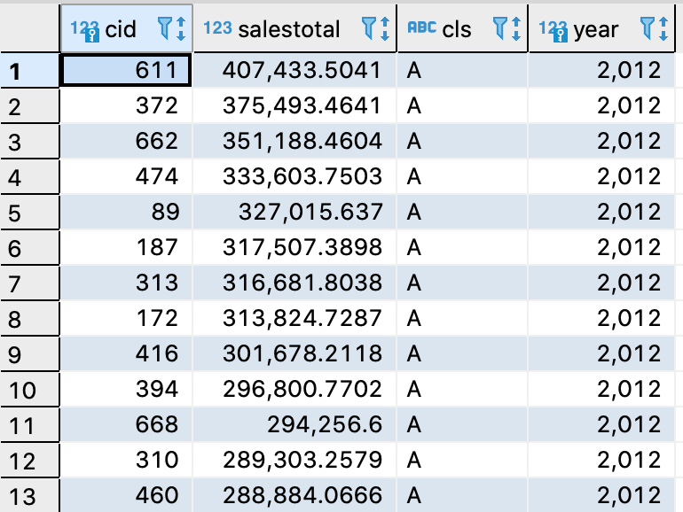
Top B-companies (2012):
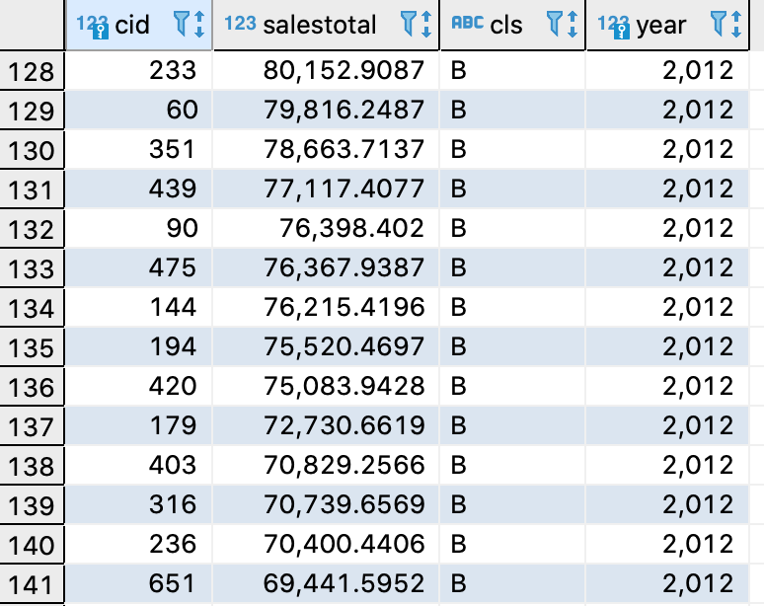
Top C-companies (2012):
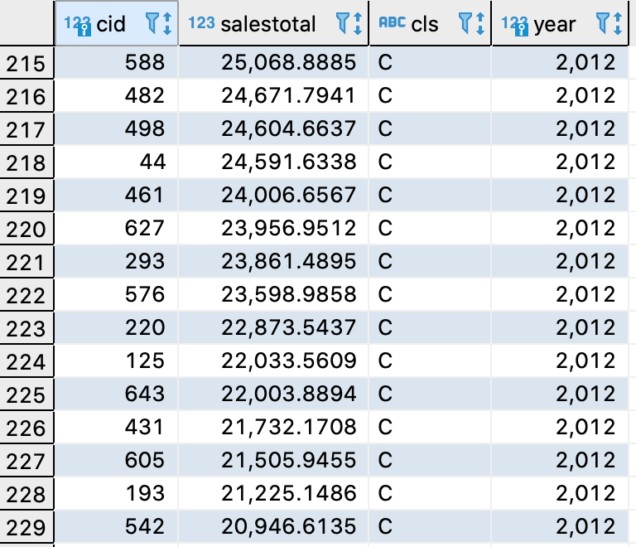

Task No5. Finding quarterly sales amount by company, and product category

insert into company_sales (cid, salesamt, "year", quarter_yr, qr, categoryid, ccls)
select
distinct
c.id cid,
sum(sod.linetotal) over(partition by extract(year from soh.orderdate), extract(quarter from soh.orderdate), c.id, p2.pcid) salesamt,
extract(year from soh.orderdate) "year",
extract(quarter from soh.orderdate) quarter_yr,
extract(year from soh.orderdate) || '.' || extract(quarter from soh.orderdate) qr,
p2.pcid categoryid,
abc.cls ccls
from company c
join customer c2 on c.cname = c2.companyname
join salesorderheader soh using(customerid)
join salesorderdetail sod using(salesorderid)
join product2 p2 using(productid)
join company_abc abc on (extract(year from soh.orderdate) = abc."year") and (c.id = abc.cid)

Task No6. Initial data preparation

def start_planning(year, quarter, user, pwd):
con = psycopg2.connect(database="2020_plans_MariaGorshunova", user=user, password=pwd, host="localhost")
cur = con.cursor()

# delete plan data from the plan_data table related to the target year and quarter
queryDelPD = """delete from plan_data where quarterid = {y} || '.' || {q}
""".format(y=year, q=quarter)

# delete records related to the target quarter in the plan_status table
queryDelPS = """delete from plan_status where quarterid = {y} || '.' || {q}
""".format(y=year, q=quarter)

# create planning status records (plan_status table) for the selected quarter
queryInsPS = """insert into plan_status(quarterid, country, status, modifieddatetime, author) select distinct {y} || '.' || {q}, countrycode, 'R', current_timestamp, '{usr}' from company""".format(y=year, q=quarter, usr = user)

# generate version N of planning data in the plan_data table
queryGenPD = """insert into plan_data(versionid, country, quarterid, pcid, salesamt)
select 'N', unique_cc.countrycode, {y} || '.' || {q}, unique_pc.categoryid, coalesce(avg(s_salesamt),0) from (select distinct countrycode from company) as unique_cc
cross join (select distinct pcid as categoryid from product2) as unique_pc
left join (select "year", quarter_yr, c_.countrycode countrycode, categoryid, sum(salesamt) s_salesamt
from company_sales as cs_
join company c_ on c_.id = cs_.cid
where cs_.ccls in ('A', 'B')
group by "year", quarter_yr, c_.countrycode , categoryid
having ("year" between ({y} - 2) and ({y} - 1) and quarter_yr = {q})) as sq
on sq.countrycode = unique_cc.countrycode and sq.categoryid = unique_pc.categoryid
group by unique_cc.countrycode, unique_pc.categoryid
""".format(y=year, q=quarter)

# copy data from version N into version P in the plan_data table
queryCopyPD = """insert into plan_data(versionid, country, quarterid, pcid, salesamt)
select 'P', country, quarterid, pcid, salesamt from plan_data where quarterid = {y} || '.' || {q} and versionid = 'N' """.format(y=year, q=quarter)

cur.execute(queryDelPD)
cur.execute(queryDelPS)
cur.execute(queryInsPS)
cur.execute(queryGenPD)
cur.execute(queryCopyPD)
con.commit()
con.close()

Line with function call to populate the plan_data and plan_status tables:

start_planning(2014, 1, 'ivan', '123')

Plan_data screenshot:
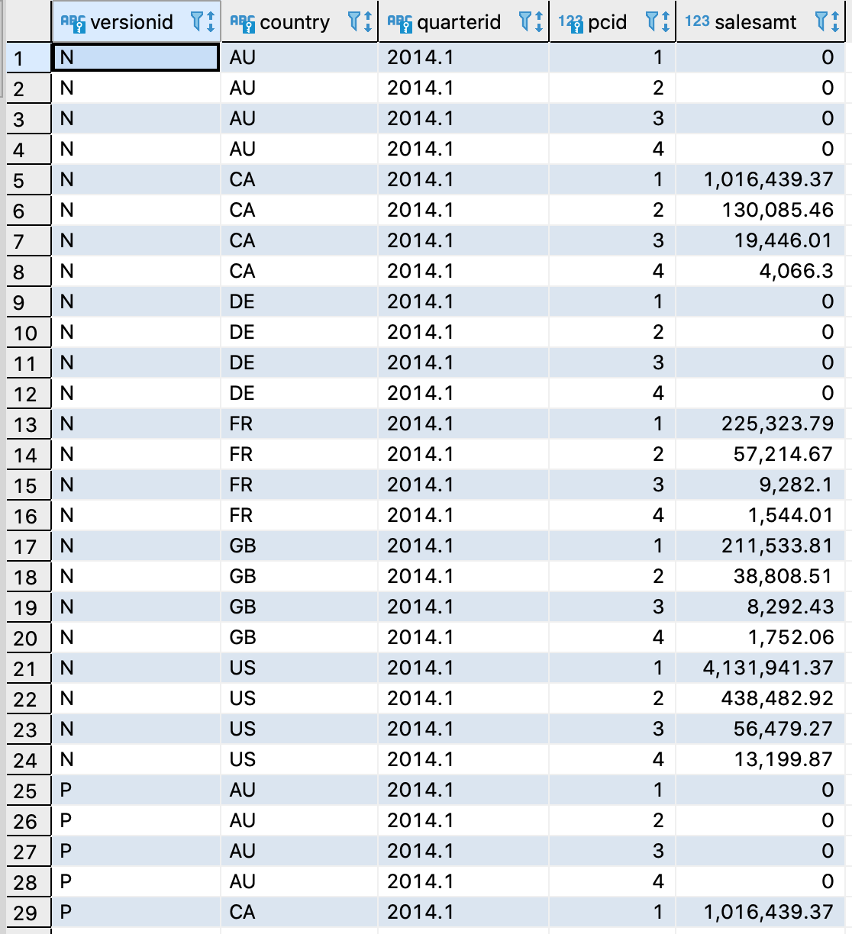

Plan_status screenshot:

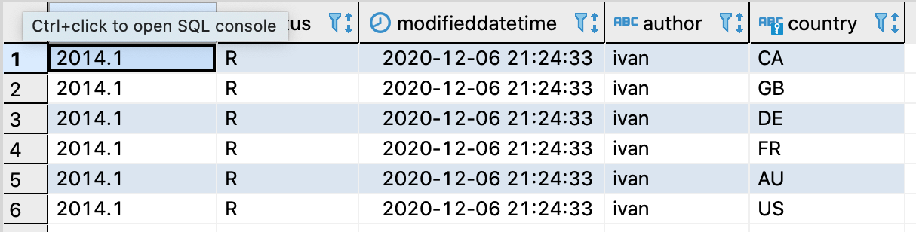

Task No7. Changing the plan data

def set_lock(year, quarter, user, pwd):
con = psycopg2.connect(database="2020_plans_MariaGorshunova", user=user, password=pwd, host="localhost")
cur = con.cursor()

# change status from R to L for data slices, that are associated with the target quarter and
# year, and connected to the current user in the country_managers configuration table
queryCngPS = """
update plan_status set status = 'L' , modifieddatetime = current_timestamp, author = current_user
where quarterid = {y} || '.' || {q} and country in (select country
from country_managers
where username = current_user)
and status = 'R'
""".format(y=year, q=quarter)

cur.execute(queryCngPS)
con.commit()
con.close()

def remove_lock(year, quarter, user, pwd):
con = psycopg2.connect(database="2020_plans_MariaGorshunova", user=user, password=pwd, host="localhost")
cur = con.cursor()

# change the planning data status from L to R
queryCngPS = """
update plan_status set status = 'R' , modifieddatetime = current_timestamp, author = current_user
where quarterid = {y} || '.' || {q}
and country in (select country
from country_managers
where username = current_user)
and status = 'L'
""".format(y=year, q=quarter)

cur.execute(queryCngPS)
con.commit()
con.close()

A screenshot of v_plan_edit contents (logged in as kirill, show the changed data before executing the remove_lock function ):
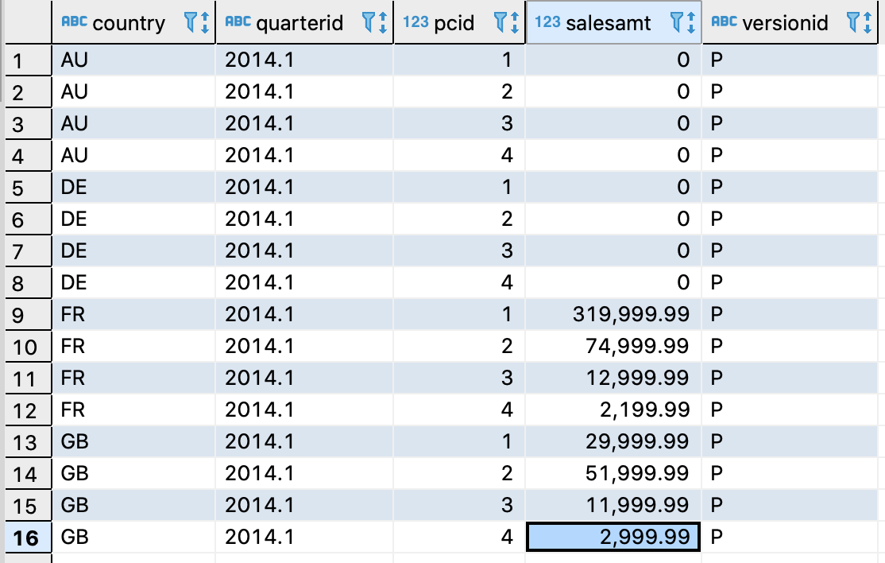

Task No8. Plan data approval

def accept_plan(year, quarter, user, pwd):

con = psycopg2.connect(database="2020_plans_MariaGorshunova", user=user, password=pwd, host="localhost")
cur = con.cursor()

#clear the A version of plan data for specific quarter and countries accessible to the current user
queryClrA = """
delete from plan_data
where versionid = 'A'
and quarterid = {y} || '.' || {q}
and country in (select country
from country_managers
where username = current_user)
""".format(y=year, q=quarter)

#read data available to the current user from the version P and save its copy into as the version A
querySaveA = """
insert into plan_data(versionid, country, quarterid, pcid, salesamt)
select 'A', country, quarterid, pcid, salesamt
from plan_data
where quarterid = {y} || '.' || {q}
and versionid = 'P'
and country in (select country
from country_managers
where username = current_user)
""".format(y=year, q=quarter)

#change the status of data being processed from 'R' to 'A'
queryCngPS = """
update plan_status set status = 'A' , modifieddatetime = current_timestamp, author = current_user
where quarterid = {y} || '.' || {q}
and country in (select country
from country_managers
where username = current_user)
and status = 'R'
""".format(y=year, q=quarter)

cur.execute(queryClrA)
cur.execute(querySaveA)
cur.execute(queryCngPS)
con.commit()
con.close()

A function call as kirill and sophie:

accept_plan(2014, 1, 'kirill', '123')
accept_plan(2014, 1, 'sophie', '123')

A screenshot of rows in the v_plan (logging in as sophie):

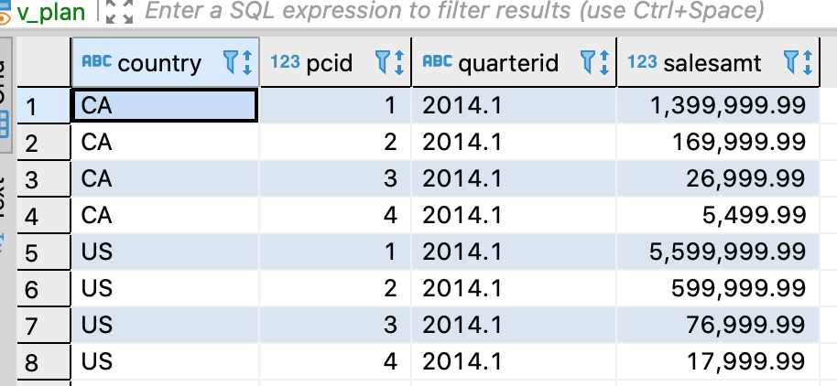

Task No9. Data preparation for plan-fact analysis in Q1 2014

Approach: Calculate actual data using salesorderheader and ordersalesdetail tables without using company_sales.

create materialized view mv_plan_fact_2014_q1
as
select "quarter", fact_query.country , pcname, (plan_query.salesamt - fact_query.fact) dev, (plan_query.salesamt - fact_query.fact)/nullif(plan_query.salesamt, 0) dev_perc from
(select "quarter", country, pcname, categoryid, sum(fact) as fact from (
select
c.id cid ,
c.countrycode country,
sum(sod.linetotal) fact,
extract(year from soh.orderdate) "year",
extract(quarter from soh.orderdate) quarter_yr,
extract(year from soh.orderdate) || '.' || extract(quarter from soh.orderdate) "quarter",
p2.pcid categoryid,
p2.pcname pcname
from company c
join customer c2 on c.cname = c2.companyname
join salesorderheader soh using(customerid)
join salesorderdetail sod using(salesorderid)
join product2 p2 using(productid)
group by cid, country, "year", quarter_yr, categoryid, pcname) nt
where nt.cid in (select distinct cid
from company_abc
where company_abc."year" = 2013
and company_abc.cls in ('A', 'B'))
and nt."year" = 2014 and nt.quarter_yr = 1
group by "quarter", country, pcname, categoryid) fact_query
left join (select * from plan_data where versionid = 'A') plan_query
on fact_query.country = plan_query.country and
fact_query."quarter" = plan_query.quarterid and
fact_query.categoryid = plan_query.pcid
order by "quarter", fact_query.country , pcname, dev, dev_perc

A screenshot of data in mv_plan_fact_2014_q1 view:

