To run VQconnector with vcc, following environment settings must be configured on default vcc lab setup:

1. Db settings
2. Update IVR Script
3. IVR portal for dial outs
4. VQConnector Installation

**DB settings:**

We have a separate database, in VCC DB store for virtualQ, called Voxtron.virtualQ. It contains mainly 2 table:

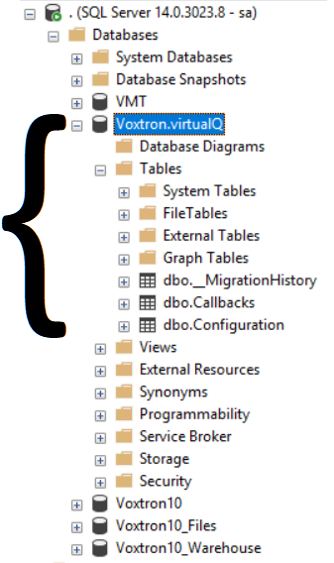

* Configuration
  + Contains all the basic settings required for VQConnector service to run.

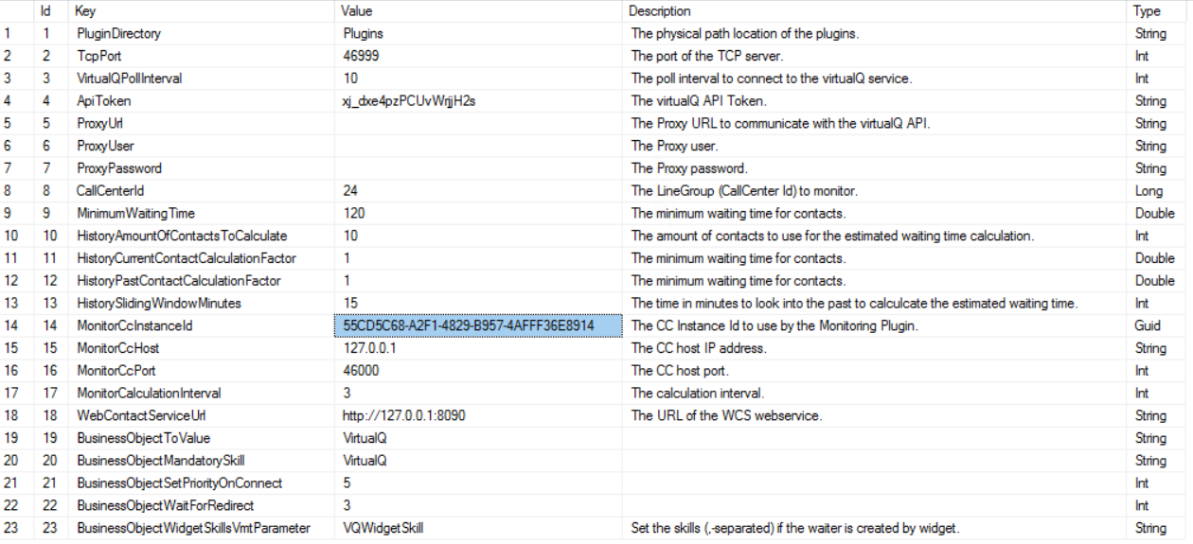

//need to ask chris/wolfgang: do we add these configurations or these are filled by default //when VQ service runs

* Callbacks
  + Contains all the callbacks info that is used to make callbacks to the client from VCC on behalf of virtualQ.

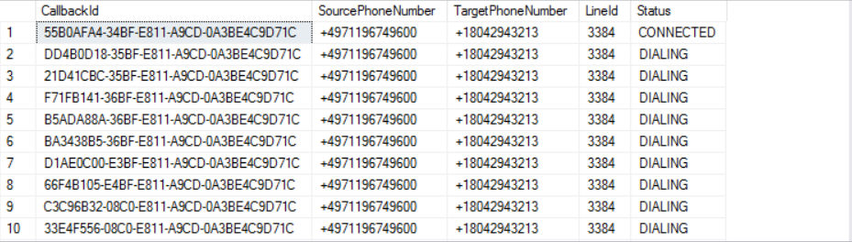

//add complete description of how this table works with code and ivr scripts

If everything is added correctly in db as show above then you will be able to see virtualQ configuration in vmt as following:

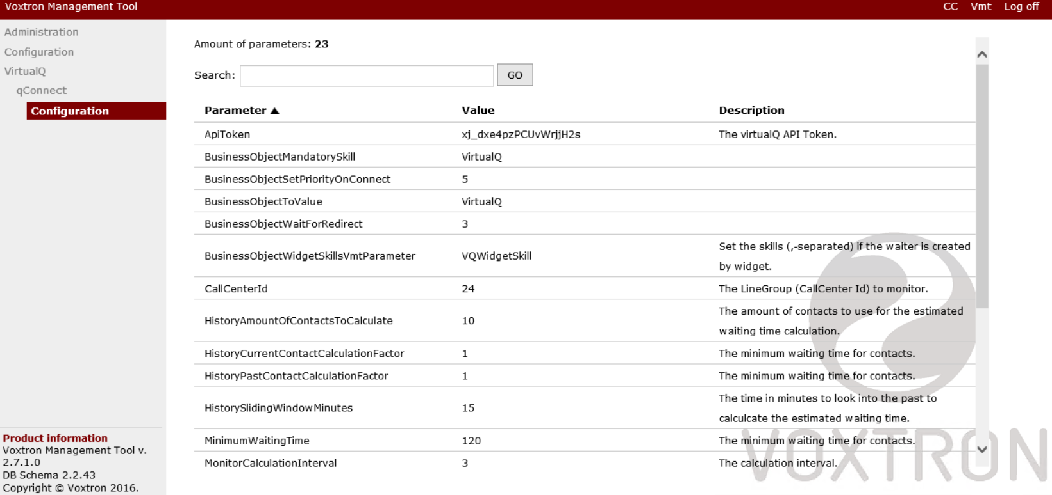

**Update IVR Script:**

1. LineUpCaller:
   1. Using called number ask VQconnector “getlineidbyphonenumber” to get line id.
   2. Ask VQconnector if the caller is linedup already or not by using “verifycaller”
   3. If caller is not lined up, line it up with virtualQ using “lineupcaller” and disconnect the call after a thankyou prompt.
2. Lined up caller calls back:

If Caller is already linedup and it’s a caller calling back then do following steps:

* 1. Tell VQconnector via “Notifycallerconnected” about the callback
  2. Play greeting to caller until agent is not connected.
  3. VQconnector now will assign a free agent with this call
  4. Check it the agent is assigned by virtualQ or not via “isagentassigned”
  5. If yes transfer call to agent
     1. If transfer fails for any reason, keep repating from step 3.
  6. Else keep repating from step c.
  7. Scripts ends when caller drops or agent is connected and call is marked finished using “NotifyCallerFinished”

1. Linedup caller Dialout:

If call is linedup using Callbackext option then vcc will dial out call on behalf of virtualQ when its signaled by VQconnector:

* 1. Connect to “Voxtron.virtualQ” db and look for table Callbacks. Db connector will pick up the caller number with status “Dialing”
  2. And then dial call the call to customer.
  3. If customer is connected script is navigated to “Lined up caller calls back” flow.

**IVR portal for dial outs:**

For caller dialout following settings are configured:

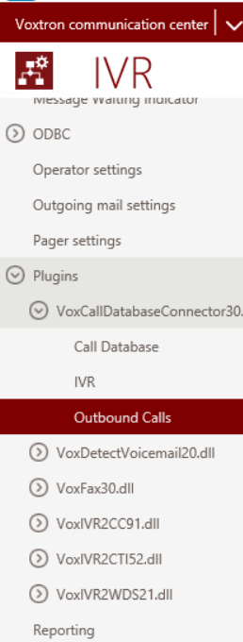

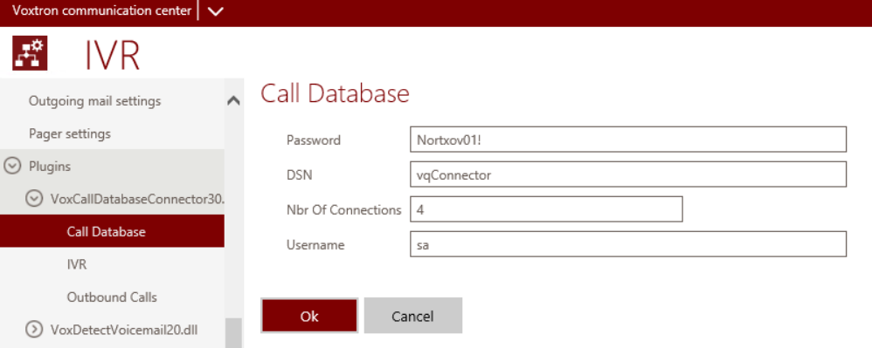

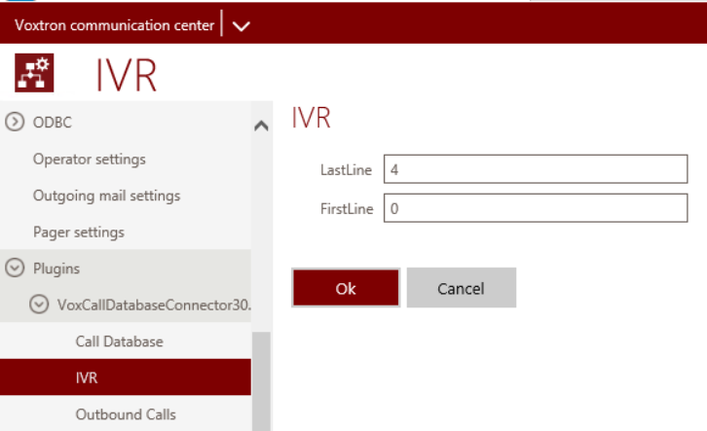

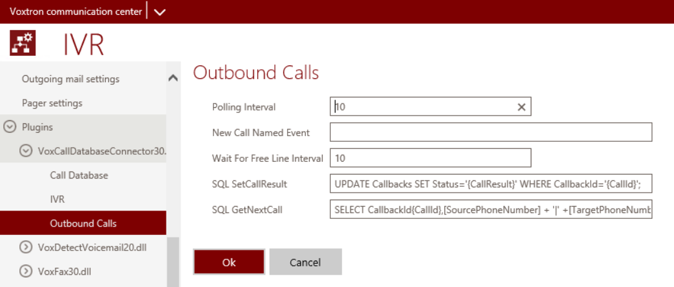

SetCallResult Query:

UPDATE Callbacks SET Status='{CallResult}' WHERE CallbackId='{CallId}';

GetNextCall Query:

SELECT CallbackId{CallId},[SourcePhoneNumber] + '|' +[TargetPhoneNumber]{PhoneNumber},[LineId]{CustomVariable} FROM Callbacks WHERE Status='PENDING';UPDATE Callbacks SET Status='DIALING' WHERE CallbackId='{CallId}';

**VQConnector Installation:**

After able all configuration what left is to install Voxtron VQconnector service. Service is installed on following path:

C:\Program Files (x86)\Voxtron\Voxtron.virtualQ.Connector.Service

Please all the binaries here in the above folder and run the install file as “Administrator”. This will install VQconnector in windows services.

Change configurations in “Voxtron.VirtualQ.Connector.Service.exe.config” according to the above vcc settings.

1. set config for DataContext and VMTContext like data source, userID and password
2. set logger info if needed.