AEGIS — Governed Agent Platform on AWS
CISO / Authorizing Official One-Pager

The governance layer that makes any AI agent deployable in a regulated environment — build the paved road once on AWS, and every agent, model, and tool inherits identity, authorization, audit, compliance, hallucination control, and chargeback automatically.
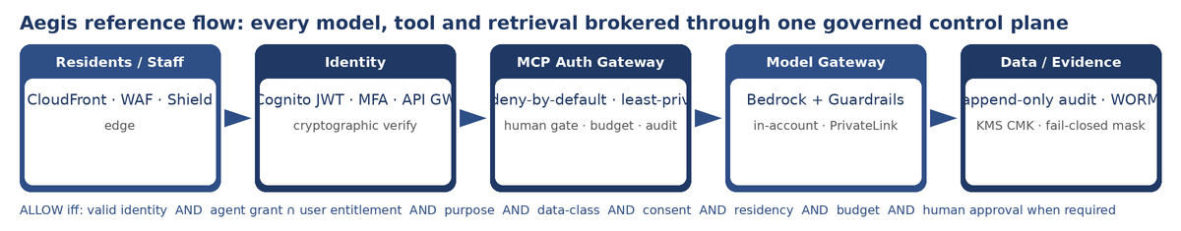

The four CISO questions, answered
Can the AI act on its own? No. Every consequential action — issue, adjudicate, release, award, transfer — is withheld from the agent in code and proven absent by a test. It executes only after a bound, single-use, separation-of-duties human approval (Step Functions waitForTaskToken), never on the agent’s own authority.
Can I trust identity? Yes. Identity is cryptographically verified (RS256 over the Cognito JWKS, issuer/audience/expiry + alg-confusion guard); client-supplied roles are never trusted. This satisfies the MFA and identity-proofing demands of CJIS v6.0 and HIPAA access control, and anchors least-privilege as an intersection (agent grant ∩ user entitlement).
Will the audit hold up? Yes. The audit is append-only and WORM: DynamoDB with PutItem-only IAM plus explicit Update/Delete deny and conditional writes, and S3 Object Lock immutable evidence. It can’t be quietly edited — which is what survives a review board, a FOIA request, or an OIG audit.
Where does the data go? Bedrock inference stays in-account over AWS PrivateLink with mandatory Guardrails on input and output; PII/PHI/FTI is masked fail-closed — if masking can’t run, the boundary denies rather than leaks. KMS customer-managed keys and account/VPC isolation separate every data class (CJI, FTI, PHI, EDU, public).

Control → regime coverage
How Aegis’s implemented controls map to the regimes a regulated buyer must satisfy. ✓ = control addresses the regime’s requirement.
Control (Aegis) | GovRAMP | CJIS v6.0 | HIPAA | FERPA | PCI | NIST AI RMF
Cryptographic identity + MFA | ✓ | ✓ MFA | ✓ | ✓ | — | Human-AI Config
Deny-by-default gateway / least-priv | ✓ | ✓ | ✓ | ✓ | ✓ | Manage
Human gate (bound, single-use, SoD) | ✓ | ✓ | ✓ | ✓ | — | Human-AI Config
In-account inference + Guardrails | ✓ | ✓ | ✓ | ✓ | — | Data Privacy
Append-only audit + WORM | ✓ | ✓ | ✓ | ✓ | ✓ | Measure
Masking (PII/PHI/FTI/card), fail-closed | ✓ | ✓ | ✓ | ✓ | ✓ | Data Privacy
KMS CMK + data-class isolation | ✓ | ✓ | ✓ | ✓ | ✓ | Info Security

Proven on AWS — not just claimed
The governance-core CloudFormation stack was deployed live (account 864217980669, us-east-1, 2026-06-30), verified at runtime, and cleanly torn down. It caught a real bug cfn-lint did not.
- Bedrock Guardrail status READY — contextual grounding (0.80 / 0.75), PII filters (email, phone, SSN), UngroundedConsequentialAction denied topic.
- End-to-end control loop — the gateway Lambda applied the guardrail and wrote exactly one append-only audit record (decision=allow, data_class=pii).
- IAM policy simulation on the gateway role: PutItem = allowed, UpdateItem = DeleteItem = explicitDeny — the agent cannot alter or delete audit history.
- WORM confirmed — S3 get-object-lock-configuration returns ObjectLockEnabled: Enabled.
- Clean teardown — bucket 404, no tables, no guardrails; zero aegis-* runtime resources remain (KMS CMK in the mandatory pending-deletion window).

What Aegis owns vs. what you own
Responsibility item | AWS | Delivery Partner | Customer
Authorized cloud / region (commercial, GovCloud) | A/R | C | I
BAA for HIPAA (signed before any PHI) | R (provides) | C | A
Live connectors to systems of record | I | R | A
IdP integration + MFA (Entra/Okta/Ping/Login.gov) | I | R | A
ATO / GovRAMP / FedRAMP authorization | C (FedRAMP path) | R (control pkg) | A
Candor is the selling point: Aegis implements and tests the technical controls and maps them to each framework. It is not yet ATO’d / GovRAMP- or FedRAMP-certified, has no live connectors or third-party penetration test, and “HIPAA-eligible” ≠ “HIPAA-compliant” — that requires a signed AWS BAA plus customer-implemented controls. Authorization, agreements, and operational ownership are customer responsibilities.
Sources: figures and controls grounded in the Aegis repo (docs 02, 05, 08, 10; DEPLOYED-AND-VALIDATED.md) and SOURCES.md (AWS official docs, government/standards bodies, NIST AI RMF). Live-deployment proofs from the 2026-06-30 run.

