AEGIS GOVERNED-AGENT PLATFORM
Where things stand, and what a partner can do
Benefits eligibility pack · prepared 2026-09-10 · evidence from the from-zero gate run ben-fpg

This brief is written to be checked, not believed. Every claim below is either tied to a named gate check from a live run whose evidence is committed to the repository, or it is listed under what is not proven. There is no third category. If you read only one section, read “The gap a partner actually closes” on page 3 — it is the honest answer to why this document exists.

1. What Aegis is, in one paragraph
Aegis is a governance control plane for agentic AI on Amazon Bedrock AgentCore. Deny-by-default Cedar authorization is evaluated against the real human’s verified identity before any tool runs; every consequential step writes hash-chained evidence to an append-only ledger and a WORM bucket, and cannot commit unless that evidence is durable in both; a separation-of-duties Step Functions gate means a different verified person approves before anything finalizes, and the agent never self-commits; tenants are physically separated, with the tenant derived from the identity rather than taken from the caller; a one-command kill switch is read before evaluation, fail-closed; and a per-tenant token and USD meter reserves before every model call and commits real usage after. The control plane ships as a pinned, hash-verified dependency — governed-core 1.11.1, consumed by URL and sha256 under pip install --require-hashes — and four vertical packs consume it.
The agents are assistants. They do not award, adjudicate, deny, or auto-submit anything. Every consequential action terminates at a human sign-off gate. Nothing here confers GxP, Part 11, HIPAA, FedRAMP or StateRAMP compliance; these are controls that support those validation activities, and validation is owned by the deploying organization.

2. What is proven live, and by what
“From zero” means the AWS account is empty when the run starts and empty when it ends, and both facts are established by asking AWS directly — not by trusting the teardown script’s own verdict. The run below passed 21 of 21 checks. The check names are the ones in the committed evidence file, so you can grep for them.
What is demonstrated | The check that proves it
Deny-by-default authorization reaches every tool, including a newly added one, and the denial names a specific policy rather than refusing everyone alike | CONN_governed_sor_proof  G111_consolidated_gate
The gateway authorizer, the Cedar engine and the runtime stand up from IaC and reach READY on the IaC-provisioned role, with IMDSv2 required | outputs_present  RT2_runtime_ready · RT2_runtime_uses_iac_role  RT2_runtime_mmdsv2
Every model call the runtime makes is guardrail-assessed — 20 rows, 20 assessed | RT2_runtime_calls_guardrail_assessed
Containment precedes evaluation: the kill switch is read first and fails closed, with a DENIED WORM record per tenant | KS_kill_switch_proof
The per-tenant meter matches the model-invocation log to the token, and a hard cap refuses at the gateway, the drafter and the runtime | BUD_budget_proof
Every governed API call is accounted for — zero orphans across CloudTrail, the per-Lambda log line and the WORM ledger | LIN_zero_orphans  LIN_case_driven
A case drives the whole workflow end to end with no unexpected errors; the fail-closed refusals that do appear are the deliberate ones | E2E_zero_unexpected
A governed outbound connector authenticates to an OAuth2 system of record with no secret in the tool, and the outbound leg is exercised during the deploy | CONN_deploy  CONN_governed_sor_proof
The account is returned to empty — stacks, AgentCore resources and connector resources each checked against AWS itself | teardown_zero_stack_residue  teardown_zero_agentcore_residue  teardown_zero_connector_residue
Offline, the pack carries 514 tests with a doc-integrity gate that fails CI when a document quotes a test count the suite no longer has, and a gate that fails CI when a new silenced error path appears on a command whose failure nothing checks. Both exist because both defects happened here.

3. The newest result, and what it cost
The template used to ship system-of-record connectors as labeled stubs. One is now real: verify_source obtains an OAuth2 machine-to-machine token from the AgentCore Identity token vault, holds no client secret itself, and calls a system of record that verifies the token’s RS256 signature against the issuer’s live published keys. An unauthenticated caller gets 401. An outsider calling the same tool through the gateway is refused by Cedar, and the refusal names the specific policy that refused it.
That last clause is doing real work. An earlier run denied the outsider and the legitimate reviewer with the same string. “Outsider denied” proved nothing then, because everything was denied. A deny-by-default claim is only evidence when the denial is selective.
Getting there took six from-zero live runs, and not one of the six failures was where it appeared to be: authentication (proof users the IaC path never creates), then the gateway (an authorizer that allow-lists exactly one client), then the system of record itself (an environment variable silently left empty because a label contained a comma). Each was hidden behind an error written to /dev/null. That defect class now fails CI.
The system of record is a real OAuth2 API with RS256/JWKS signature verification. It is ours.
Proving the governed path reaches it is not proving a customer’s system of record has been governed. connect_system_of_record stays stubbed in the manifest for exactly that reason.

4. What is not proven, stated plainly
Not proven | Why, and what would change it
A connector to a real system of record | connect_system_of_record is stubbed on purpose. Standing the connector up against our own mock took six live runs; a real integration adds the customer’s IdP, network boundary, token lifetimes and change control on top of that. It is engineering work, not configuration.
The other three packs, live | Pharmacovigilance, financial aid and housing share the same hash-locked core and received the same fixes with unit tests, but none has had an AgentCore-era live gate. The gate harness itself exists only in the benefits pack.
Manifest signing, live | The manifest is Ed25519-signed and verification passes offline; the signing path has not been exercised on a live gate.
The Organizations-level SCP perimeter | The org SCP and VPC-endpoint policy that prevent direct model calls ship in the repo. Demonstrating them requires an AWS Organization, which we do not have. This is a hard blocker, not a backlog item.
Scale, multi-region, multi-account, real data | One pack, one account, one region (us-east-1), synthetic data, two tenants. The separate governance/audit account in the architecture is the target topology; the gate runs single-account.
Any compliance status | Not GxP, Part 11, HIPAA, FedRAMP or StateRAMP authorized, and not an official AWS solution.

5. The gap a partner actually closes
Every piece of evidence in this brief was produced by the author, on the author’s own AWS account.
An independent review discounted it for that reason and was right to. No amount of further self-testing closes it. Someone else’s run is the thing that closes it.
That is the single most valuable thing a partner can do, and it is deliberately cheap: the protocol is written down, the harness is committed, and it needs no contact with us.

The ask, in priority order
- Run the independent verification on your own sandbox account. 45–75 minutes wall-clock, most of it unattended, a few dollars of AWS spend, everything torn down at the end and you confirm zero residue yourself. Clone the repo, check out the released tag, run scripts/independent_verify.py --dry-run first (no AWS calls, no spend), then the real run. It writes its own report.
- A failure is a useful result. If a step does not work, or you needed a fix that is not in the documentation, that is a real defect and recording it is the entire point. Please do not ask us to talk you through it — that would defeat the exercise. Note it and move on.
- Bring a real system of record. The next honest milestone for CONN-1 is the same proof against a real IdP and a real API — EIV, The Work Number, a state eligibility system. We can do the engineering; we cannot manufacture the counterparty.
- Get us inside an AWS Organization. The org-level SCP perimeter is written and cannot be demonstrated without one. This is the cheapest unblock on the list.
- A pilot with realistic data and a domain SME. The program rules and thresholds in the pack are illustrative federal defaults. They need an owner who can say what the authoritative rules are and sign off on them.
- Adversarial review. Specifically of the Cedar policy set and the fault semantics — what happens when the WORM copy fails, when a task token is released twice, when a caller forges consent. Three external review rounds have each found something real; a fourth would too.

What you would need
- An AWS sandbox account you control, us-east-1, admin-ish rights, CDK bootstrapped.
- Amazon Bedrock model access enabled for Claude Sonnet in that account and region.
- Python 3.12+, Node, the AWS CLI authenticated. No connection to our account or credentials.

6. The architecture, and how to read it
Three colours, and the third is the point: green is demonstrated on this live run and labelled with the gate check that proves it; amber is code that exists and is unit-tested but that no live run has demonstrated; grey is deliberately not ours — stubbed in the manifest, or the adopter’s to own. The grey boxes are drawn at the same size and in the same places as the green ones. A diagram that showed only what works would be a sales diagram, not an architecture. The editable original is Aegis-Architecture-Verified.drawio; the image below is rendered from the same source, so the two cannot disagree.
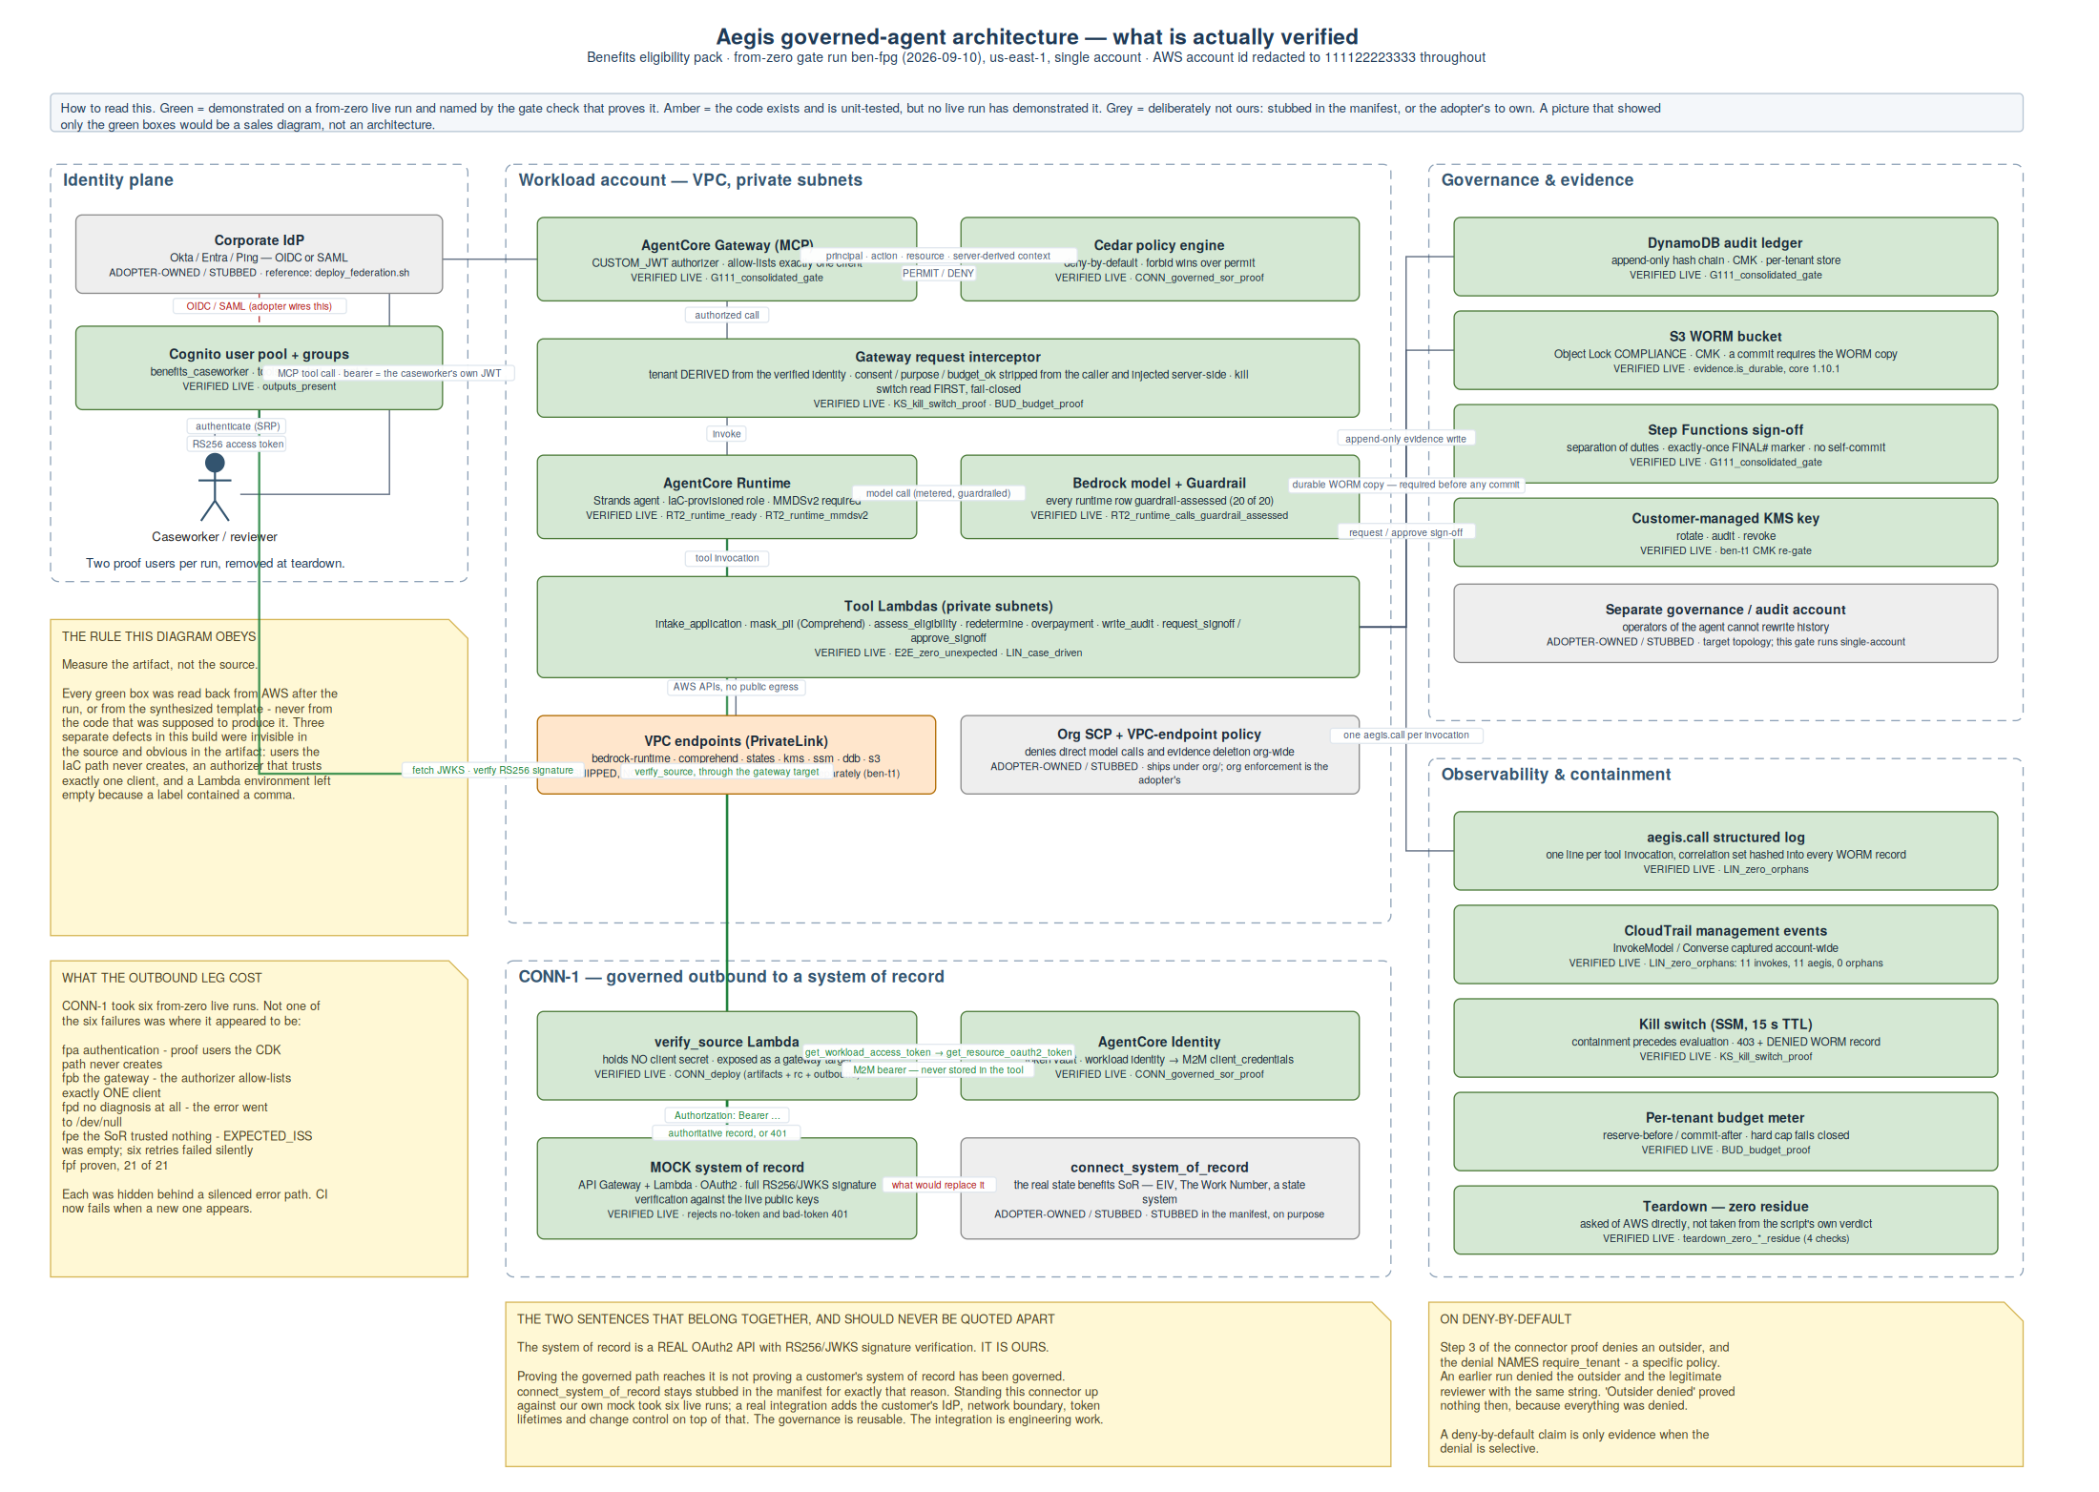

Appendix — the run record
Run ben-fpg · 2026-09-10 · us-east-1 · single account · governed-core 1.11.1 · deployed from zero, exercised, torn down. Every check below is reproduced verbatim from evidence/FULL-PORTFOLIO-GATE-benefits_runtime_agent.json. The AWS account id is redacted to 111122223333 throughout the repository.
Result | Check | Detail
PASS | preflight_no_agentcore_residue | {'gateways': [], 'policy_engines': [], 'agent_runtimes': []} (a leftover policy engine is adopted by name and its policy names cannot be re-created; delete these before deploying)
PASS | deploy | rc=0 in 722.2s
PASS | outputs_present | identity=True gateway=True compute_runtime_role=ben-fpg-agentcore-runtime
PASS | RT2_configure_on_iac_role | agentcore deploy agentcore create CONFIGURE_EXIT=0
PASS | RT2_launch | "2026/09/10/[runtime-logs]" --since 1h LAUNCH_EXIT=0
PASS | RT2_runtime_uses_iac_role | runtime=benefits_runtime_agent-ccFPa76fqX role=ben-fpg-agentcore-runtime
PASS | RT2_runtime_ready | status=READY
PASS | RT2_runtime_mmdsv2 | requireMMDSV2=True before=True enforced=False
PASS | G111_consolidated_gate | rc=0 in 531.9s
PASS | KS_kill_switch_proof | rc=0 in 105.0s
PASS | BUD_budget_proof | rc=0 in 373.3s
PASS | RT2_runtime_calls_guardrail_assessed | runtime_rows=20 guardrail_assessed=20
PASS | LIN_case_driven | case=LIN-0E6D3D states=['Extract', 'GuardExtracted', 'MaskPii', 'GuardDeidentified', 'AssessEligibility', 'GuardRulesExecuted', 'CheckAdverseNotice', 'DraftNotice', 'AuditIntent', 'HumanSign
PASS | LIN_zero_orphans | rc=0 covered=True orphans=0 invokes=11 aegis=11 settle=417.0s
PASS | E2E_zero_unexpected | rc=0 note": "Errors>0 on intake-application/assess-eligibility/write-audit are the deliberate fail-closed TenantError refusals; see log_groups classification", "unexpected_total": 0, "verd
PASS | CONN_deploy | rc=0(ok=True) outbound_ok=True artifacts_ok=True in 106.7s artifacts={'sor_lambda': True, 'verify_lambda': True, 'sor_rejects_anonymous': 401, 'credential_provider': True, 'gateway_target':
PASS | CONN_governed_sor_proof | rc=0 xtends to the new connector (outsider denied) -- PASS outsider call to verify_source DENIED (Cedar deny-by-default) -> DENY multi-tenant: identity carries no tenant (custom:tenant); r
PASS | CONN_teardown_zero_residue | user caseworker [connector-destroy] removed proof user outsider [connector-destroy] removed resource server ben-fpg-sor [connector-destroy] removed hosted domain ben-fpg-sor-111122223333
PASS | teardown_zero_stack_residue | destroy_rc=1 stacks_clean=True (no stacks with prefix ben-fpg-) model_logging_as_before=True (toolkit ECR residue is reported in steps.toolkit_residue and is NOT gated - L37)
PASS | teardown_zero_agentcore_residue | {'gateways': [], 'policy_engines': [], 'agent_runtimes': []} (gateways, policy engines and runtimes live outside CloudFormation and survive stack deletion - four orphaned READY gateways were
PASS | teardown_zero_connector_residue | left=[] unchecked=[] (asks AWS directly; the connector's own CLEAN verdict is not evidence here - on 2026-09-09 it printed CLEAN over live resources because its aws CLI probes were failing i

