**Computational Methods**

The structure-data files (SDFs) and SMILES representations for compounds with antithrombotic properties, including quercetin (CID: 5280343), gallic acid (CID: 370), chlorogenic acid (CID: 1794427), catechol (CID: 289), caffeic acid (CID: 689043), coumaric acid (CID: 637542), and rosmarinic acid (CID: 5281792), were obtained from the PubChem database. The X-ray structure of the warfarin-VKOR-GFP fusion protein complex was retrieved from the Protein Data Bank (PDB ID: 6WV3) with the resolution 2.2 Å (Liu et al., 2021). Protein structure refinement was performed using the Molecular Operating Environment (MOE) version 2019.0102, employing an updated refinement protocol to enhance structural accuracy. Molecular docking was conducted using AutoDock, adopting a rigid-flexible docking approach with the Lamarckian genetic algorithm and optimized parameters for improved convergence. Receptor and ligand preparation included assigning Gasteiger partial charges and identifying rotatable bonds, following established protocols (Shityakov et al., 2014; Shityakov et al., 2021). The binding site was centered on the co-crystallized ligand with Cartesian coordinates: x = -9.83 Å, y = 26.82 Å, z = 55.76 Å, and a grid box size of 60 x 60 x 60 Å to ensure comprehensive sampling. Structure-based (Ts) similarity scores were calculated using SMILES strings with the RDKit package. Descriptor-based (Td) similarity scores utilized Lipinski's rule descriptors (molecular weight [MW], logP, hydrogen bond donors [HBD], hydrogen bond acceptors [HBA], and aromatic rings [AR]) alongside Gibbs free energy (ΔGbind) values, as defined by:

$$T\left(A,B\right)=\frac{\sum{\left(A_{i}∙B_{i}\right)}}{\sum{A_{i}^{2}}+\sum{B_{i}^{2}}-\sum{\left(A_{i}∙B_{i}\right)}} \left(eq. 1\right)$$

where $A_{i}$ and $B_{i}$ represent descriptor values for molecules A and B. To address scale disparities (e.g., MW in hundreds, logP in small values, ΔG negative), descriptors were normalized to a [0, 1] range using:

$$X_{norm}=\frac{X-X_{min}}{X_{max}-X_{min}} (eq.2)$$

Molecular visualizations were generated using PyMOL, and data plots were created with GraphPad Prism version 10.0 for enhanced clarity and presentation.

**Results and Discussion**

To identify the active compounds in Cannabis sativa seeds (CSS) responsible for the observed anticoagulant activity (Table 1), we conducted validated rigid-flexible molecular docking using the warfarin-VKOR-GFP complex (Figure 1A).



A

B

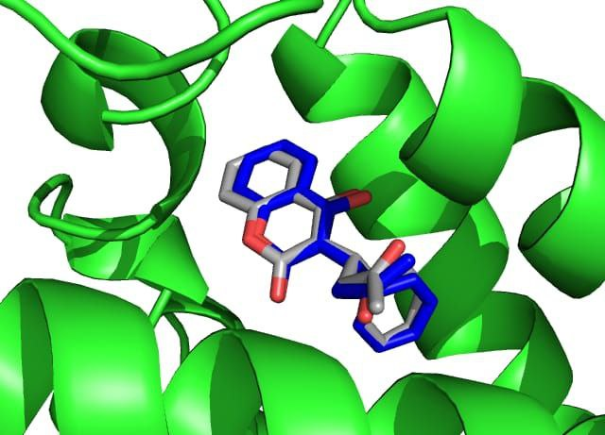

Figure 1: Validated molecular docking (re-docking) of the warfarin-VKOR complex, demonstrating an RMSD of less than 2.0 Å between the experimental (depicted in blue) and theoretical (depicted in grey) poses (A). Structure-based (Ts) and descriptor-based (Td) Tanimoto similarity functions for of Cannabis sativa compounds (B). The thresholds (0.3 and 0.7) are depicted as dotted lines.

As a result, rosmarinic acid (ΔGbind = -10.91 kcal/mol), chlorogenic acid (ΔGbind = -11.6 kcal/mol), and quercetin (ΔGbind = -10.77 kcal/mol) exhibited higher binding affinities to VKOR than warfarin (ΔGbind = -10.11 kcal/mol), suggesting their possible contribution to the prolonged APTT observed in *ex vivo* studies. However, no experimental evidence in the literature confirms direct interactions between polyphenolic compounds and VKOR that contribute to anticoagulant effects. For instance, liquiritigenin, a polyphenol from liquorice, modulates VKORC1 to inhibit ferroptosis in acute kidney injury, not directly affecting coagulation (Guo et al., 2024).

To enhance the specificity and selectivity of docking results, we employed a chemomolecular modeling approach integrating chemoinformatics and molecular docking. The 4-hydroxycoumarin moiety was used as a reference for structural similarity calculations because this scaffold is a key part of the warfarin molecule responsible for its bioactivity (Liu et al., 2021).

Structure-based (Ts) analysis using the 4-hydroxycoumarin scaffold revealed high structural similarity of warfarin and quercetin to this scaffold (Figure 1B). Conversely, descriptor-based (Td) analysis, incorporating molecular properties (Table 1) and binding affinity, confirmed that warfarin and quercetin exhibit the highest similarity (Td = 0.71), slightly exceeding the established similarity (T ≥ 0.7) threshold (Mellor et al., 2019; Kleandrova et al., 2021). These findings suggest that quercetin may share mechanistic similarities with warfarin, highliting the need for further experimental validation to confirm its anticoagulant role.

Table 1: Molecular properties and binding affinities (ΔGbind in kcal/mol) of analyzed ligands determined from C. sativa.

|  |  |  |  |  |  |  |
| --- | --- | --- | --- | --- | --- | --- |
| **Name** | **MW** | **LogP** | **HBD** | **HBA** | **AR** | **ΔGbind** |
| Quercetin | 302.24 | 1.99 | 5 | 7 | 3 | -10.77 |
| Gallic acid | 170.12 | 0.5 | 4 | 4 | 1 | -6.42 |
| Chlorogenic acid | 354.31 | -0.64 | 6 | 8 | 1 | -11.6 |
| Catechol | 110.11 | 1.09 | 2 | 2 | 1 | -5.39 |
| Caffeic acid | 180.16 | 1.19 | 3 | 3 | 1 | -7.07 |
| Coumaric acid | 164.16 | 1.49 | 2 | 2 | 1 | -6.04 |
| Rosmarinic acid | 360.32 | 1.76 | 5 | 7 | 2 | -10.91 |
| Warfarin | 308.33 | 3.61 | 1 | 4 | 3 | -10.11 |

**Data Availability Statement**

The data and code supporting the reproducible results of this computational modeling and simulation study are openly available in the GitHub repository at: <https://github.com/virtualscreenlab/VKOR/>.

**References**

Liu, S., et al. (2021). "Structural basis of antagonizing the vitamin K catalytic cycle for anticoagulation." Science **371**(6524).

Shityakov, S. and C. Forster (2014). "In silico predictive model to determine vector-mediated transport properties for the blood-brain barrier choline transporter." Adv Appl Bioinform Chem **7**: 23-36.

Shityakov, S., et al. (2021). "Scaffold Searching of FDA and EMA-Approved Drugs Identifies Lead Candidates for Drug Repurposing in Alzheimer's Disease." Front Chem **9**.

Guo, R.-Z., Li, J., Pan, S.-K., Hu, M.-Y., Lv, L.-X., Feng, Q., Qiao, Y.-J., Duan, J.-Y., Liu, D.-W., & Liu, Z.-S. (2024). Liquiritigenin, an active ingredient of liquorice, alleviates acute kidney injury by VKORC1-mediated ferroptosis inhibition. The American Journal of Chinese Medicine, 52(5), 1507–1526.

Mellor, C. L., et al. (2019). "Molecular fingerprint-derived similarity measures for toxicological read-across: Recommendations for optimal use." Regul Toxicol Pharmacol **101**: 121-134

Kleandrova, V. V., et al. (2021). "QSAR Modeling for Multi-Target Drug Discovery: Designing Simultaneous Inhibitors of Proteins in Diverse Pathogenic Parasites." Front Chem **9**: 634663.