Nguyễn Đức Tài

21024541

Github: https://github.com/virtue1803/cnm_tuan07

B1: tìm S3 trên AWS

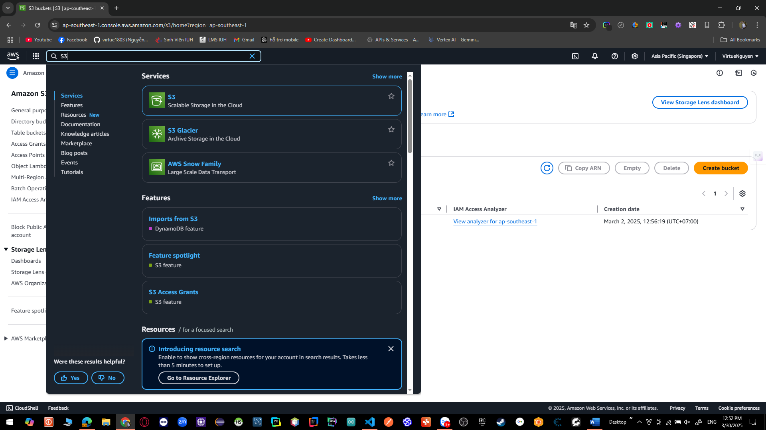

B3:bỏ chọn **Block *all* public access**

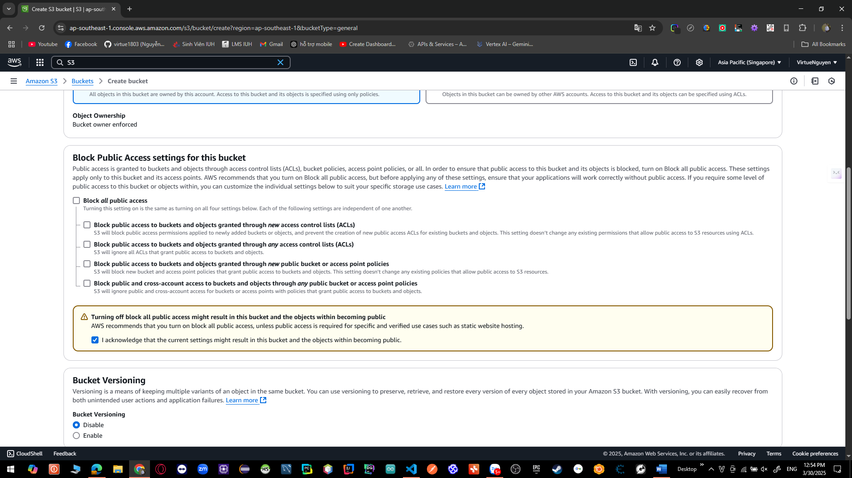

B4: tạo bucket

B5: Tạo 1 CloudFront Distribution:

B6: bấm Create distribution. Chú ý domain name của distribution vừa tạo.

B7: tạo thành công

B8 cập nhật vào code  
  
