Assignment-1

- List up to IO different protocols that appear in the protocol column in the unfiltered packet-listing window.

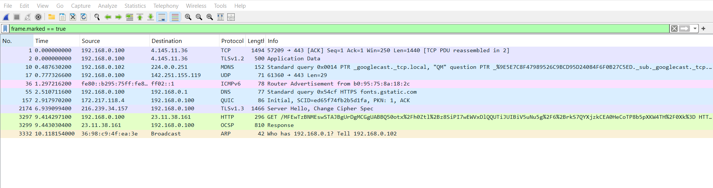

- TCP: Transmission Control Protocol
- TLSv1.2 / TLSv1.3: Transport Layer Security (version 1.2 and version 1.3)
- MDNS: Multicast Domain Name System
- UDP: User Datagram Protocol
- ICMPv6: Internet Control Message Protocol version 6
- DNS: Domain Name System
- QUIC: Quick UDP Internet Connections
- HTTP: Hypertext Transfer Protocol
- OCSP: Online Certificate Status Protocol
- ARP: Address Resolution Protocol

- What is the Internet address of the www.gujaratuniversity.ac.in? What is the Internet address of your computer?

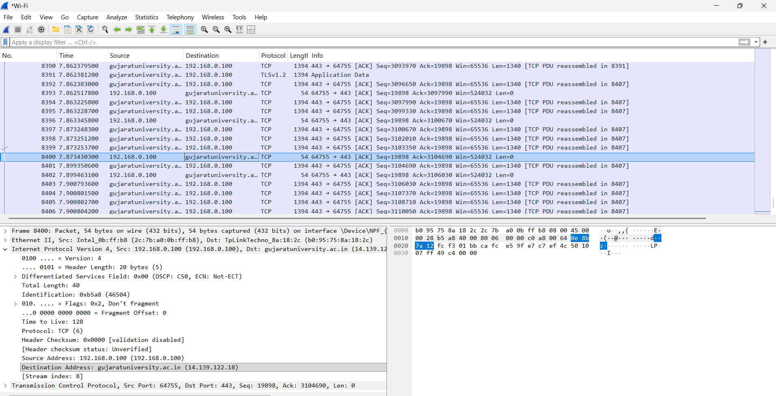

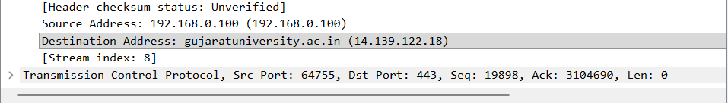

- Internet address of the www.gujaratuniversity.ac.in : gujratuniversity.ac.in (14.139.122.18)
- Internet address of the User’s Computer: 192.168.0.100 (192.168.0.100)

- http protocol only with Wireshark running on your computer.

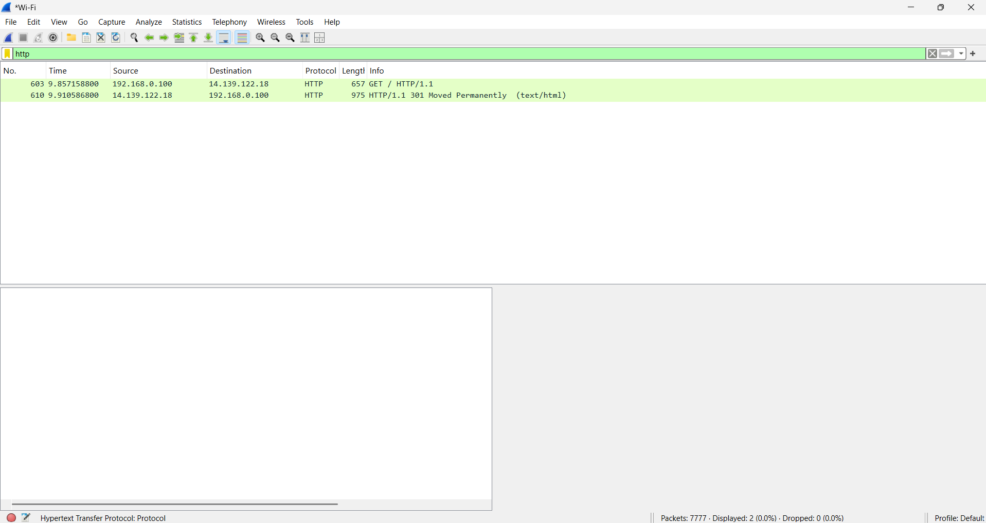

- Filter : http

- How many packets did you capture (total of all protocols, not just HTTP)?

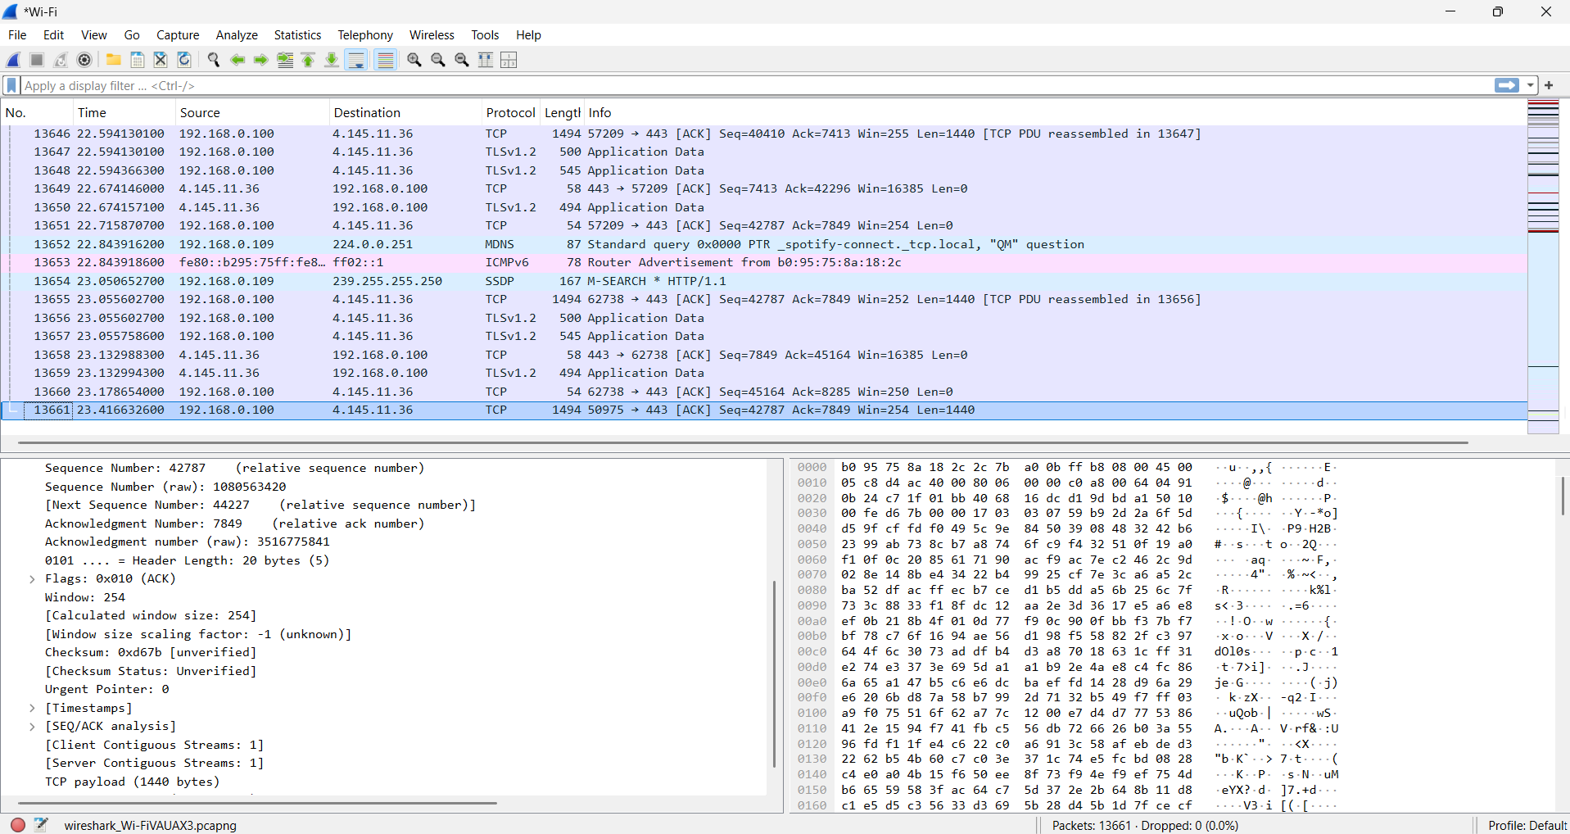

- Number of packets : 13661

- Now, use display filters to determine how many packets contain your ip address (hint: Use ip.addr instead of the clumsy ip.src or ip.dst format).

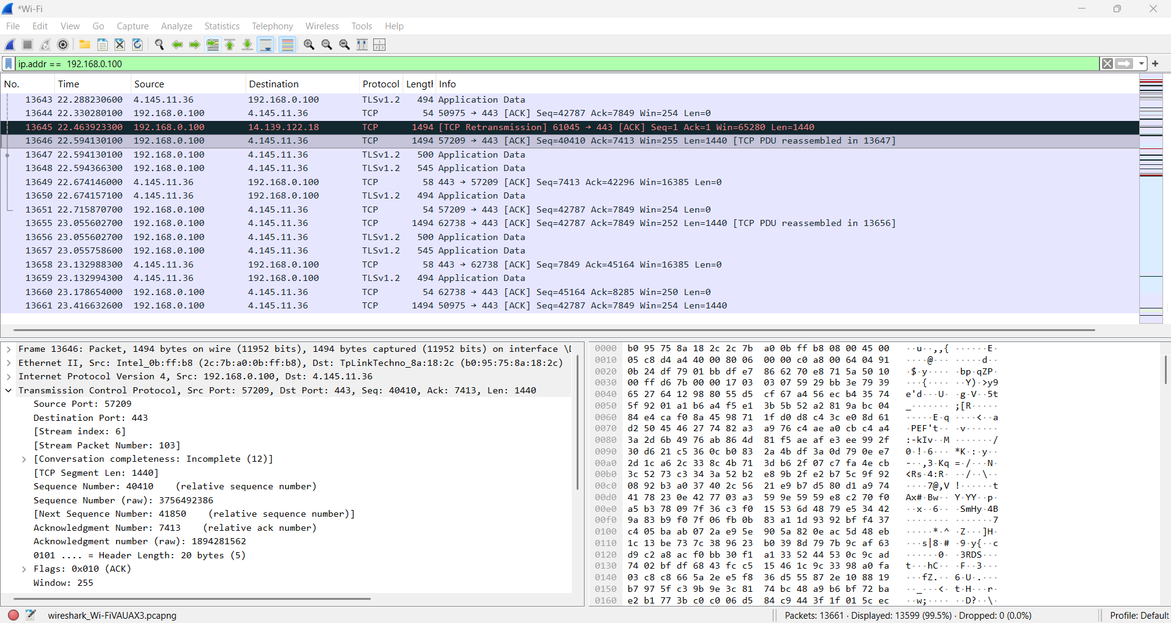

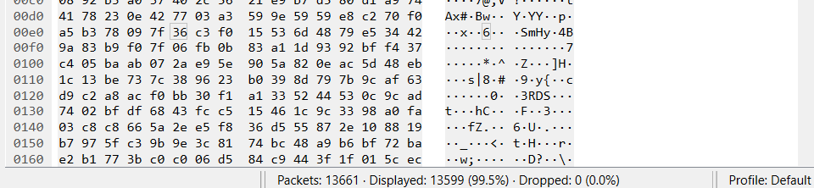

- Number of packets which contain the user’s IP address: 13599

- What is this filter you used? Now, reverse the filter to determine how many packets don’t contain your ip address.

- The filter is ip.addr == 192.168.0.100

- The reversed filter is! (ip.addr == 192.168.0.100)

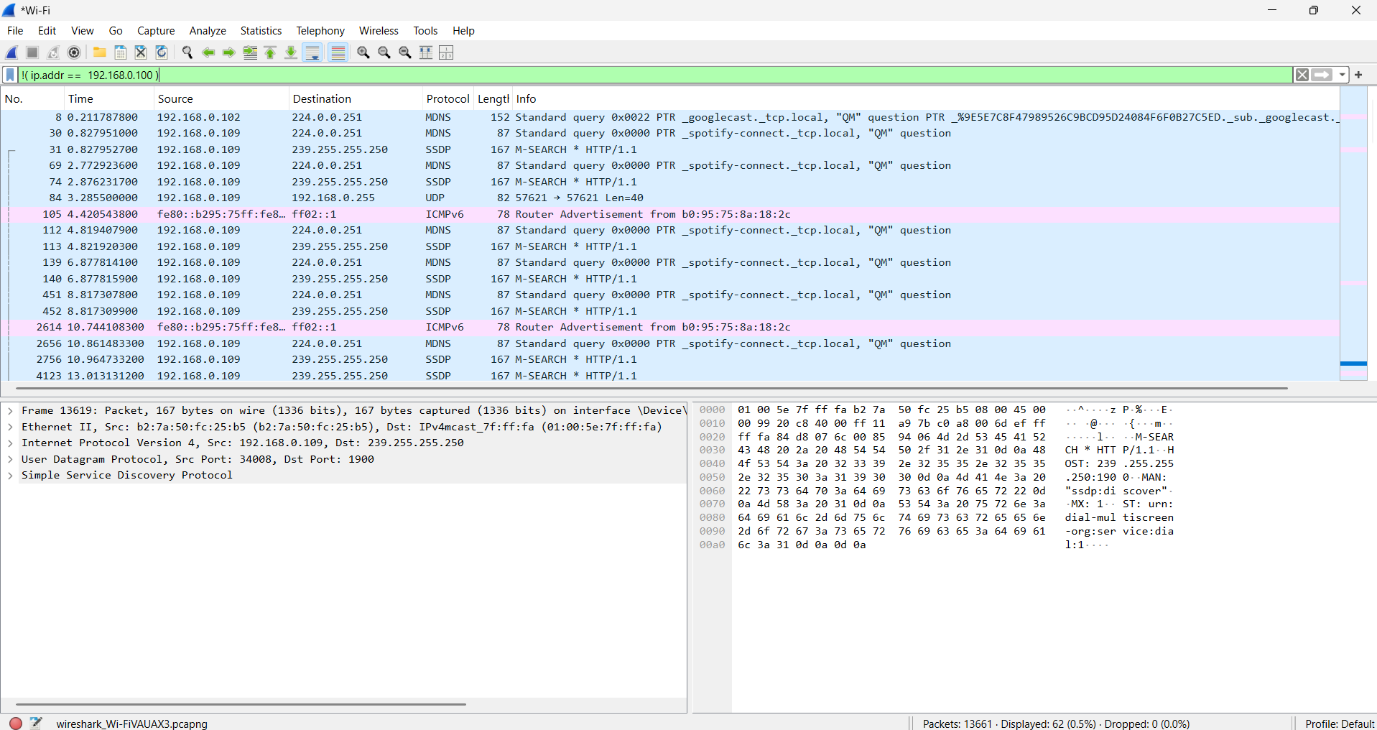

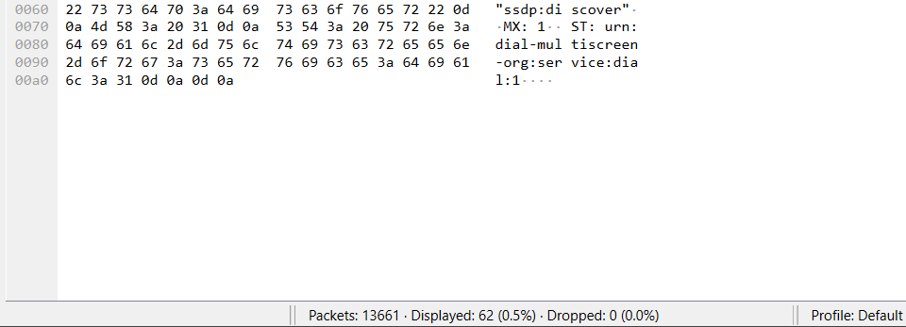

- Number of packets displayed: 62

- What is the IP address of your computer? Of the gtu.ac.in server?

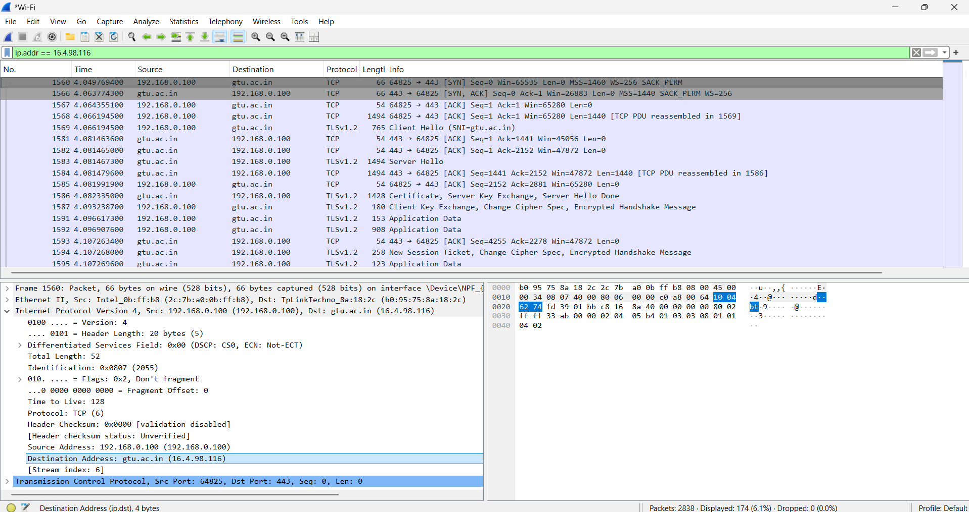

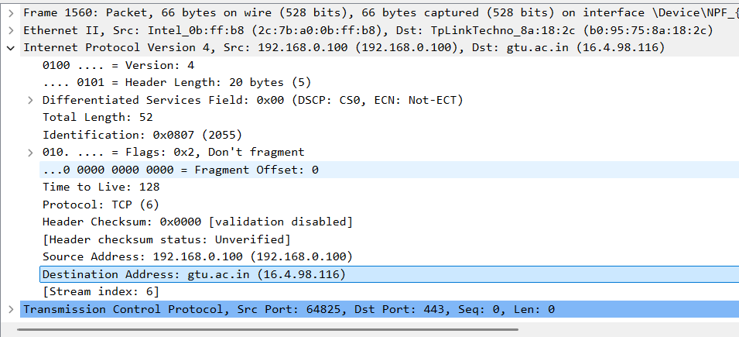

- IP address of gtu.ac.in: 16.4.98.116
- IP address of User’s Computer: 192.168.0.100

- What HTTP version is your browser running? What version of HTTP is the server running?( HTTP browser request line (GET / HTTP/1.1)& HTTP server response line (HTTP/1.1 200 OK)( http.request.method == GET)

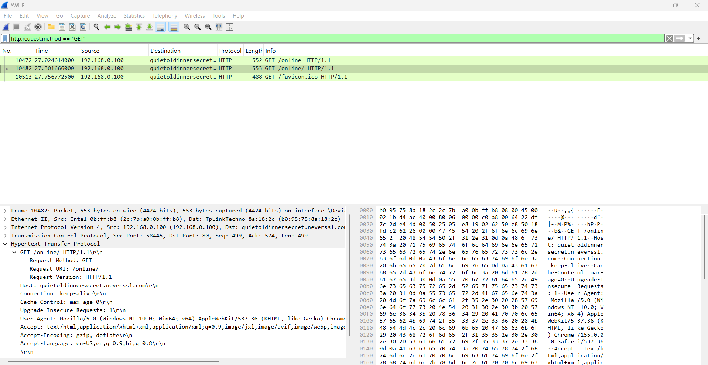

Browser Request HTTP version : HTTP/1.1

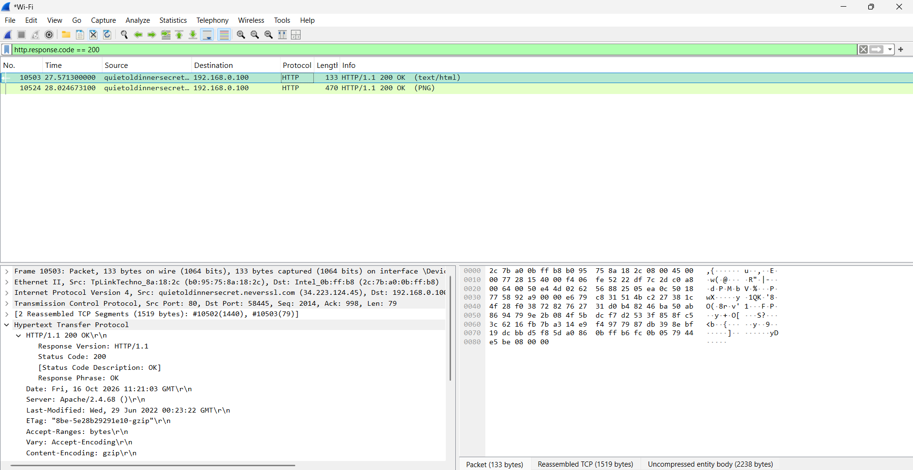

Server Response HTTP version : HTTP/1.1

- What is the status code and phrase returned from the server to your browser?( http.response.code)

Status Code: 200

- What languages does your browser indicate to the server that it can accept? Which header line is used to indicate this information? http.request or http.accept_language

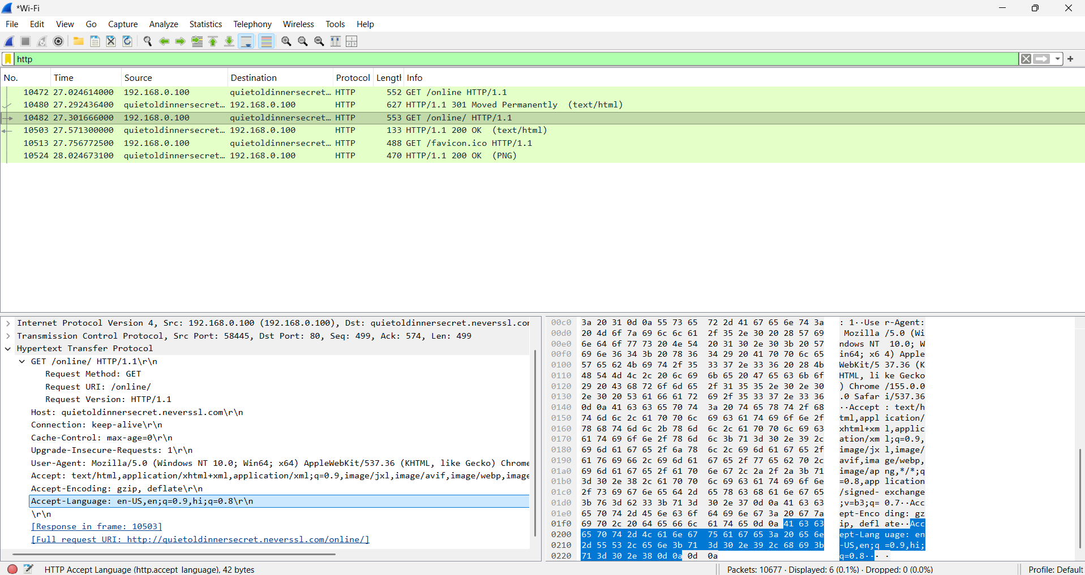

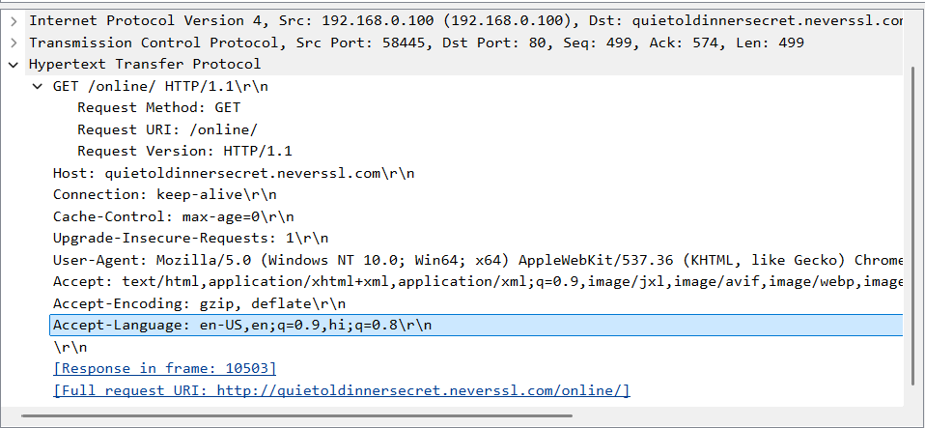

Accept-Language: en-US,en;q=0.9,hi;q=0.8\r\n

The browser indicates accepted languages using the Accept-Language HTTP request header so the answer is : http.accept_language.
Languages : en-US,en;

- When was the HTML-file, that you have retrieved, last modified at the server? Which header line is used to indicate this information? http.response.code == 200 && http.last_modified

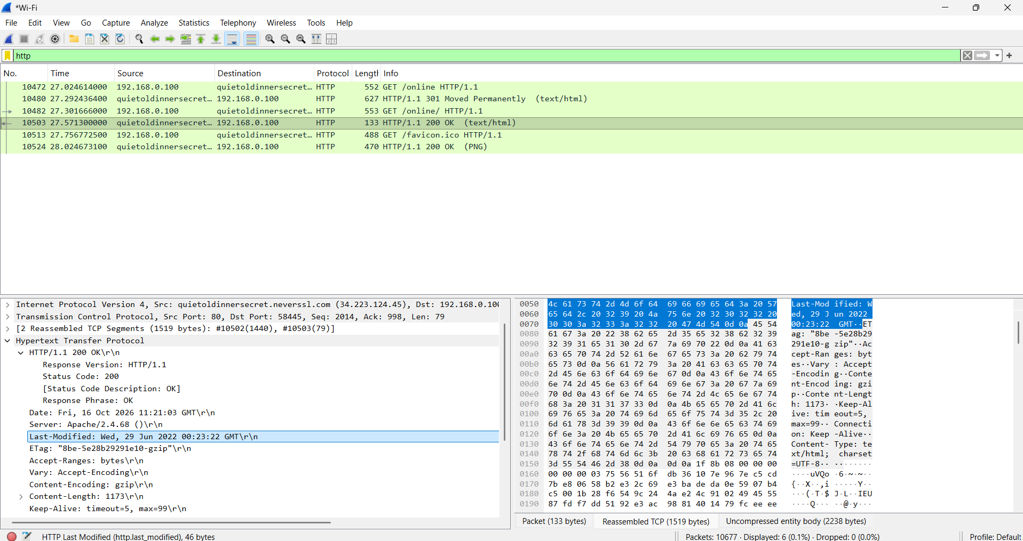

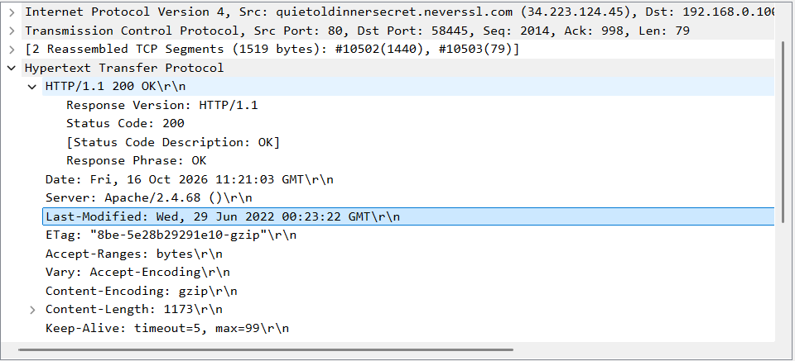

The HTML file was last modified at Wed, 29 Jun 2022 00:23:22 GMT ,
http.last_modified header line is used to indicate this information.

- How many bytes of content (size of file) are returned to your browser? Which header line is used to indicate this information? HTTP Conditional GET/Response Interaction

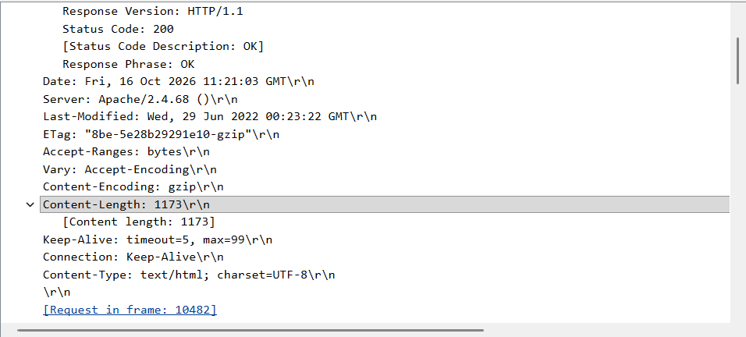

Content length: 1173
The header line Content-Length is used to indicate this information.

- Start up the Wireshark packet sniffer, and make sure that “http” is in the displayfilter, so that only captured HTTP messages will be displayed in the packet-list pane.

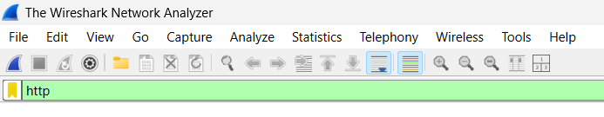

- Enter the following URL into your browser: http://gaia.cs.umass.edu/wireshark-labs/HTTP-wireshark-file1.html Your browser should display a very simple HTML file.

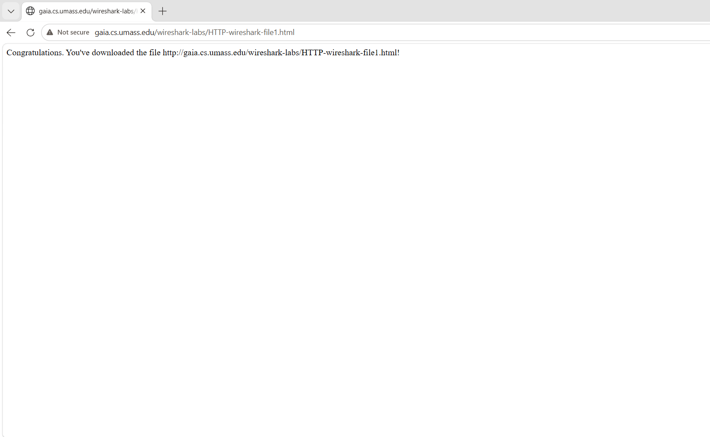

- Quickly enter the same URL into your browser again (or simply select the refresh button on your browser).

- Stop Wireshark packet capture.

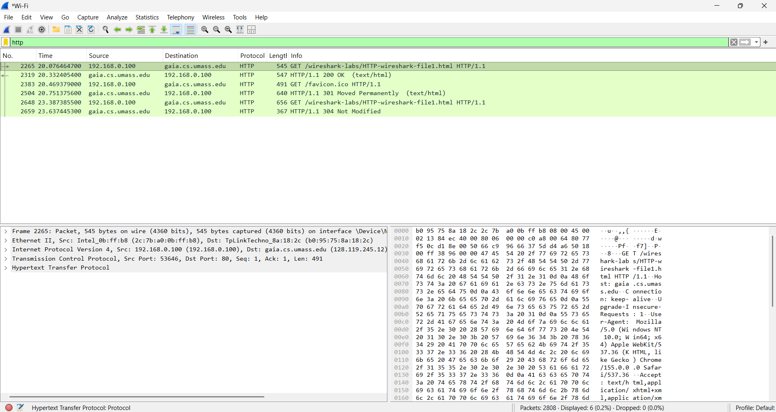

- Inspect the contents of the first HTTP GET request from your browser to the server. Is there an “IF-MODIFIED-SINCE” header line in the HTTP GET message? Why or why not?

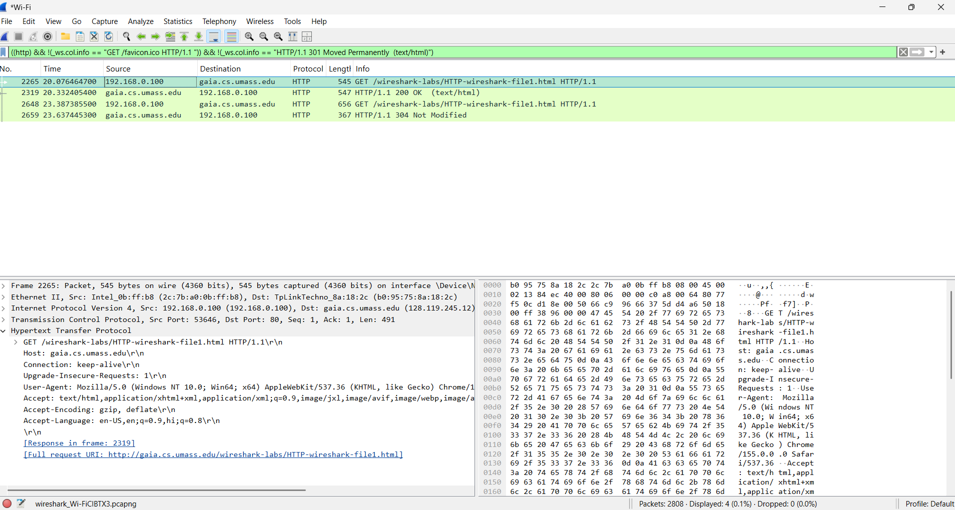

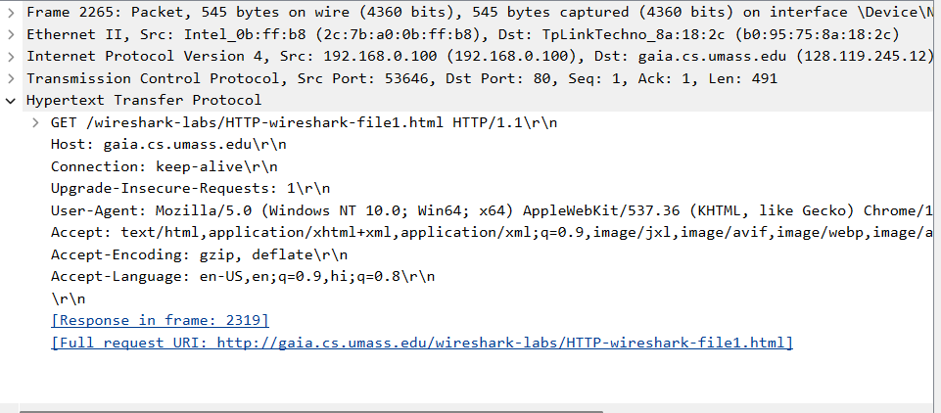

- There’s no “IF-MODIFIED-SINCE” header line in the HTTP GET message.

- The browser is requesting the file for the first time, so it usually does not have a previously cached copy with a modification date to validate. Therefore, it generally sends a GET request without this header.

- Inspect the contents of the server response. Has the server explicitly returned the contents of the file? How can you tell?

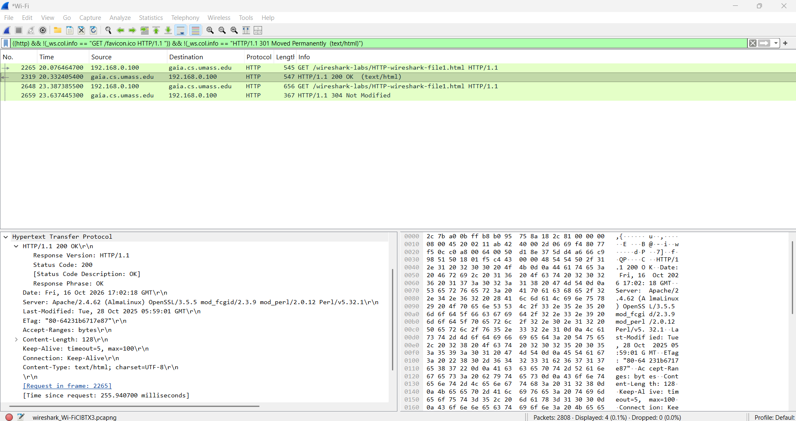

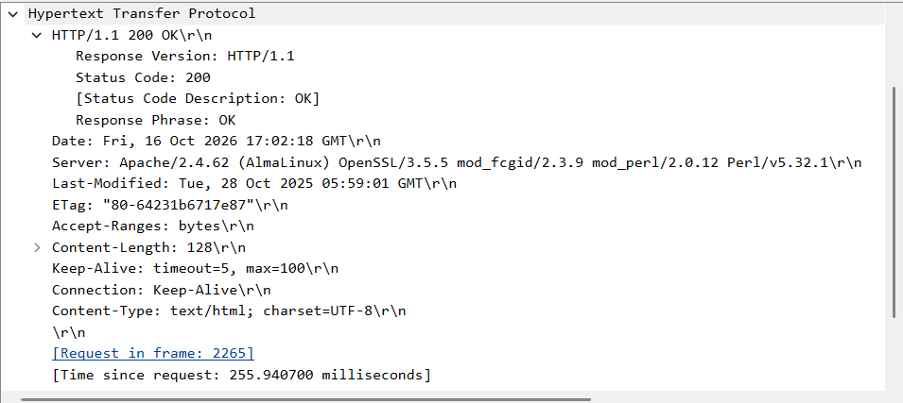

- A 200 OK response containing the HTML document means the server has sent the file's contents to the browser.

- Now inspect the contents of the second HTTP GET request from your browser to the server. Is there an “IF-MODIFIED-SINCE:” header line in the HTTP GET message? If so, what information follows the “IF-MODIFIED-SINCE:” header line?

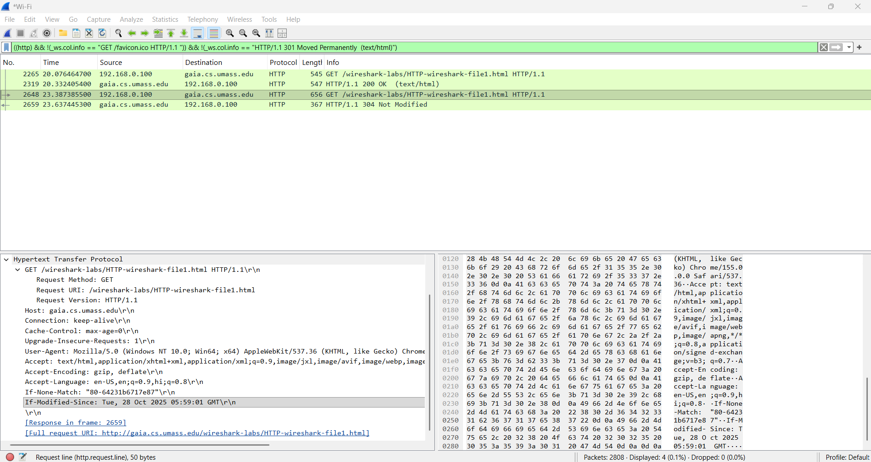

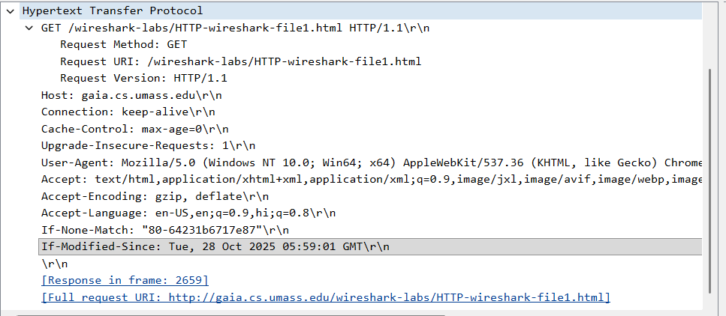

- Yes there is an “IF-MODIFIED-SINCE:” header line in the HTTP GET message. Its followed by the date and the time “Tue, 28 Oct 05:59:01 GMT\r\n”
- What is the HTTP status code and phrase returned from the server in response to this second HTTP GET? Has the server explicitly returned the contents of the file? Explain.

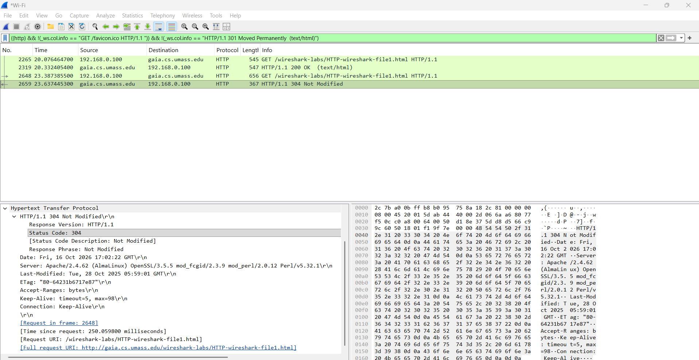

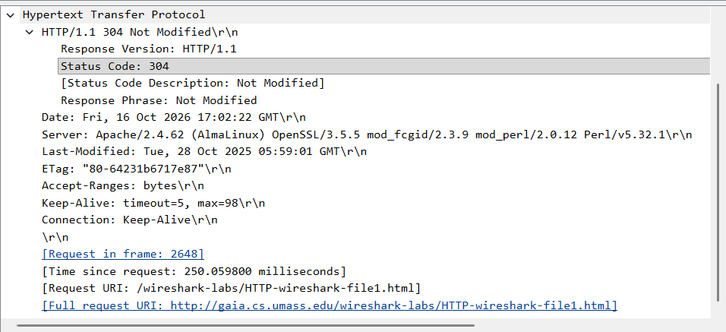

- Status Code: 304
- Response Phrase: Not Modified
- The server indicates that the cached copy is still valid, so the browser can reuse its local copy. If your capture instead shows 200 OK, the server has returned the resource normally.

- How many HTTP GET request messages has your browser sent? Which packet in the trace contains the request for the Bill of Rights? Note: The packets here are only those containing HTTP messages and data.

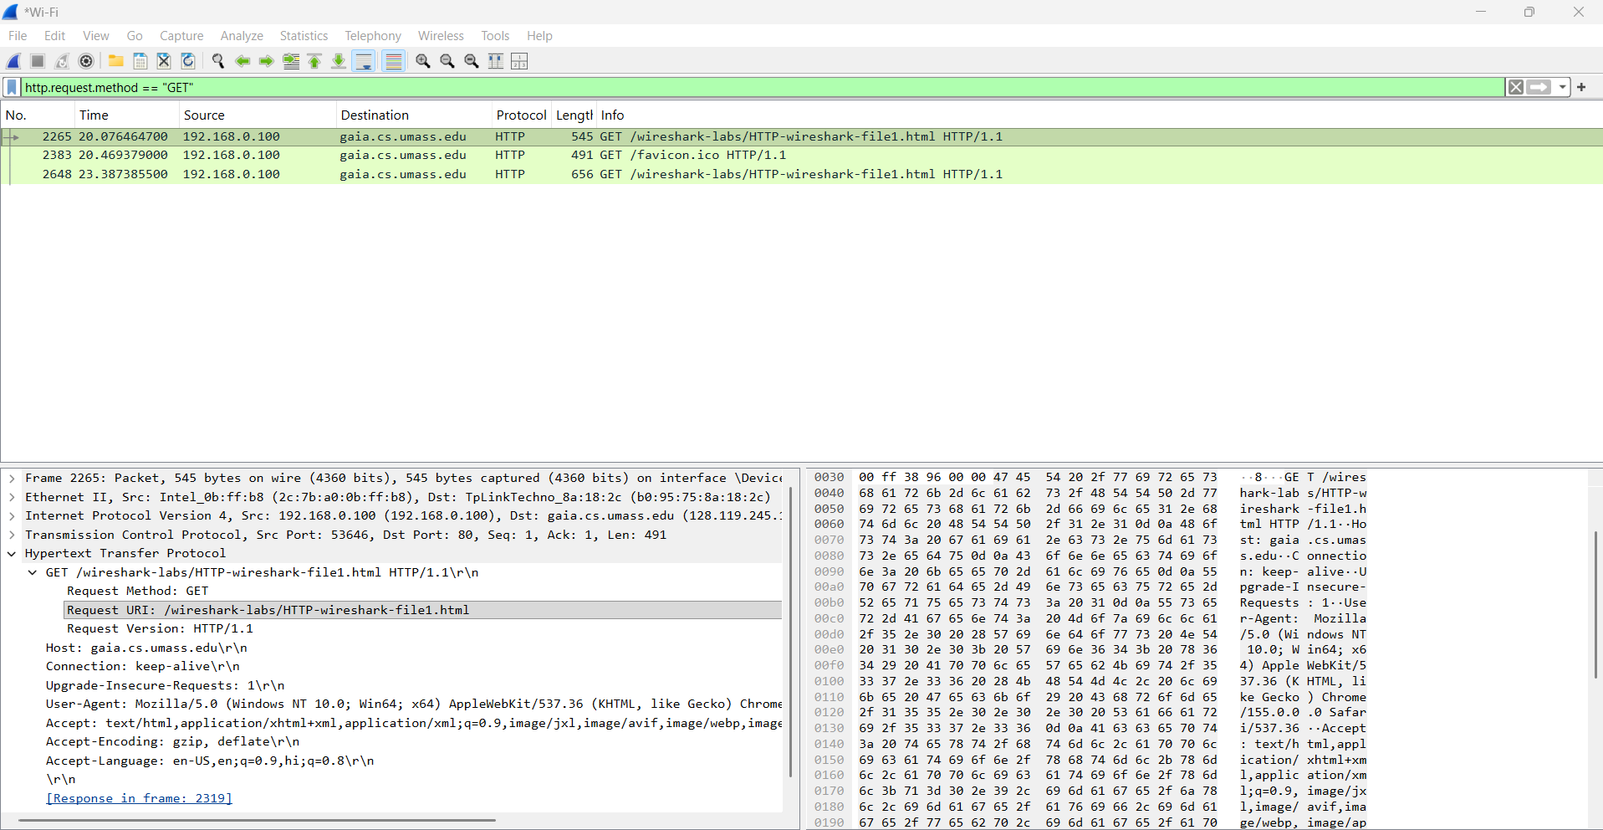
There are 3 packages with the request method “GET” ( The second request is for the favicon . A favicon is a small image displayed next to the page title in the browser tab.)

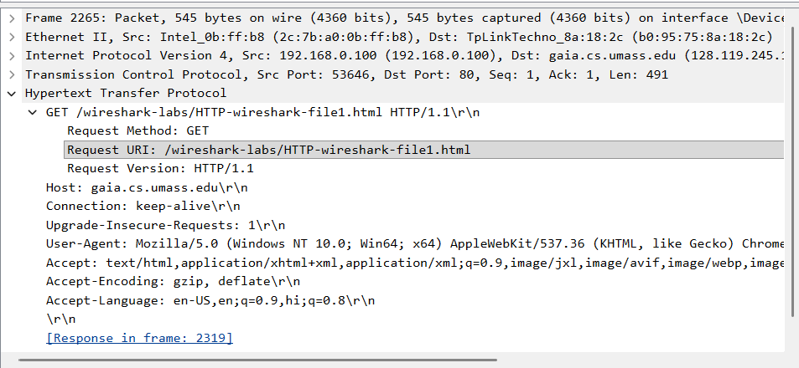

The packet containing the Bill of Rights request is the one whose request URI identifies the relevant file. The first packet contains the Bill of Rights.

- Which packet in the trace contains the status code and phrase associated with the response to the HTTP GET request? What is the status code and phrase in the response?

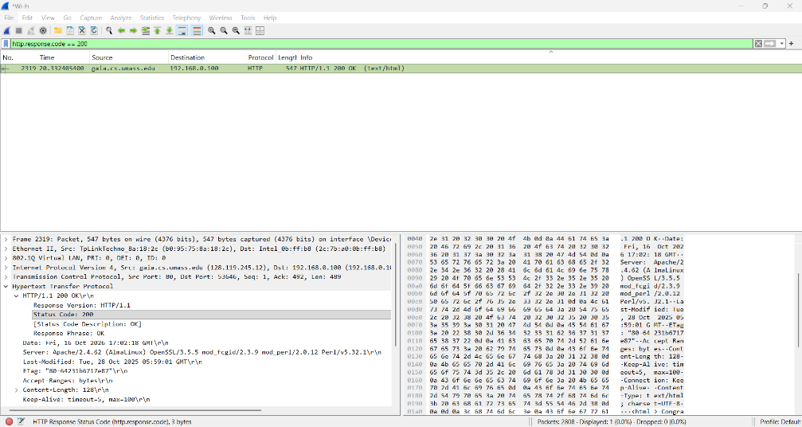

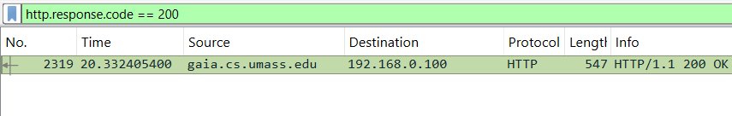

Packet No : 2319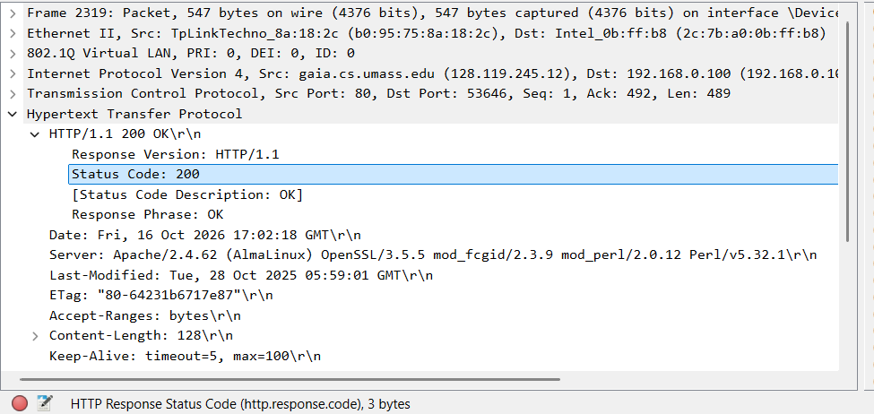

Status Code: 200
Response Phrase: OK

- Discuss http GET and RESPONSE.

HTTP GET request
- It is sent by the client (browser) to request a resource from a web server.
- It contains the request method, requested URL/path, HTTP version, and headers.
- Example: GET /wireshark-labs/HTTP-wireshark-file1.html HTTP/1.1

HTTP response
- It is sent by the server after receiving the request.
- It contains an HTTP version, status code, status phrase, response headers, and sometimes a response body.
- 200 OK indicates a successful request, usually with the requested content.
- 304 Not Modified indicates that a valid cached copy can be reused, without resending the resource body.

- Count the total number of HTTP GET requests. Ans.: Enter in filter: http.request.method==GET , then count total ------ marked.

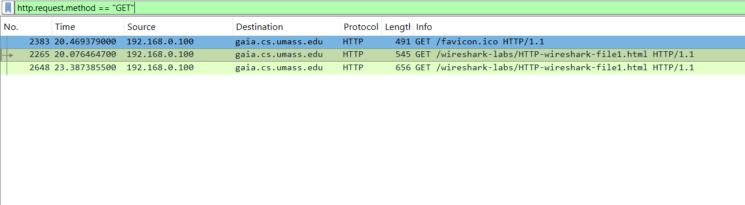

- Total Number of Get Requests: 3 ( including 1 for favicon )

- How much time elapsed between the first HTTP GET request from client and the HTTP response (OK) from server? Ans.: http.request.method==GET || http.response

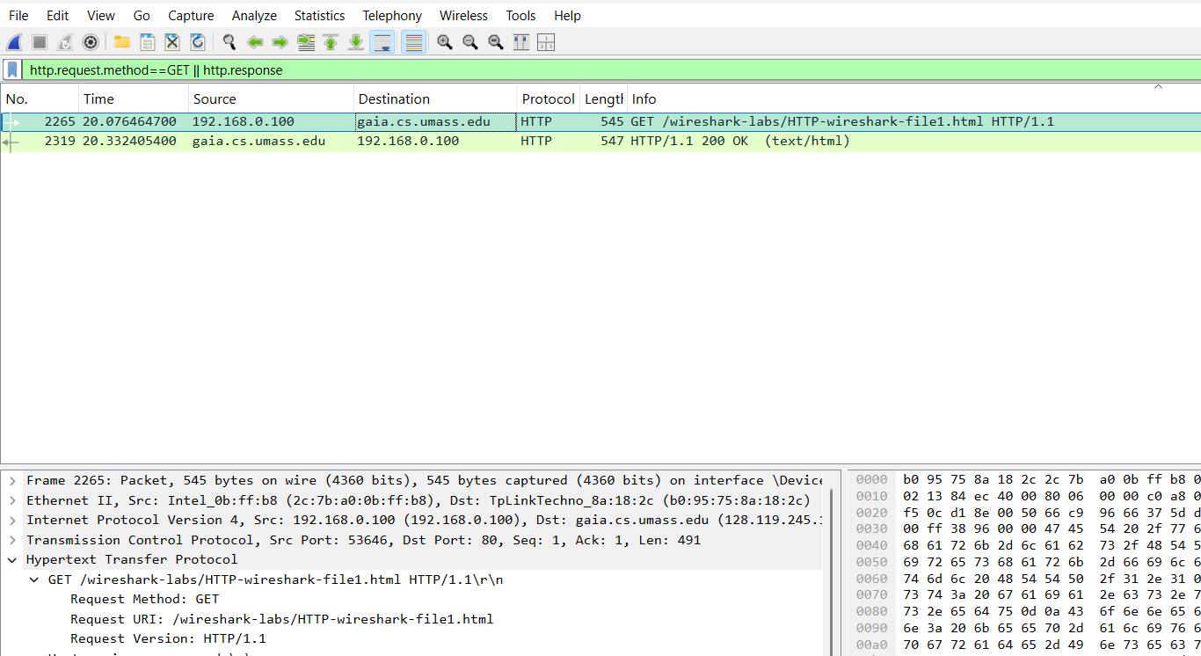

$$\text{Elapsed time}=\text{Response time}-\text{GET request time}$$
Elapsed time = 20.332405400 $-$ 20.076464700
Elapsed time = 0.2559407s
- Identify the source and destination ports used to transfer the first HTTP GET request.
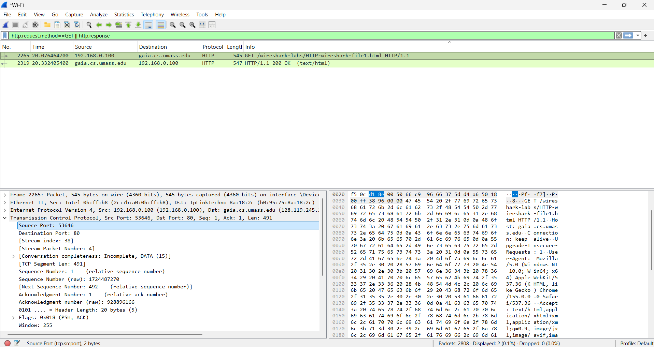

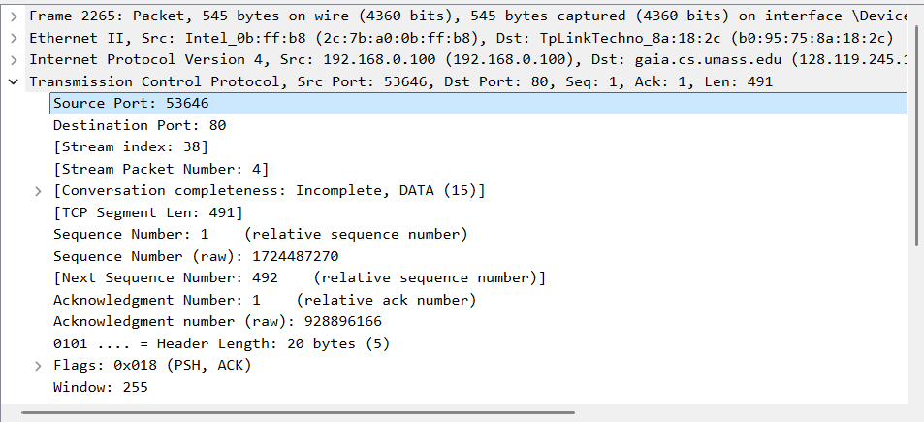

Source Port: 53646
Destination Port: 80

- Identify the client and server ip address in the first HTTP GET request? Ans.: Apply filter http.request.method==GET, see the IP , within this you will find source ip address and destination ip address.

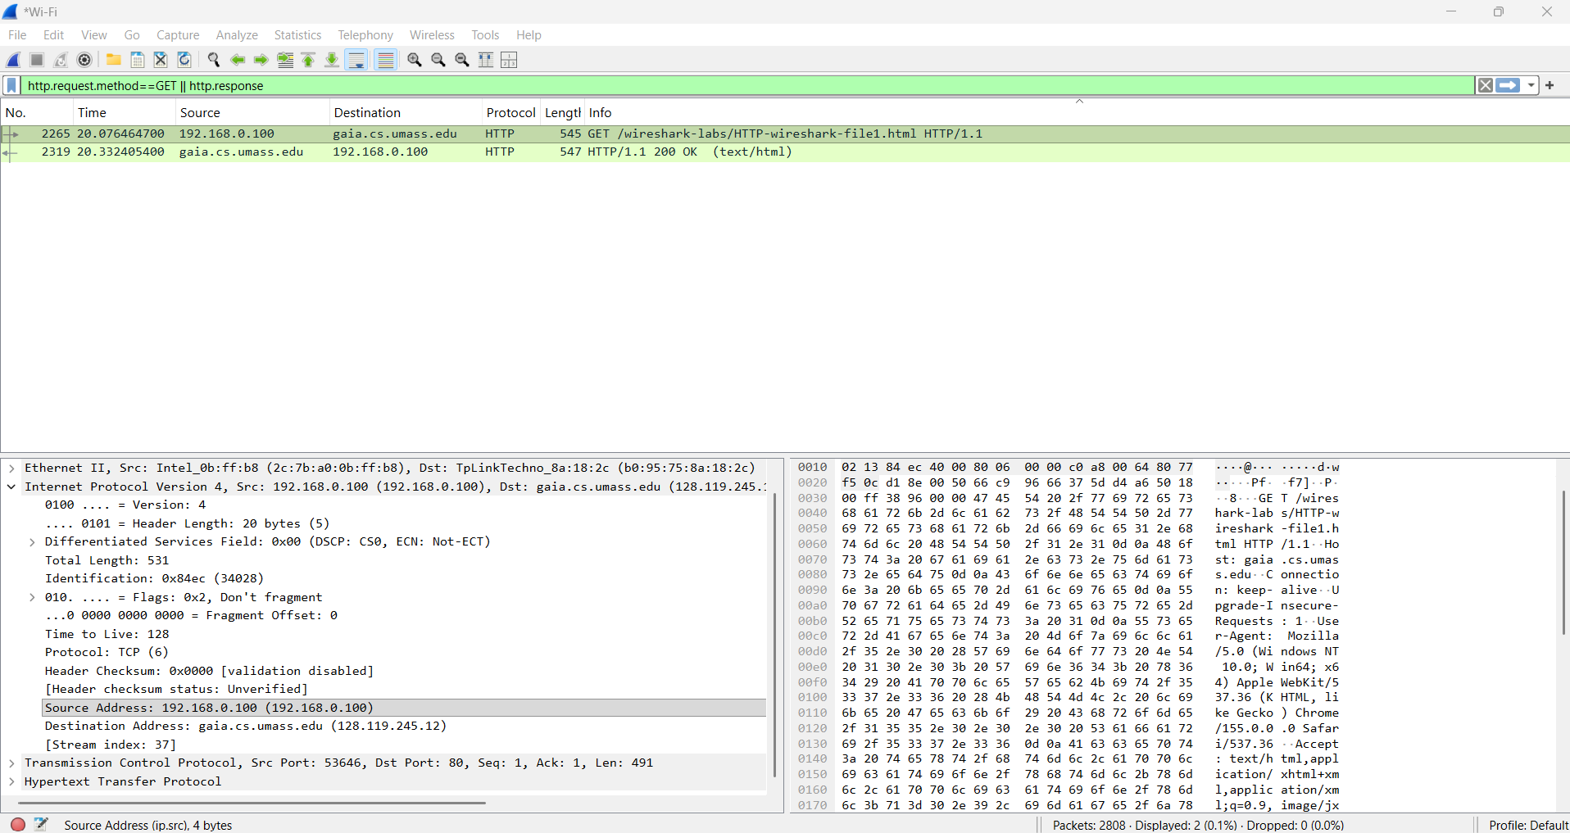

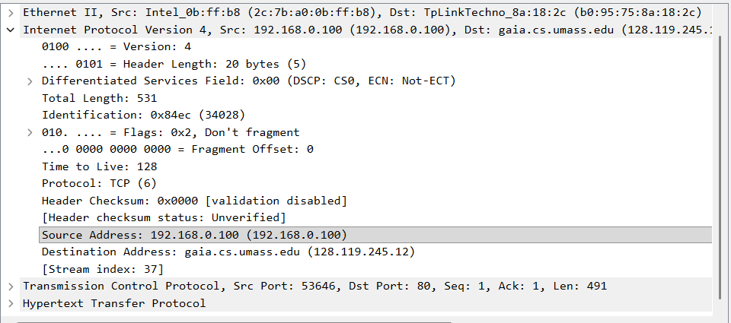

Source IP Address: 192.168.0.100
Destination Address: 128.119.245.12

- Identify the client and server MAC address in the first HTTP GET request? Ans.: Apply filter http.request.method==GET, see the Ethernet , within this you will find source MAC and destination MAC.

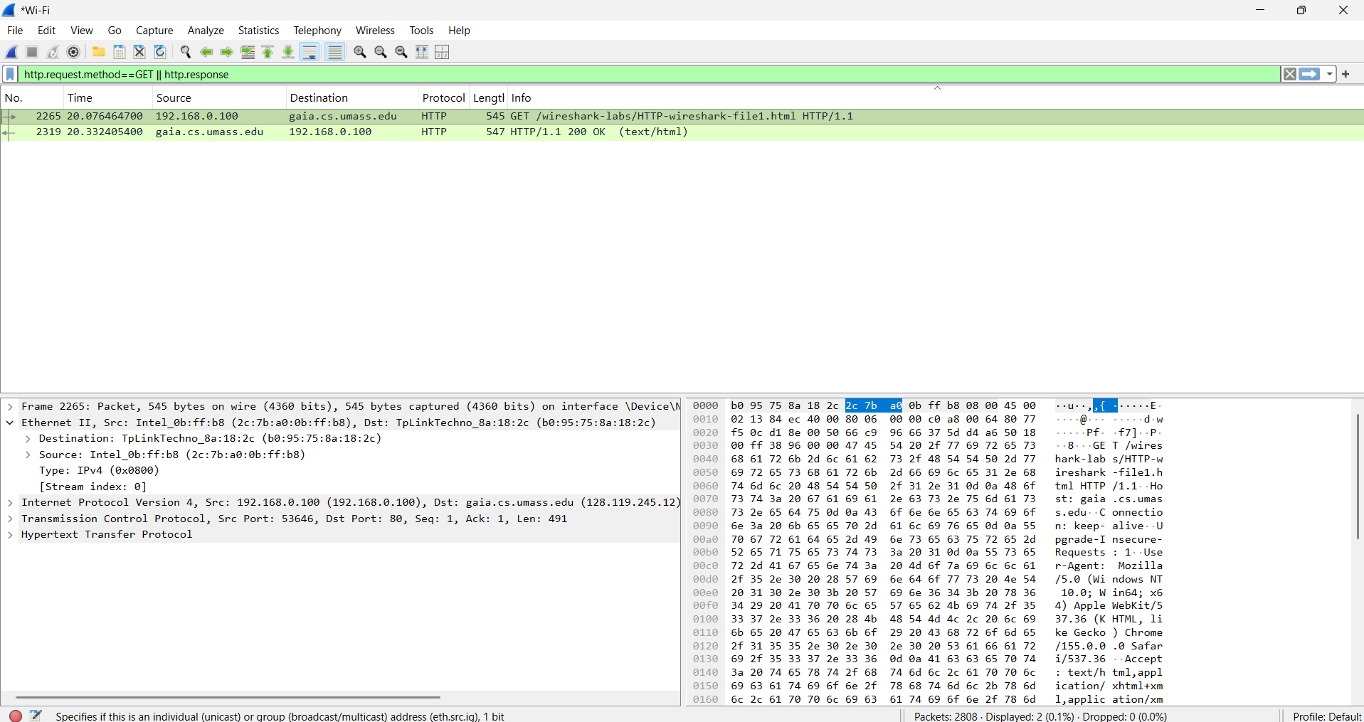

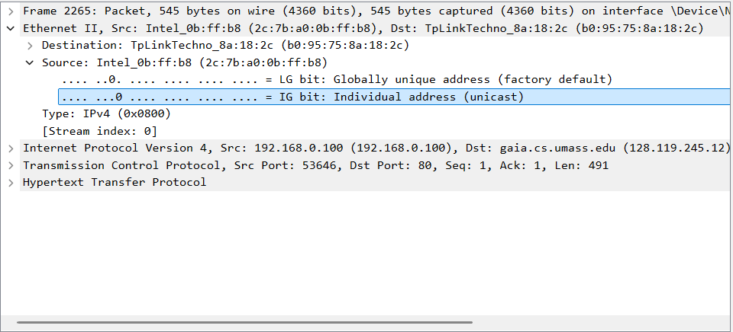

Destination MAC address: b0:95:75:8a:18:2c
Source MAC address: 2c:7b:a0:0b:ff:b8

DNS PROTOCOL
Start Wireshark packet capture. - Open your browser and visit https://www.amazon.com/ This generates DNS packets because the browser first requests the IP address of amazon from the DNS server. - After the website opens successfully, stop the Wireshark packet capture.
- Use the filtering functionality of Wireshark by typing “dns” in the filtering field, new window will appear:

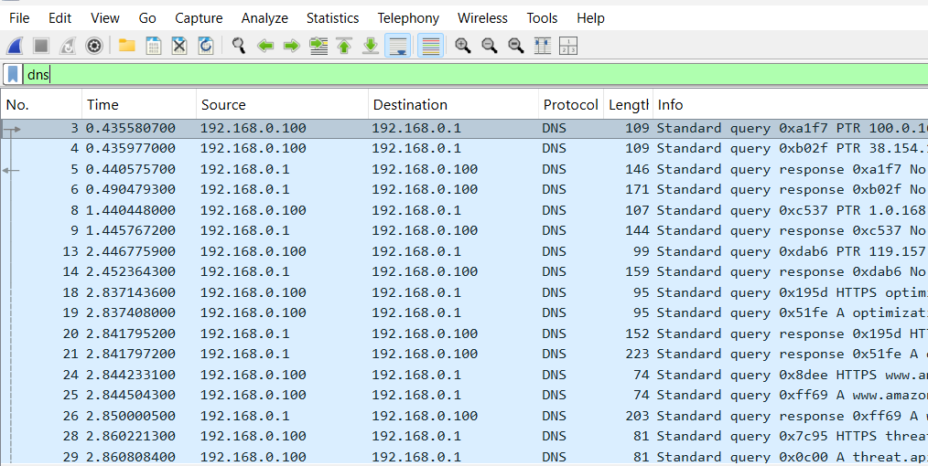

- Let’s try now to find out what are those packets contain by following one of the conversations (also called network flows), select one of the packets and press the right mouse button, you should see another screen appear. Click on Follow UDP Stream, and then you will see another screen showing content https://www.amazon.com/

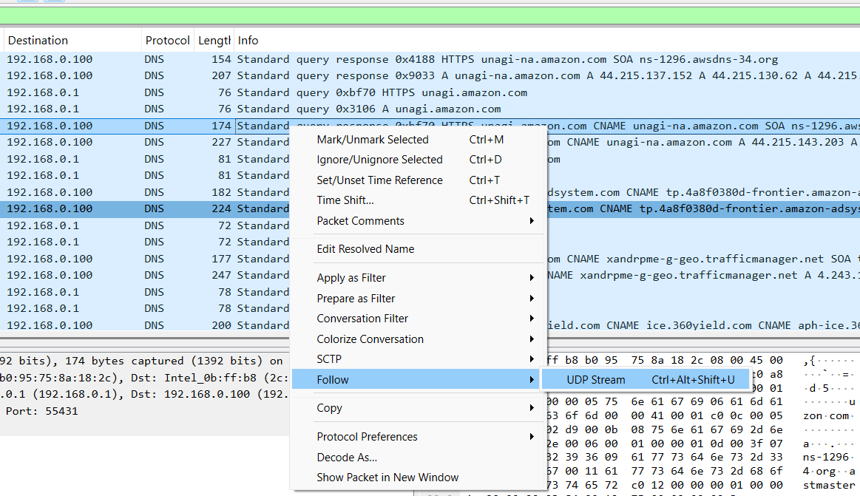

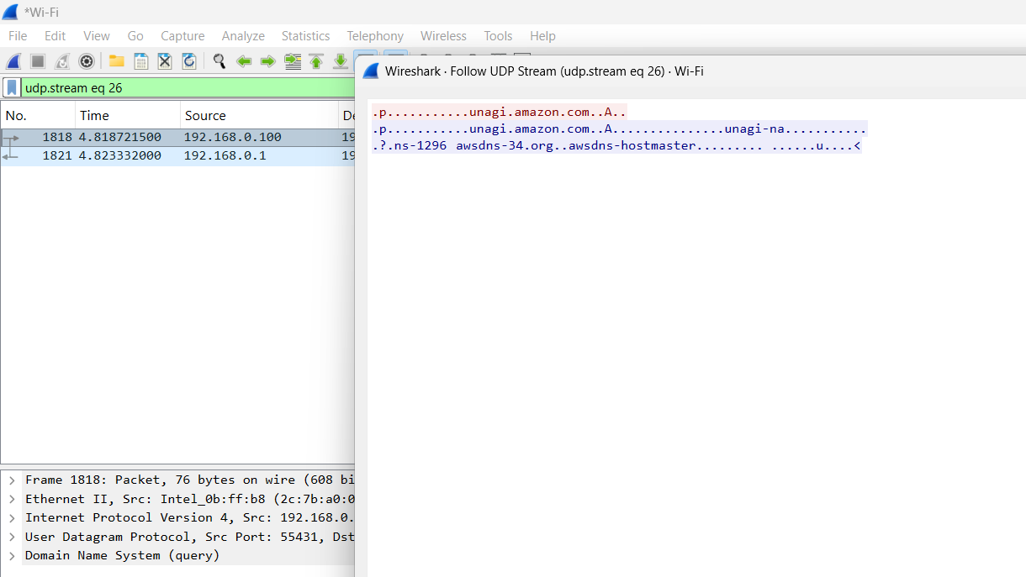

- At Command prompt ; Nslookup https://www.amazon.com/

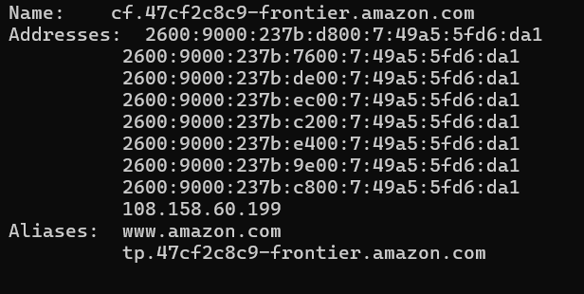

- Locate the DNS Query and Response message, Are they sent on UDP or TCP

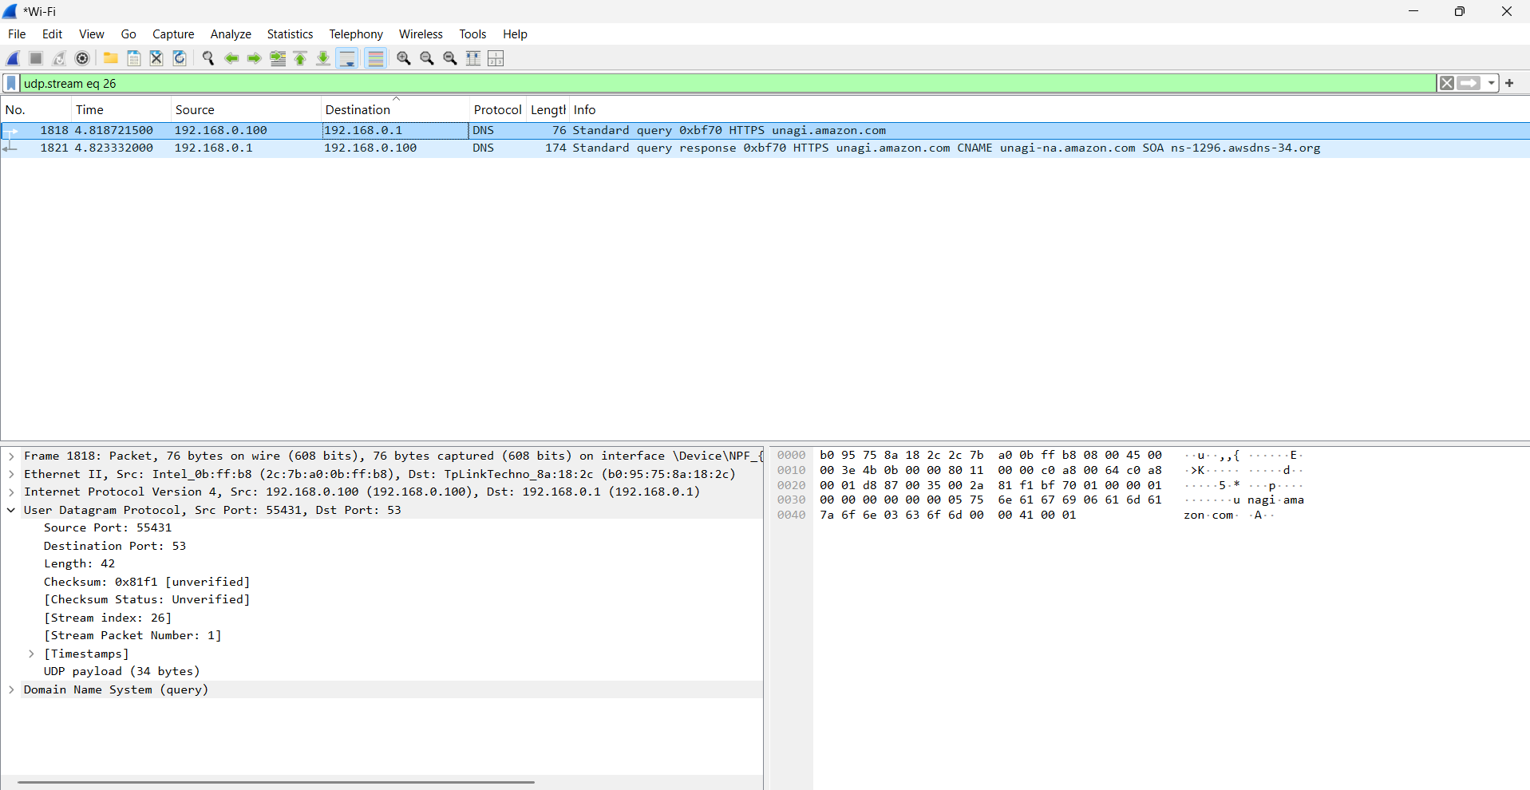

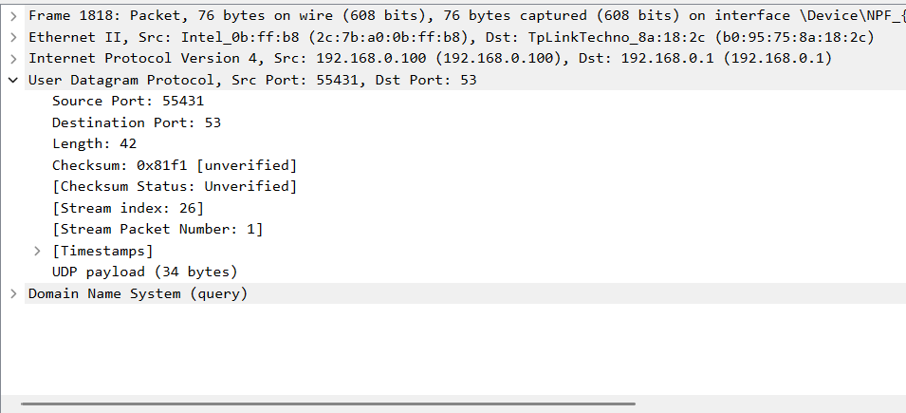

Query is sent on UDP protocol.
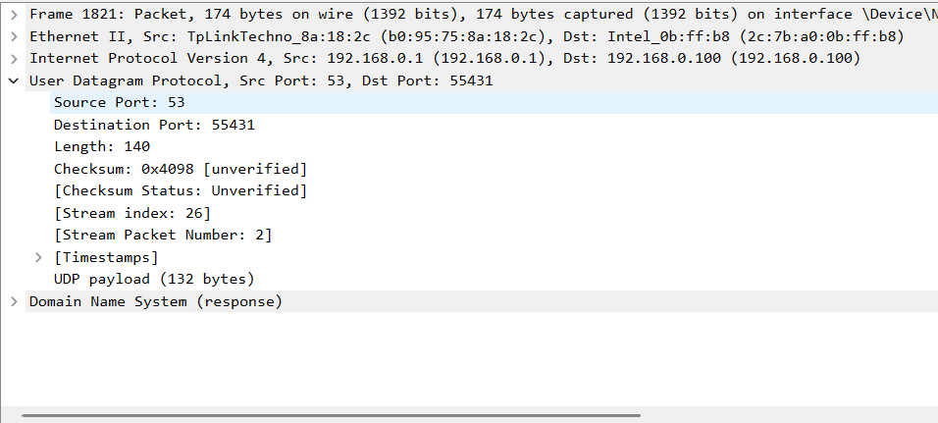

The Response is sent on UDP.

Both Query and Response are sent on UDP.

- What is the destination port for the DNS query message ? What is the source port of of DNS response message?

Query:
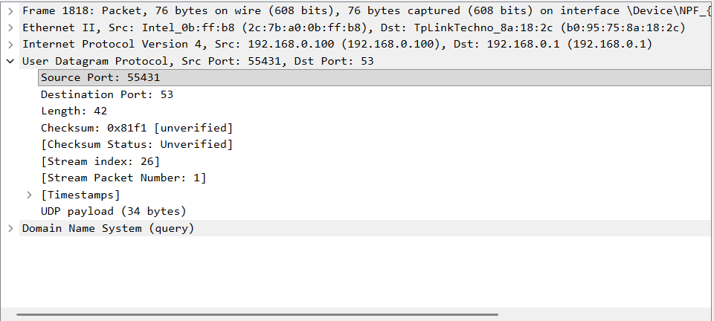

Response: 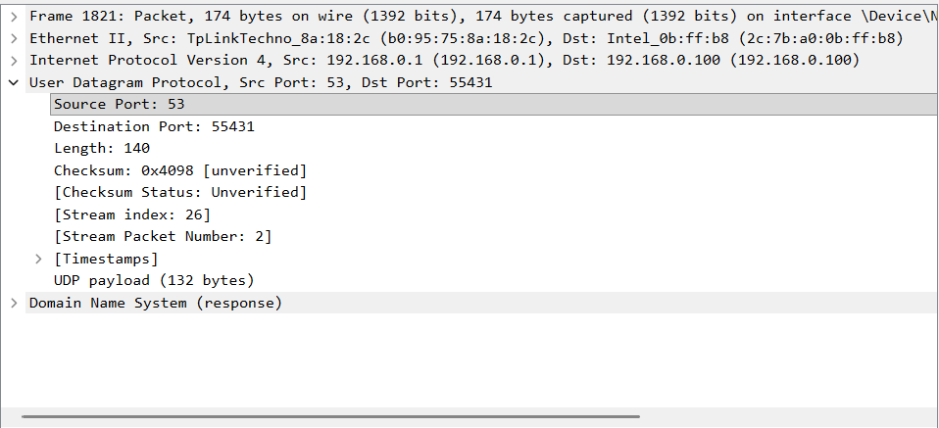
- DNS query destination port: 53
- DNS response source port: 53
- The client's temporary source port in the query becomes the destination port in the response.

- What is the source IP address of the DNS Query message? Is it the IP address of your computer? Verify using ipconfig. Are these two IP address the same?

DNS Query :
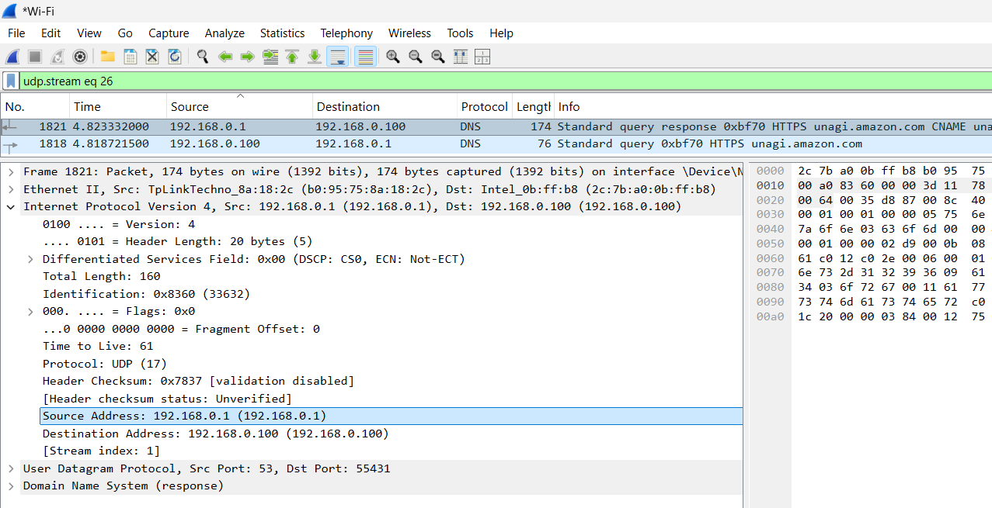

Ipconfig :
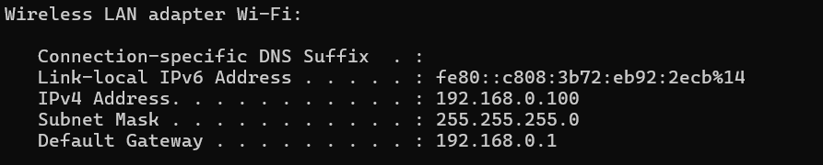

They are the same (192.168.0.100).

- What is the destination IP address of the DNS Query message? Is it the IP address of your local DNS server? Verify using ipconfig/all. Are these two IP address the same?

DNS Query:

Ipconfig /all: 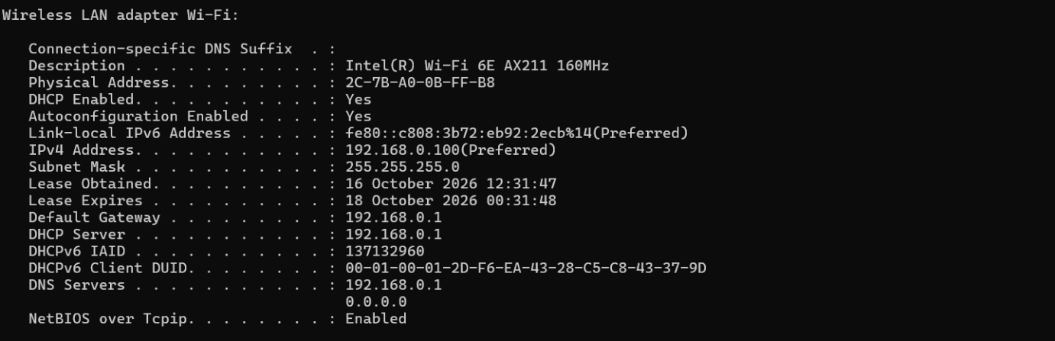

They are the same.

- Examine the DNS query message. What “Type” of DNS query is it? Does the query message contain any “answers”?

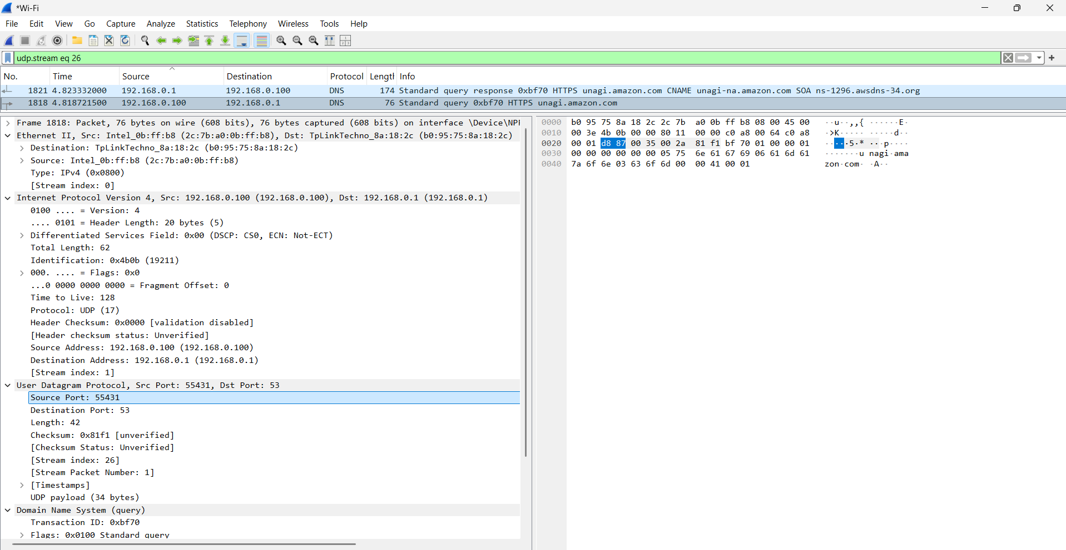

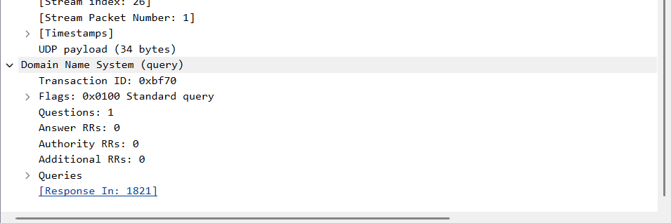

It’s a Standard Type query and it doesn’t contain any answers.

- Examine the DNS response message. How many “answers” are provided? What do each of these answers contain? The response DNS message contains one answer containing information about the name of the host, the type of address, class, the TTL,the data length .

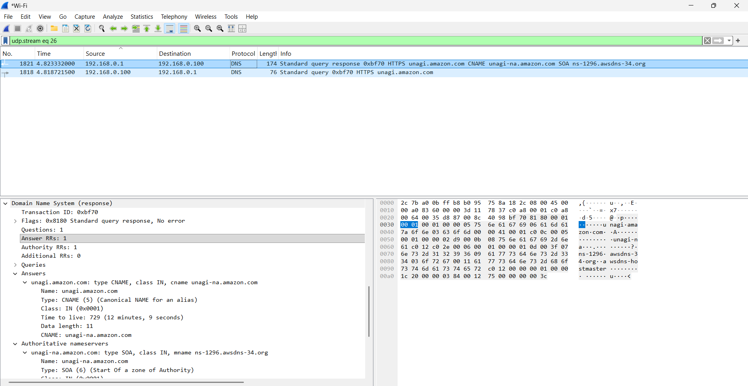

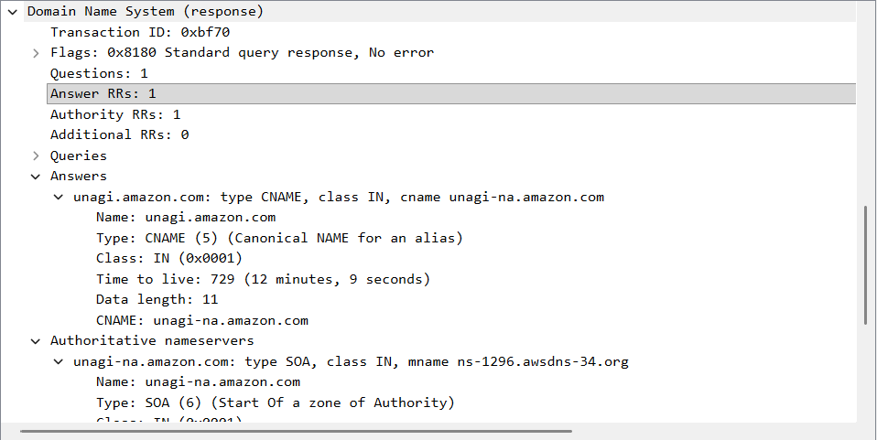

There’s only one answer and it contains information about the name of the host, the type of address, class, the TTL,the data length .

- What Protocol use in Payload? How many bytes use in Payload?
And
- Find stream index and stream packet number of DNS Response.

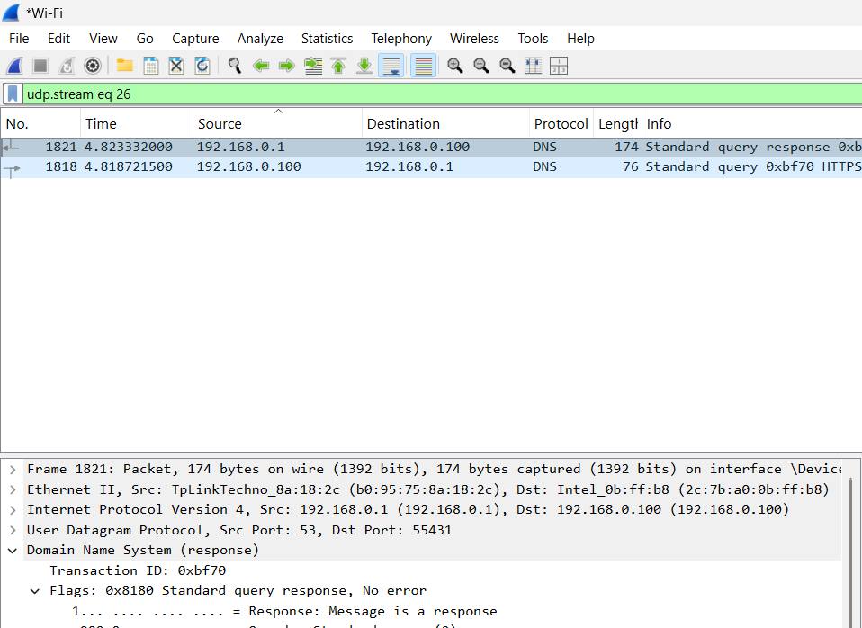

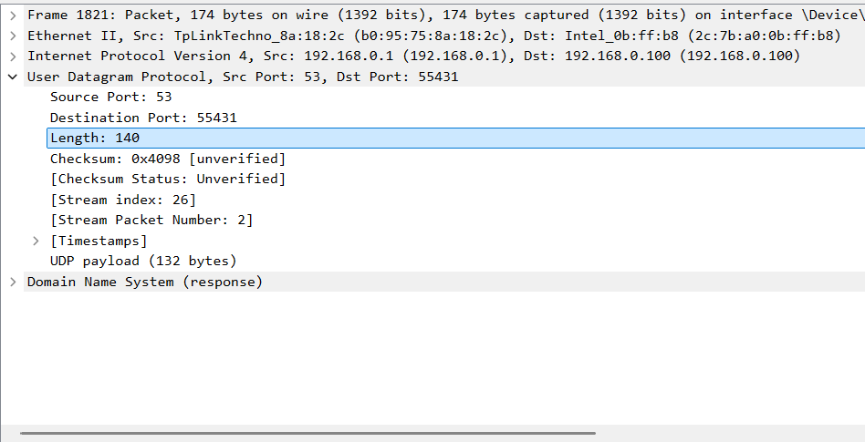

- Protocol in the UDP payload: DNS, for an ordinary DNS packet.
- UDP payload size: 132 ( 140 – 8 (for header) )
- Stream Index : 26
- Stream Packet No. : 2

TCP Protocol:

• Start up your web browser. Go the http://gaia.cs.umass.edu/wireshark-labs/alice.txt and retrieve an ASCII copy of Alice in Wonderland. Store this file somewhere on your computer. • Next go to http://gaia.cs.umass.edu/wireshark-labs/TCPwireshark-file1.html.

- What is the IP address and TCP port number used by the client computer (source) that is transferring the file to gaia.cs.umass.edu? To answer this question, the easiest way is to select the HTTP POST message (or any HTTP message of the same file upload) in Wireshark. Then, open the TCP packet details. In the packet details window, you can find the client's IP address and TCP port number.

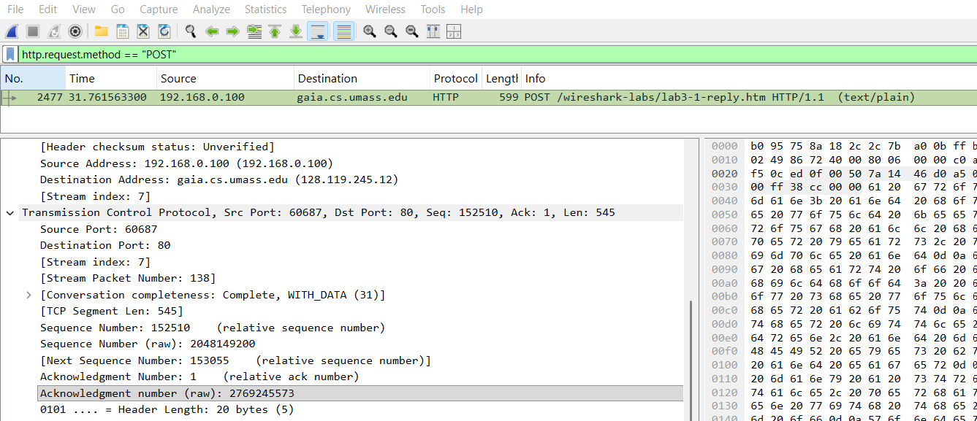
Client’s TCP Port Number : 60687

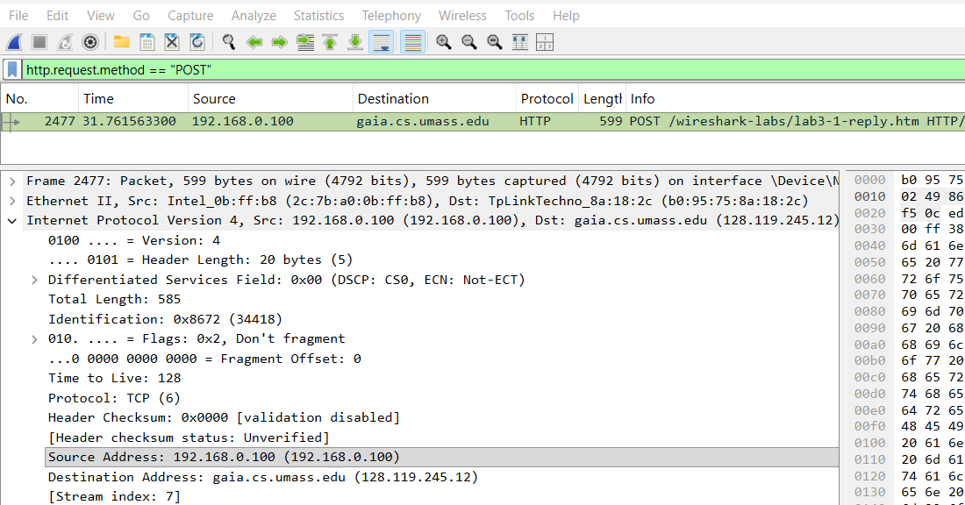
Client’s IP address : 192.168.0.100
2.What is the IP address of gaia.cs.umass.edu? On what port number is it sending and receiving TCP segments for this connection? 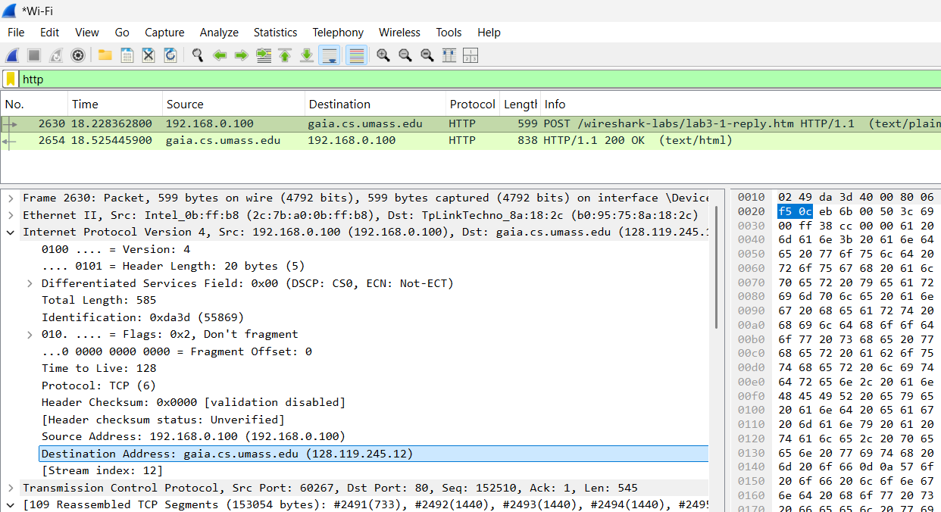

128.119.245.12 is the IP address of gaia.cs.umass.edu.

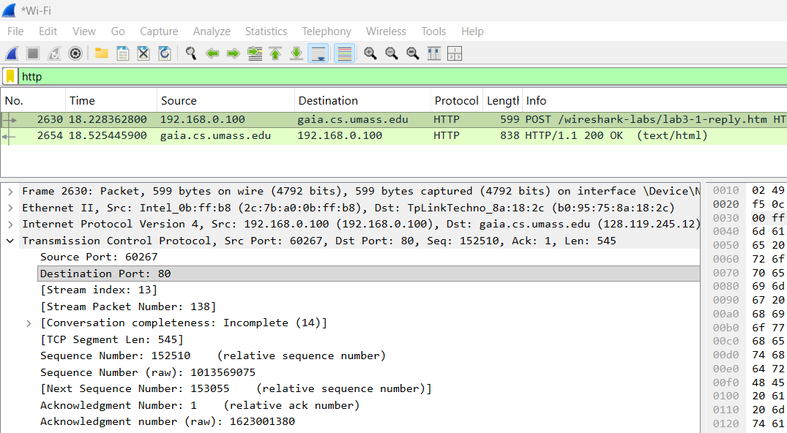
It’s sending and receiving TCP segments on port number : 80.
3. What is the IP address and TCP port number used by your client computer (source) to transfer the file to gaia.cs.umass.edu?
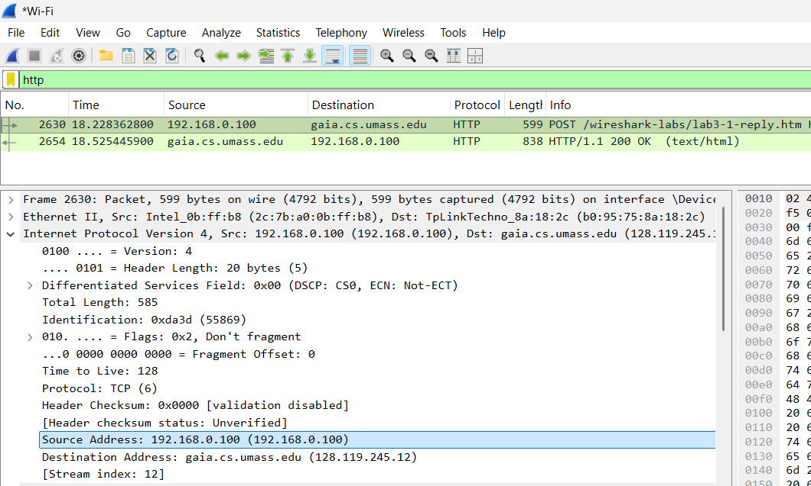

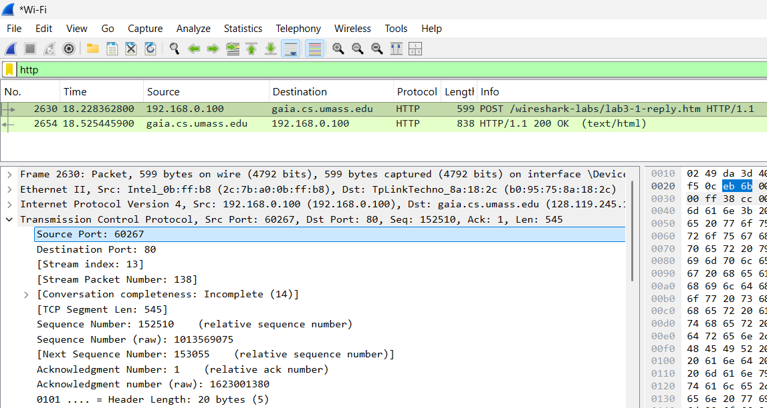

4.What is the sequence number of the TCP SYN segment that is used to initiate the TCP connection between the client computer and gaia.cs.umass.edu? What is it in the segment that identifies the segment as a SYN segment? Apply this filter: tcp.flags.syn == 1 && tcp.flags.ack == 0.

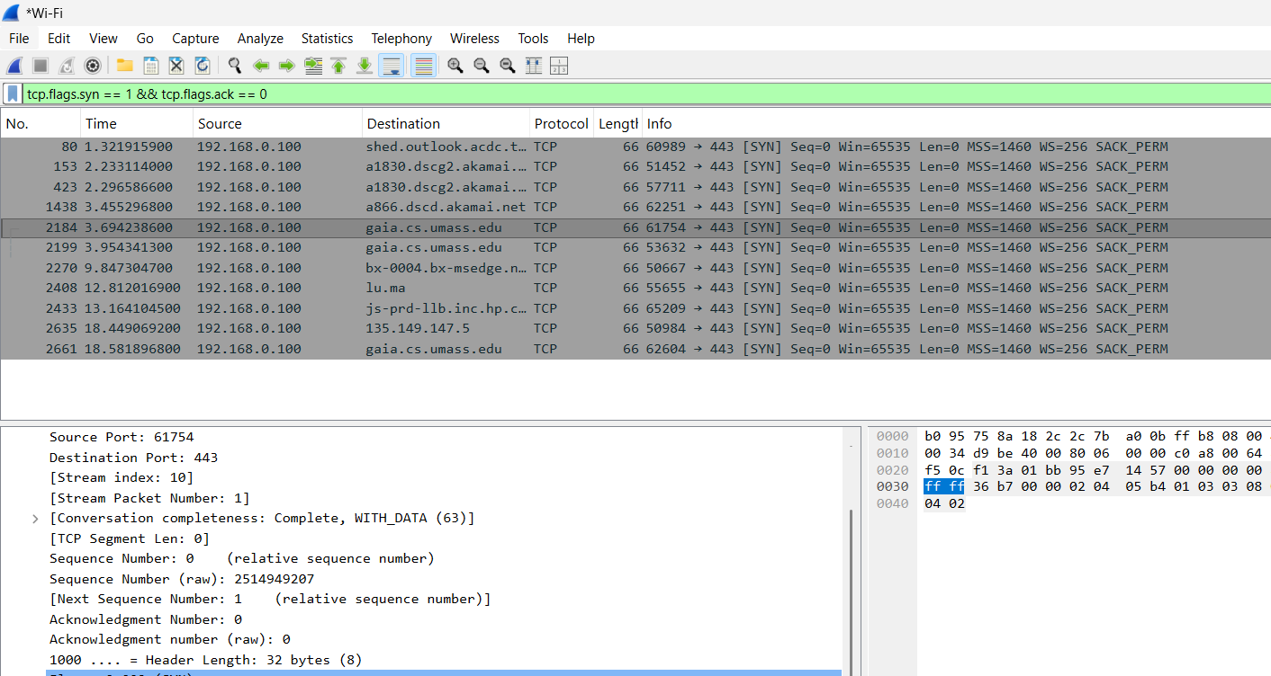

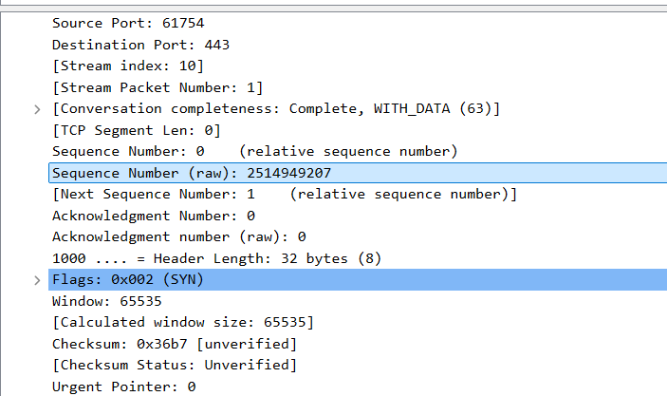
Sequence Number: 2514949207

The sequence number is the Initial Sequence Number (ISN) shown in your packet. The packet is identified as a SYN because the SYN flag is set to 1 and the ACK flag is not set.
5.What is the sequence number of the SYNACK segment sent by gaia.cs.umass.edu to the client computer in reply to the SYN? What is the value of the Acknowledgement field in the SYNACK segment? How did gaia.cs.umass.edu determine that value? What is it in the segment that identifies the segment as a SYNACK segment?

Apply:
tcp.flags.syn == 1 && tcp.flags.ack == 1

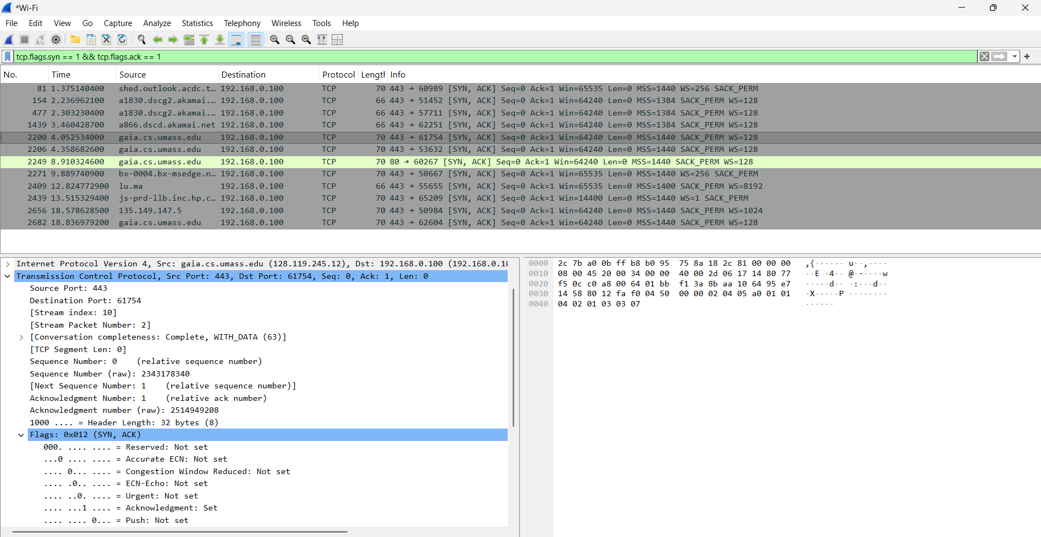
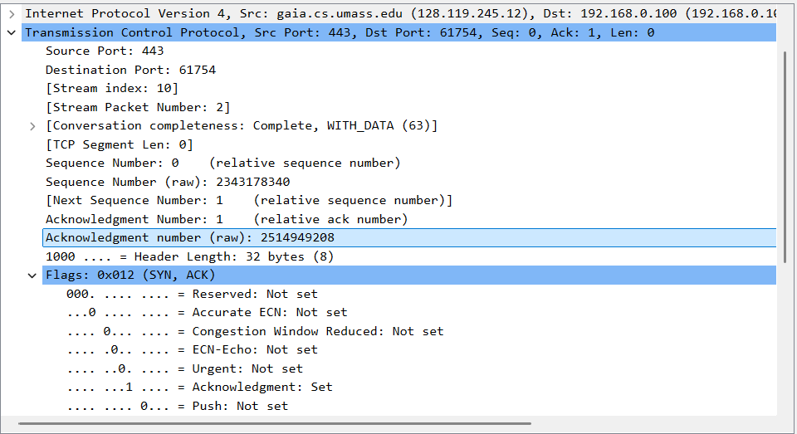

Sequence number: 2343178340
Acknowledgement number:2514949208. ( SYN sequence number + 1 = 2514949207 + 1 )
Identifying flags: SYN = 1 and ACK = 1.

The server acknowledges the client's SYN because a SYN consumes one sequence number, even though it carries no application data.

6.Find the TCP packet that contains the HTTP POST command. What is its Sequence Number? To find the HTTP POST command, look at the packet contents in the bottom pane of the Wireshark window and find the packet whose Data field contains the word "POST".

Apply http.request.method == "POST".

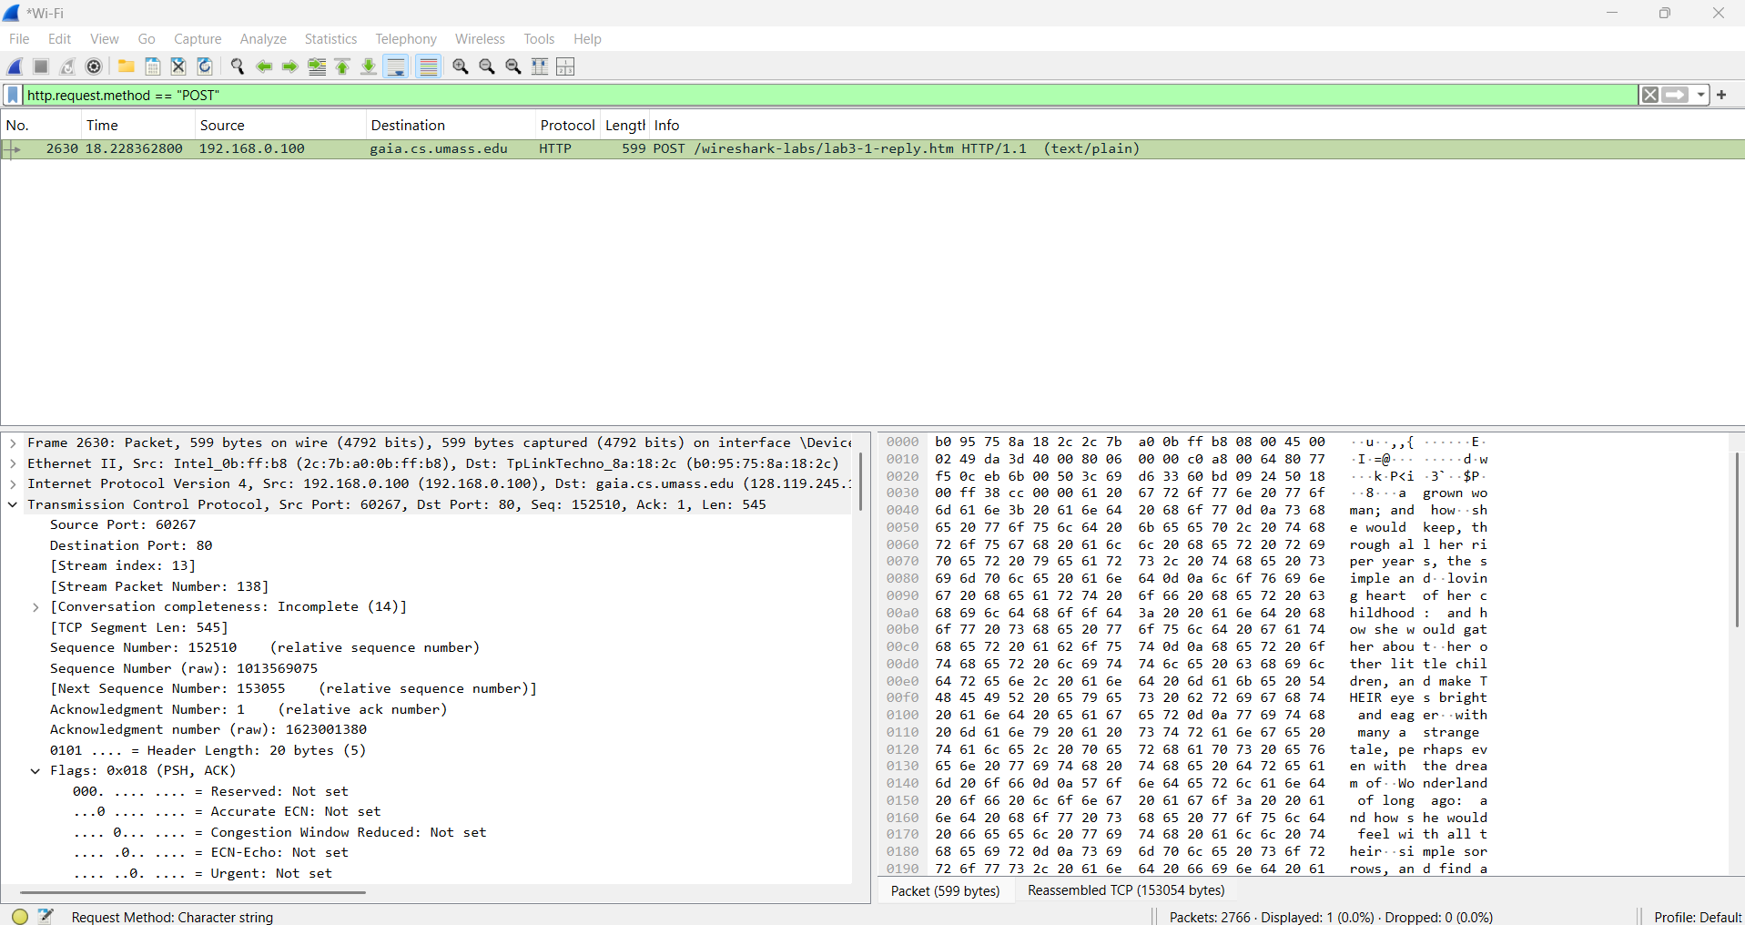
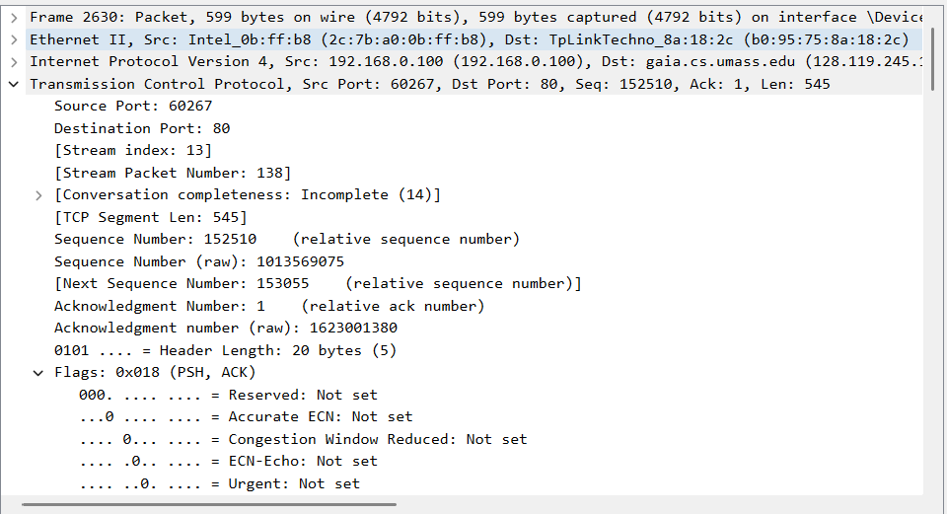

Sequence number : 1013569075

7.What is the length of each of the first six TCP segments?

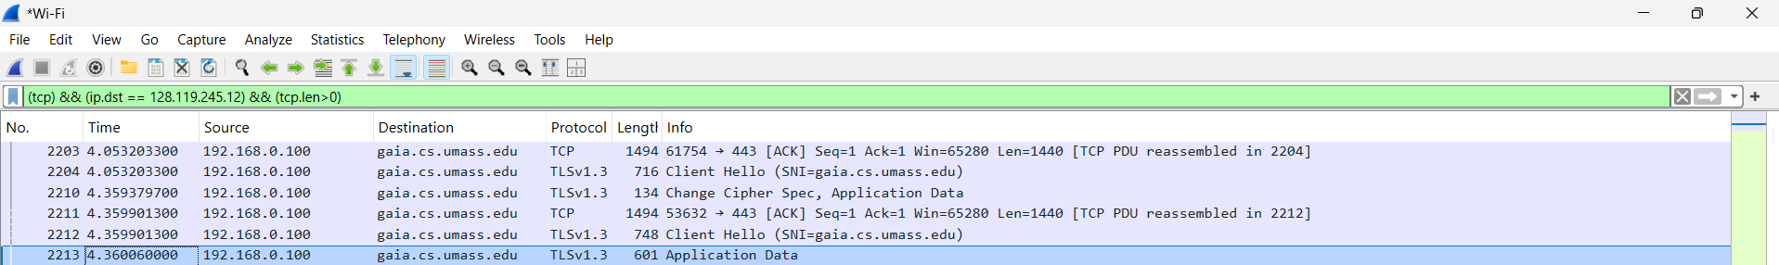

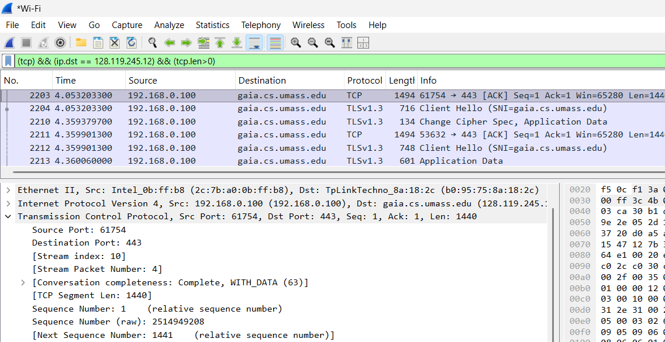
Packet No 2203 Length : 1440
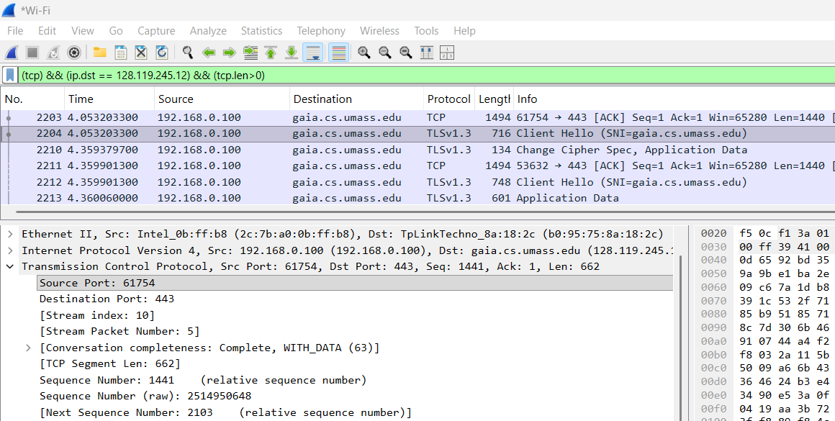

Packet No 2204 Length : 662

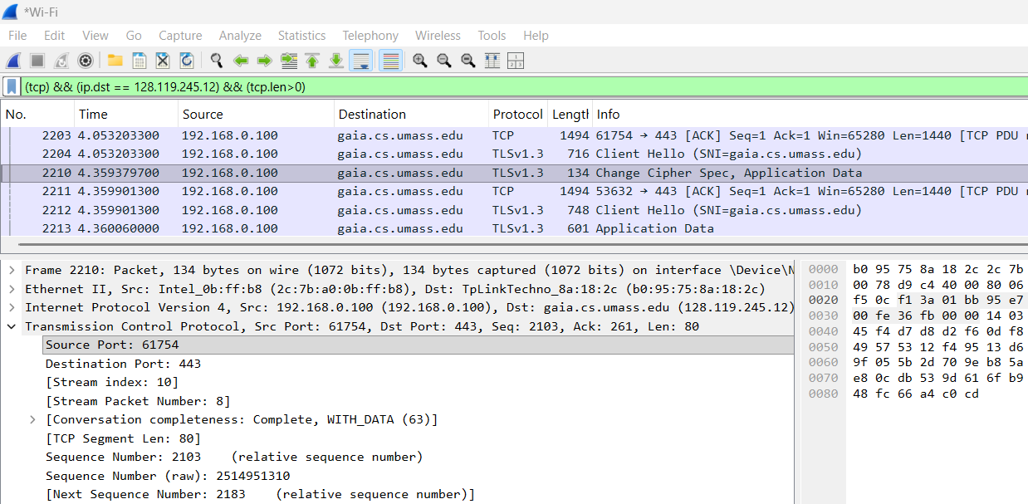

Packet No 2210 Length : 80

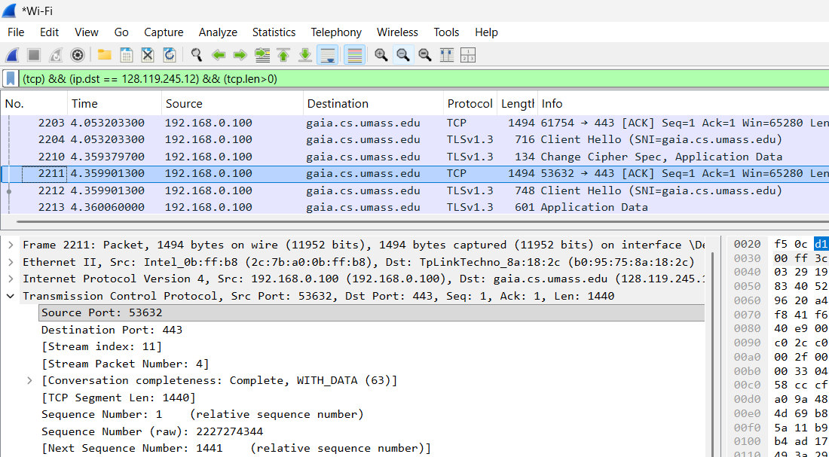

Packet No 2211 Length : 1440

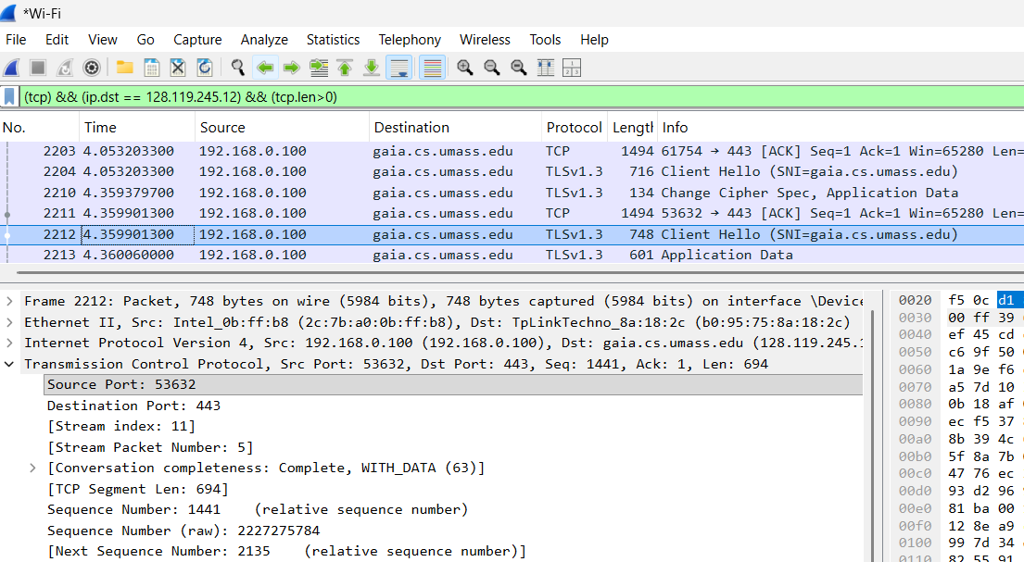
Packet No 2212 Length : 694

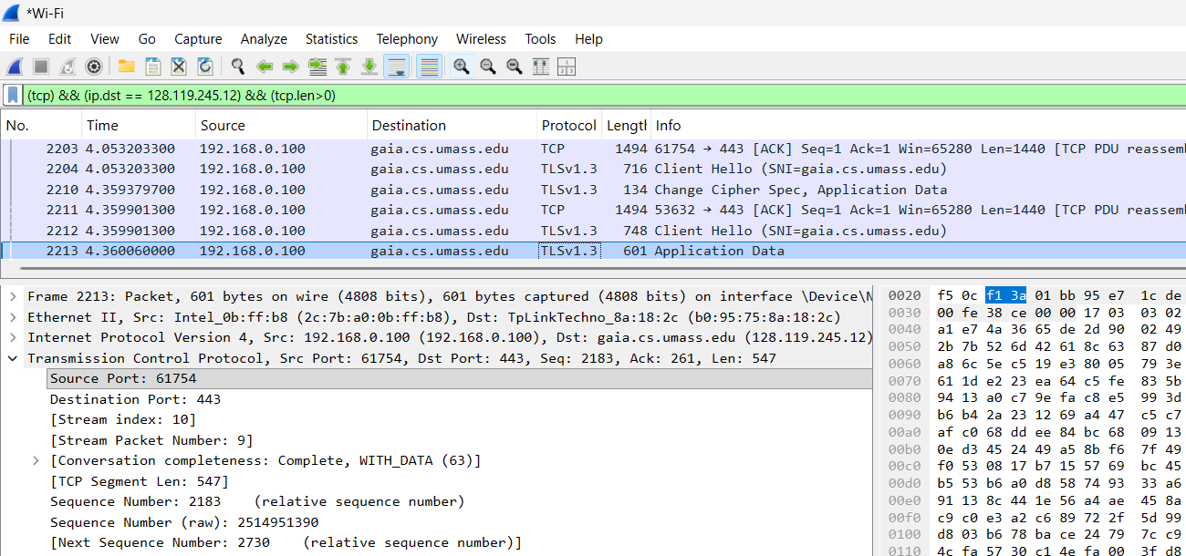

Packet No 2213 Length : 547

https://www.myntra.com/
UDP Protocol:
1.Select one UDP packet from your trace. From this packet, determine how many fields there are in the UDP header.Name these fields. Determine the length (in bytes) of the each of the udp header fields.

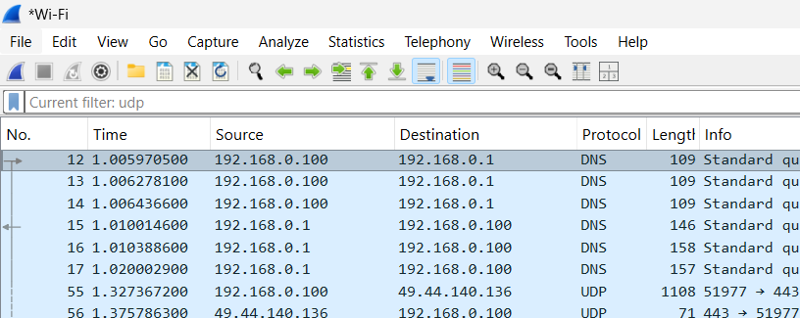

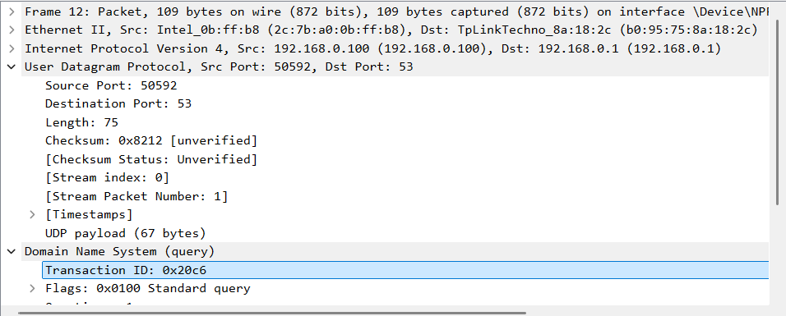
There are 4 header fields.
Field | Length
Source Port | 2 bytes
Destination Port | 2 bytes
Length | 2 bytes
Checksum | 2 bytes
Total header length | 8 bytes

2.The value in the Length field is the length of what? (You can consult the text for this answer). Verify your claim with your captured UDP packet.

The UDP Length field specifies the total length of the UDP datagram, including both the UDP header and its payload.
UDP Length=8+Payload Length
Verification: Wireshark shows UDP Length as 75 bytes, the payload is 75 - 8 = 67 bytes.

3.What is the maximum number of bytes that can be included in a UDP payload? (Hint: the answer to this question can be determined by your answer to 2. above)
Ans:
For a conventional IPv4 packet without IP options, the theoretical maximum is 65,507 bytes.
Calculation:
65,535-20-8=65,507
Here, 65,535 is the maximum IPv4 packet length, 20 is the minimum IPv4 header length, and 8 is the UDP header length.

4.What is the largest possible source port number? (Hint: see the hint in 3.)
Ans:
65535

5. What is the protocol number for UDP? Give your answer in both hexadecimal and decimal notation. To answer this question, you’ll need to look into the Protocol field of the IP datagram containing this UDP segment .

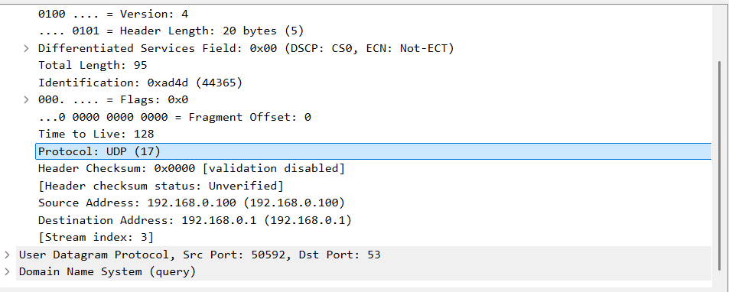

- Decimal: 17
- Hexadecimal: 0x11

6. Examine a pair of UDP packets. The first packet is sent by your host, and the second packet is the reply to the first packet. Compare the source and destination port numbers of both packets. What is the relationship between them?

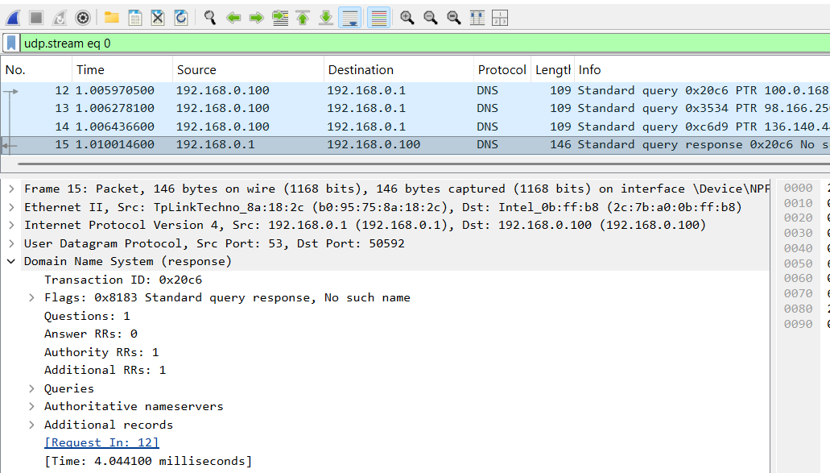
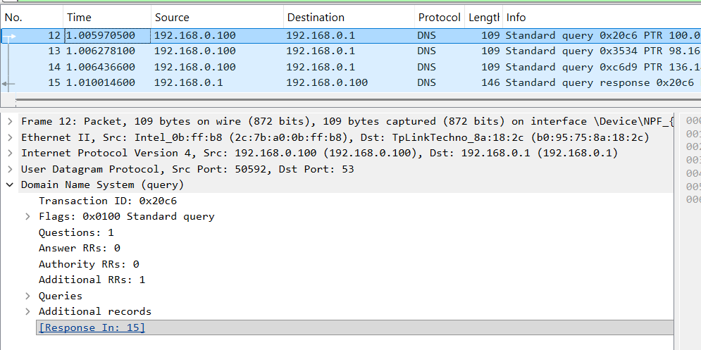
Packet 12 and Packet 15 are a request-response pair.
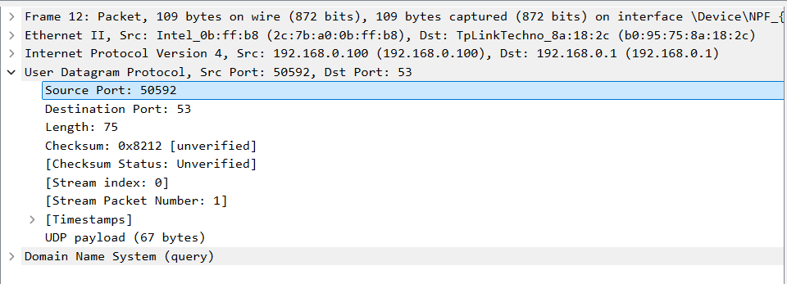

Request Source port: 50592
Destination Source port: 53

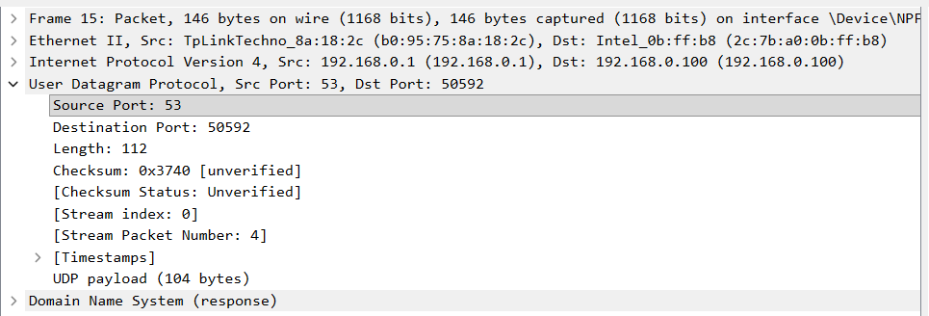

Request Source port: 53
Destination Source port: 50592

The source and destination ports are normally reversed in the reply.

ICMP protocol
❖ Open Command Prompt (CMD) and Wireshark. Start packet capture in Wireshark.
❖ Run the command ping -n 10 www.sandesh.com.
❖ After all 10 ping requests and replies are completed, stop the capture.
❖ Apply the icmp filter and use the same captured packets to answer all the ICMP (Ping) practical questions.
1.What is the IP address of your host? What is the IP address of the destination host?
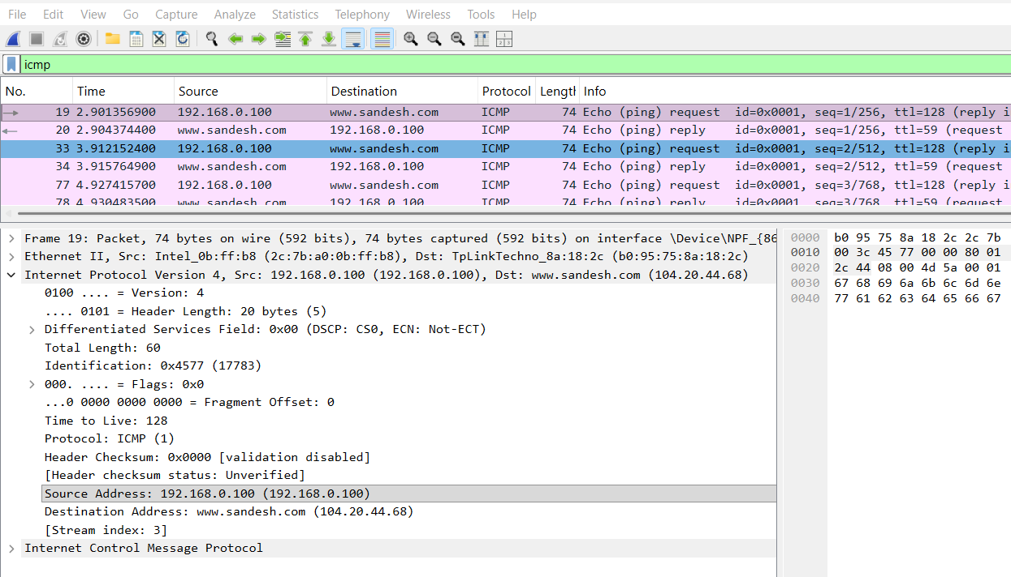
Source Address: 192.168.0.100
Destination Address: 104.20.44.68
2.Why doesn't an ICMP packet have source and destination port numbers?

Answer: ICMP is a network-layer control and diagnostic protocol carried directly inside IP packets. It does not use TCP or UDP ports to identify applications. Instead, ICMP uses fields such as Type and Code to identify the message's purpose.

3. Examine one of the ping request packets sent by your host. What are the ICMP type and code numbers? What other fields does this ICMP packet have? How many bytes are the checksum, sequence number and identifier fields?

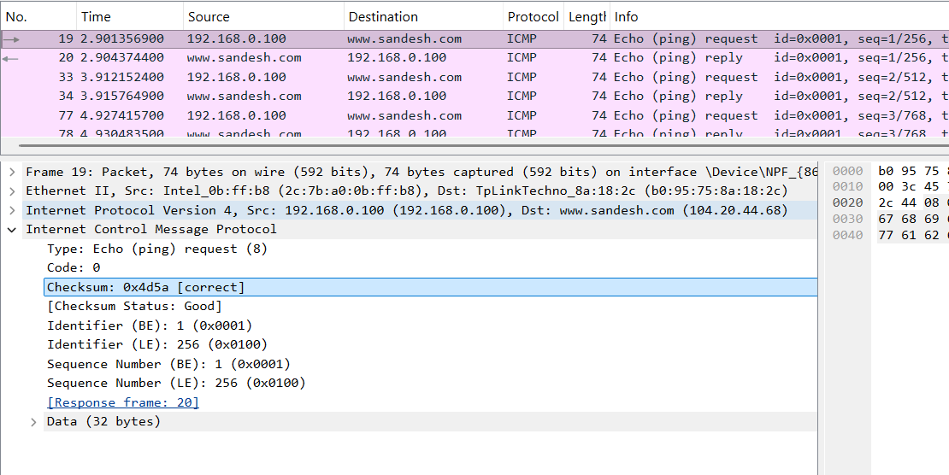
Type: Echo (ping) request (8) and Code: 0
A standard IPv4 Echo Request has the following fields:
Field | Value or length
Type | 8 — Echo Request
Code | 0
Checksum | 2 bytes
Identifier | 2 bytes
Sequence Number | 2 bytes
Data | Variable length

4.What is the IP address of your host? What is the IP address of the target destination host? (using tracert command)

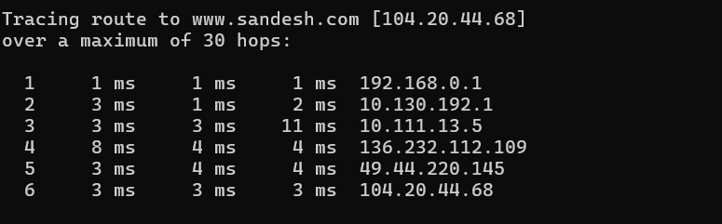
IP address of Client’s host: 192.168.0.1
IP address of the target destination host: 104.20.44.68

5.If ICMP uses UDP packets instead, will the Protocol Number still be 1? If not, what will it be?

Answer: No. The IP Protocol field would be 17 (decimal), or 0x11 (hexadecimal), because that is the assigned protocol number for UDP.
For normal IPv4 ICMP, the protocol number is 1.

6. Look at the last three ICMP packets received by your computer. How are they different from the ICMP Error packets? Why are they different?
Ans:

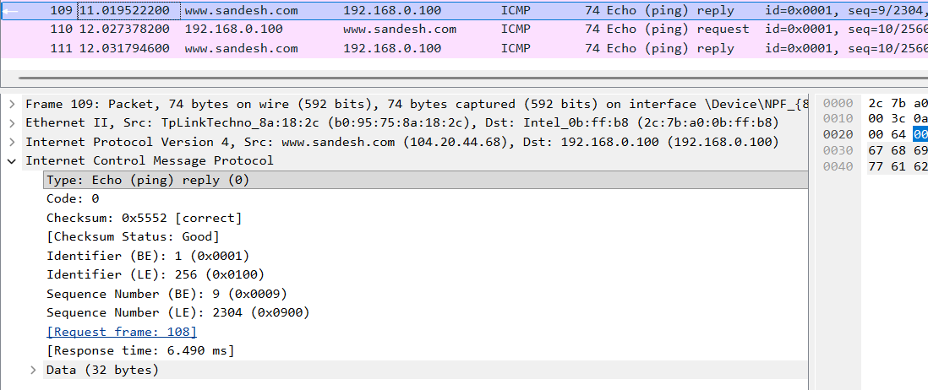
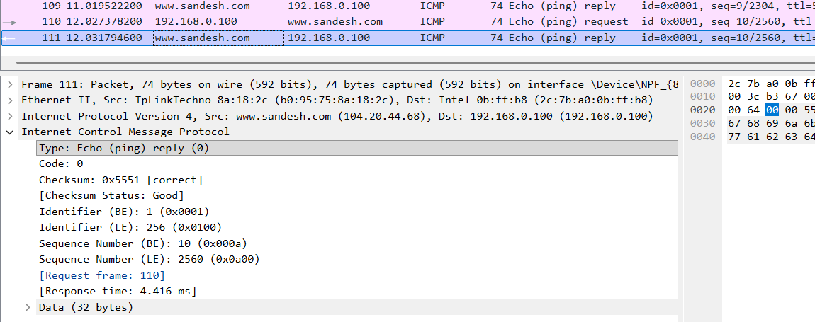

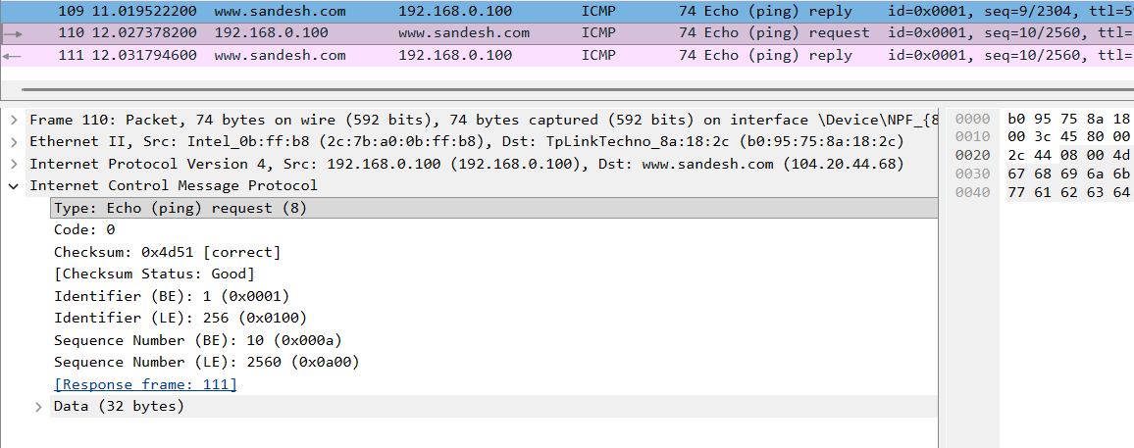

“ Type: Echo (ping) request (8) “
Means an outgoing ping request rather than the incoming reply.
Type 8: Source = your computer; Destination = target host.
Type 0: Source = target host; Destination = your computer.
the last three packets are Echo Replies from the ping test, have:
- Type: 0 or 8 ( outgoing ping request )
- Code: 0
These indicate successful ping replies or pings .
ICMP Error messages instead report network problems. Examples include:
- Type 3 — Destination Unreachable
- Type 11 — Time Exceeded
Echo Replies confirm that a destination responded to a ping, whereas error messages report delivery or routing problems.

7. What is the ICMP Type and Code for Echo Reply
Answer for IPv4:
- Type: 0
- Code: 0
For comparison, an IPv4 Echo Request has Type 8 and Code 0.

8. What is the purpose of the tracert command? What is the purpose of the ping command?
Ans:
Ping
Tests whether a destination responds over the network and measures round-trip time. It can also help identify packet loss.
Example: ping -n 10 www.sandesh.com
Traceroute (tracert in Windows)
Shows the route packets take toward a destination by identifying intermediate hops and measuring their response times.
Example: tracert www.sandesh.com

