MLOps Assignment-1

End-to-End ML Model Development, CI/CD, and Production Deployment
Course: MLOps (S1-25_AIMLCZG523)
Dataset: UCI Heart Disease Dataset

Group 24 Team Member Names:

- Virendra Vinay Sahakari (2024AB05036) --------100% contribution
- Snehal Swapnil Chavan (2024AB05033) ---------100% contribution
- Shripad Prakash Kelapure (2024AA05957) ---- 100% contribution
- Abhishek Kumar (2024AB05032) -----------------100% contribution

End-to-end pipeline video:

https://drive.google.com/file/d/17pkA18EDvsnzUgMrVjjL85U5GwxIz6yS/view?usp=sharing

Introduction
Heart disease is one of the leading causes of mortality worldwide. Early detection and prediction of heart disease can significantly assist healthcare professionals in taking preventive actions and improving patient outcomes.
This project demonstrates an end-to-end MLOps pipeline for predicting heart disease using patient medical data. The focus of this assignment is not only model building but also the application of modern MLOps practices such as experiment tracking, CI/CD automation, containerization, Kubernetes deployment, and monitoring.

Dataset Description & Data Acquisition
The Heart Disease UCI Dataset was used in this project. The dataset was obtained from the UCI Machine Learning Repository using a reproducible Python-based download approach.
Dataset Characteristics:
- Total samples: 303
- Number of features: 13
- Target variable: Binary classification (0 = No heart disease, 1 = Heart disease)
The dataset was programmatically loaded and the target variable was converted from multi-class to binary to suit the classification objective.

Architecture Diagram
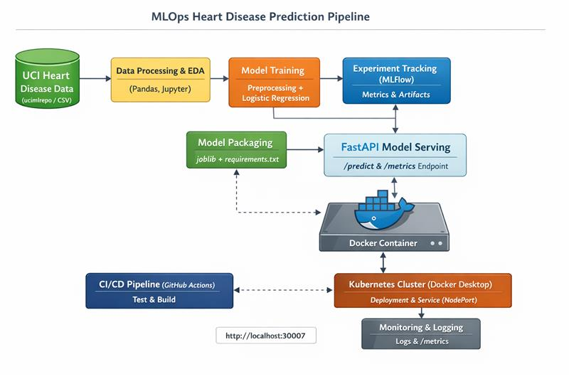

Exploratory Data Analysis (EDA)
Exploratory Data Analysis (EDA) was performed to understand the structure, distribution, and relationships within the dataset. The following analyses were carried out:
- Target class distribution analysis
- Feature distribution visualization using histograms
- Correlation analysis using a heatmap
EDA helped identify feature scaling requirements and potential relationships between features and the target variable.
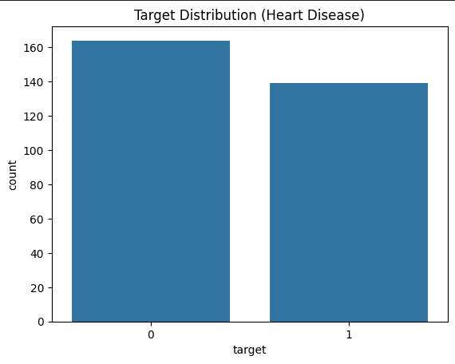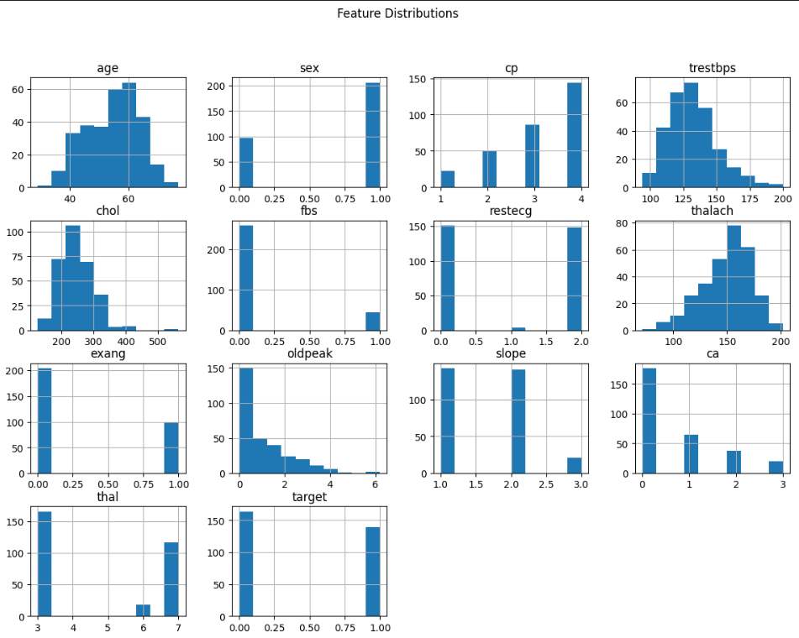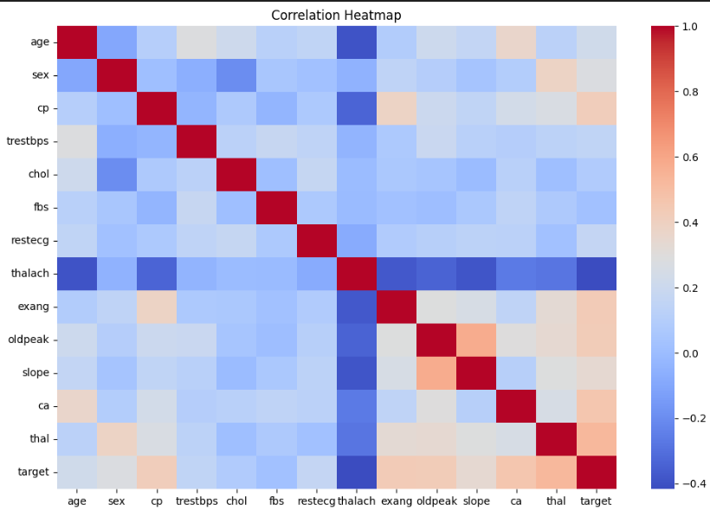

Feature Engineering & Model Development
A preprocessing pipeline was built using scikit-learn to ensure consistent feature transformations during both training and inference. Missing values were handled using median imputation and numerical features were standardized.
A Logistic Regression classifier was selected as the primary model due to its interpretability and effectiveness for binary classification tasks. The model was evaluated using accuracy, precision, recall, and ROC-AUC metrics.

Experiment Tracking with MLflow
MLflow was integrated into the training pipeline to track experiments. The following were logged:
- Model parameters
- Performance metrics
- Trained model artifacts
MLflow enabled transparent experiment comparison and ensured reproducibility.
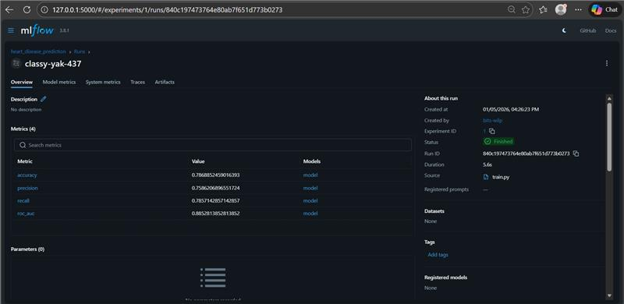

Model Packaging & Reproducibility
The trained model and preprocessing pipeline were saved using joblib. A requirements.txt file was created to capture all dependencies. This ensures that the entire project can be executed from a clean environment without inconsistencies.

CI/CD Pipeline & Automated Testing
A CI pipeline was implemented using GitHub Actions. The pipeline automatically installs dependencies and runs unit tests on every push to the repository, ensuring code reliability and early detection of issues
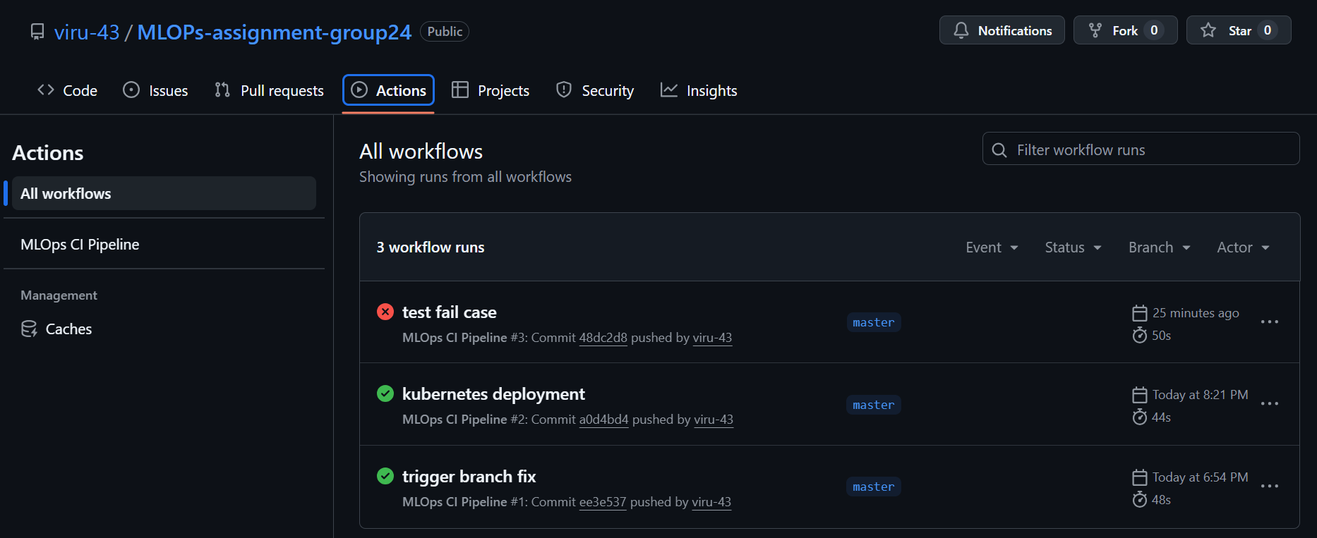

Model Containerization
The FastAPI-based model serving application was containerized using Docker. The Dockerfile packages the application code, trained model, and dependencies into a portable container. The container was successfully built and tested locally.
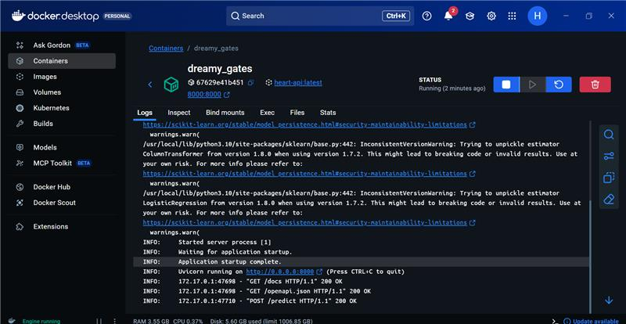

Production Deployment using Kubernetes
The Dockerized API was deployed to a local Kubernetes cluster using Docker Desktop. Kubernetes Deployment and Service manifests were used to manage the application lifecycle and expose the API using a NodePort service.
The deployment was verified by accessing the /docs and /predict endpoints through the Kubernetes service.
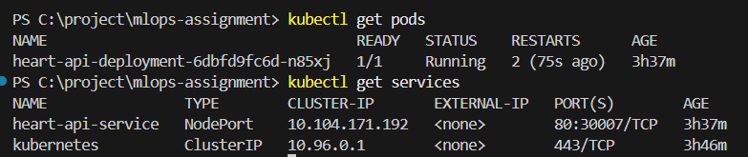
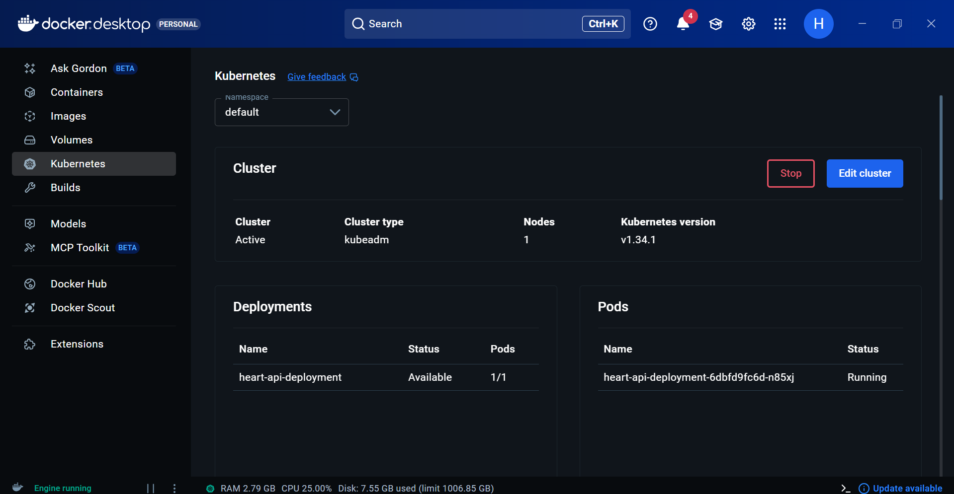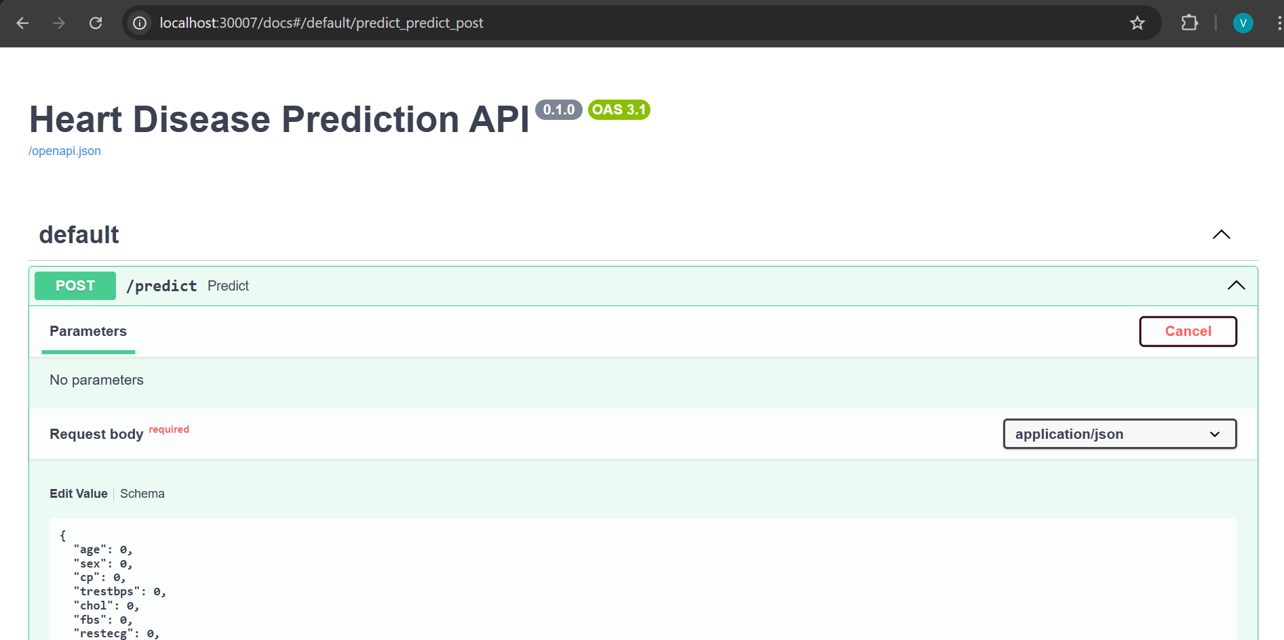

Monitoring & Logging
Basic monitoring and logging were implemented to observe API behavior. Incoming prediction requests and model outputs were logged using Python’s logging module. Additionally, a /metrics endpoint was added to track the total number of prediction requests.
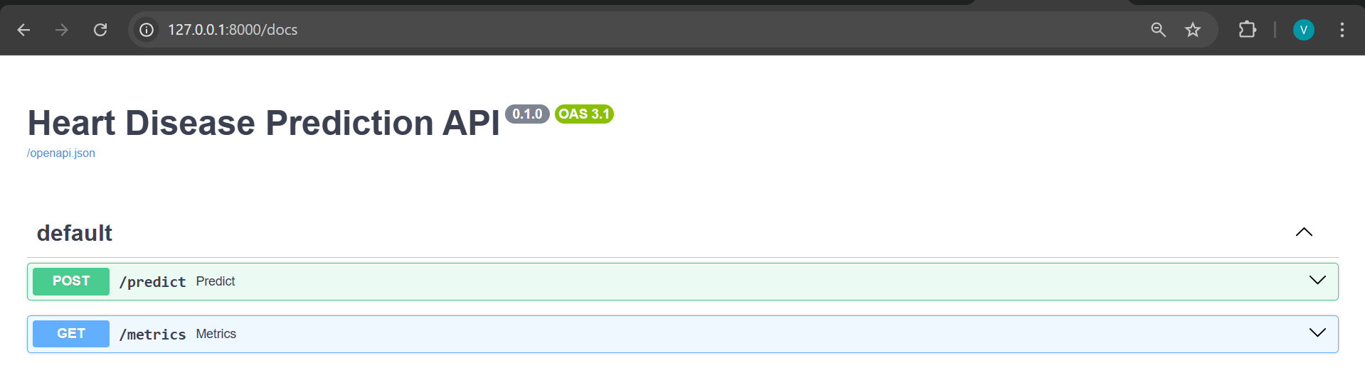

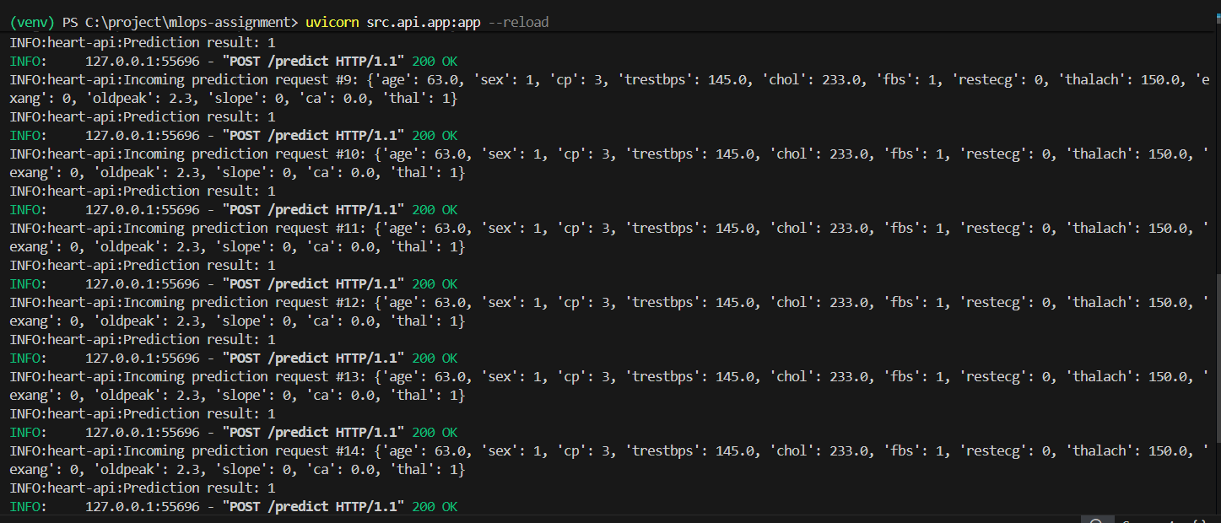

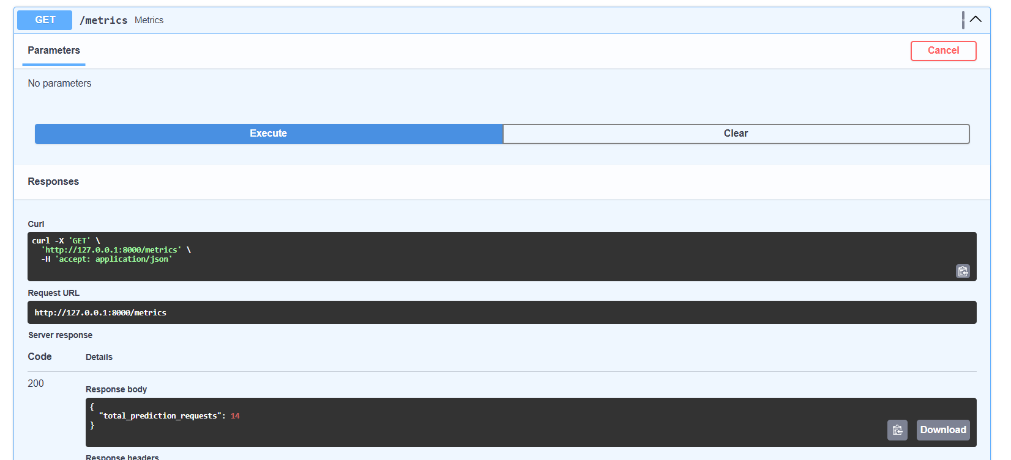

Conclusion
This project successfully demonstrates a complete end-to-end MLOps workflow. The implementation covers data acquisition, model development, experiment tracking, CI/CD automation, containerization, Kubernetes deployment, and monitoring, aligning with real-world MLOps best practices.

Repository & Deliverables
GitHub Repository Link: https://github.com/viru-43/MLOPs-assignment-group24.git
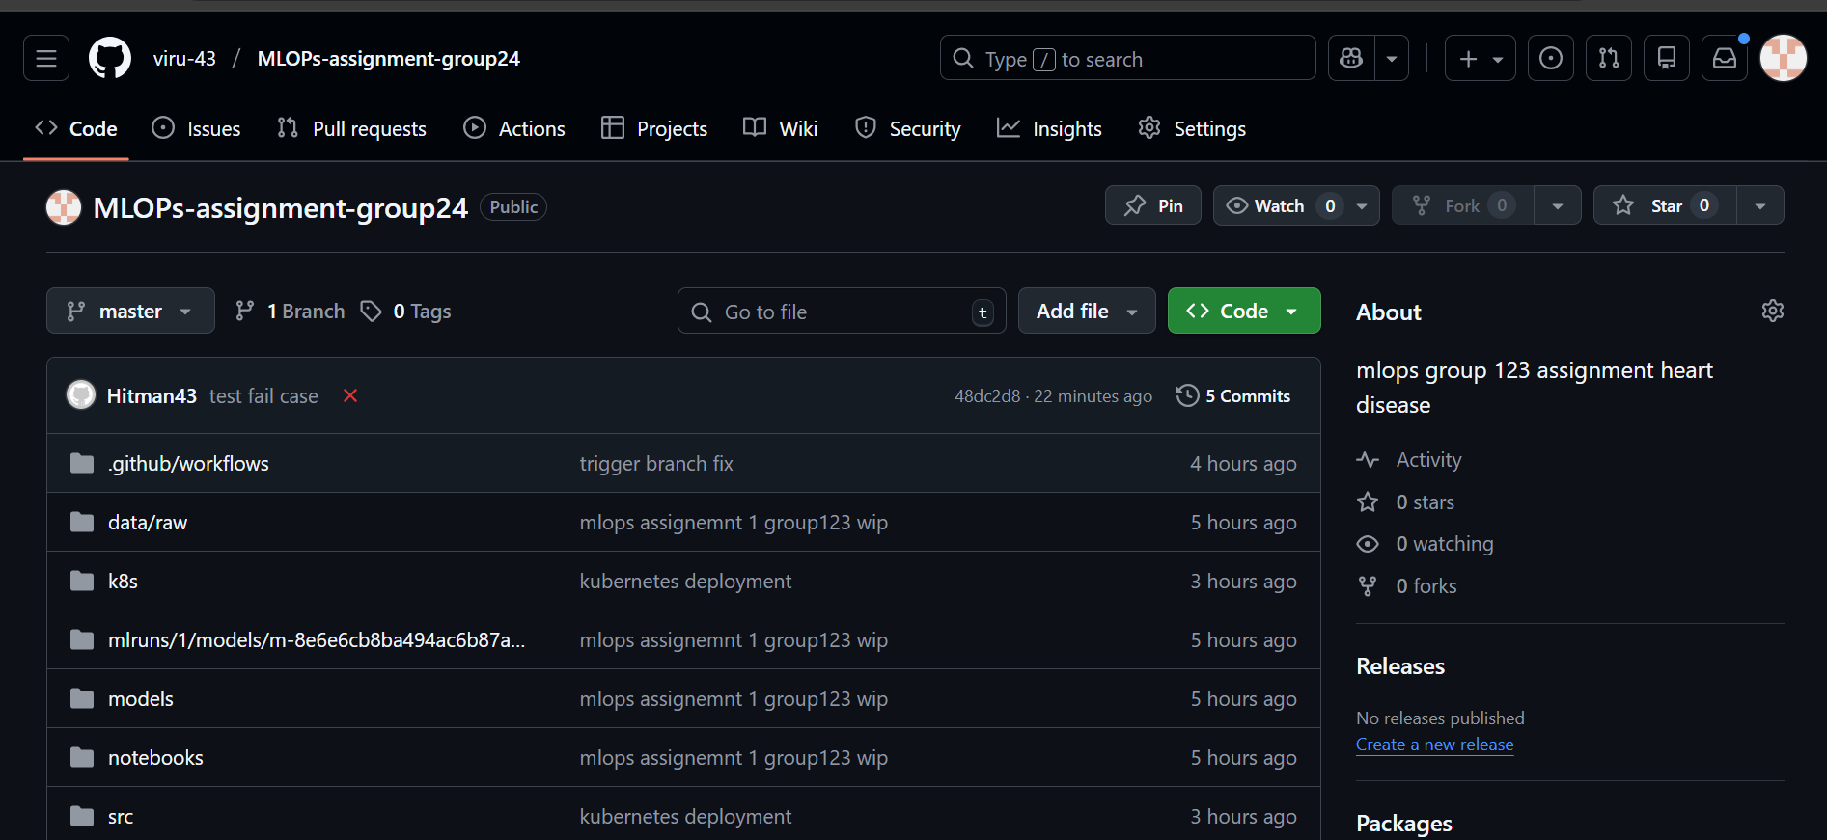
All required screenshots and a demonstration video have been submitted along with this report.

