1. **British Guiana 1c Magenta Stamp**

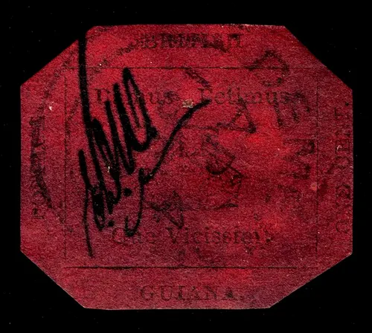

* **Description:** The world’s rarest and most valuable stamp dating from 1856, famed for its single surviving specimen. It has a magenta background and was used in British Guiana (now Guyana).
* **Auction Price:** $9.48 million in 2014.
* A true collector's gem, breaking world records for stamp auctions.[1][2]

1. **Honus Wagner T206 Baseball Card**

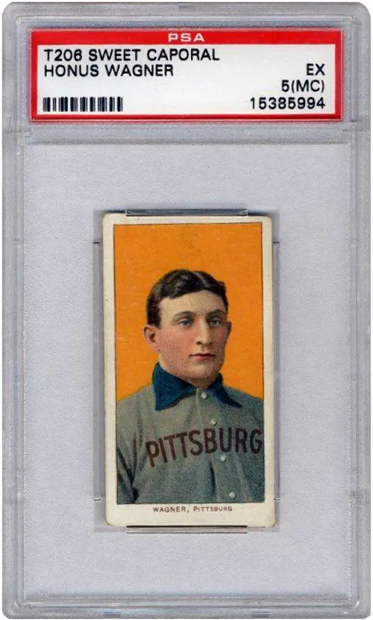

* **Description:** Considered the "Holy Grail" of sports cards, featuring legendary player Honus Wagner. Highly sought-after for its rarity due to limited production.
* **Auction Price:** $7.25 million.
* Its scarcity and connection to baseball history make it the most prized trading card.[2]

1. **Pinner Qing Dynasty Vase**

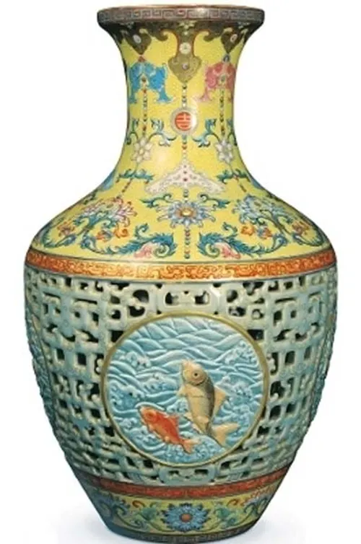

* **Description:** An 18th-century Chinese porcelain vase adorned with intricate floral designs and vibrant colors, discovered in a modest home in London.
* **Auction Price:** $80.2 million in 2010.
* Exceptional craftsmanship and historical significance from the Qing Dynasty.[3]

1. **Badminton Cabinet**



* **Description:** An opulent 18th-century Florentine cabinet, over 12 feet tall and featuring elaborate inlays of semi-precious stones.
* **Auction Price:** $36 million in 2004.
* Its grandeur and artistry make it one of the most expensive furniture pieces.[3]

1. **1933 Saint-Gaudens Double Eagle Gold Coin**

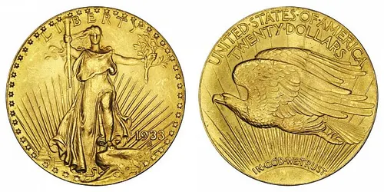

* **Description:** The only legal-to-own coin of its kind, survived the gold recall in the Great Depression. Considered the most valuable coin.
* **Auction Price:** $18.9 million in 2021.
* Symbolizes historic monetary events and coin collecting prestige.[1]

1. **Once Upon a Time in Shaolin (Wu-Tang Clan)**

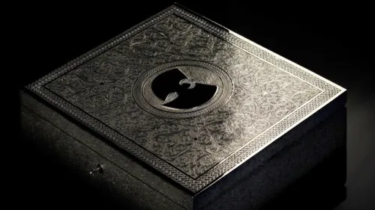

* **Description:** A one-of-a-kind music album produced by the Wu-Tang Clan, with only one copy ever released. Comes in a custom silver-and-nickel box.
* **Auction Price:** $2 million.
* Shrouded in exclusivity and subject to strict usage agreements.[2]

1. **Super Mario Bros. (NES, Sealed Copy)**

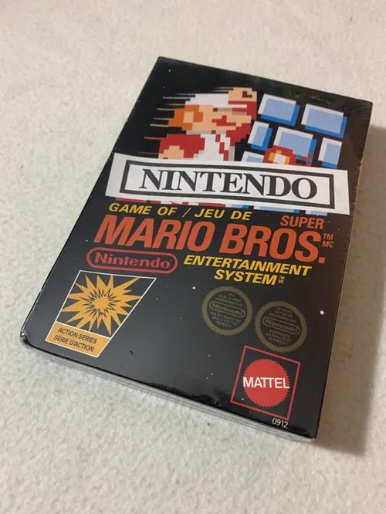

* **Description:** Early run, unopened copy of Nintendo’s original game, preserved for decades.
* **Auction Price:** $2 million.
* Gaming history landmark and prized among video game collectors.[2]

1. **Apollo 11 Lunar Sample Bag**

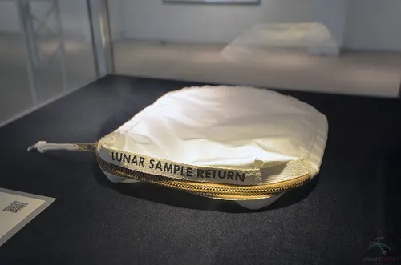

* **Description:** Used by astronauts on the Apollo 11 mission to collect moon dust.
* **Auction Price:** $1.8 million.
* Unique piece of space exploration history.[2]

Images of these collectibles can be found on trusted auction platforms, stock image sites, or archives linked to their sale galleries. Each item stands out as a rare, historical, and culturally significant collectible, valued for its story as much as its price.[4][5][6][2]

⁂

1. <https://kuvera.in/blog/10-most-expensive-collectibles-ever-sold/>
2. <https://myrepublic.net/sg/blog/broadband/unbelievable-auctions-10-collectibles-that-made-history/>
3. <https://timesofindia.indiatimes.com/etimes/trending/8-most-expensive-antiques-in-the-world/photostory/111485576.cms>
4. <https://www.shutterstock.com/search/collectibles>
5. <https://www.istockphoto.com/photos/valuable-antiques>
6. <https://www.gettyimages.ca/photos/collectibles-expensive?page=2>
7. <https://www.shutterstock.com/category/vintage/antiques-collectibles>
8. <https://www.williamgeorge.com/blog/top-10-most-collectable-items>
9. <https://www.sothebys.com/en/buy/luxury/collectibles>
10. <https://www.gettyimages.in/photos/antique-collection>
11. <https://www.colleconline.com/en/blog/282/top-14-most-expensive-collectibles-in-the-world>
12. <https://www.istockphoto.com/photos/collectibles>
13. <https://stock.adobe.com/search?k=antique+items>
14. <https://www.hayesparsons.co.uk/the-top-10-most-valuable-collectibles/>
15. <https://www.goodhousekeeping.com/life/g65038070/vintage-items-you-may-want-to-borrow-from-grandma/>
16. <https://www.mearto.com/blog/75-items-you-have-at-home-that-could-be-worth-a-fortune>
17. <https://www.collectorbazar.com>
18. <https://intelligentcollector.com/50-great-collectibles/>
19. <https://indiantiquest.com>
20. <https://www.shutterstock.com/search/collectables-luxury>