**Contribe – Bookstore (C# Work sample Implementation -** [**http://www.contribe.se/arbetsprov-net**](http://www.contribe.se/arbetsprov-net)**)**

**GitHub URL:**

**Created 4 projects:**

1. **CONTRIBE.BOOKSTORE.MODEL**
2. **CONTRIBE.BOOKSTORE.UNITTEST**
3. **CONTRIBE.BOOKSTORE.SERVICES**
4. **CONTRIBE.BOOKSTORE**

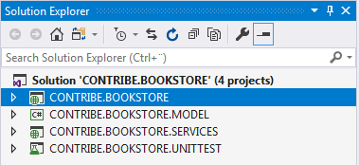

**1) CONTRIBE.BOOKSTORE.MODEL project**

* **Library project contains the interface, entity classes and helper classes in the following folder structure.**
* **Business entity layer contains the backend code.**

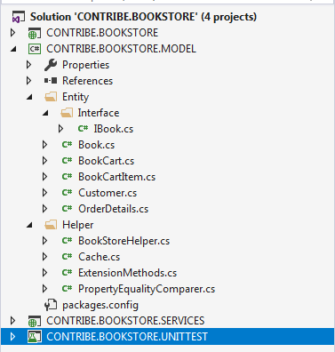

**The following embedded excel sheet shows the class structure,**



**2) CONTRIBE.BOOKSTORE.UNITTEST project**

* **Unit test project contains unit test cases for all the business objects operation.**
* **Test cases covered for business entities and helper operations for classes such as Book, BookCart, BookStoreHelper and Customer.**

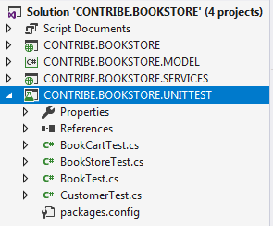

**3) CONTRIBE.BOOKSTORE.SERVICES project**

* **WCF project contain the WCF services implementation based on interface** IBookstoreService
* **Operation contracts were implemented in such a way that to enable asynchronous operations for increasing the scalability.**
* **Service layer**

**4) CONTRIBE.BOOKSTORE project**

* **ASP.NET MVC web project contain the front end client side (jquery) and server side code**
* **User interface layer**

**Project Dependencies**

|  |  |
| --- | --- |
| CONTRIBE.BOOKSTORE.MODEL | NIL |
| CONTRIBE.BOOKSTORE.UNITTEST | CONTRIBE.BOOKSTORE.MODEL |
| CONTRIBE.BOOKSTORE.SERVICES | CONTRIBE.BOOKSTORE.MODEL |
| CONTRIBE.BOOKSTORE | NIL |

**I have enabled multiple startup projects to activate both WCF service and ASP.NET MVC web application when running application by pressing F5 (Debug -> Start Debugging)**

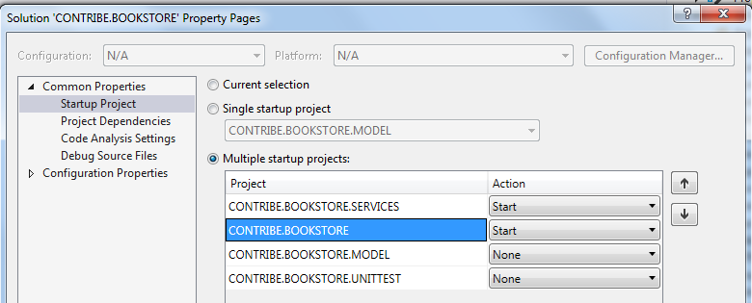

**1) Home screen without simple login**

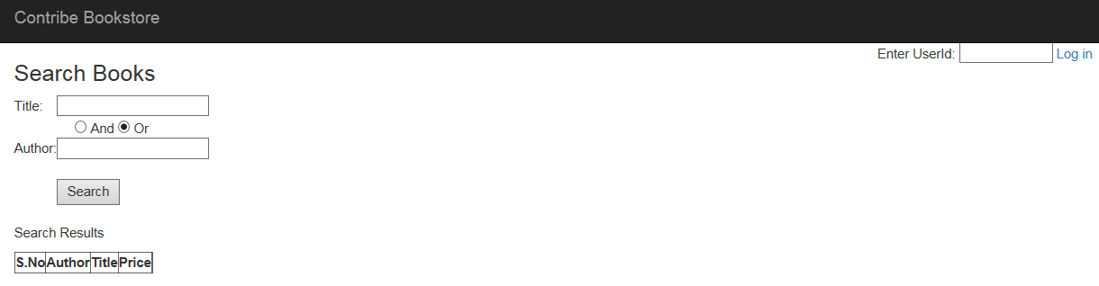

**2) Home screen after simple log in (not real login but used for placing order only) – give some text and click login.**

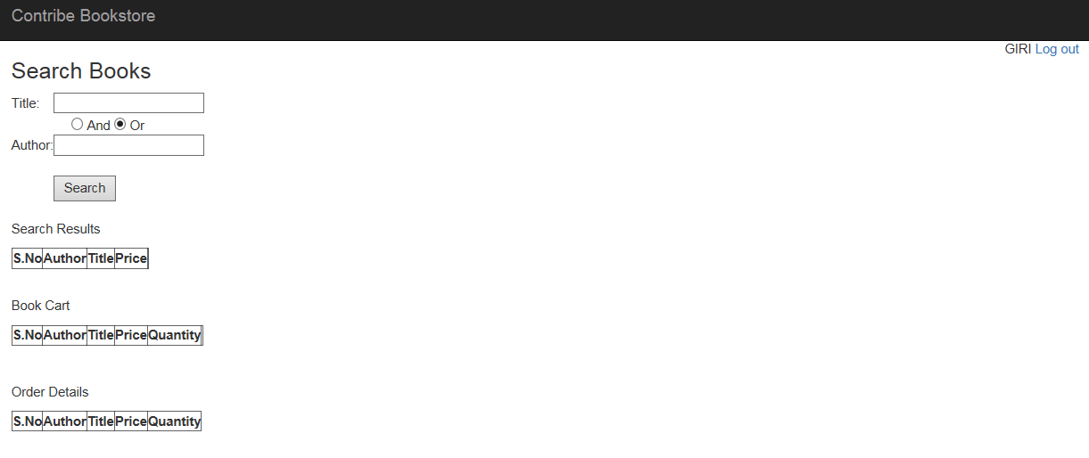**3) Search books with title alone**

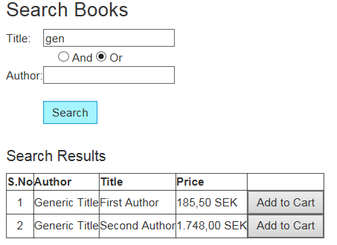

**4) Search books with title or author**

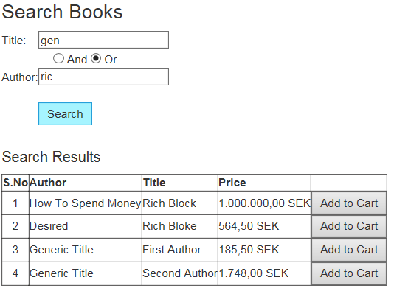

**5) Search books with title and author (no matching results)**

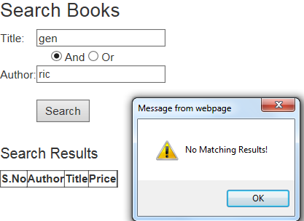

**6) Search books with title and author (matching results)**

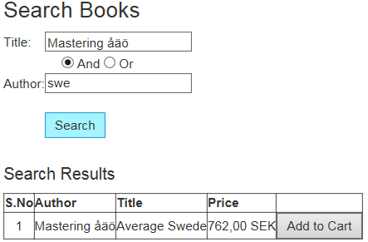

**7) Add to Cart (multiple clicks of Add to Cart will increment quantity by 1)**

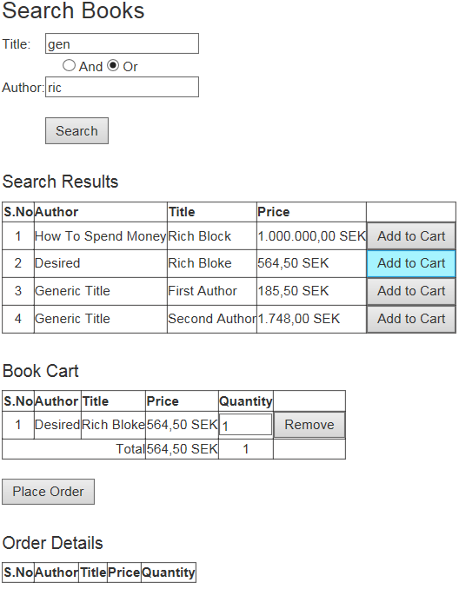

**8) Quantity can be updated with in Book Cart as well (onChange event)**

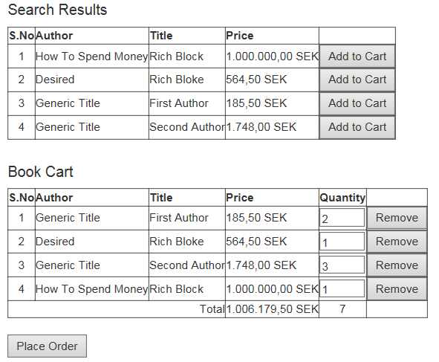

**9) Item can be removed from Book Cart by clicking Remove button**

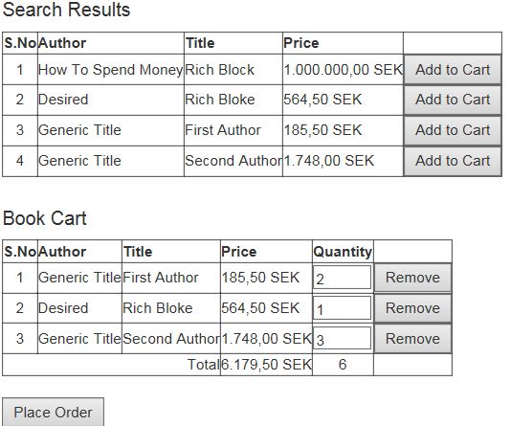

**10) Order can be placed by clicking Place Order button (Not in stock will be listed as below with quantity)**

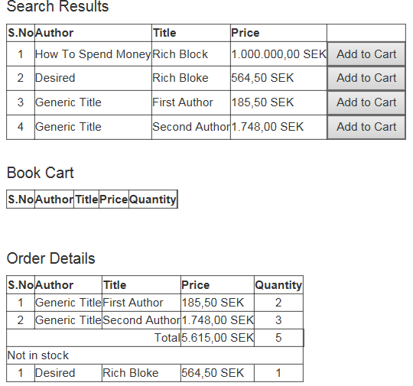

**Unit test Results**

