**PYTHON: ASSIGNMENT 02**

**Problem Statement 01**

Given a list of lists

numbers_nested = [[1,-1,2],[0,-5,3,5,-2],[1,2,1,0,-2,-3]]

Write a program to grab only positive numbers in each nested list and put that in a new list

**Expected Output**

[1, 2, 3, 5, 1, 2, 1]

**Code:**

numbers_nested = [[1, -1, 2], [0, -5, 3, 5, -2], [1, 2, 1, 0, -2, -3]]

positive_numbers = []

for nested_list in numbers_nested:

    for num in nested_list:

        if num > 0:

            positive_numbers.append(num)

print(positive_numbers)

**Output:**

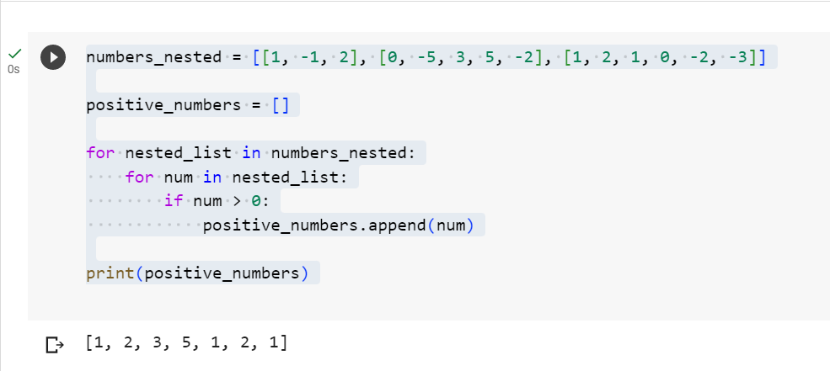

**Problem Statement 02**

Given a list of lists

L = [ [1,2,3] , [ 4,5,6,3 ], [-1,-2,-10,5,8] ]

Write a program to to print the average sum of value from each inner list and print the sum of each average

**Expected Output**

6/3 + 18/4 + 0 ⇒ 2 + 4.5 ⇒ 6.5

**Code:**

L = [[1, 2, 3], [4, 5, 6, 3], [-1, -2, -10, 5, 8]]

sum_of_averages = 0

for inner_list in L:

    average = sum(inner_list) / len(inner_list)

    sum_of_averages += average

print(sum_of_averages)

**Output:**

