**PYTHON: ASSIGNMENT 03**

##### PROBLEM STATEMENT 1: Game of "Functions"

**Write a Python function to sum all the numbers in a list.**

Sample List : (8, 2, 3, 0, 7)

Expected Output : 20

Explanation:

Summation should like 8+2+3+0+7 = 20

**Code:**

my_list = [8, 2, 3, 0, 7]

sum_of_numbers = sum(my_list)

print(sum_of_numbers)

**EXECUTION:**

##### PROBLEM STATEMENT 2: String inside the function

**Write a Python program to reverse a string.**

﻿Sample String : "1234abcd"

Expected Output : "dcba4321"

**Code:**

sample_string = "1234abcd"

reversed_string = sample_string[::-1]

print(reversed_string)

**EXECUTION:**

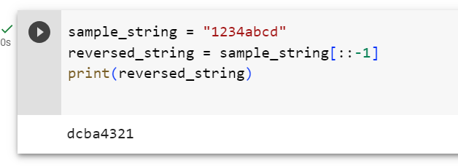

##### PROBLEM STATEMENT 3: Calculate the Upper and The lower Case

**Write a Python function that accepts a string and calculate the number of upper case letters and lower case letters.**

﻿Sample String : 'The quick Brow Fox'

Expected Output :

No. of Upper case characters : 3

No. of Lower case Characters : 12

**Code:**

def count_upper_lower(string):

upper_count = 0

lower_count = 0

for char in string:

if char.isupper():

upper_count += 1

elif char.islower():

lower_count += 1

return upper_count, lower_count

# Example usage

sample_string = 'The quick Brow Fox'

upper, lower = count_upper_lower(sample_string)

print("No. of Upper case characters:", upper)

print("No. of Lower case characters:", lower)

**EXECUTION:**

