Github link:

<https://github.com/virupakshi2007/Virupakshi_ICP1/tree/400cfd3bb62b813a42bf3cb0a734a34a4a878867>

Q 1.1)

import random

def main():

# give the input string

input_string = input("Enter a string: ")

# Convert the string to a list of characters

char_list = list(input_string)

# Delete random characters

num_deletions = random.randint(2, min(5, len(char_list))) # Delete 2 to 5 characters

for _ in range(num_deletions):

if len(char_list) >= 2:

index_to_delete = random.randint(0, len(char_list) - 1)

del char_list[index_to_delete]

else:

print("String is too short to delete more characters.")

break

# Reverse the output string

reversed_string = ''.join(reversed(char_list))

# Print the reversed string

print("Reversed string:", reversed_string)

if __name__ == "__main__":

main()

So, here we are giving a string ‘python’, so we need to delete at least two characters, here in the output given below, ‘t’ and ‘p’ has been deleted and therefore after deleting two characters in this case, the reserved string is nohy.

Output: 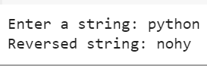

Q 1.2)

def main():

try:

num1 = float(input("Enter the first number: "))

num2 = float(input("Enter the second number: "))

# writing formulas for all the arthimetic operations

addition = num1 + num2

subtraction = num1 - num2

multiplication = num1 * num2

# logic to avoid dividing by zero

if num2 != 0:

division = num1 / num2

else:

division = "Cannot divide by zero"

print("Addition:", addition)

print("Subtraction:", subtraction)

print("Multiplication:", multiplication)

print("Division:", division)

except ValueError:

print("Invalid input. Please enter valid numbers.")

if __name__ == "__main__":

main()

Here, for the first number we gave 5 and the second number we gave 10, so according to these values we perform addition as 15 and subtraction, multiplication and division.

Output:

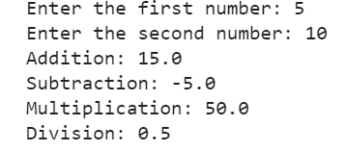

Q 2)

def main():

sentence = input("Enter a sentence: ")

# given condition to replace the word python with pythons

updated_sentence = sentence.replace('python', 'pythons')

# Print the output

print("updated sentence:", updated_sentence)

if __name__ == "__main__":

main()

In this program, we pass a string and we need to replace python with pythons, wherever it appears in the givenm string.

Output:

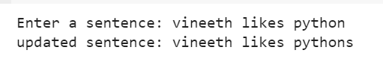

Q 3)

def main():

try:

class_score = float(input("Enter the class score: "))

# Check whether if the class score is greater than 100

if class_score > 100:

print("Invalid input. Class score cannot exceed 100.")

return

# write the if else conditions based on the grading scale

if class_score >= 90:

letter_grade = 'A'

elif class_score >= 80:

letter_grade = 'B'

elif class_score >= 70:

letter_grade = 'C'

elif class_score >= 60:

letter_grade = 'D'

else:

letter_grade = 'F'

# Print the grade

print("Letter grade:", letter_grade)

except ValueError:

print("Invalid input. Please enter a valid number.")

if __name__ == "__main__":

main()

Here, if the class score is greater than 90 we give A, so using a if and elif conditions we gave set the grades accordingly.

Output:

