1.1)

First_name = ( input("Your First Name : "))

last_name = (input("Your Last Name : "))

Full_Name = print(First_name + last_name)

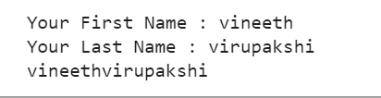

1.2)

def string_alternative(Str):

output = ""

for a in range(len(Str)):

if a % 2 == 0:

output += Str[a]

return output

print(string_alternative("Good evening"))



2)

file1 = open('input.txt', 'r')

counts = dict()

data = file1.read()

words = data.split()

for word in words:

if word in counts:

counts[word] += 1

else:

counts[word] = 1

print(counts)

f = open('output.txt', 'w')

f.write(data)

f.write('\nword_count:\n')

for key, value in counts.items():

f.write(f"{key}: {value}\n")

f.close()



3.1)

L1=list(map(float,input().split()))

L2=[]

for x in L1:

x=x*2.54

L2.append(x)

print(L2)

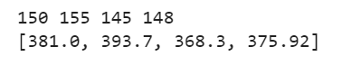

3.2)

L1=list(map(float,input().split()))

L2=[x*2.54 for x in L1]

print(L2)

