from google.colab import drive

drive.mount('/content/gdrive')

path_to_csv = '/content/gdrive/MyDrive/Colab Notebooks/diabetes.csv'

pip install tensorflow

import keras

import pandas

import tensorflow as tf

from tensorflow.keras.layers import Dense, Activation # You can import individual layers like Dense from keras.layers

from keras.models import Sequential

# load dataset

from sklearn.model_selection import train_test_split

import pandas as pd

import numpy as np

dataset = pd.read_csv(path_to_csv, header=None).values

X_train, X_test, Y_train, Y_test = train_test_split(dataset[:,0:8], dataset[:,8],

test_size=0.25, random_state=87)

np.random.seed(155)

my_first_nn = Sequential() # create model

my_first_nn.add(Dense(20, input_dim=8, activation='relu')) # hidden layer

my_first_nn.add(Dense(1, activation='sigmoid')) # output layer

my_first_nn.compile(loss='binary_crossentropy', optimizer='adam', metrics=['acc'])

my_first_nn_fitted = my_first_nn.fit(X_train, Y_train, epochs=100,

initial_epoch=0)

print(my_first_nn.summary())

print(my_first_nn.evaluate(X_test, Y_test))

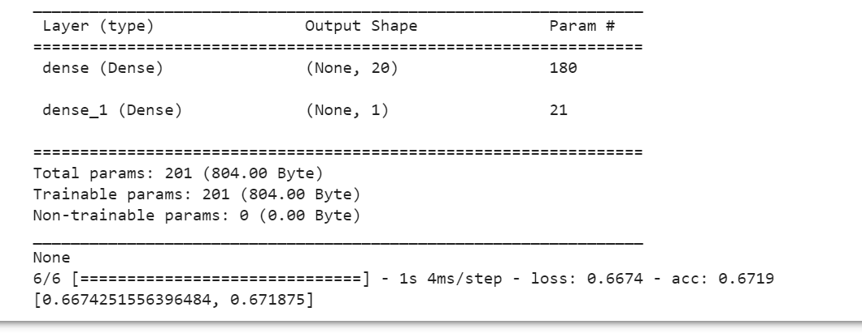

import keras

import pandas as pd

import numpy as np

from keras.models import Sequential

import tensorflow as tf

from tensorflow.keras.layers import Dense, Activation

from sklearn.model_selection import train_test_split

# load dataset

path_to_csv = '/content/gdrive/MyDrive/Colab Notebooks/diabetes.csv'

dataset = pd.read_csv(path_to_csv, header=None).values

# split dataset into training and test sets

X_train, X_test, Y_train, Y_test = train_test_split(dataset[:,0:8], dataset[:,8],

test_size=0.25, random_state=87)

# define the model

np.random.seed(155)

my_second_nn = Sequential()

my_second_nn.add(Dense(20, input_dim=8, activation='relu'))

my_second_nn.add(Dense(20, input_dim=8,activation='relu'))

my_second_nn.add(Dense(20, input_dim=8,activation='relu'))

my_second_nn.add(Dense(1, activation='sigmoid'))

my_second_nn.compile(loss='binary_crossentropy', optimizer='adam', metrics=['accuracy'])

# train the model

my_second_nn_fitted= my_second_nn.fit(X_train, Y_train, epochs=100,

initial_epoch=0)

# evaluate the model on the test set

score = my_second_nn.evaluate(X_test, Y_test, batch_size=64)

print(my_second_nn.summary())

print("Test accuracy:", score[1])

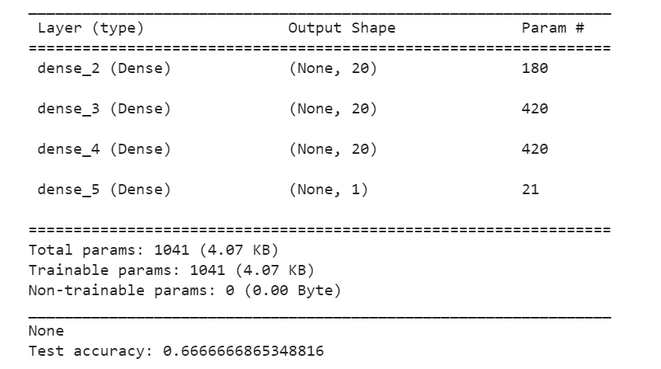

path_to_csv = '/content/gdrive/MyDrive/Colab Notebooks/breastcancer.csv'

import pandas as pd

import numpy as np

from sklearn.datasets import load_breast_cancer

from sklearn.model_selection import train_test_split

from sklearn.preprocessing import StandardScaler

from keras.models import Sequential

from keras.layers import Dense

# Load dataset

data = load_breast_cancer()

# Split dataset into training and testing sets

X_train, X_test, y_train, y_test = train_test_split(data.data, data.target,

test_size=0.25, random_state=87)

# Normalize data

sc = StandardScaler()

X_train_norm = sc.fit_transform(X_train)

X_test_norm = sc.transform(X_test)

# Create model

np.random.seed(155)

model = Sequential()

model.add(Dense(20, input_dim=30, activation='relu'))

model.add(Dense(1, activation='sigmoid'))

model.compile(loss='binary_crossentropy', optimizer='adam', metrics=['accuracy'])

# Train model

model.fit(X_train_norm, y_train, epochs=100, initial_epoch=0)

# Evaluate model on testing set

loss, accuracy = model.evaluate(X_test_norm, y_test)

print(model.summary())

print("Loss:", loss)

print("Accuracy:", accuracy)

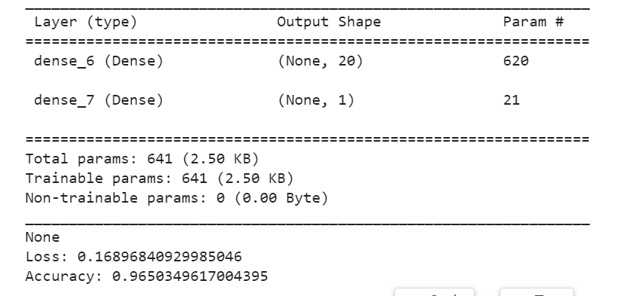

from keras import Sequential

from keras.datasets import mnist

import numpy as np

from keras.layers import Dense

from keras.utils import to_categorical

(train_images,train_labels),(test_images, test_labels) = mnist.load_data()

print(train_images.shape[1:])

#process the data

#1. convert each image of shape 28*28 to 784 dimensional which will be fed to the network as a single feature

dimData = np.prod(train_images.shape[1:])

print(dimData)

train_data = train_images.reshape(train_images.shape[0],dimData)

test_data = test_images.reshape(test_images.shape[0],dimData)

#convert data to float and scale values between 0 and 1

train_data = train_data.astype('float')

test_data = test_data.astype('float')

#scale data

train_data /=255.0

test_data /=255.0

#change the labels frominteger to one-hot encoding. to_categorical is doing the same thing as LabelEncoder()

train_labels_one_hot = to_categorical(train_labels)

test_labels_one_hot = to_categorical(test_labels)

#creating network

model = Sequential()

model.add(Dense(512, activation='relu', input_shape=(dimData,)))

model.add(Dense(512, activation='relu'))

model.add(Dense(10, activation='softmax'))

model.compile(optimizer='rmsprop', loss='categorical_crossentropy', metrics=['accuracy'])

history = model.fit(train_data, train_labels_one_hot, batch_size=256, epochs=10, verbose=1,

validation_data=(test_data, test_labels_one_hot))

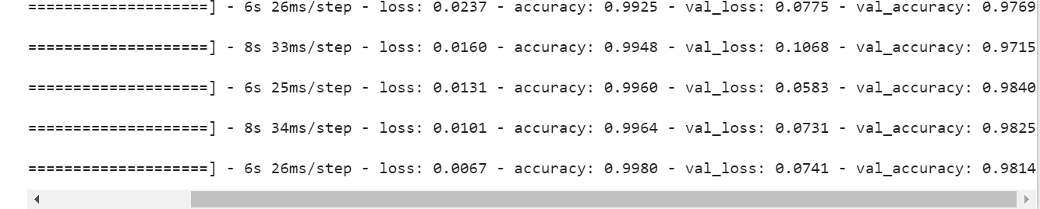

import matplotlib.pyplot as plt

# Plot training & validation accuracy values

plt.plot(history.history['accuracy'])

plt.plot(history.history['val_accuracy'])

plt.title('Model accuracy')

plt.ylabel('Accuracy')

plt.xlabel('Epoch')

plt.legend(['Train', 'Test'], loc='upper left')

plt.show()

# Plot training & validation loss values

plt.plot(history.history['loss'])

plt.plot(history.history['val_loss'])

plt.title('Model loss')

plt.ylabel('Loss')

plt.xlabel('Epoch')

plt.legend(['Train', 'Test'], loc='upper left')

plt.show()

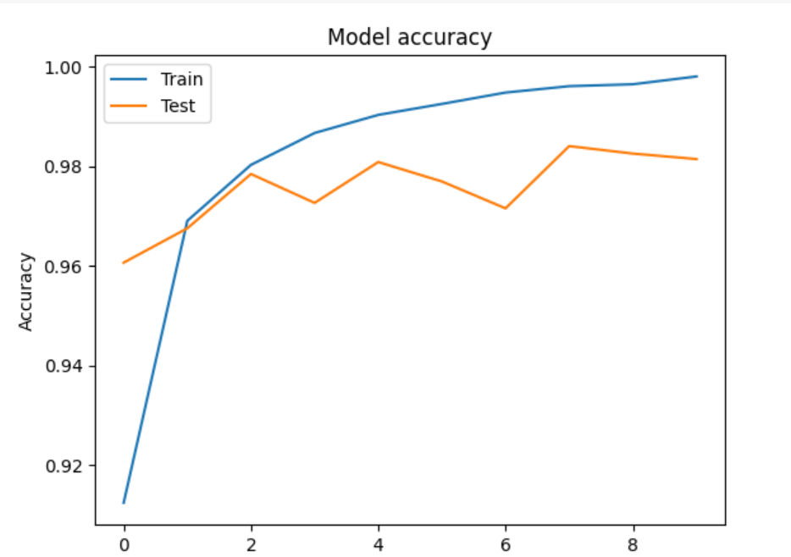

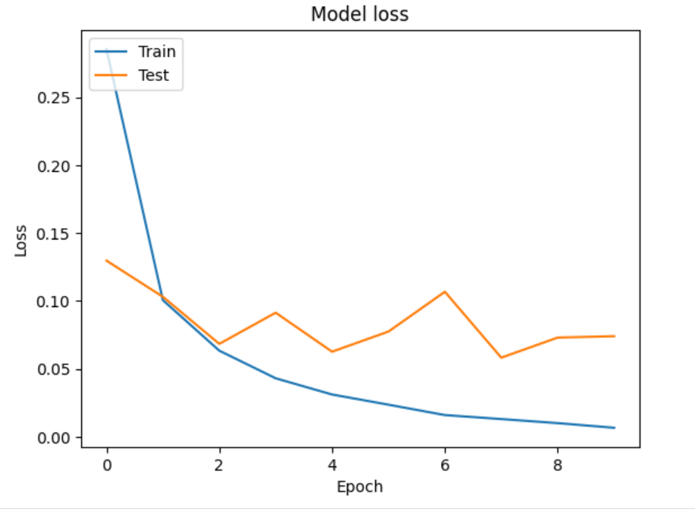

import matplotlib.pyplot as plt

# select a random image from test data

image_index = 1234

img = test_images[image_index]

# plot the image

plt.imshow(img, cmap='gray')

# reshape image to 1D vector

img = img.reshape((1, 784))

# normalize pixel values

img = img / 255.0

# predict class of image

result = model.predict(img)

print("Predicted digit:", np.argmax(result))

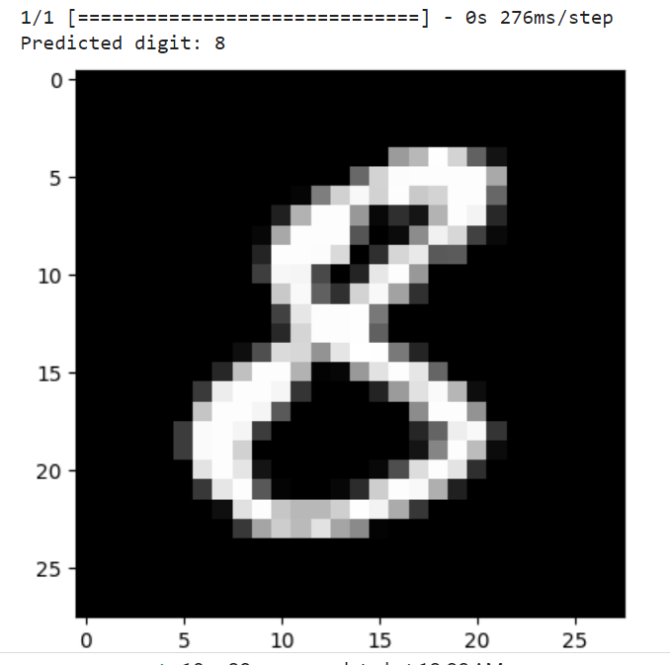

from keras import Sequential

from keras.datasets import mnist

import numpy as np

from keras.layers import Dense

from keras.utils import to_categorical

(train_images,train_labels),(test_images, test_labels) = mnist.load_data()

print(train_images.shape[1:])

#process the data

#1. convert each image of shape 28*28 to 784 dimensional which will be fed to the network as a single feature

dimData = np.prod(train_images.shape[1:])

print(dimData)

train_data = train_images.reshape(train_images.shape[0],dimData)

test_data = test_images.reshape(test_images.shape[0],dimData)

#convert data to float and scale values between 0 and 1

train_data = train_data.astype('float')

test_data = test_data.astype('float')

#scale data

train_data /=255.0

test_data /=255.0

#change the labels frominteger to one-hot encoding. to_categorical is doing the same thing as LabelEncoder()

train_labels_one_hot = to_categorical(train_labels)

test_labels_one_hot = to_categorical(test_labels)

#creating network

model = Sequential()

model.add(Dense(512, activation='tanh', input_shape=(dimData,)))

model.add(Dense(256, activation='tanh'))

model.add(Dense(128, activation='tanh'))

model.add(Dense(10, activation='softmax'))

model.compile(optimizer='rmsprop', loss='categorical_crossentropy', metrics=['accuracy'])

history = model.fit(train_data, train_labels_one_hot, batch_size=256, epochs=10, verbose=1,

validation_data=(test_data, test_labels_one_hot))

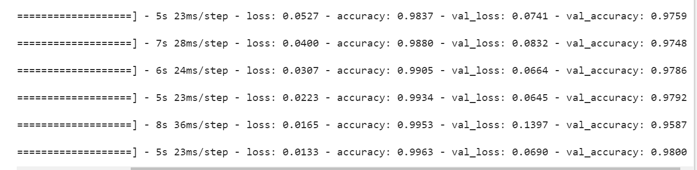

from keras import Sequential

from keras.datasets import mnist

import numpy as np

from keras.layers import Dense

from keras.utils import to_categorical

(train_images,train_labels),(test_images, test_labels) = mnist.load_data()

print(train_images.shape[1:])

#process the data

#1. convert each image of shape 28*28 to 784 dimensional which will be fed to the network as a single feature

dimData = np.prod(train_images.shape[1:])

print(dimData)

train_data = train_images.reshape(train_images.shape[0],dimData)

test_data = test_images.reshape(test_images.shape[0],dimData)

#convert data to float and scale values between 0 and 1

train_data = train_data.astype('float')

test_data = test_data.astype('float')

#change the labels frominteger to one-hot encoding. to_categorical is doing the same thing as LabelEncoder()

train_labels_one_hot = to_categorical(train_labels)

test_labels_one_hot = to_categorical(test_labels)

#creating network

model = Sequential()

model.add(Dense(512, activation='relu', input_shape=(dimData,)))

model.add(Dense(512, activation='relu'))

model.add(Dense(10, activation='softmax'))

model.compile(optimizer='rmsprop', loss='categorical_crossentropy', metrics=['accuracy'])

history = model.fit(train_data, train_labels_one_hot, batch_size=256, epochs=10, verbose=1,

validation_data=(test_data, test_labels_one_hot))

test_loss, test_acc = model.evaluate(test_data, test_labels_one_hot, verbose=0)

print(f'Test loss: {test_loss:.3f}, Test accuracy: {test_acc:.3f}')

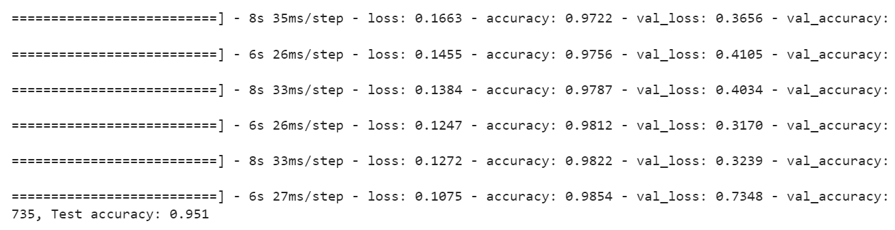

import keras

from keras.datasets import mnist

from keras.models import Sequential

from keras.layers import Dense, Dropout

import matplotlib.pyplot as plt

import numpy as np

# load MNIST dataset

(x_train, y_train), (x_test, y_test) = mnist.load_data()

# normalize pixel values to range [0, 1]

x_train = x_train.astype('float32') / 255

x_test = x_test.astype('float32') / 255

# convert class labels to binary class matrices

num_classes = 10

y_train = keras.utils.to_categorical(y_train, num_classes)

y_test = keras.utils.to_categorical(y_test, num_classes)

# create a list of models to train

models = []

# model with 1 hidden layer and tanh activation

model = Sequential()

model.add(Dense(512, activation='tanh', input_shape=(784,)))

model.add(Dropout(0.2))

model.add(Dense(num_classes, activation='softmax'))

models.append(('1 hidden layer with tanh', model))

# model with 1 hidden layer and sigmoid activation

model = Sequential()

model.add(Dense(512, activation='sigmoid', input_shape=(784,)))

model.add(Dropout(0.2))

model.add(Dense(num_classes, activation='softmax'))

models.append(('1 hidden layer with sigmoid', model))

# model with 2 hidden layers and tanh activation

model = Sequential()

model.add(Dense(512, activation='tanh', input_shape=(784,)))

model.add(Dropout(0.2))

model.add(Dense(512, activation='tanh'))

model.add(Dropout(0.2))

model.add(Dense(num_classes, activation='softmax'))

models.append(('2 hidden layers with tanh', model))

# model with 2 hidden layers and sigmoid activation

model = Sequential()

model.add(Dense(512, activation='sigmoid', input_shape=(784,)))

model.add(Dropout(0.2))

model.add(Dense(512, activation='sigmoid'))

model.add(Dropout(0.2))

model.add(Dense(num_classes, activation='softmax'))

models.append(('2 hidden layers with sigmoid', model))

# train each model and plot loss and accuracy curves

for name, model in models:

model.compile(loss='categorical_crossentropy', optimizer='adam', metrics=['accuracy'])

history = model.fit(x_train.reshape(-1, 784), y_train, validation_data=(x_test.reshape(-1, 784), y_test),

epochs=20, batch_size=128, verbose=0)

# plot loss and accuracy curves

plt.plot(history.history['loss'], label='train_loss')

plt.plot(history.history['val_loss'], label='val_loss')

plt.plot(history.history['accuracy'], label='train_accuracy')

plt.plot(history.history['val_accuracy'], label='val_accuracy')

plt.title(name)

plt.xlabel('Epoch')

plt.legend()

plt.show()

# evaluate the model on test data

loss, accuracy = model.evaluate(x_test.reshape(-1, 784), y_test, verbose=0)

print('{} - Test loss: {:.4f}, Test accuracy: {:.4f}'.format(name, loss, accuracy))

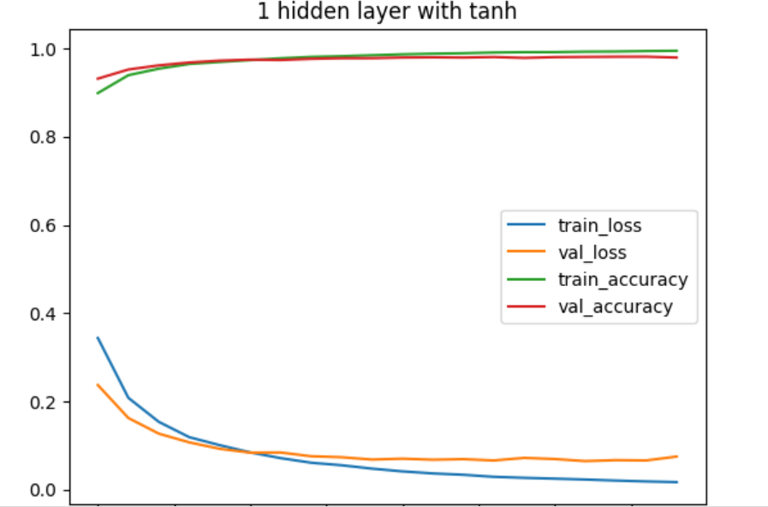

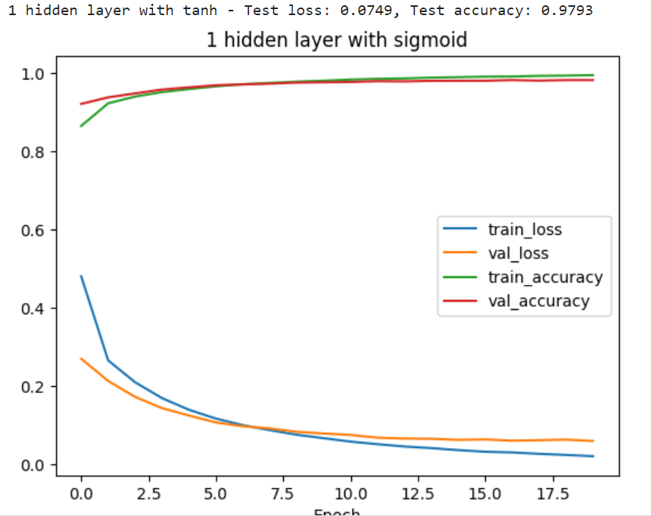

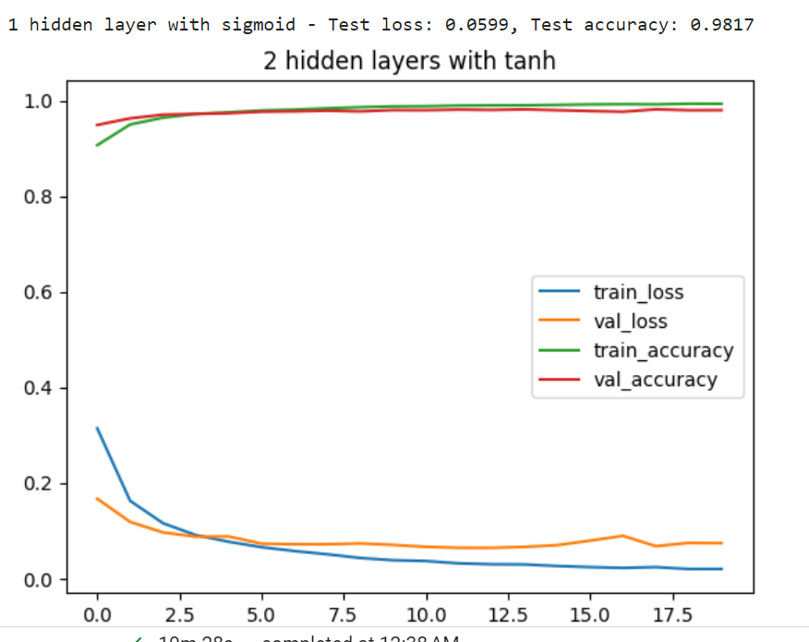

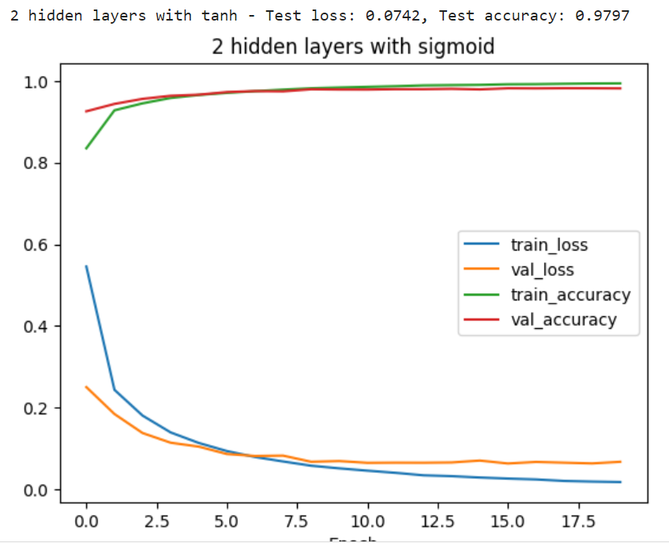

import keras

from keras.datasets import mnist

from keras.models import Sequential

from keras.layers import Dense, Dropout

import matplotlib.pyplot as plt

import numpy as np

# load MNIST dataset

(x_train, y_train), (x_test, y_test) = mnist.load_data()

# convert class labels to binary class matrices

num_classes = 10

y_train = keras.utils.to_categorical(y_train, num_classes)

y_test = keras.utils.to_categorical(y_test, num_classes)

# create a list of models to train

models = []

# model with 1 hidden layer and tanh activation

model = Sequential()

model.add(Dense(512, activation='tanh', input_shape=(784,)))

model.add(Dropout(0.2))

model.add(Dense(num_classes, activation='softmax'))

models.append(('1 hidden layer with tanh', model))

# model with 1 hidden layer and sigmoid activation

model = Sequential()

model.add(Dense(512, activation='sigmoid', input_shape=(784,)))

model.add(Dropout(0.2))

model.add(Dense(num_classes, activation='softmax'))

models.append(('1 hidden layer with sigmoid', model))

# model with 2 hidden layers and tanh activation

model = Sequential()

model.add(Dense(512, activation='tanh', input_shape=(784,)))

model.add(Dropout(0.2))

model.add(Dense(512, activation='tanh'))

model.add(Dropout(0.2))

model.add(Dense(num_classes, activation='softmax'))

models.append(('2 hidden layers with tanh', model))

# model with 2 hidden layers and sigmoid activation

model = Sequential()

model.add(Dense(512, activation='sigmoid', input_shape=(784,)))

model.add(Dropout(0.2))

model.add(Dense(512, activation='sigmoid'))

model.add(Dropout(0.2))

model.add(Dense(num_classes, activation='softmax'))

models.append(('2 hidden layers with sigmoid', model))

# train each model and plot loss and accuracy curves

for name, model in models:

model.compile(loss='categorical_crossentropy', optimizer='adam', metrics=['accuracy'])

history = model.fit(x_train.reshape(-1, 784), y_train, validation_data=(x_test.reshape(-1, 784), y_test),

epochs=20, batch_size=128, verbose=0)

# plot loss and accuracy curves

plt.plot(history.history['loss'], label='train_loss')

plt.plot(history.history['val_loss'], label='val_loss')

plt.plot(history.history['accuracy'], label='train_accuracy')

plt.plot(history.history['val_accuracy'], label='val_accuracy')

plt.title(name)

plt.xlabel('Epoch')

plt.legend()

plt.show()

# evaluate the model on test data

loss, accuracy = model.evaluate(x_test.reshape(-1, 784), y_test, verbose=0)

print('{} - Test loss: {:.4f}, Test accuracy: {:.4f}'.format(name, loss, accuracy))

