1)

import numpy as np

from tensorflow.keras.datasets import cifar10

from tensorflow.keras.models import Sequential

from tensorflow.keras.layers import Dense, Dropout, Flatten, Conv2D, MaxPooling2D

from tensorflow.keras.constraints import MaxNorm

from tensorflow.keras.optimizers import SGD

from tensorflow.keras.utils import to_categorical

# fix random seed for reproducibility

seed = 7

np.random.seed(seed)

# load data

(X_train, y_train), (X_test, y_test) = cifar10.load_data()

# convert from int to float and normalize inputs from 0-255 to 0.0-1.0

X_train = X_train.astype('float32') / 255.0

X_test = X_test.astype('float32') / 255.0

# one hot encode outputs

y_train = to_categorical(y_train)

y_test = to_categorical(y_test)

num_classes = y_test.shape[1]

# Create the model

model = Sequential()

model.add(Conv2D(32, (3, 3), input_shape=(32, 32, 3), padding='same', activation='relu', kernel_constraint=MaxNorm(3)))

model.add(Dropout(0.2))

model.add(Conv2D(32, (3, 3), activation='relu', padding='same', kernel_constraint=MaxNorm(3)))

model.add(MaxPooling2D(pool_size=(2, 2)))

model.add(Flatten())

model.add(Dense(512, activation='relu', kernel_constraint=MaxNorm(3)))

model.add(Dropout(0.5))

model.add(Dense(num_classes, activation='softmax'))

# Compile model

epochs = 25

lrate = 0.01

sgd = SGD(lr=lrate, momentum=0.9, nesterov=False)

model.compile(loss='categorical_crossentropy', optimizer=sgd, metrics=['accuracy'])

print(model.summary())

# Fit the model

model.fit(X_train, y_train, validation_data=(X_test, y_test), epochs=epochs, batch_size=32)

# Final evaluation of the model

scores = model.evaluate(X_test, y_test, verbose=0)

print("Accuracy: %.2f%%" % (scores[1] * 100))

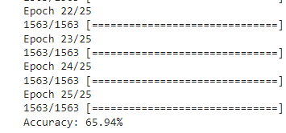

2)

import numpy as np

from tensorflow.keras.datasets import cifar10

from tensorflow.keras.models import Sequential

from tensorflow.keras.layers import Dense, Dropout, Flatten, Conv2D, MaxPooling2D

from tensorflow.keras.constraints import MaxNorm

from tensorflow.keras.optimizers import SGD

from tensorflow.keras.utils import to_categorical

# fix random seed for reproducibility

seed = 7

np.random.seed(seed)

# load data

(X_train, y_train), (X_test, y_test) = cifar10.load_data()

# convert from int to float and normalize inputs from 0-255 to 0.0-1.0

X_train = X_train.astype('float32') / 255.0

X_test = X_test.astype('float32') / 255.0

# one hot encode outputs

y_train = to_categorical(y_train)

y_test = to_categorical(y_test)

num_classes = y_test.shape[1]

# Create the model

model = Sequential()

model.add(Conv2D(32, (3, 3), input_shape=(32, 32, 3), padding='same', activation='relu', kernel_constraint=MaxNorm(3)))

model.add(Dropout(0.2))

model.add(Conv2D(32, (3, 3), activation='relu', padding='same', kernel_constraint=MaxNorm(3)))

model.add(MaxPooling2D(pool_size=(2, 2)))

model.add(Conv2D(64, (3, 3), padding='same', activation='relu', kernel_constraint=MaxNorm(3)))

model.add(Dropout(0.2))

model.add(Conv2D(64, (3, 3), activation='relu', padding='same', kernel_constraint=MaxNorm(3)))

model.add(MaxPooling2D(pool_size=(2, 2)))

model.add(Conv2D(128, (3, 3), padding='same', activation='relu', kernel_constraint=MaxNorm(3)))

model.add(Dropout(0.2))

model.add(Conv2D(128, (3, 3), activation='relu', padding='same', kernel_constraint=MaxNorm(3)))

model.add(MaxPooling2D(pool_size=(2, 2)))

model.add(Flatten())

model.add(Dropout(0.2))

model.add(Dense(1024, activation='relu', kernel_constraint=MaxNorm(3)))

model.add(Dropout(0.2))

model.add(Dense(512, activation='relu', kernel_constraint=MaxNorm(3)))

model.add(Dropout(0.2))

model.add(Dense(num_classes, activation='softmax'))

# Compile model

epochs = 25

lrate = 0.01

sgd = SGD(lr=lrate, momentum=0.9, nesterov=False)

model.compile(loss='categorical_crossentropy', optimizer=sgd, metrics=['accuracy'])

print(model.summary())

# Fit the model

history = model.fit(X_train, y_train, validation_data=(X_test, y_test), epochs=epochs, batch_size=32)

# Final evaluation of the model

scores = model.evaluate(X_test, y_test, verbose=0)

print("Accuracy: %.2f%%" % (scores[1] * 100))

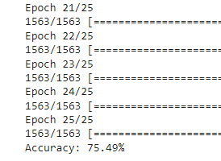

3) predictions = model.predict(X_test[:4])

print(predictions)

print(np.argmax(predictions, axis=1))

print(y_test[:4])

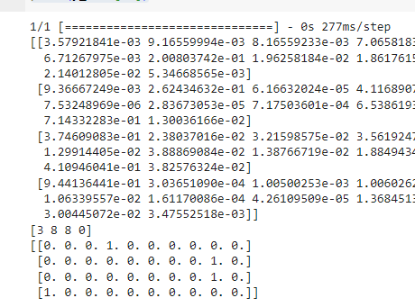

4)

import matplotlib.pyplot as plt

# Plot training & validation accuracy values

plt.plot(history.history['accuracy'])

plt.plot(history.history['val_accuracy'])

plt.title('Model accuracy')

plt.ylabel('Accuracy')

plt.xlabel('Epoch')

plt.legend(['Train', 'Validation'], loc='upper left')

plt.show()

# Plot training & validation loss values

plt.plot(history.history['loss'])

plt.plot(history.history['val_loss'])

plt.title('Model loss')

plt.ylabel('Loss')

plt.xlabel('Epoch')

plt.legend(['Train', 'Validation'], loc='upper left')

plt.show()

