MYSQL-REPLICATION SERVER DOCS

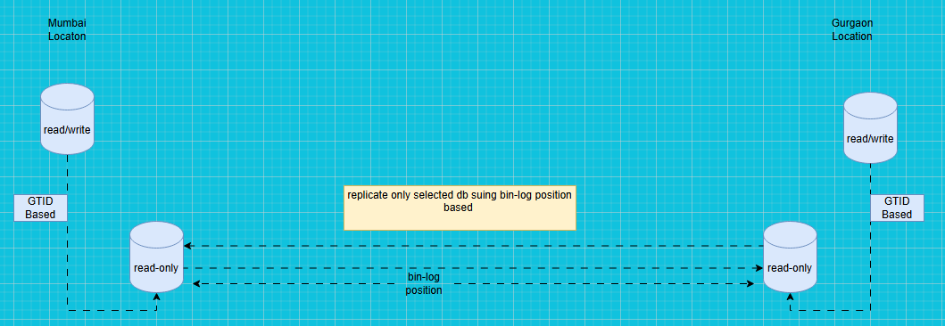

Note : ❌ GTID + binlog position together is NOT valid

| Mode | Can you mix? |
| --------------------------- | ---------------------------- |
| GTID-based replication | ❌ Cannot use binlog position |
| Binlog-position replication | ❌ Cannot use GTID |

⚠️ This will NOT work as shown

My Suggestion

✅ OPTION 1 — CLEAN & RECOMMENDED (GTID-based)

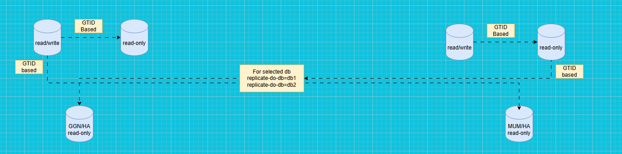

✔ Easy failover
✔ Safe
✔ Recommended for MySQL 5.7 / 8.0

❌ OPTION 2 — Binlog-position based (NOT recommended now)

This would work only if:

GTID is completely disabled
gtid_mode=OFF
enforce_gtid_consistency=OFF

CHANGE MASTER TO
MASTER_LOG_FILE='mysql-bin.000001',
MASTER_LOG_POS=12345;

🚨 MAJOR DESIGN RISK IN YOUR DIAGRAM

❌ Replicating between READ-ONLY servers
If your replication source is a read-only replica:
❌ Replication can break
❌ Binlog might be incomplete
❌ Failover becomes unsafe
✅ Correct rule
Replication source should always be a PRIMARY (RW)
| Question | Answer
| --------------------------------------------------| -----------------
| Will your current design work as shown? | ❌ NO
| GTID + binlog position together? | ❌ INVALID
| RO → RO replication safe? | ❌ NOT recommended
| GTID-only design safe? | ✅ YES
| RW → RO cross-site replication | ✅ YES

