Installation of MySQL Server

Version : 8.4.7 LTS

mysql-8.4.7-winx64.msi

https://dev.mysql.com/downloads
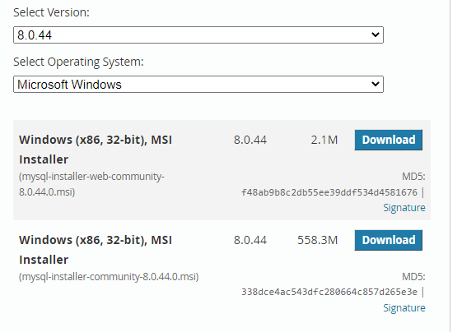

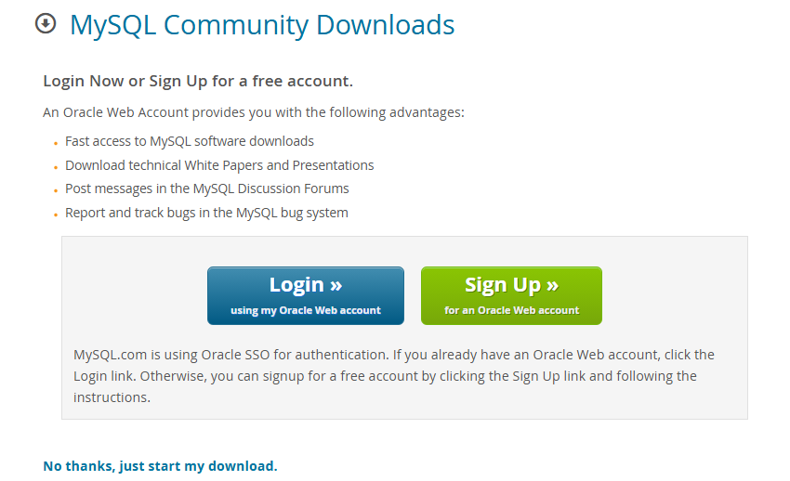

After donwnload I run in the server 20.20.20.11

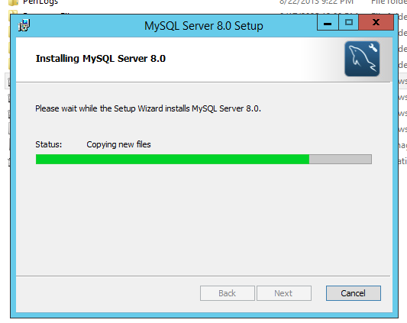

During instllation require visual studio package
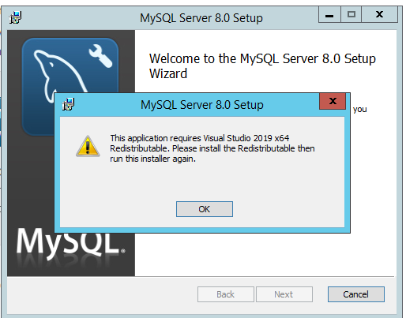

Download and install
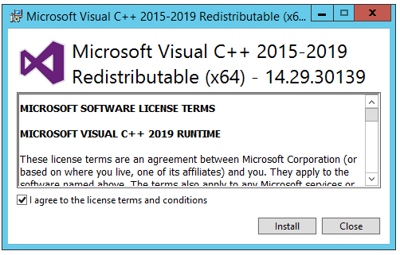

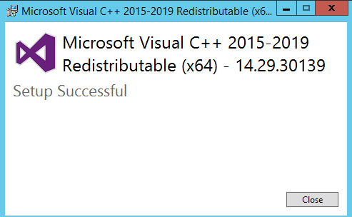

Now again I run the mysql setup run with administrator

For the internet download package
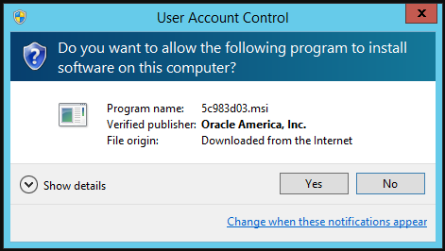

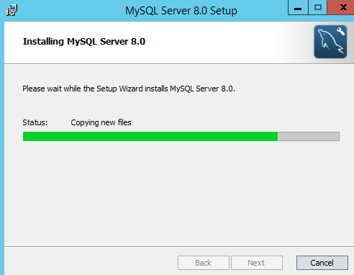

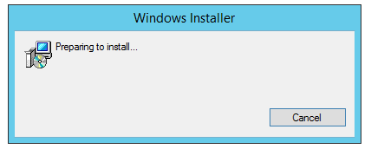
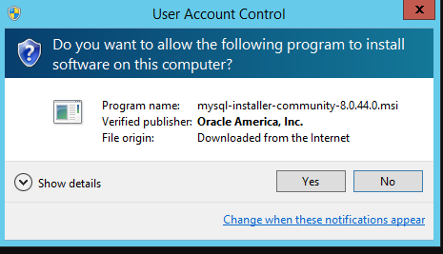

Select server only and click on next

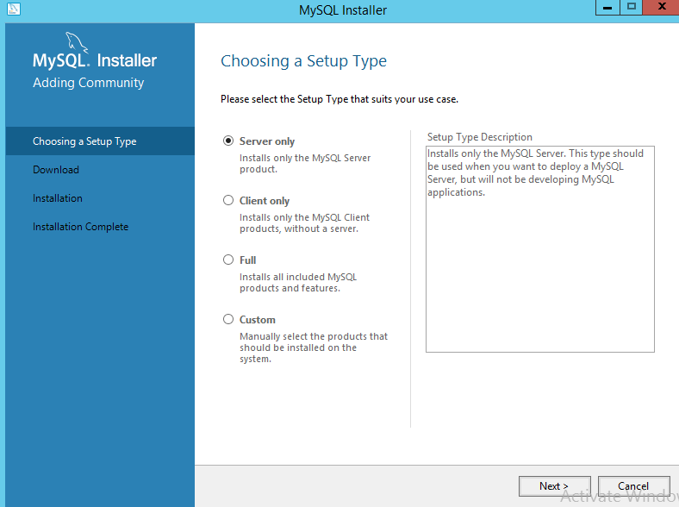

Click on install

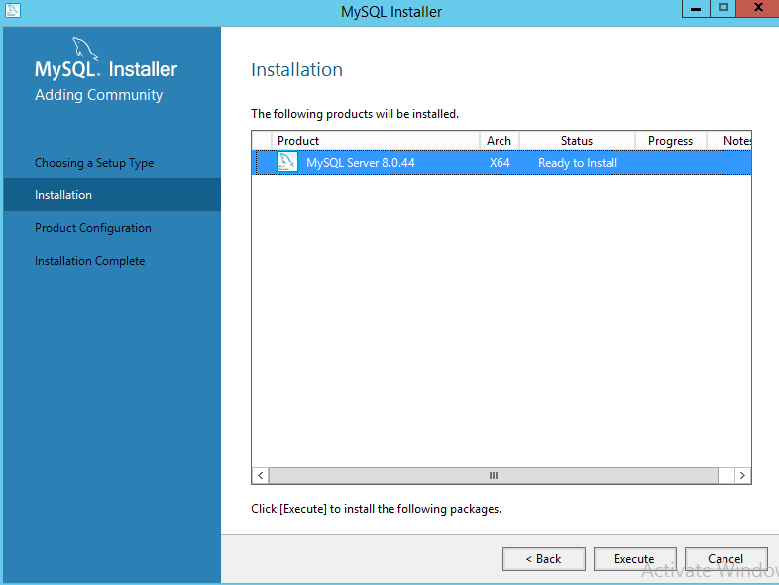

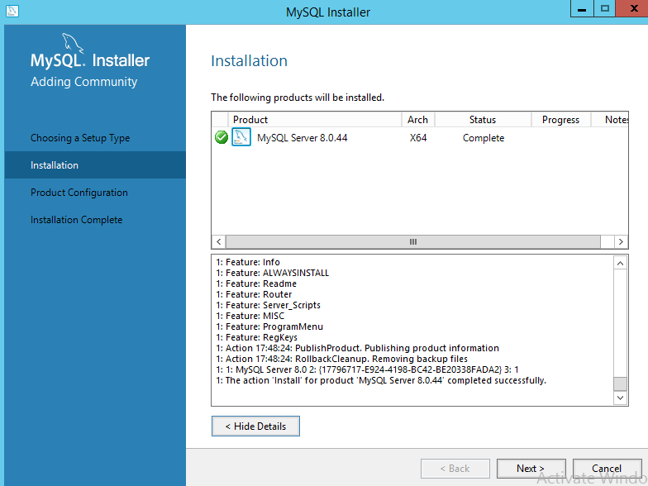

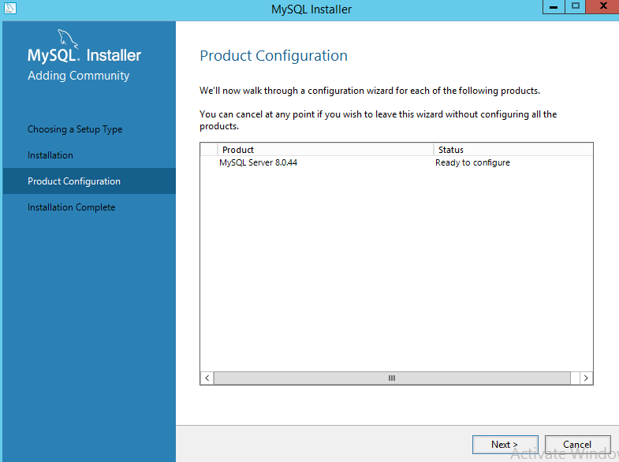

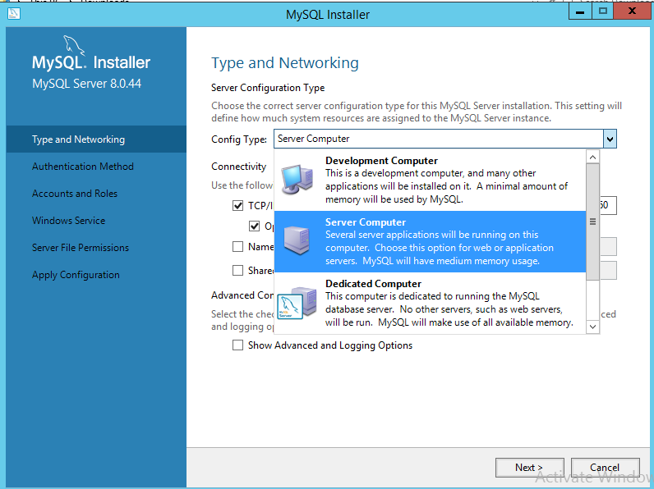

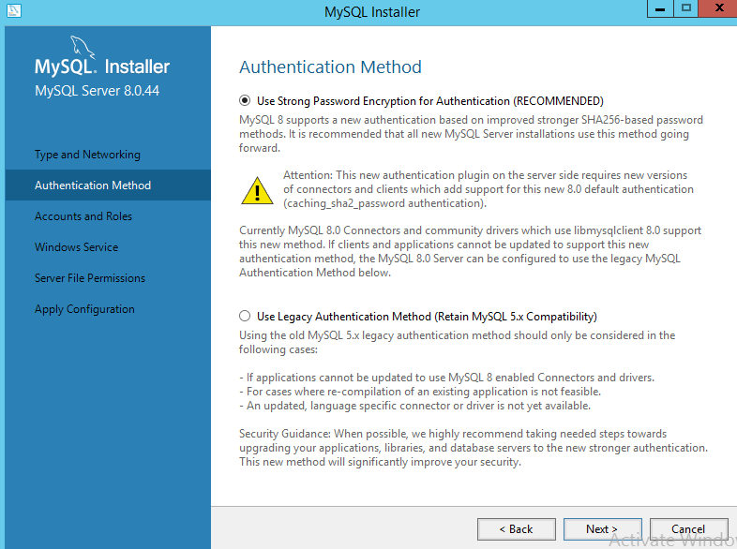

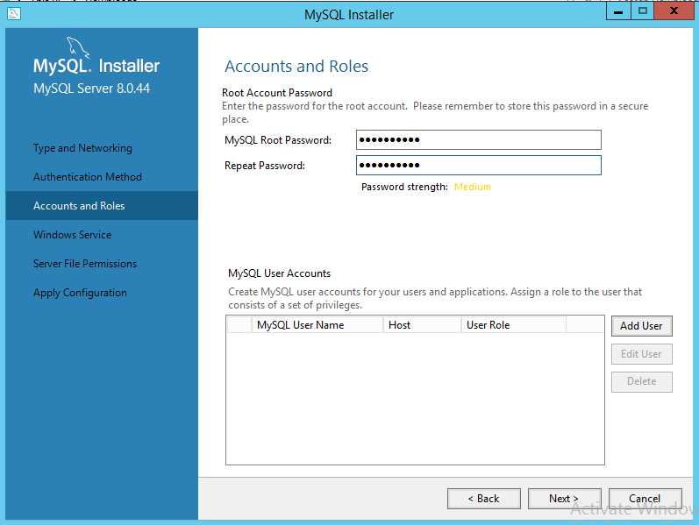

User root :
Password : Db@d3v2025

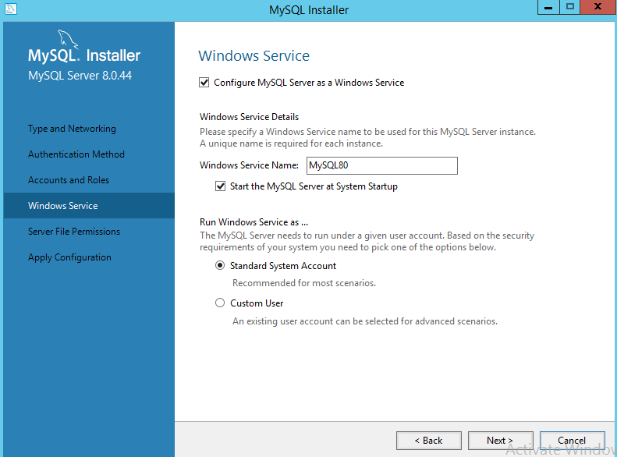

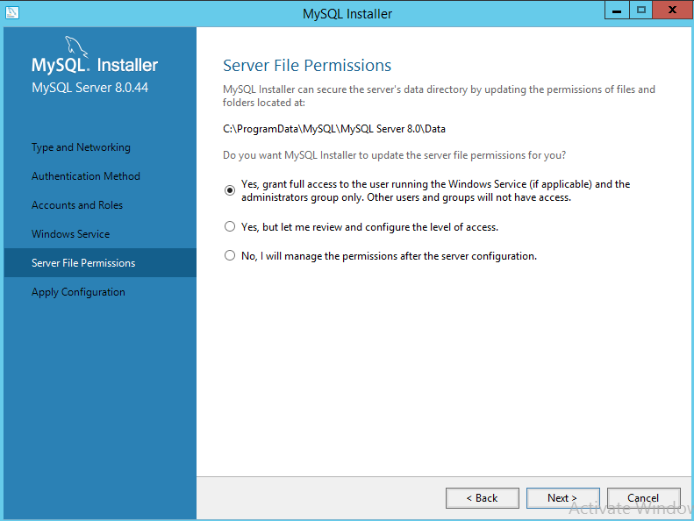

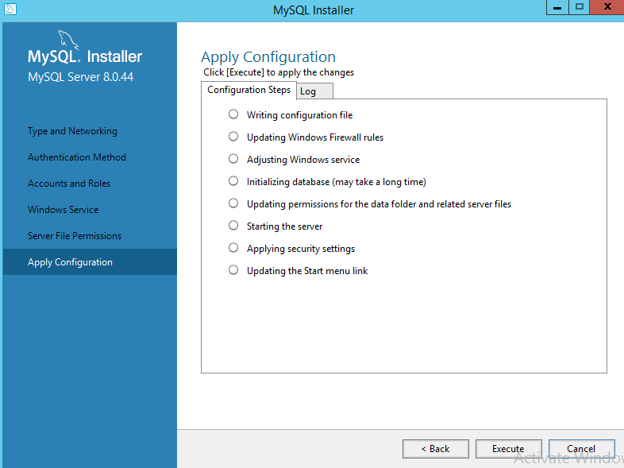

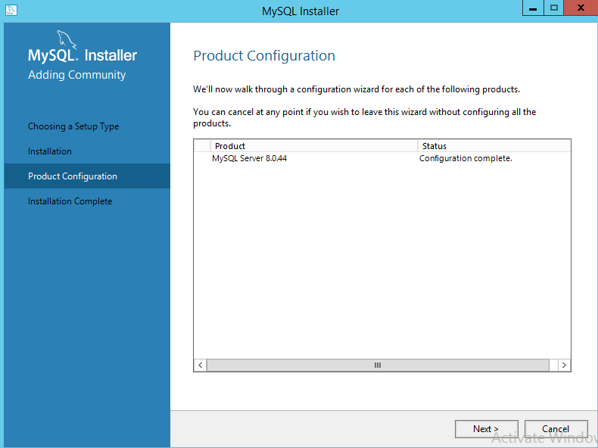

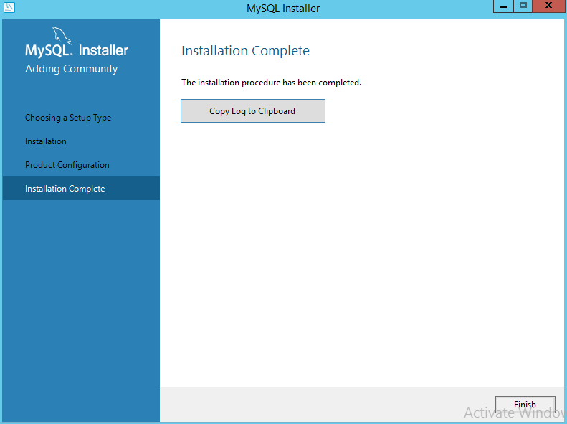

Data directory :

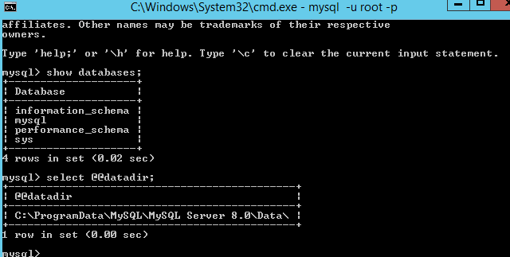

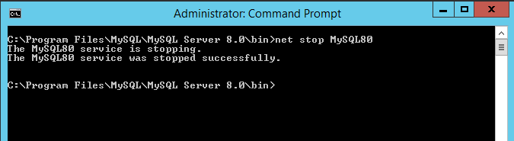

Change data directory

Open cmd run as administrator and type below command to stop the mysql service

Create a folder in your desired location

D:\MYSQL

Copy the source folder data in to your D:\MYSQL
C:\ProgramData\MySQL\MySQL Server 8.0\Data

Edit in my.cnf file
C:\ProgramData\MySQL\MySQL Server 8.0\my.ini

Open in notepad
datadir=C:/ProgramData/MySQL/MySQL Server 8.0/Data

Note : open this folder and administrator permission

Click on start
Type notepad
Right click run as administrator

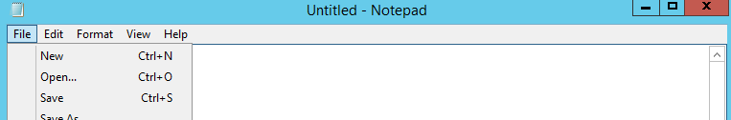

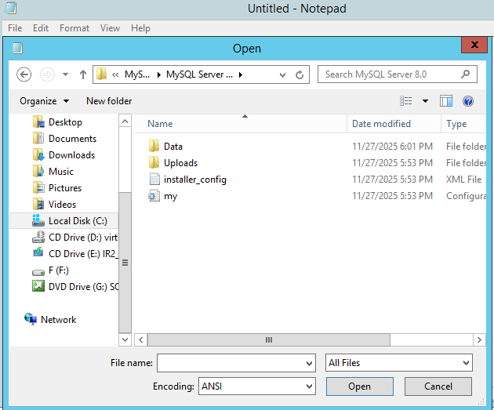

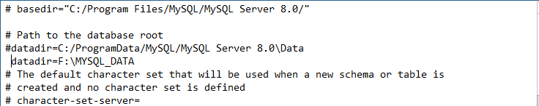

Add to D driver folder permission of mysql server

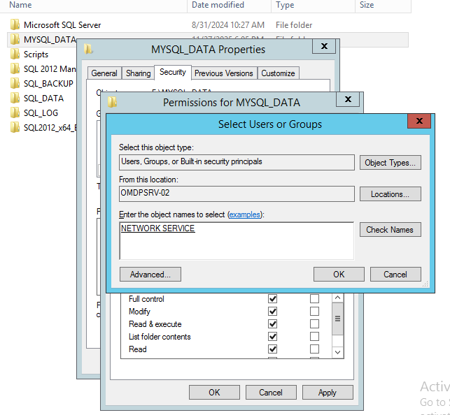

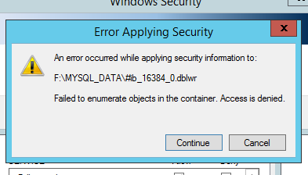

Note : in this case u just give administartor permission

Below are the extra activities I do to test purpose only
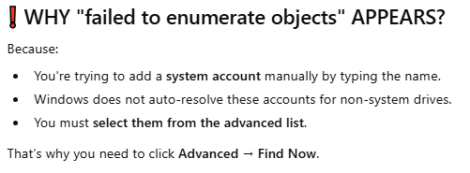

Give full permission
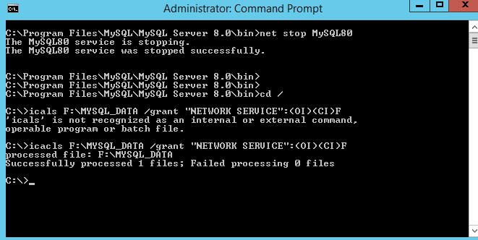

Check permission

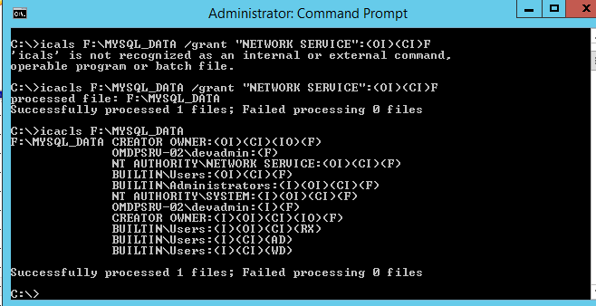

Not started

Then
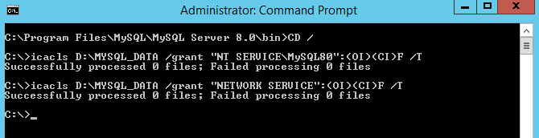

Use
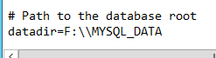

Give adminstrator permission

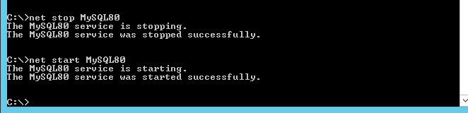

Install MySQL Workbench

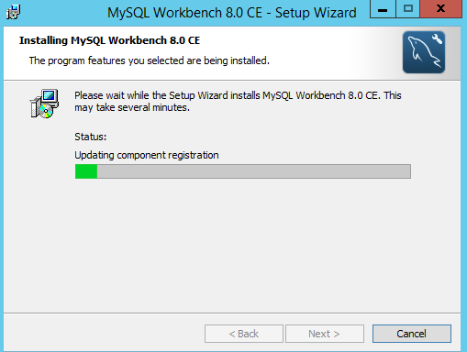

Note : After this installation succesffuly I got one pop The MySQL Workbecnh 8.x does not support Windows Server 2012 R2
It supports only
Windows Server 2016
Windows Server 2019
Windows Server 2022

Windows Server 2012 R2 is out of support
But still work . but wasn’t designed for your platform

Create a user dba
Assign permission to that user

GRANT ALL PRIVILEGES ON *.* TO 'dba_user'@'%' WITH GRANT OPTION;
Flush privileges;

My Server configration details :

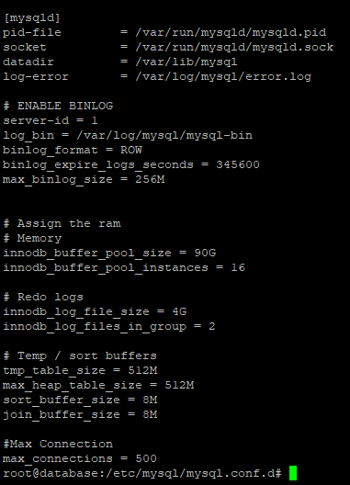

Check the errorlog

sudo tail -n 50 /var/log/mysql/error.log

Restore linux database mysql backup in to windows GUI server

STEP 1: Export Database on Linux (Dump File)
For single db
mysqldump -u root -p mydatabase > mydatabase.sql

For all db
mysqldump -u root -p --all-databases > all_databases.sql

STEP 2: Copy Dump File to Windows

scp mydatabase.sql windowsUser@windows-ip:/Users/windowsUser/Desktop/
Or using winscp

STEP 3: Place SQL File on Windows Server

D:\mysql_backups\mydatabase.sql

STEP 4: Import Into MySQL on Windows
Open Command Prompt as Administrator

Go to MySQL bin directory:
cd ‘C:\Program Files\MySQL\MySQL Server 8.0\bin’

STEP 4A — Restore into an Existing Database
If database already exists:
mysql -u root -p mydatabase < D:\mysql_backups\mydatabase.sql

STEP 4B — Restore into a New Database
Create the database:
mysql -u root -p -e "CREATE DATABASE mydatabase;"

Import data:
mysql -u root -p mydatabase < D:\mysql_backups\mydatabase.sql

STEP 4C — Restore ALL Databases From Dump
Use this only if the dump contains all databases:

mysql -u root -p < D:\mysql_backups\all_databases.sql

STEP 5: Verify the Restore
Login into mysql
mysql -u root -p

-------------------DBA Task----------------
Check Database Size :

SELECT
schema_name AS `Database`,
ROUND(SUM(data_length + index_length) / 1024 / 1024, 2) AS `Size_MB`
FROM
information_schema.schemata s
LEFT JOIN
information_schema.tables t
ON s.schema_name = t.table_schema
GROUP BY
schema_name
ORDER BY
Size_MB DESC;

Restore database in alldatabase.sql file

- Create that name database like jjj
Create database jjj
In windows find the backup in all database.sql file

Select-String -Path "C:\path\to\all_databases_2025-11-25_22-00-01.sql" -Pattern "CREATE DATABASE `jjj`"

In linux
grep "CREATE DATABASE \`jjj\`" all_databases_2025-11-25_22-00-01.sql
grep -i "USE \`jjj\`" all_databases_2025-11-25_22-00-01.sql

Correct way :

Most dumps include USE dbname; instead of CREATE DATABASE. You can extract the database content using USE as the starting point:

sed -n '/^USE `jjj`/,/^USE `/p' all_databases_2025-11-25_22-00-01.sql | sed '$d' > jjj_20251127.sql

Importe the only that database dump into seprate file and restore

mysql -u username -p jjj < jjj_only.sql

To restore the database

mysql -u username -p -e "CREATE DATABASE IF NOT EXISTS jjj;"
mysql -u username -p jjj < all_databases_2025-11-25_22-00-01.sql

