# Estonian population

You can see the Estonian total population and population by gender.

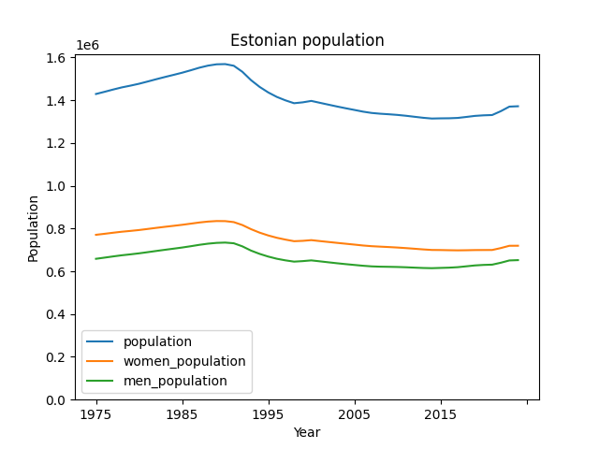

## Data Sources:

Source: The World Bank (https://data.worldbank.org/indicator/SP.POP.TOTL?locations=EE)

Source: The World Bank (https://data.worldbank.org/indicator/SP.POP.TOTL.FE.IN?locations=EE)

|  |  |  |  |
| --- | --- | --- | --- |
| year | population | women_population | men_population |
| 1975 | 1429352 | 770791 | 658561 |
| 1976 | 1439576 | 775510 | 664066 |
| 1977 | 1450211 | 780501 | 669710 |
| 1978 | 1460188 | 785198 | 674990 |
| 1979 | 1468333 | 788965 | 679368 |
| 1980 | 1477219 | 793105 | 684114 |
| 1981 | 1487666 | 798102 | 689564 |
| 1982 | 1498414 | 803234 | 695180 |
| 1983 | 1508745 | 808126 | 700619 |
| 1984 | 1518617 | 812733 | 705884 |
| 1985 | 1528781 | 817508 | 711273 |
| 1986 | 1540190 | 822867 | 717323 |
| 1987 | 1552221 | 828347 | 723874 |
| 1988 | 1561900 | 832617 | 729283 |
| 1989 | 1568131 | 835135 | 732996 |
| 1990 | 1569174 | 834760 | 734414 |
| 1991 | 1561314 | 830135 | 731179 |
| 1992 | 1533091 | 816402 | 716689 |
| 1993 | 1494128 | 797180 | 696948 |
| 1994 | 1462514 | 780920 | 681594 |
| 1995 | 1436634 | 767691 | 668943 |
| 1996 | 1415594 | 756861 | 658733 |
| 1997 | 1399535 | 748296 | 651239 |
| 1998 | 1386156 | 740850 | 645306 |
| 1999 | 1390244 | 742527 | 647717 |
| 2000 | 1396985 | 745852 | 651133 |
| 2001 | 1388115 | 741421 | 646694 |
| 2002 | 1379350 | 737236 | 642114 |
| 2003 | 1370720 | 733031 | 637689 |
| 2004 | 1362550 | 728994 | 633556 |
| 2005 | 1354775 | 724989 | 629786 |
| 2006 | 1346810 | 720757 | 626053 |
| 2007 | 1340680 | 717551 | 623129 |
| 2008 | 1337090 | 715418 | 621672 |
| 2009 | 1334515 | 713460 | 621055 |
| 2010 | 1331475 | 711219 | 620256 |
| 2011 | 1327439 | 708506 | 618933 |
| 2012 | 1322696 | 705519 | 617177 |
| 2013 | 1317997 | 702440 | 615557 |
| 2014 | 1314545 | 699883 | 614662 |
| 2015 | 1315407 | 699484 | 615923 |
| 2016 | 1315790 | 698661 | 617129 |
| 2017 | 1317384 | 698042 | 619342 |
| 2018 | 1321977 | 698558 | 623419 |
| 2019 | 1326898 | 699376 | 627522 |
| 2020 | 1329522 | 699591 | 629931 |
| 2021 | 1330932 | 699762 | 631170 |
| 2022 | 1348840 | 708704 | 640136 |
| 2023 | 1370286 | 719434 | 650852 |
| 2024 | 1371986 | 719653 | 652333 |