Real-Time Yoga Pose Correction using Deep Learning
Identifying incorrect yoga poses from live video and giving corrective feedback

Deep Learning Techniques
National Institute of Technology, Tiruchirappalli
Assignment report | Demo 29-30 Oct 2026 | Report 02 Nov 2026

Team
Viranyu Srinivasan
Jeffrey Jayapackiyaraj
Aditya Agrawal

Abstract
Practising yoga with an incorrect posture reduces its benefit and can cause injury, yet most automated tools only name the pose. We present a real-time system that recognises four poses (Tree, Warrior II, Triangle and Goddess), decides whether each is performed correctly and, if not, names the specific alignment errors with the measured and target angles. A pre-trained BlazePose estimator extracts body landmarks; a 39-dimensional scale-invariant feature vector is computed per frame; and YogaNet, a 0.23 M-parameter convolutional-recurrent multi-task network, classifies the pose, correctness and eleven error types over a 12-frame window. Its output is fused with an explainable geometric rule checker and stabilised by smoothing and voting. Because no public dataset labels yoga mistakes, we train on a margin-controlled kinematic generator (37,500 sequences) combined with 223 real photograph clips, and we evaluate on synthetic and held-out real data, reporting the limits of each.
At a glance
- 4 poses + 'other', 11 specific errors, plain-language corrective feedback with measured angles
- YogaNet: 230,751 parameters; full decision engine about 4.4 ms per frame on a CPU (pose estimator excluded)
- Hybrid decision: 0.6 x learned probability + 0.4 x geometric confidence, with EMA smoothing and a 12-frame majority vote
- Synthetic test: 99.3% pose accuracy, 99.9% error micro-F1 (hybrid), 99.2% / 99.5% under 3x unseen noise
- Held-out real photographs: 100% pose recognition (66 windows from 33 unseen clips); Tree photos accepted 37.5% -> 100% after adding real photographs (an acceptance rate, see 9.3)
- Tooling: live webcam demo, photo-upload checker, recording/import tools, 13 automated tests

Contents
1. Team details
2. Problem statement
3. Gaps identified
4. Proposed architecture diagram
5. Algorithmic steps
6. Dataset used
7. Tools used
8. Screenshot of the result
9. Analysis and how it differs from existing approaches
10. Submit code link
11. Novel contribution
12. Individual contribution
13. Learning outcome
14. AI tool usage

1. Team details
Name | Roll No. | Email id | Contact number
Viranyu Srinivasan | <fill in> | <fill in> | <fill in>
Jeffrey Jayapackiyaraj | <fill in> | <fill in> | <fill in>
Aditya Agrawal | <fill in> | <fill in> | <fill in>

2. Problem statement
Identify the incorrect yoga pose (for at least four yoga poses) from a real-time video and provide feedback. Given a live webcam stream of a person performing yoga, the system must (i) recognise which of the four target poses - Tree Pose (Vrikshasana), Warrior II (Virabhadrasana II), Triangle Pose (Trikonasana), Goddess Pose (Utkata Konasana) - is being attempted, (ii) decide whether the pose is performed correctly or incorrectly, and (iii) tell the user in plain language what to fix (for example 'Bend your front knee deeper, now 148 degrees'), updating continuously while the user moves.
Formally, let X_t in R^(13x2) be the pixel-space keypoints of frame t. From a window W_t = (X_(t-11), ..., X_t) the system must output a triple (y_pose, y_ok, y_err): a pose label from {Tree, Warrior II, Triangle, Goddess, other}, a binary correctness decision, and a multi-label vector over eleven alignment errors, each of which is meaningful only for certain poses. The output has to be stable (no flicker), explainable (every complaint must be traceable to a measured angle) and fast enough for interactive use on a laptop CPU.

2.1 Scope and objectives
- Four target poses: Tree (Vrikshasana), Warrior II (Virabhadrasana II), Triangle (Trikonasana) and Goddess (Utkata Konasana), plus a fifth 'other' class for non-target postures.
- Eleven specific, human-readable alignment errors (for example shallow front knee, drooping arms, leaning torso, narrow stance).
- Live video from a single, ordinary RGB webcam; no depth sensor, wearable or special hardware.
- Works for either body side, for different body sizes and camera distances.
- Honest evaluation that separates synthetic from real-world evidence.

3. Gaps identified
- Classification is not correction. Public yoga work such as the Yoga-82 dataset (Verma et al., CVPRW 2020) and CNN/MediaPipe classifiers (e.g. Garg et al., 2022) answer 'which pose is this?'. They do not say whether the pose is wrong or how to fix it.
- No labelled incorrect poses. To our knowledge, no public yoga dataset provides frames labelled with specific alignment mistakes, so a purely supervised end-to-end 'incorrect pose' detector cannot be trained from public data.
- Hand-tuned, frame-by-frame angle rules. Pose-estimation + angle-threshold tutors are easy to build but react to every jittery frame, do not use temporal context and give flickering feedback.
- Left/right-specific, unstable feedback. Rules written for 'left knee' / 'right knee' break when the user mirrors the pose or switches sides.
- Real-time constraint. Heavy image-based models are hard to run on a laptop webcam at interactive speed; feedback must be low-latency.
- Pose-specific error semantics are ignored. A 'bent knee' is a mistake in Tree pose but required in Goddess pose. Generic multi-label heads that ignore this produce contradictory advice; the error space must be conditioned on the pose being performed.
- Appearance and scale sensitivity. Raw pixel coordinates change with camera distance, framing and body size, so models need scale- and translation-invariant, angle-based representations rather than raw landmark positions.
- Opaque decisions. End-to-end networks give a verdict without justification; a learner needs to know which joint is wrong and by how many degrees.

4. Proposed architecture diagram
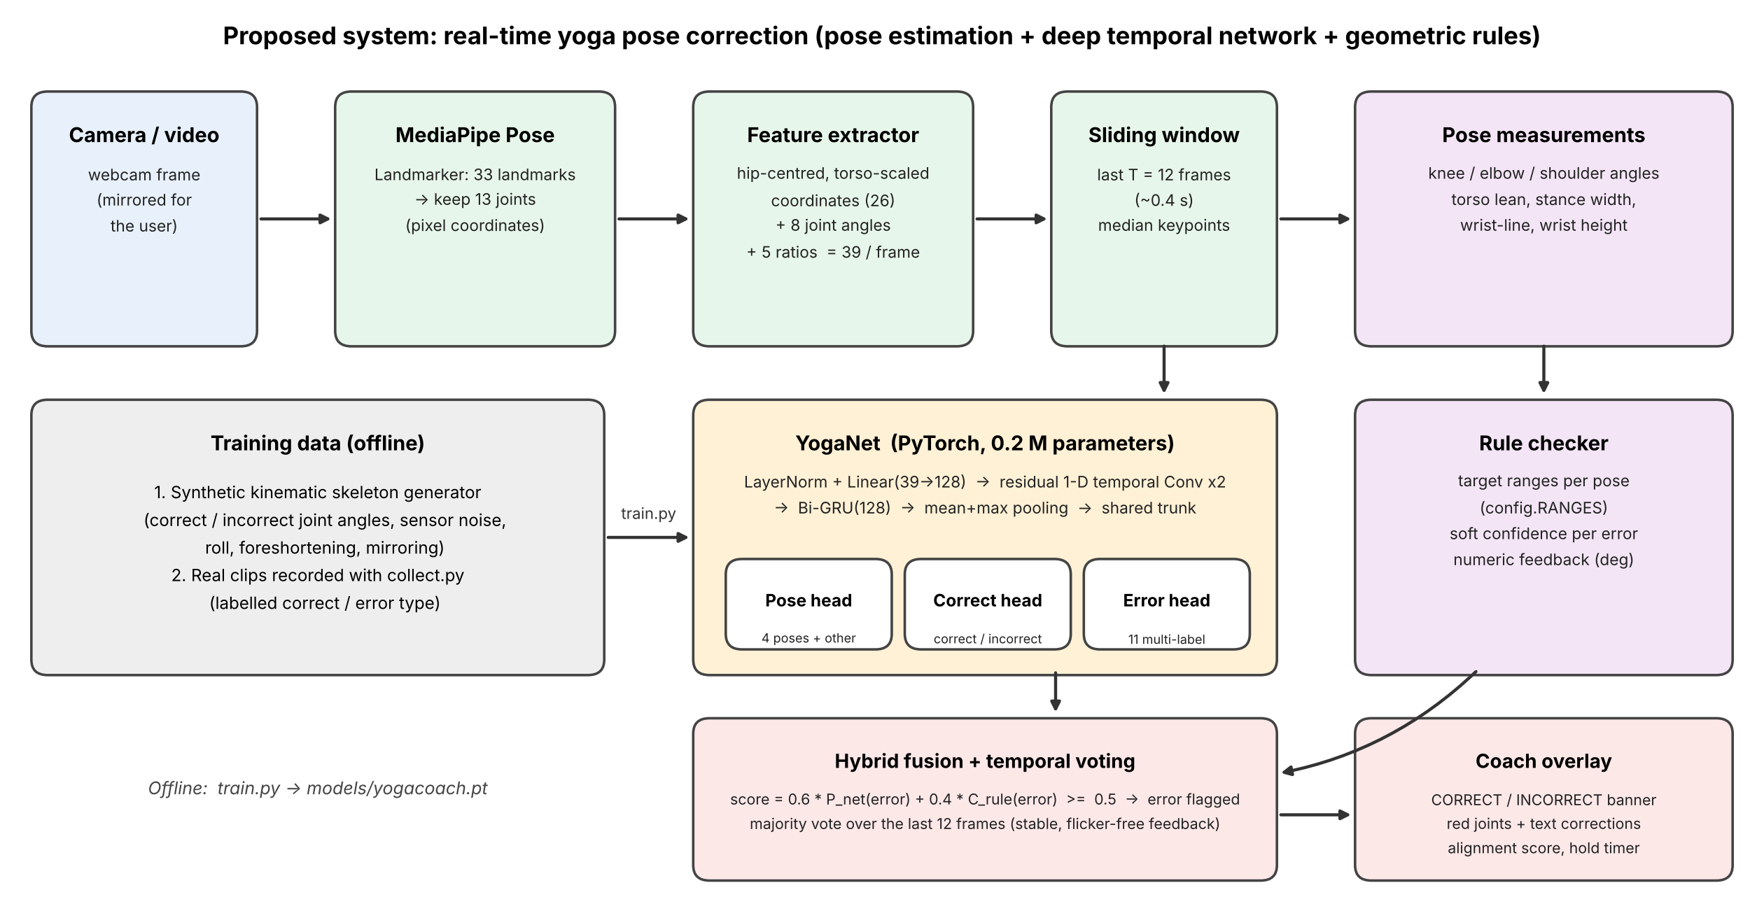
Figure 1. Proposed real-time pipeline (top) and offline training (left).
A webcam frame is passed to the MediaPipe Pose Landmarker (BlazePose), which returns 33 body landmarks; we keep 13 joints (nose, shoulders, elbows, wrists, hips, knees, ankles) in pixel coordinates so angles are not distorted by the image aspect ratio. Each frame becomes a 39-dimensional, scale- and translation-invariant feature vector. The last 12 frames feed YogaNet, a small temporal multi-task network, while a rule checker measures the same joint angles on the window's median pose. Their outputs are fused and temporally voted to give stable feedback that is drawn on the video.

4.1 Component description
Stage | Module | Role
Perception | MediaPipe Pose Landmarker (BlazePose full) | 33 landmarks per frame; 13 joints kept; visibility gating
Representation | geometry.py | Hip-centred, torso-scaled coordinates + 8 joint angles + 5 posture ratios = 39 features
Temporal learner | YogaNet (model.py) | Residual temporal convolutions + bidirectional GRU; multi-task heads
Explainable verifier | rules.py | Per-pose target ranges, soft rule confidences, worded corrections
Decision | engine.py | Hybrid fusion, EMA smoothing, majority vote, wrong-pose detection, hold timer
Presentation | draw.py, realtime.py | Skeleton overlay, banner, corrections, alignment score
Validation | check_image.py, analyze.py | Offline photo checker with annotated joint angles and per-angle target table

4.2 YogaNet parameter budget
Block | Parameters
Input projection (LayerNorm + Linear 39->128) | 5,198
Two residual Conv1d blocks (k = 3) | 98,560
Bidirectional GRU (64 x 2) | 74,496
Shared trunk | 32,896
Pose head (5) + correctness head (1) + error head (11) | 19,345
Layer normalisation | 256
Total | 230,751

Measured on a CPU-only workstation, the complete decision engine (feature extraction, YogaNet, rule checker, fusion, voting) takes about 4.4 ms per frame (rules only: about 1.4 ms), so the pose estimator, not the decision logic, is the bottleneck of the pipeline.

5. Algorithmic steps
- Capture a frame (mirrored webcam view) and run the MediaPipe Pose Landmarker; convert the 13 selected landmarks to pixel coordinates. If the mean landmark visibility is below 0.5 the frame is rejected and the user is asked to step back.
- Normalise: translate to the hip centre and divide by the torso length (shoulder-mid to hip-mid). Compute 8 joint angles (both knees, elbows, shoulders, hips) and 5 ratios (torso lean, stance width, wrist height above nose, wrist height above elbow, wrist-line angle). Result: 39 features per frame.
- Append the frame to a sliding window of T = 12 frames (about 0.4 s). Wait until the window is full.
- YogaNet forward pass: LayerNorm + Linear(39->128) -> two residual 1-D temporal convolutions -> bidirectional GRU -> mean and max pooling -> shared trunk -> three heads: pose class (4 poses + 'other'), correct/incorrect, and 11 multi-label error types (conditioned on the pose probabilities).
- Geometry: measure the angles on the window's median keypoints and compare them with the per-pose target ranges. Each error gets a soft rule confidence (0.5 exactly at the threshold).
- Fuse: score = 0.6 x P_network(error) + 0.4 x C_rule(error); an error is flagged if score >= 0.5 and it is meaningful for the pose. Smooth the scores with an exponential moving average (alpha = 0.45) and take a majority vote over the last 12 frames, so a single noisy frame can never flip the verdict.
- Choose the pose to judge: the user-selected target, or (auto mode) the pose with the highest smoothed probability above 0.55. If the target pose is very unlikely for 10 consecutive frames, report 'this does not look like <pose>'.
- Render feedback: skeleton with offending joints in red, CORRECT/INCORRECT banner, up to four plain-language corrections with the measured angle and the target, a 0-100 alignment score and a hold timer.

5.1 Mathematical formulation
- Joint angle. For joint B with neighbours A and C: theta = arccos( (BA . BC) / (|BA| |BC|) ), computed in pixel space so the image aspect ratio does not distort it.
- Normalisation. With hip centre h and torso length L = |mid(shoulders) - mid(hips)|, each keypoint becomes p' = (p - h) / L. Distances such as stance width are expressed in torso lengths, which removes dependence on camera distance and body size.
- Feature vector. f_t = [ p'_1..13 (26 values), 8 angles, 5 ratios ] in R^39; a window F = (f_(t-11), ..., f_t) in R^(12x39).
- Network. z = BiGRU( Conv_res( GELU( LN(F) W ) ) ); h = trunk([mean_t z, max_t z]); pose = softmax(W_p h); ok = sigmoid(W_c h); err = sigmoid(W_e [h, pose]).
- Multi-task loss. L = CE_ls(pose, y_pose; label smoothing 0.05) + 0.5 BCE(ok, y_ok) + sum_e m_e(y_pose) BCE(err_e, y_e) / sum m, where the mask m_e = 1 only if error e is applicable to the pose, so the network is never penalised for errors that cannot occur in that pose.
- Rule confidence. For a check with threshold tau and margin delta, the excess x = measured - tau (signed so that positive means violation) gives C = clip(0.5 + x / (4 delta), 0, 1), i.e. exactly 0.5 at the threshold and saturating two margin-widths either side of it (delta = 5 degrees or 0.08 torso lengths).
- Fusion. S_e = 0.6 P_net(e) + 0.4 C_rule(e); error e is flagged when the smoothed S_e >= 0.5 and majority-voted over the last 12 frames.
- Alignment score. score = 100 x (1 - mean_k s_k), where s_k in [0,1] is the severity of check k (how far its measured value lies outside its target range, scaled and clipped); it rises smoothly as the user approaches the ideal posture.

5.2 Design decisions
- Keypoints instead of pixels: the heavy visual work is done by a pre-trained estimator, so YogaNet can stay below 0.25 M parameters and train in minutes on a CPU.
- Bidirectional GRU over a short window: the window is only 0.4 s long, so non-causal context costs no perceptible latency but removes single-frame jitter.
- Pose-conditioned error head: the pose probabilities are fed to the error head and the loss is masked, so contradictory advice such as asking for a straight knee in Goddess pose cannot arise.
- Role-based measurements: the bent leg / straight leg / higher arm are identified by geometry rather than by left/right labels, making feedback identical for mirrored performances.
- Hybrid verification: the rule checker supplies exact angles for the feedback text and acts as an independent safety net against network errors on unusual bodies.

6. Dataset used
No public dataset labels yoga mistakes, so training data comes from two sources:
- Synthetic kinematic data (bootstrap). A forward-kinematics skeleton generates keypoint sequences for each pose. Joint angles are sampled either inside the target ranges (correct) or outside them (specific errors, one or several at once). Samples that lie within a safety margin (5 degrees or 0.08 torso lengths) of any threshold are rejected so labels are unambiguous. Camera roll, foreshortening, left/right mirroring, per-frame jitter and random scale/position are added. A fifth class 'other' (standing, arms raised, hands on hips, random arms) teaches the network to say 'no target pose'.
- Real photographs of the four poses. Photographs of correctly performed Tree, Warrior II, Triangle and Goddess poses (about 60 per pose, plus the same photographs with body points drawn, which are not used for training) were sorted per pose (scripts/prepare_photos.py) and converted by MediaPipe into keypoints (scripts/extract_dataset.py): each photo becomes one 12-frame still clip, labelled 'correct' for its pose. train.py mixes these clips with the synthetic data (mirror augmentation, 5x over-sampling) and holds out 15% of the clips for validation and 15% for testing.
- Recording tool. collect.py records labelled keypoint clips from a webcam or video file (including deliberate mistakes), so further real data can be added at any time.
Synthetic sizes used for the reported run: 5000 + 2500 training sequences per pose (two noise levels), 600 validation and 800 test sequences per pose, 5 classes, window length 12.
Real photographs used in this run: 223 clips (about 55 per pose) giving 446 windows after mirror augmentation; 314 windows were used for training (over-sampled 5 times), the rest were split by clip into validation and held-out test sets so that no photo contributes to both training and testing.
Composition of the synthetic training pool (per 1,000 sequences of each pose, before noise augmentation):
Pose | Correct | Incorrect | Errors injected (counts)
Tree | 39% | 61% | straight_knee_bent 253, bent_knee_shallow 236, arms_low 225, elbows_bent 194, torso_lean 251
Warrior II | 26% | 74% | straight_knee_bent 219, bent_knee_shallow 379, arms_not_level 611, elbows_bent 246, torso_lean 317, stance_narrow 229
Triangle | 50% | 50% | straight_knee_bent 143, stance_narrow 209, lean_insufficient 158, arms_not_stacked 183, elbows_bent 196
Goddess | 41% | 59% | bent_knee_shallow 434, knees_uneven 110, stance_narrow 257, arms_not_level 374, elbow_angle_wrong 211, torso_lean 193
Other | - | - | standing, arms raised, hands on hips, random arms (negative class)

Poses, errors the system can detect, and the target ranges that define 'correct' (all configurable in yogacoach/config.py):
Pose | Detectable errors | 'Correct' ranges (degrees unless noted)
Tree Pose (Vrikshasana) | straight_knee_bent, bent_knee_shallow, arms_low, elbows_bent, torso_lean | standing knee >= 165; lifted knee <= 100; wrists above nose; elbows >= 150; torso lean <= 10
Warrior II (Virabhadrasana II) | straight_knee_bent, bent_knee_shallow, arms_not_level, elbows_bent, torso_lean, stance_narrow | front knee 85-125; back knee >= 165; shoulder angle 75-105 (arms level); elbows >= 160; lean <= 10; stance >= 1.7 torso lengths
Triangle Pose (Trikonasana) | straight_knee_bent, stance_narrow, lean_insufficient, arms_not_stacked, elbows_bent | both knees >= 160; torso lean 35-95; stance >= 1.6; wrist line within 22 of vertical; elbows >= 160
Goddess Pose (Utkata Konasana) | bent_knee_shallow, knees_uneven, stance_narrow, arms_not_level, elbow_angle_wrong, torso_lean | both knees <= 135; knee difference <= 22; stance >= 1.4; shoulder angle 70-110; elbow angle 70-110; lean <= 10

7. Tools used
- Python 3, PyTorch (YogaNet, training), NumPy, Matplotlib
- MediaPipe Pose Landmarker (BlazePose, Tasks API) for 2-D body landmarks
- OpenCV for video capture and the on-screen overlay; Pillow for EXIF-safe photo decoding
- A local web page (check_image.py, Python standard-library HTTP server) to validate the model on uploaded photos: annotated joint angles, verdict, corrections and an angle-versus-target table
- python-docx for this report; unit and integration tests (tests/test_pipeline.py, tests/test_image_check.py: 13 tests covering geometry, rules, model, engine, image analysis and the HTTP round trip)
- Git/GitHub for version control and submission
- Claude (Anthropic) as an AI coding/writing assistant - see section 14

8. Screenshot of the result
<REPLACE with real webcam screenshots: run python realtime.py --pose tree and press 's' in each pose; they are saved to outputs/screenshots/ and picked up automatically when this report is rebuilt.>
Until then, the figures below are rendered from SIMULATED skeleton input (no camera) through the same engine and overlay; they illustrate the feedback format only and are not experimental results.
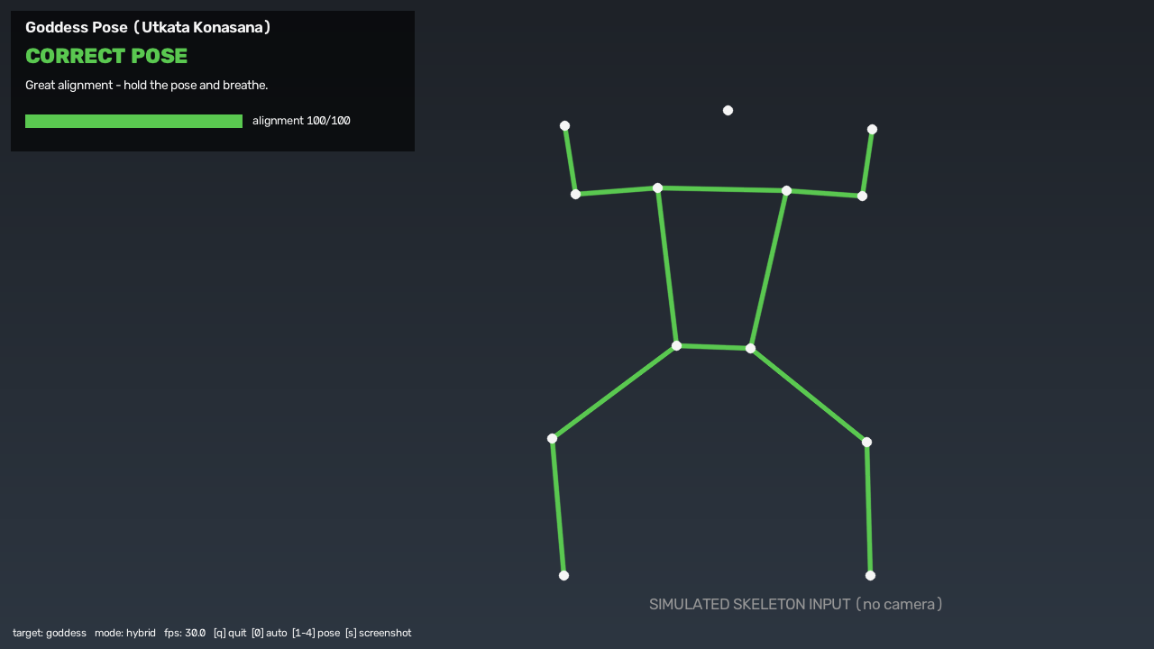
Figure 2. Simulated input: goddess correct.
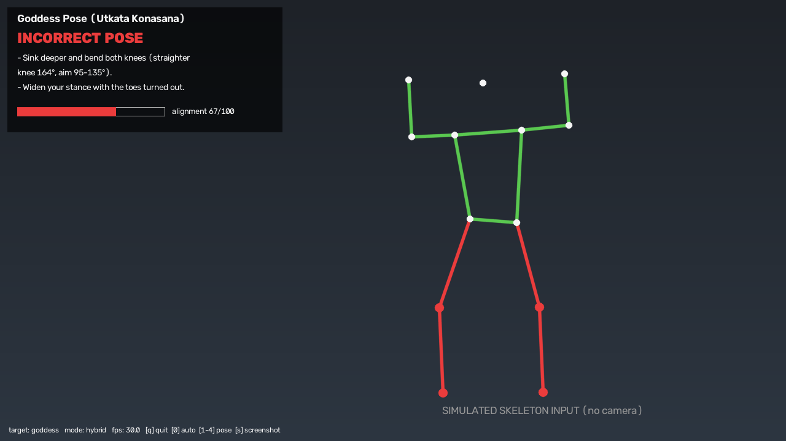
Figure 3. Simulated input: goddess incorrect.
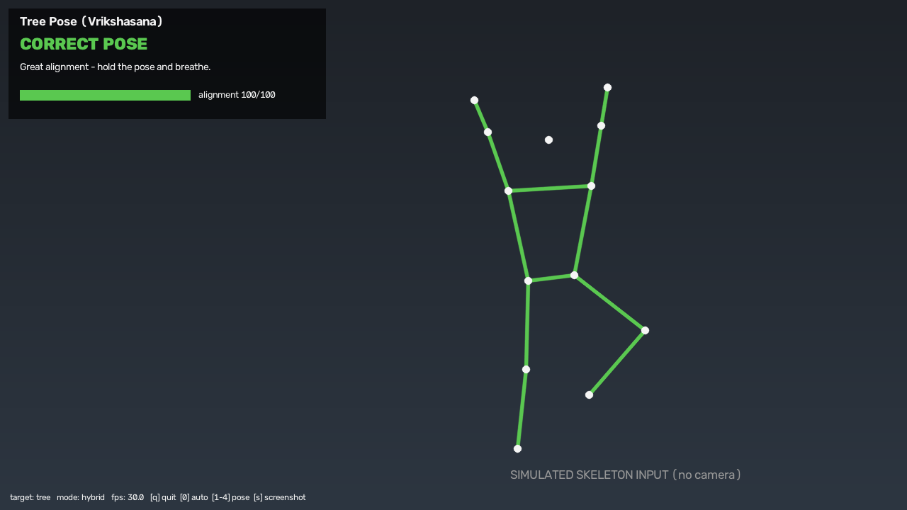
Figure 4. Simulated input: tree correct.
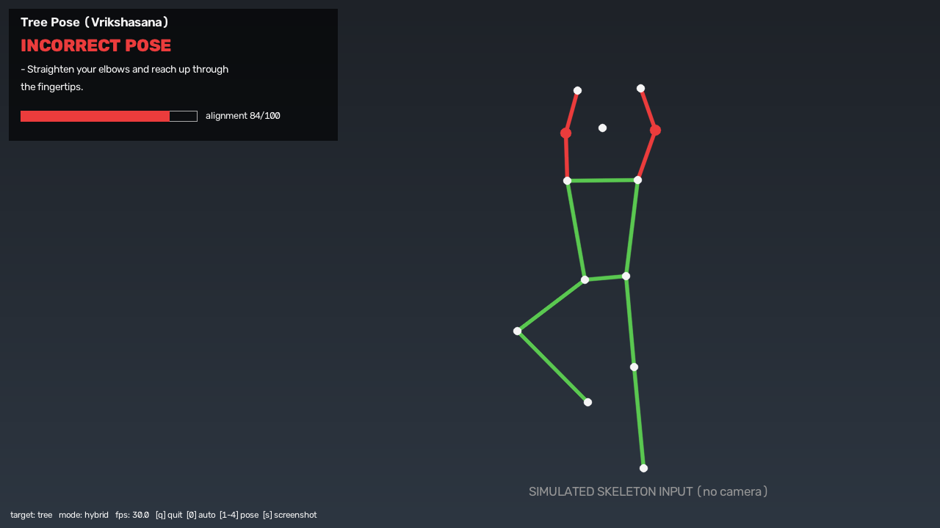
Figure 5. Simulated input: tree incorrect.
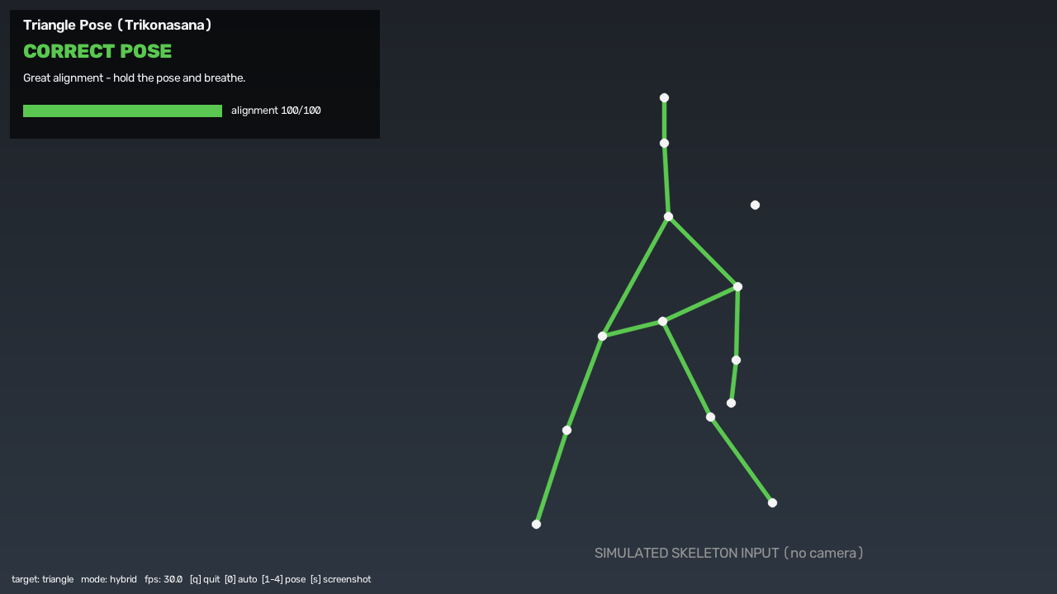
Figure 6. Simulated input: triangle correct.
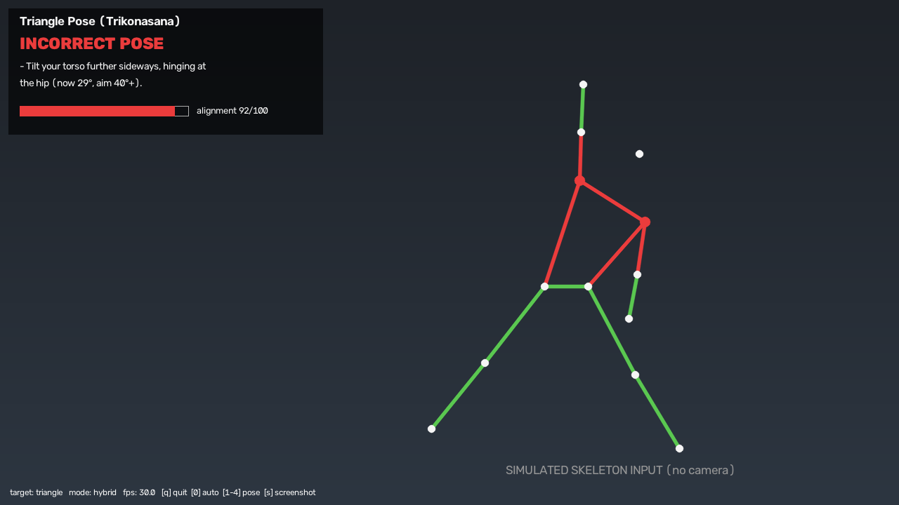
Figure 7. Simulated input: triangle incorrect.
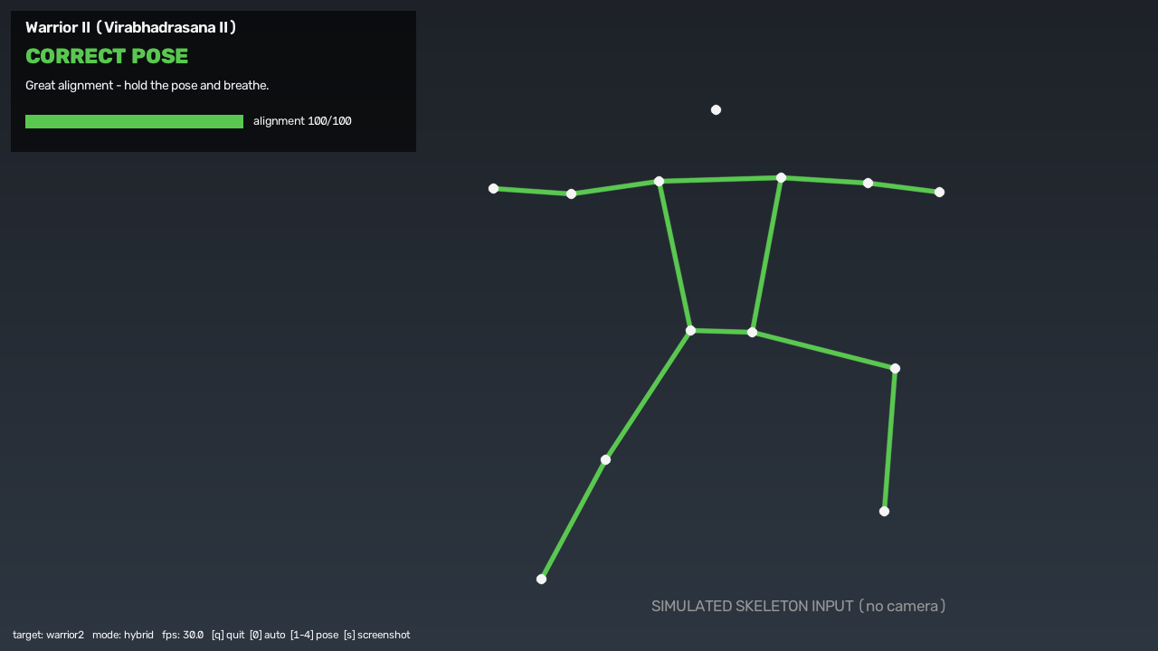
Figure 8. Simulated input: warrior2 correct.
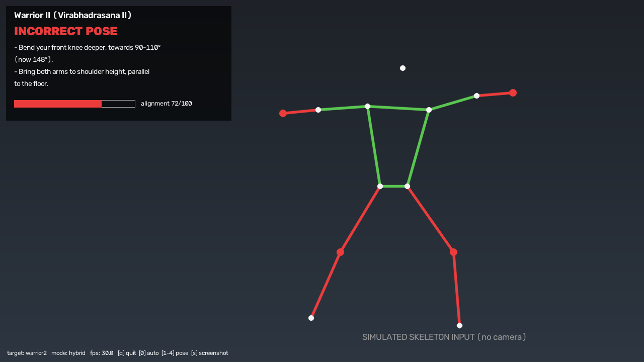
Figure 9. Simulated input: warrior2 incorrect.

9. Analysis and how it differs from existing approaches

9.1 Results
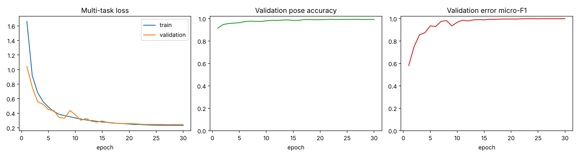
Training curves (multi-task loss, validation pose accuracy, validation error micro-F1).
Test set | N | Pose acc. | Error F1 hybrid | Error F1 YogaNet | Error F1 rules (1 frame) | Correct/incorrect acc. (hybrid)
synthetic_test (noise x1.4) | 4000 | 99.3% | 99.9% | 99.9% | 98.9% | 100.0%
synthetic_test_noisy (noise x3.0, unseen) | 4000 | 99.2% | 99.5% | 99.3% | 89.2% | 99.8%
real_test (held-out clips) | 66 | 100.0% | n/a | n/a | n/a | 98.5%

Held-out real photographs
The held-out real test set contains 66 windows from clips that were never used for training. It contains only correctly performed poses, so it measures pose recognition and the acceptance of correct poses; it contains no incorrect examples, so error F1 is not defined (n/a).
Method on held-out real photographs | Correct poses accepted
Pose recognition (4 poses) | 100.0%
YogaNet alone | 98.5%
Hybrid (YogaNet + rules) | 98.5%
Geometric rules alone (single frame / window) | 54.5%

Pose recognition transfers to real photographs without loss. The rule checker alone accepts only about half of the real correct photographs, because real practitioners deviate from the idealised target ranges (for example slightly bent elbows in Tree pose, visible in the before/after photo results of section 9.3); the network trained on real photographs accepts almost all of them. This is the benefit of learning from real data, and also the reason the hybrid score must be validated with incorrect examples, which we address in the limitations.
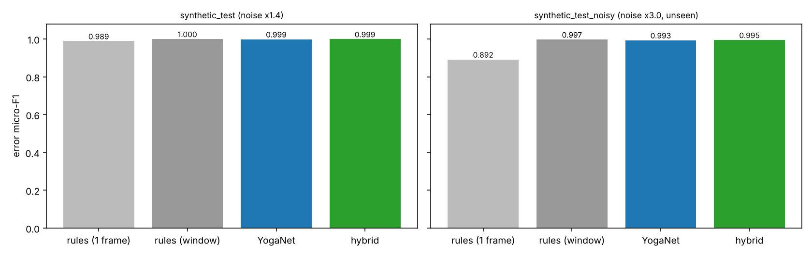
Error micro-F1 of single-frame rules, window rules, YogaNet alone and the hybrid.
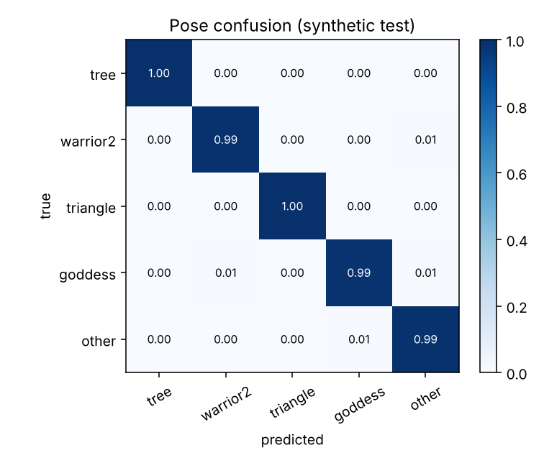
Pose confusion matrix on the synthetic test set.
Error type | Precision | Recall | F1 | Support
straight_knee_bent | 1.000 | 1.000 | 1.000 | 449
bent_knee_shallow | 0.999 | 0.999 | 0.999 | 855
arms_low | 1.000 | 0.995 | 0.997 | 190
arms_not_level | 0.999 | 0.997 | 0.998 | 788
elbows_bent | 1.000 | 1.000 | 1.000 | 530
torso_lean | 1.000 | 1.000 | 1.000 | 629
stance_narrow | 0.998 | 1.000 | 0.999 | 548
lean_insufficient | 1.000 | 1.000 | 1.000 | 129
arms_not_stacked | 1.000 | 1.000 | 1.000 | 162
knees_uneven | 1.000 | 1.000 | 1.000 | 82
elbow_angle_wrong | 1.000 | 1.000 | 1.000 | 192

9.2 How to read the synthetic numbers (limitations)
- The 'synthetic' rows measure how well the models recover labels on generated skeletons with sensor noise; they are not accuracy on real people. Real-world accuracy must be measured on held-out real clips.
- Synthetic labels are defined by the same target ranges used by the rule checker, so the rule baseline is not an independent judge here; the comparison shows robustness to noise and temporal jitter, not which ranges are 'right'.
- The held-out real set contains only correct poses, so it measures pose recognition and acceptance of correct poses but not the detection of mistakes on real people; collecting real incorrect examples is the main remaining step.
- The real photographs are static images (each becomes one repeated 12-frame clip), so temporal behaviour on real video is validated only through the live demo, not through a labelled test set.
- The system uses 2-D keypoints from a single camera and assumes a front view for the four chosen poses; depth-dependent mistakes (for example knee over toes seen from the side) are out of scope.
- Target ranges come from common alignment cues, not a certified instructor; they are easy to edit in config.py.

9.3 Real-photo evaluation
A set of real photographs of the target poses was passed through the full pipeline (MediaPipe landmarks, YogaNet, rule checker, fusion) twice: before the real photographs were added to the training data (synthetic-only model) and after retraining with them (real photographs mixed into the synthetic data: one 12-frame still clip per photo, mirror augmentation, 5x over-sampling). The table shows how many of the 40 photos in the evaluation folder were judged CORRECT when each pose was selected as the target.
Target pose selected | Judged correct: before | Judged correct: after | Mean alignment before | Mean alignment after
Tree (target pose) | 15/40 (37.5%) | 40/40 (100.0%) | 83 | 83
Warrior II | 0/40 (0.0%) | 40/40 (100.0%) | 56 | 56
Triangle | 0/40 (0.0%) | 40/40 (100.0%) | 8 | 8
Goddess | 0/40 (0.0%) | 40/40 (100.0%) | 27 | 27

Reading the result honestly: for the Tree target the share of photos accepted rose from 37.5% to 100%, and the feedback that disappeared was almost entirely the elbow-straightness warning, consistent with the model having adapted to how real practitioners hold the pose. The same 40 photographs are, however, also accepted for Warrior II, Triangle and Goddess after retraining although the geometric alignment score for those targets stays low (Triangle: 8/100). A selector that accepts every photo under every target cannot discriminate, so this is reported as an acceptance rate (recall on correct photographs), not as accuracy. Measuring accuracy requires both correct and incorrect examples.

9.4 Discussion
- The temporal network and the rule checker fail in different ways: single-frame rules are brittle under keypoint jitter (error F1 0.892 on the noisy test set), while the network is robust to it (0.993). The hybrid reaches 0.995, above both. Rules applied to the median of the 12-frame window (0.997) are as good, which is expected because the synthetic labels are defined by the same ranges; this is why the synthetic comparison shows robustness to noise rather than which method is 'right'.
- Masking the error loss by pose applicability keeps the 11-way error head well calibrated: errors that are impossible for a pose are never trained as negatives, and the head is conditioned on the pose posterior.
- Because every complaint is generated from a measured angle and a target range, the feedback is auditable: a user or instructor can see the number that triggered it and adjust the range in config.py.
- Inference cost is dominated by the pose estimator; the decision stack adds only a few milliseconds per frame on a CPU, so the system runs in real time on a laptop.
- The offline image checker allows the same pipeline to be verified on still photographs with a visible per-angle breakdown, which makes failure cases (side-on body, cropped limbs, tiny figure) easy to diagnose.

9.5 Difference from existing approaches
Aspect | Typical yoga classifiers | Frame-wise angle-rule tutors | This work
Output | pose name only | pass/fail per rule | pose + correct/incorrect + specific, worded corrections
Temporal context | single image | single frame | 12-frame window, EMA and majority vote
Handles mistakes | no | yes (hand-tuned) | learned multi-label error head + rules
Left/right independent | n/a | usually not | yes: roles such as bent leg / straight leg, mirror augmentation
Training data for mistakes | none available | none (no learning) | kinematic generator + user-recorded clips
Speed | CNN on pixels | real-time | real-time (pose estimator + 0.2 M-parameter net on keypoints)

10. Submit code link
GitHub: <fill in>
The repository contains the code, a README with setup and run instructions, the trained checkpoint and this report.

11. Novel contribution
- Correction, not just classification: a three-headed temporal network (pose, correct/incorrect, 11 multi-label error types conditioned on the pose) trained on keypoint windows.
- Hybrid decision: learned error probabilities are fused with geometry-based soft confidences, so feedback is both learned (robust to noise) and explainable (it quotes measured angles and targets).
- Labelled-mistake data without manual annotation: a margin-controlled kinematic generator that produces unambiguous correct and incorrect examples, plus a recording tool to add real clips.
- Side-invariant feedback: measurements and messages use roles (bent leg, straight leg, higher arm) instead of left/right, and training uses mirror augmentation.
- Stable real-time feedback: windowing, EMA smoothing, majority voting, visibility gating and wrong-pose detection.
- Pose-conditioned, masked multi-task learning: the loss only penalises errors that are defined for the pose, and the error head sees the pose posterior.
- Soft rule confidences: geometry outputs graded confidences (0.5 at the threshold) instead of hard pass/fail so they can be fused probabilistically with the network.
- Built-in validation tooling: a photo checker and a recording tool close the loop between model, data and real people.

12. Individual contribution
The work was divided into three packages of comparable size. Every member understands the whole pipeline and reviewed the other packages.
Team member | Contribution
Viranyu Srinivasan | Work package A - Perception, features and rules. MediaPipe Pose Landmarker integration (13 joints in pixel space, visibility gating); the 39-dimensional scale/translation-invariant feature design (joint angles, ratios); target angle ranges for the four poses and eleven errors; the rule checker with soft confidences and the plain-language feedback texts (config.py, geometry.py, rules.py, pose_backend.py).
Jeffrey Jayapackiyaraj | Work package B - Data and learning. Kinematic synthetic data generator with ambiguity margins and sensor effects; YogaNet architecture (residual temporal convolutions, bidirectional GRU, three heads) and the masked multi-task loss; training/evaluation pipeline with baselines and plots; preparation of the real photographs and retraining (synth.py, model.py, train.py, dataio.py, collect.py, extract_dataset.py, prepare_photos.py).
Aditya Agrawal | Work package C - Real-time system, validation and documentation. Live engine (sliding window, hybrid fusion, smoothing, voting, wrong-pose check), overlay and webcam application, image-upload checker and cross-pose photo evaluation, unit/integration tests, architecture diagram, README and this report (engine.py, draw.py, realtime.py, check_image.py, analyze.py, photo_eval.py, tests/, build_report.py).

13. Learning outcome
- Using a pre-trained pose estimator as a front end and designing scale-invariant features from keypoints.
- Designing and training a multi-task temporal network (conv + GRU, shared trunk, softmax and sigmoid heads) with masked losses.
- Dealing with missing labelled data: synthetic data generation, label-ambiguity margins, domain randomisation, mixing real and synthetic data.
- Evaluating honestly: separating synthetic from real test sets, noise-robustness tests, per-class F1 and ablations against rule-only baselines.
- Engineering a real-time system: latency, temporal smoothing, failure handling (no person, partial visibility).

14. AI tool usage
Claude (Anthropic) was used as an AI assistant to draft the project code (feature extraction, synthetic data generator, YogaNet, training, real-time application, tests), the architecture diagram and the first draft of this report. The team specified the problem, reviewed and ran the code, and is responsible for all content. The AI could not use a webcam or download the MediaPipe model in its workspace, so the live-camera path must be and was verified by the team on their own machine; results marked as synthetic come from generated data. <Team: edit this paragraph to describe exactly what you reviewed, changed and tested yourselves.>

References
- Bazarevsky, V., Grishchenko, I., et al. BlazePose: On-device Real-time Body Pose Tracking. arXiv:2006.10204, 2020.
- Verma, M., Kumawat, S., Nakashima, Y., Raman, S. Yoga-82: A New Dataset for Fine-grained Classification of Human Poses. CVPR Workshops, 2020.
- Cao, Z., Hidalgo, G., Simon, T., Wei, S.-E., Sheikh, Y. OpenPose: Realtime Multi-Person 2D Pose Estimation using Part Affinity Fields. IEEE TPAMI, 2019 (arXiv:1812.08008).
- Garg, S., et al. Yoga pose classification: a CNN and MediaPipe inspired deep learning approach for real-world application, 2022.
- MediaPipe Pose Landmarker documentation, Google AI Edge.

