**INTERNSHIP COMPLETION LETTER**

**Date**

Vnurture Technologies

501/502 Span Trade Center

Opp Kochrab Ashram

Paldi Ahmedabad 380007

This is to certify that **Name** , has successfully completed internship in the field of

**Subject** from **15 Days Summer Internship(20-6-2022 to 9-7-2022)**.

We also offer career counseling and placement guidance.

Congratulations and Best Wishes,

Team Vnurture Technologies,

Ms. Jinal Modi

7043122287

[help.vnurture@gmail.com](mailto:help.vnurture@gmail.com)

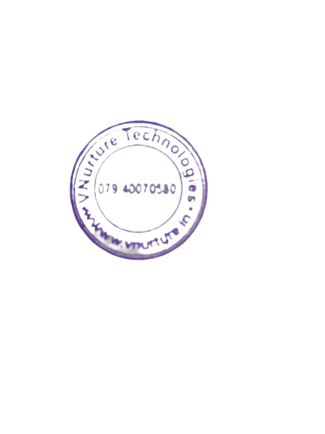



About Vnurture Technologies:

Established in 2015, Vnurture is primarily focused on Software Development and IT Industry Readiness programs. Our focus areas include Artificial Intelligence, Machine Learning/ Deep Learning, Data Analytics with Python/R/SPSS/KNIME, IoT, Mobile (Flutter, Android, IOS) and Web technologies, React JS,

Node JS, Full stack, MERNstack, MEAN Stack and visualization tools like Power BI, and advanced Excel. Our clients are from diverse sectors including Finance/Banking, Supply chain, Govt, Healthcare, E-Commerce, Hospitality, Industrial automation, Media, and Entertainment sectors.