# Economics

**Industrial Economics and International Trade (HUT 300)**

**Module – 1**

**(Basic Concepts and Demand and Supply Analysis)**

Economics originated from the Greek word ‘IOKONOMIA’ which means Household Management. It is Adam Smith who is considered as Father of Economics > 1776 > ‘Wealth of Nations’. Economics studies how the society and individuals use the limited resources to satisfy the unlimited wants.

# Scarcity and Choice

Scarcity means that resources are not available in the required quantity to satisfy all the wants and needs. Since we face Scarcity, people have to make choice between goods and services. In 1932, Lionnel Robinson (‘Nature and significance of Economics’) defined economics as a “science which studies the human behaviour in relationship with given ends and scarce means”

# Economic Problems of an economy

An economy is a system in which people earn their living by performing different economic activities like production, consumption and investment. Economic problems are reflected in the form of Central or Basic Problems of an economy. According to Samuelson, there are three fundamental and interdependent problems in an economic organisation—what, how and for whom—which are grouped under allocation of resources.

# ​Allocation of Resources

* 1. **​What Goods to Produce and How Much to Produce?**

Due to limited resources, every economy has to decide what goods to produce and in what quantities. An economy has to make a choice of the wants which are important for the economy as a whole. For example, if the economy decides to produce more cloth, it is bound to reduce the production of food. The reason is that resources used to produce food and cloth are limited and given. An economy cannot produce more of both food and cloth. Thus, an economy has to decide what goods it would produce on the basis of availability of technology, cost of production, cost of supplying and demand for the commodity.

# ​How to Produce?

A technique of production which would maximise output or minimise cost should be used. We generally consider two types of techniques of production: labour-intensive and capital-intensive

techniques. In labour-intensive technique, more labour and less capital is used. In capital- intensive technique, more capital and less labour is used. Hence, producers must always produce efficiently by using the most efficient technology. Thus, every economy has to choose the most efficient technique of producing a commodity.

# c) For Whom to Produce?

This is the question of how to distribute the product among the various sections of the society. Thus, guiding principle of this problem is output of the economy be distributed among different sections of the society in such a way that all of them get a minimum level of consumption.

# ​Full Utilisation of Resources

It emphasis the fuller and optimal utilization of resources.

# ​Economic Efficiency

The aim of an economy, which wants to be economically efficient.

# ​Economic Growth

With discovery of new stock of resources or an advancement in technology, the productive capacity of an economy increases.

# Production Possibility Curve

Production possibility curve or frontier (PPF) shows the various alternative combinations of goods and services that an economy can produce when the resources are all fully and efficiently employed. PPC shows the obtainable options. There is a maximum limit to the amount of goods and services which an economy can produce with the given resources and the state of technology. The resources can be used to produce various alternative goods which are called production possibilities and the curve showing the different production possibilities is called production possibility curve.

Production Possibility Schedule and Curve PP schedule refers to tabular presentation of different possible combinations of two goods that an economy can produce with given resources and available technology.

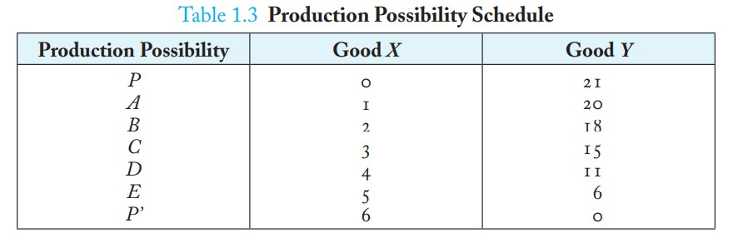

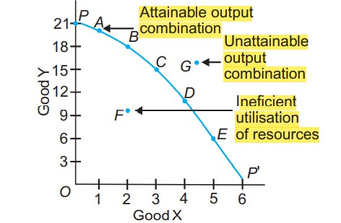

The economy can either produce OP of good Y or OP' of good X or any other combination shown by points A, B, C, D or E. All points on the curve are attainable. The problem is that of choice, i.e., to choose among the attainable points on the curve. It depends upon tastes and preferences of an individual. This is the basic problem of an economy. Any point inside the curve, such as point F, indicates unemployment of resources or inefficient use of resources. Any point outside the curve, such as point G, is unattainable given the scarcity of resources. An economy always produces on a PPC.

# Features of Production Possibility Curve

PPC slopes downward. A production possibility curve slopes downward from left to right because under the condition of full employment of resources, production of one good can be increased only after sacrificing production of some quantity of the other good. It is so because resources are scarce.

PPC is concave to the origin. A production possibility curve is concave to the point of origin because of increasing marginal rate of transformation (MRT) or increasing marginal opportunity

cost (MOC). Slope of PPC is defined as the quantity of good Y given up in exchange for additional unit of good X.

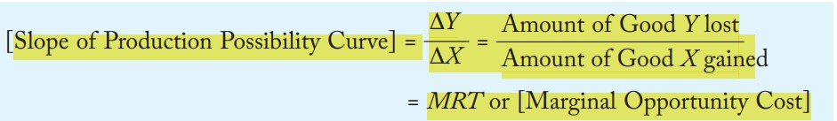

Marginal opportunity cost is opportunity cost of good X gained in terms of good Y given up. It is also called Marginal Rate of Transformation (MRT). Concave shape of PPC means that slope of PPC increase which implies that MRT increases. It means that for producing an additional unit of a good, sacrifice of units of other good (i.e. opportunity cost) goes on increasing.

# Shifts in Production Possibility Curve

With discovery of new stock of resources or an advancement in technology, the productive capacity of an economy increases. PPC will shift to the right when: (a) new stock of resources is discovered. (b) There is advancement in technology.

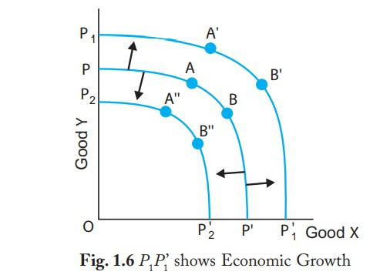

PPC will shift to the left when a) Resources are destroyed because of national calamity like earthquake, fire, war, etc. (b) There is use of outdated technology.

# The main objectives of firms are:

1. Profit maximisation
2. Sales maximisation
3. Increased market share/market dominance
4. Social/environmental concerns
5. Co-operatives

# Profit maximisation

Usually, in economics, we assume firms are concerned with maximising profit. Higher profit means:

* + Higher dividends for shareholders.
  + More profit can be used to finance research and development.
  + Higher profit makes the firm less vulnerable to takeover.
  + Higher profit enables higher salaries for workers

# Sales maximisation

* + Firms often seek to increase their market share – even if it means less profit. This could occur for various reasons:
  + Increased market share increases monopoly power and may enable the firm to put up prices and make more profit in the long run.
  + Managers prefer to work for bigger companies as it leads to greater prestige and higher salaries.
  + Increasing market share may force rivals out of business

# Growth maximisation

This is similar to sales maximisation and may involve mergers and takeovers. With this objective, the firm may be willing to make lower levels of profit in order to increase in size and gain more market share. More market share increases its monopoly power and ability to be a price setter.

# Long run profit maximisation

In some cases, firms may sacrifice profits in the short term to increase profits in the long run. For example, by investing heavily in new capacity, firms may make a loss in the short run but enable higher profits in the future.

# Social/environmental concerns

A firm may incur extra expense to choose products which don’t harm the environment or products not tested on animals. Alternatively, firms may be concerned about local community / charitable concerns. Some firms may adopt social/environmental concerns as part of their branding. This can ultimately help profitability as the brand becomes more attractive to consumers.

# Co-operatives

A co-operative is run to maximise the welfare of all stakeholders – especially workers. Any profit the co-operative makes will be shared amongst all members.

# Definition of firm and types

A firm is a for-profit business organization—such as a corporation, limited liability company (LLC), or partnership—that provides professional services. Most firms have just one location

There are 4 main types of business organization: sole proprietorship, partnership, corporation, and Limited Liability Company, or LLC.

# Sole Proprietorship

The simplest and most common form of business ownership, sole proprietorship is a business owned and run by someone for their own benefit. The business’ existence is entirely dependent on the owner’s decisions, so when the owner dies, so does the business.

Advantages of sole proprietorship:

* All profits are subject to the owner
* There is very little regulation for proprietorships
* Owners have total flexibility when running the business
* Very few requirements for starting—often only a business license Disadvantages:
* Owner is 100% liable for business debts
* Equity is limited to the owner’s personal resources
* Ownership of proprietorship is difficult to transfer
* No distinction between personal and business income

# Partnership

These come in two types: general and limited. In general partnerships, both owners invest their money, property, labor, etc. to the business and are both 100% liable for business debts. In other words, even if you invest a little into a general partnership, you are still potentially responsible

for all its debt. General partnerships do not require a formal agreement—partnerships can be verbal or even implied between the two business owners.

Advantages of partnerships:

* Shared resources provides more capital for the business
* Each partner shares the total profits of the company
* Similar flexibility and simple design of a proprietorship
* Inexpensive to establish a business partnership, formal or informal Disadvantages:
* Each partner is 100% responsible for debts and losses
* Selling the business is difficult—requires finding new partner
* Partnership ends when any partner decides to end it

# Corporation

Corporations are, for tax purposes, separate entities and are considered a legal person. This means, among other things, that the profits generated by a corporation are taxed as the “personal income” of the company. Then, any income distributed to the shareholders as dividends or profits are taxed again as the personal income of the owners.

Advantages of a corporation:

* Limits liability of the owner to debts or losses
* Profits and losses belong to the corporation
* Can be transferred to new owners fairly easily
* Personal assets cannot be seized to pay for business debts Disadvantages:
* Corporate operations are costly
* Establishing a corporation is costly
* Start a corporate business requires complex paperwork
* With some exceptions, corporate income is taxed twice

# Law of Diminishing Marginal Utility

Basic Concepts

# Utility

The term utility refers to the want satisfying power of a commodity. Utility is essentially a subjective concept depending upon the intensity of consumer’s desire or want for that commodity at that time. Thus, utility differs from person to person, place to place and time to time. Utility is a cardinal concept i.e., it can be measured. Benham formulated the unit of measurement of utility as utils.

# Total Utility (TU)

It is the sum of all the utilities that a consumer derives from the consumption of a certain amount of a commodity.

**TUn = MU1 + MU2 + + MUn**

# Marginal Utility (MU)

It is addition made to the total utility as consumption is increased by one more unit of the commodity. Mathematically, it is calculated as:

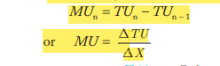

# Law of Diminishing Marginal Utility (DMU) / Theory of Consumer Behaviour

* Theory has been developed by Prof. Alfred Marshall

# Assumptions of the Theory

* Rationality
* Commodities should be homogenous and normal
* No time gap between the consumption of goods
* No change in taste and preferences
* No change in price of the commodity

# Statement of Theory

* As the consumer consumes more and more units of a same good, the additional utility (MU) from each additional units goes on decreasing.

# Relationship between TU and MU

|  |  |  |
| --- | --- | --- |
| **Units Consumed** | **TU** | **MU** |
| **0** | **0** | **0** |
| **1** | **10** | **10** |
| **2** | **18** | **8** |
| **3** | **24** | **6** |
| **4** | **27** | **3** |
| **5** | **29** | **2** |
| **6** | **29** | **0** |
| **7** | **27** | **-2** |

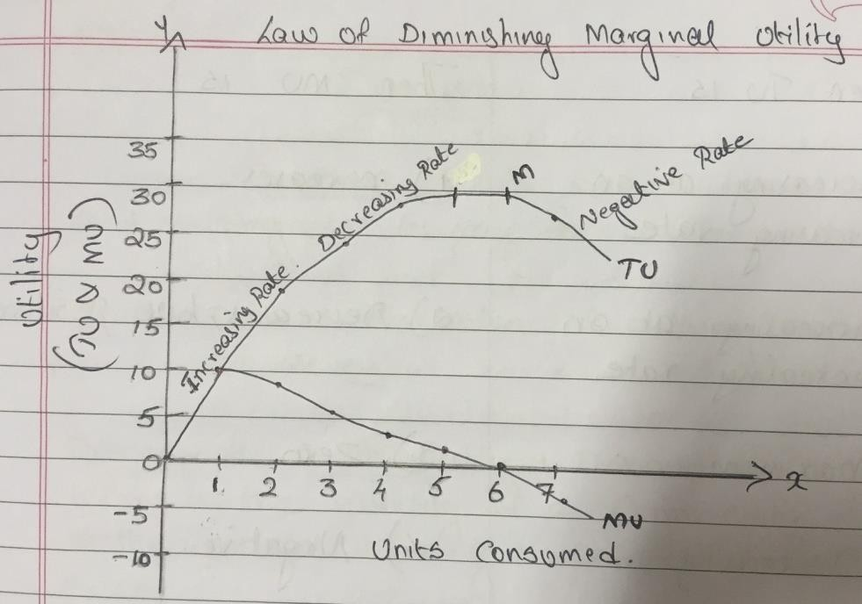

**Observations:**

1. As the consumer has more of the good, the TU increases less than in proportion and the MU gradually declines but is positive.
2. When TU is maximum, called saturation point, MU is zero.
3. When TU falls, MU becomes negative.

A stage comes when marginal utility becomes zero. At this point total utility becomes maximum. If the consumer consumes beyond this stage, marginal utility becomes negative and total utility falls. It means that consumer starts getting disutility i.e., dissatisfaction instead of getting satisfaction. Since, economists believe that a consumer is a rational being, he wants to maximize his satisfaction. A consumer would not like to go beyond zero marginal utility.

# STAGE 1

**Increasing Returns**

TU, MU increases at an increasing rate

# Stage 2

**Diminishing Returns**

MU starts falling

TU increases at a diminishing rate.

At the end of second stage, MU reaches zero and TU reaches at its maximum (Point M)

# Stage 3

**Negative Returns**

After point M, MU becomes negative. TU starts falling.

# Consumer’s Equilibrium

A consumer is said to be in equilibrium when he maximizes his satisfaction, given income and prices of the commodities.

# Case I

**One Commodity Case**

Let us suppose that a consumer has a given income with which he consumes only one commodity X.

Thus, a consumer is in equilibrium when he satisfies the following condition:

**i.e., MU of the good = Price of the product or MUX = PX**

# Case 2

**Two Commodities Case – Law of Equi-Marginal Utility**

Consumer’s equilibrium conditions in case of two goods X and Y can be written as:

C:\Users\user\Desktop\1.PNG

# Demand

* Demand is the desire backed by the ability and willingness to pay for a commodity.
* Quantity demanded refers to the particular quantity which buyers are willing and able to buy on a given price during a given period of time.
* Demand for a commodity is defined as the quantity of that commodity which a consumer is willing to buy at a particular price during a particular period of time.

# Factors affecting individual demand for a good

1. **Price of the Commodity**

There is inverse relationship between price of a commodity and demand for a commodity. In general, demand for a commodity is more at lower price and less at a higher price and vice versa. But this relationship does not exist in giffen goods and Veblen goods.

**Giffen Good**: Demand for Giffen goods rises when the price rises and falls when the price falls. The term "Giffen goods" was coined by Robert Giffen. The concept of Giffen goods focuses on a low income, non-luxury products that have very few close substitutes. Examples of Giffen goods can include bread, rice, and wheat

**Veblen Good:** A Veblen good is a good for which demand increases as the price increases, because of its exclusive nature and appeal as a status symbol. Examples of Veblen goods include designer jewelry, yachts, and luxury cars.The demand curve for a Veblen good is upward sloping.

1. **​Income of the Consumer**
   1. If x is a **normal good** then with an increase in income, consumer buys more of the good. Goods whose demand rises when income rises are called normal goods. Example: clothes, books, etc.
   2. If x is an **inferior good** then an increase in income causes its demand to decrease. This is because as income rises, purchasing power rises and consumers substitute more superior goods for inferior goods. Goods whose demand falls when income rises are called inferior goods. Example: Coarse cereals.
2. **​Prices of Other Goods**
3. When X and Z are Substitutes

Substitute goods are those which are an alternative to one another in consumption. Examples are: tea or coffee; wheat or rice. The demand for a good usually moves in the same direction to a change in price of its substitutes. Substitute goods are those goods in which rise in price of good lead to rise in demand of another good.

1. When X and Z are Complements

Complementary goods are those which are jointly used or consumed together to satisfy a want. Examples are: tea and sugar; car and petrol. Thus, demand for a good move in the opposite direction to a change is price of its complementary good. Complementary goods are those goods in which rise in price of good lead to fall in demand of another good.

1. **Consumer’s Tastes and Preferences**

Any change in consumer’s tastes causes demand to change. If there is a change in tastes in favour of a good, then it will lead to increase in demand and any unfavourable change will lead to decrease in demand.

1. **Future Expectations of Buyers**

Future expectation is also one of the factors which cause change in demand. If it is expected by the consumer that the price of the commodity will rise in future, he will start buying more units of the commodity in the present, at the existing price.

1. **Size of Population**

As the population increases the demand for commodity goes up and vice versa

**Demand function**

It shows the functional relationship between demand for a commodity and its determinants. It can be expressed as:

DX = f (PX, PZ,Y, T, E, N, Yd )

DX = Demand for commodity X PX = Price of commodity X

PZ = Prices of related goods Y = Income of consumer

T = Taste and preferences of consumer E = Future expectation

N = No. of consumers

Yd = Distribution of income

**Law of Demand**

The law of demand states that if remaining things are constant then as price of a commodity increases demand for the commodity decreases and as price of a commodity decreases demand for the commodity increases.

**DX = f (PX), ceteris paribus**

**DX = Quantity demanded of good X, PX = Price of the good X**

# The Demand Schedule and the Demand Curve

Demand Schedule It is a tabular presentation showing the different quantities of a good that buyers of the good are willing to buy at different prices during a given period of time.

Demand Curve The graphical representation of the demand function is called a demand curve.

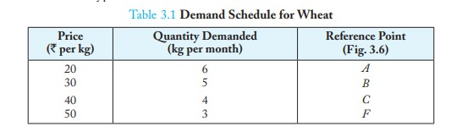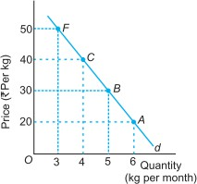

# Changes in Demand

2 types of changes in demand

1. Change in demand due to change in price – Expansion and Contraction of Demand – Movement along demand curve
2. Change in demand due to factors other than price – Increase and Decrease in demand – Shift in demand curve

# Movement: Change in Quantity Demanded

A movement along the demand curve is caused by a change in the price of the good, other things remaining constant. It is also called change in quantity demanded of the commodity. Movement is always along the same demand curve, i.e., no new demand curve is drawn. Movement along a demand curve can bring about:

(a) Expansion of demand, or (b) Contraction of demand

Extension of Demand or Contraction of Demand.

Expansion or Extension of demand refers to rise in demand due to fall in the price of the good. Contraction of demand refers to fall in demand due to rise in the price of the good.

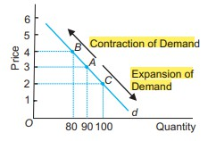

Point A on the demand curve d is the original situation. An upward movement from point A to a point such as point B shows contraction or lesser quantity demanded at a higher price. Downward movement from point A to a point such as point C shows expansion or more quantity demanded at a lower price.

# Shift: Change in Demand

A shift of the demand curve is caused by changes in factors other than price of the good. A change in factors causes shift of the demand curve. It is also called change in demand. In a shift, a new demand curve is drawn. A shift of the demand curve can bring about: (a) Increase in demand, or (b) Decrease in demand.

1. Increase in Demand: It refers to more demand at a given price. The causes of increase in demand are: (i) Increase in the income of the consumers in case of normal goods. (ii) Decrease in the income of the consumers in case of inferior goods. (iii) Increase in the price of substitute goods. (iv) Fall in the price of complementary goods. (v) Consumers’ taste becoming stronger in favour of the good.
2. Decrease in Demand: It refers to less demand at the given price. It occurs due to unfavourable changes in factors other than the price of the good.

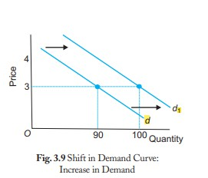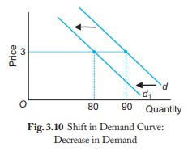

# Elasticity of Demand

* It refers to the degree of responsiveness change in qty demanded of a commodity due to change in price or any other factors.
* It was put forward by Alfred Marshall
* 3 Types of elasticity of demand
* Price Elasticity
* Income Elasticity
* Cross Elasticity

# Price elasticity of demand

It measures the responsiveness of demand of a good to a change in its price. Types of price elasticities of Demand

1. Perfectly elastic demand
2. Perfectly inelastic demand
3. Unit elastic demand / Unitary elastic demand
4. Elastic demand / More elastic demand
5. Inelastic demand / Less elastic demand

# Perfectly Elastic Demand (eD= ∞)

When the demand for a commodity rises or falls to any extent without any change in price, the demand for the commodity is said to be perfectly elastic. It is an ideal and imaginary situation.

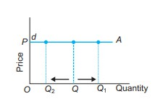

# Perfectly Inelastic demand

Perfectly inelastic demand (eD = 0) When the demand of a commodity does not change as a result of change in its price, the demand is said to be perfectly inelastic. The perfectly inelastic demand curve is a vertical line parallel to y-axis. As it is clear from the diagram, price may be OP or OP1 or OP2 , but the demand will be constant at OQ. In other words, there is no effect of changes in the price on the quantity demanded. It exists in case of essentials like life saving drugs.

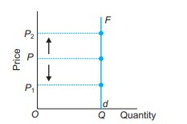

# Unit Elastic Demand (eD = 1)

When percentage change in demand is equal to the percentage change in price, the demand for the commodity is said to be unitary elastic. The unitary elastic demand curve shows that when price falls from OP to OP1 , demand rises from OQ to OQ1 . The change in demand (QQ1 ) is equal to the change in price (PP1 ). It exists in case of normal goods.

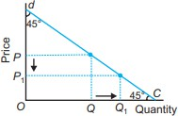

# Elastic (or more than unit elastic) Demand (1 < eD < ∞)

When a change in price leads to a more than proportionate change in demand, the demand is said to be elastic or more than unit elastic. The elastic demand curve shows that when price falls from OP to OP1 , demand rises from OQ to OQ1 . The change in demand (QQ1 ) is more than the change in price (PP1 ). It exists in case of luxuries.

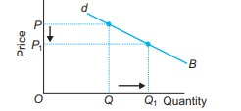

# Inelastic (or less than unit elastic) Demand (0 < eD < 1)

When a change in price leads to a less than proportionate change in the demand, the demand is said to be less elastic or inelastic. The inelastic demand curve shows that change in quantity demanded (QQ1 ) is less than change in price (PP1 ). It exists in case of necessities like food, fuel, etc.

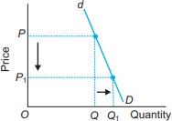

# Measurement of Price Elasticity of Demand by Percentage Method

Percentage method is also called proportionate method. The absolute value of the coefficient of elasticity of demand ranges from zero to infinity. According to this method, eD is calculated by the following formula

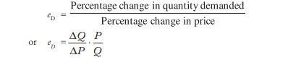

* + A consumer spends 40 on a good at a price of 1 per unit and 60 at a price of 2 per unit. What is the price elasticity of demand? What kind of good it is? What shape its demand curve will take? Ans: 0.25 (The good has an inelastic demand. It is a necessity like food, fuel etc. The demand curve for this good is steep.)
  + When the price of a commodity falls by 2 per unit, its quantity demanded increases by 10 units. Its price elasticity of demand is (–) 1. Calculate its quantity demanded at the price before change which was 10 per unit. Ans: 50 Units
  + The quantity demanded of a commodity falls by 5 units when its price rises by 1 per unit. Its price elasticity of demand is (–) 1.5. Calculate the price before change if at this price quantity demanded was 60 units. Ans 18 Rs
  + The market demand for a good at a price of 10 per unit is 100 units. When its price changes its market demand falls to 50 units. Find out the new price if the price elasticity of demand is (–)2. Ans: 12.50 rs
  + If the elasticity of demand for salt is zero and a household demands 2 kg. of salt in a month at 5 per kg, how much will it demand at 7.50 per kg? Ans: 2 Kg

# Supply

Supply refers to the quantities of a commodity which a seller offers for sale at a particular price in a given period of time. It refers to the desired qty of commodity that the seller offers for sale in the market. Supply of a commodity means quantity of the commodity which a firm is willing to sell at a given price during a particular time.

# Factors affecting supply of a commodity

1. **Price of the Commodity**

At a higher price, producer offers more quantity of the commodity for sale and at a lower price, less quantity of the commodity is offered for sale. There is a direct relationship between price and quantity supplied as shown by law of supply.

# ​Price of Related Good

Supply of a commodity depends upon the prices of its related goods, especially substitute goods. If the price of a commodity remains constant and the price of its substitute good Z increases, the producers would prefer to produce substitute good Z. As a result, the supply of commodity X will decrease and that of substitute good Z will increase. This will shift the supply curve of good X leftward. Thus, an increase in the price of substitute good will lead to decrease in supply curve of the other good and vice-versa.

# ​State of Technology

If there is a change in the technique of production leading to a fall in the cost of production, supply of commodity will increase.

# Prices of Inputs

An increase in input price or cost will shift the supply curve to the left (decrease in supply) and vice-versa.

# Government Policy

Government’s policy also affects the supply of a commodity. If heavy excise taxes are imposed on a commodity, it will discourage producers and as a result, its supply will decrease.

# Supply function

Supply function is a functional relationship between quantity supplied of a commodity and factors affecting it.

# SX = f (PX, PZ, T, C, GP)

where,

SX = Supply of commodity X f = function of

PX = Price of commodity X P = Price of related good, Z T = Technological changes

C = Cost of production or price of inputs GP = Government policy or excise tax rate.

# The law of supply

Law of supply derives the relationship between price and quantity supplied. According to the law of supply, other things remaining the same, quantity supplied of a commodity is directly related to the price of the commodity. In other words, other things remaining the same, when price of a commodity rises, its quantity supplied increases and when the price falls, quantity supplied also falls.

Symbolically, the law of supply is expressed as:

# SX = f (PX), ceteris paribus

**The Supply Schedule and the Supply Curve**

Supply schedule is a tabular statement that gives the law of supply, i.e., it gives the different quantity supplied of a commodity at different prices per unit of time.

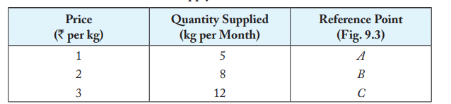

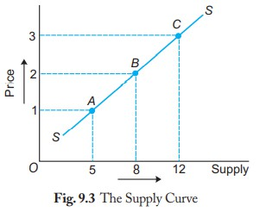

Supply curve shows graphically the relationship between quantities supplied of a commodity to its price. The curve shows positive or direct relationship between the price and quantity supplied of the commodity. With rise in price, the curve rises upward from left to the right.

# Changes in Supply

2 types of changes in Supply

* Change in supply due to change in price – Expansion and Contraction of supply – Movement along supply curve
* Change in supply due to factors other than price – Increase and Decrease in supply – Shift in supply curve

# Change in Quantity Supplied (Movement along the supply curve)

A movement along the supply curve is caused by changes in the price of the good, other things remaining constant. It is also called change in quantity supplied of the commodity. In a movement, no new supply curve is drawn. Movement along a supply curve can bring about:

* 1. ​Expansion or extension of supply, or
  2. Contraction of supply.

Expansion or extension of supply refers to rise in supply due to rise in price of the good. Contraction of supply refers to fall in supply due to fall in price of the good.

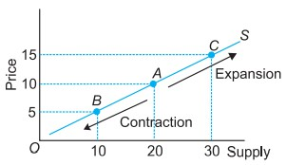

**Expansion and contraction of Supply**

Point A on the supply curve is the original situation. An upward movement from point A to a point such as C shows expansion or more supply at a higher price. A downward movement from point A to a point such as point B shows contraction or less supply at a lesser price.

# Change in Supply (Shift in supply curve)

A change (or shift) in supply curve is caused by changes in factors other than the price of the good. A change in many factors causes shift in the supply curve. It is also called change in supply. In a shift, a new supply curve is drawn.

A shift of the supply curve can bring about: (a) Increase in supply, or (b) Decrease in supply.

Increase in Supply (i.e., Rightward shift in supply curve) When supply of a commodity rises due to favourable changes in factors other than price of the commodity, it is called increase in supply. Increase in supply means more quantity supplied at the same price. It also means that same quantity supplied at a lower price.

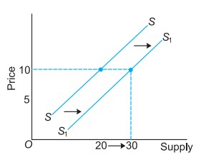

SS is the original supply curve. An increase in supply is shown by rightward shift of the supply curve from SS to S1 S1 .

Decrease in Supply

(i.e., leftward shift in supply curve) When supply of a commodity falls due to unfavourable changes in factors other than its price, it is called decrease in supply. Decrease in supply means less quantity is supplied at the same price. It also means that same quantity is supplied at a higher price.

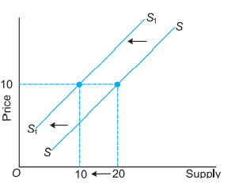

In the figure, SS is the original supply curve. A decrease in supply is shown by leftward shift of the supply curve from SS to S1 S1 .

# Elasticity of supply

Alfred Marshall developed the concept of elasticity of supply. Price elasticity of supply is defined as the responsiveness of quantity supplied of a commodity to changes in its own price.

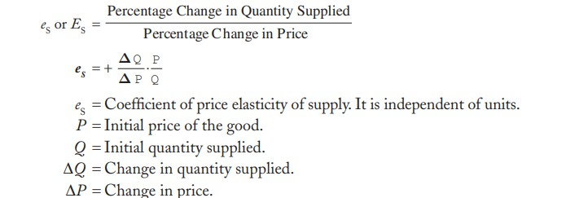

# Different types of elasticity of supply

1. Perfectly elastic supply
2. Perfectly inelastic supply
3. Unit elastic supply / Unitary elastic supply
4. Elastic supply / More elastic supply
5. Inelastic supply / Less elastic supply

# Perfectly Elastic Supply (eS = ∞).

Supply of a commodity is said to be perfectly elastic when its supply expands (rises) or contracts (falls) to any extent without any change in the price. The coefficient of eS = ∞ (infinity). The perfectly elastic supply curve is SA which is a horizontal line.

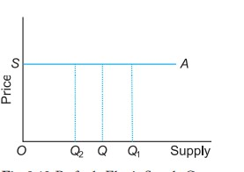

# Perfectly Inelastic Supply (eS = 0).

When supply of a commodity does not change irrespective of any change in its price, it is called perfectly inelastic supply. In this case, eS = 0. The supply curve, S3R, is a vertical line showing that quantity supplied is fixed at OS3 units irrespective of the price.

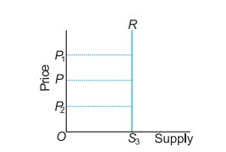

# Unitary Elastic Supply (eS = 1)

Supply of a commodity is said to be unitary elastic if percentage change in supply equals the percentage change in price. In this case, the coefficient of eS is equal to one. The unitary elastic supply curve is OC which is a straight positively sloping line from the origin.

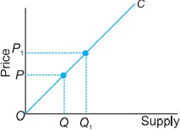

# Elastic Supply (1 < eS < ∞)

When percentage change in supply is more than the percentage change in price, supply is said to be elastic or more than unitary elastic. In this case, the value of the eS is more than one.

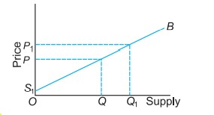

# Inelastic Supply (0 < eS < 1)

When percentage change in quantity supplied is less than percentage change in price, supply is said to be inelastic or less than unitary elastic.

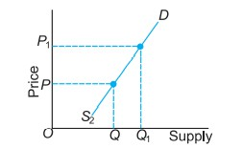

# Meaning of Equilibrium

The term equilibrium means the state in which there is no tendency on the part of consumers and producers to change. The two factors determining equilibrium price are demand and supply. Equilibrium Price Equilibrium price is the price at which the sellers of a good are willing to sell the same quantity which buyers of that good are willing to buy. Thus, equilibrium price is the price at which demand and supply are equal to each other.

Market Equilibrium

Equilibrium price is determined by the equality between demand and supply. At this price,

**Quantity demanded = Quantity supplied**

# Equilibrium between Demand and Supply

The forces of demand and supply determine the price of a commodity. Equilibrium price will be determined where quantity demanded is equal to quantity supplied. This is called market price. This price has a tendency to persist. If at a price the market demand is not equal to market supply there will be either excess demand or excess supply and the price will have tendency to change until it settles once again at a point where market demand equals market supply. A demand and supply schedule and curve will show the determination of equilibrium price.

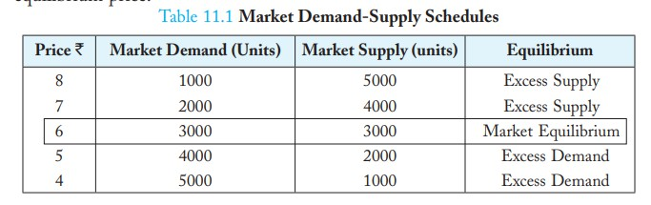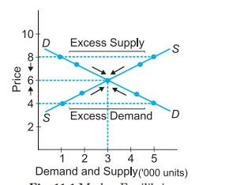

In Table 11.1, demand and supply of the commodity at different prices are shown. The equilibrium price is fixed at 6 where the quantity demanded and the quantity supplied are equal, i.e., equal to 3000 units.

From the figure, quantity demanded and supplied is measured on the x-axis and price on the y- axis. DD is the downward sloping demand curve and SS is the upward sloping supply curve.

Both these curves intersect each other at point E which is the equilibrium point and it implies that at price of 6, demand is for 3000 units and supply is also of 3000 units. Thus, equilibrium price is 6. If price is 4, there will be an excess demand of 4000 units. There will be competition among buyers. It will push up the price. Rise in price will result in fall in market demand and rise in market supply. This reduces the excess demand. The changes continue till price settles at equilibrium level. If price is 7, there will be an excess supply of 2000 units. There will be competition among sellers. This will reduce the price. Fall in price will result in rise in demand and fall in supply. These changes continue till price settles at equilibrium price. Thus, market equilibrium is a situation of zero excess demand and zero excess supply.

# Effects of changes in demand and supply on equilibrium price

Increase in Demand

When demand of a commodity increases, while supply remains constant, equilibrium price will increase. At the same time, quantity sold and purchased will also increase. This is shown in Fig.

11.2. In the original situations, the DD and SS curves intersect at point E to give equilibrium price as OP and output as OQ. Chain Effects of Excess Demand: Keeping supply constant, if the demand increases, the demand curve shifts from DD to D1 D1 . This creates an excess demand of EA units at the given price, OP.

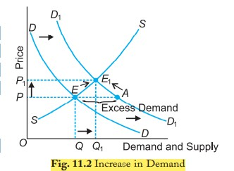

Decrease in Demand

If the demand of a commodity decreases, while supply remains constant, the equilibrium price and output will fall. In Fig. 11.3, quantity demanded and supplied is shown on the x-axis and price of commodity on the y-axis. DD is the original demand curve. SS is the original supply curve. E is the equilibrium point. Decrease in demand is given by leftward shift of DD curve to D1 D1 . This creates excess supply of AE units at price OP.

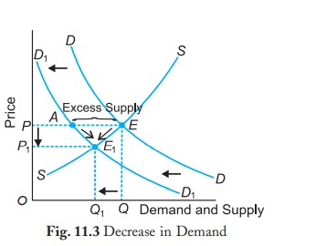

Increase in Supply

If the supply of a commodity increases, while demand remains constant, equilibrium price will fall. This is shown in Fig. 11.4. In the figure, quantity demanded and supplied is shown on the x- axis and price of commodity on the y-axis. DD is the original demand curve. SS is the original supply curve. E is the original equilibrium point. SS increases to S1 S1 . It creates excess supply of EB at the given price OP.

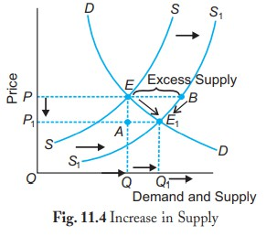

Decrease in Supply

If the supply of a commodity decreases, while demand remains constant, equilibrium price will increase. There will be excess demand of EB units at price OP.

# C:\Users\user\Desktop\4.PNGConsumer Surplus

* Consumer surplus is defined as the difference between the consumers' willingness to pay for a commodity and the actual price paid by them.
* A surplus occurs when the consumer’s willingness to pay for a product is greater than its market price.
* Consumer surplus always increases as the price of a good falls and decreases as the price of a good rises.

# Producer Surplus

* Producer surplus is the difference between how much a person would be willing to accept for given quantity of a good versus how much they can receive by selling the good at the market price.
* The difference or surplus amount is the benefit the producer receives for selling the good in the market

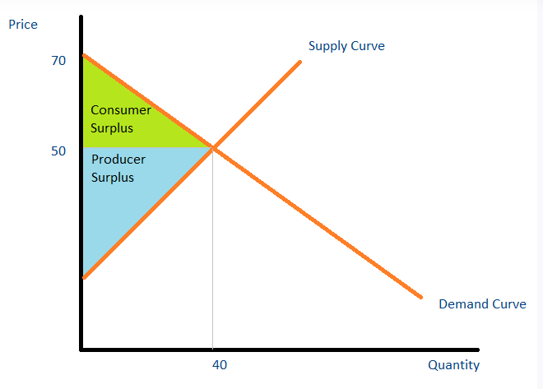

The point where the demand and supply meet is the equilibrium price. The area above the supply level and below the equilibrium price is called product surplus (PS), and the area below the demand level and above the equilibrium price is the consumer surplus (CS).

# Taxation

* Taxation is the means by which a government or the taxing authority imposes or levies a tax on its citizens and business entities.
* *Taxation* refers to the practice of government collecting money from its citizens to pay for public services.
* A tax is a mandatory fee or financial charge levied by any government on an individual or an organization to collect revenue for public works providing the best facilities and infrastructure.

# Deadweight Loss

A deadweight loss is a cost to society created by market inefficiency, which occurs when supply and demand are out of equilibrium. A deadweight loss is the irrecoverable reduction in economic efficiency that occurs when free-market equilibrium is disturbed by a market intervention or other shock to supply and/or demand.

# Example of Deadweight Loss

A new sandwich shop opens in your neighborhood selling a sandwich for $10. You perceive the value of this sandwich to be $12 and, therefore, are happy to pay $10 for it. Now, assume the government imposes a new sales tax on food items which raises the cost of the sandwich to $15. At $15, you feel that the sandwich is overvalued and believe that the new cost is not a fair price and, therefore, are not willing to buy the sandwich at $15. Many consumers, but not all, feel this way about the sandwich and the sandwich shop sees a decrease in demand for its sandwich and a decline in revenues. The deadweight loss in this example is the unsold sandwiches as a result of the new $15 cost. If the decrease in demand is severe enough, the

sandwich shop could go out of business, further increasing the negative economic effects of the new tax.