Module – 2 Production and Cost

# Production

Production is defined as the transformation of inputs into output. Production includes not only production of physical goods like cloth, rice, etc., but also production of services like those of a doctor, teacher, lawyer, etc.

# Production Function

The term production function means physical relationship between inputs used and the resulting output. A production function is an expression of quantitative relation between change in inputs and the resulting change in output. It is expressed as:

## Q = f (i1, i2 in)

Where Q is output of a specified good i1, i2 i n are the inputs usable in producing this good.

To simplify let us assume that there are only two inputs, labour (L) and capital (K), required to produce a good. The production function then takes the form:

Q = f (K, L)

# Short-run and Long-run Production Function

There are two types of production function:

1. Short-run Production Function.

It refers to production in the short-run where there is at least one factor in fixed supply and other factors are in variable supply. In short-run, production will increase when more units of variable factors are used with the fixed factor. Fixed factors refer to those factors whose supply cannot be changed during short-run. For example, land, plant, factory building, minimum electricity bill, etc.

1. Long-run Production Function.

It refers to production in the long-run where all factors are in variable supply. In the long-run, production will increase when all factors are increased in the same proportion. Variable factors refer to those factors whose supply can be varied or changed. For example, raw materials, daily wages, etc.

# Concepts of Product

Total Physical Product (TPP) or Total Product (TP)

Total Physical Product (TPP) or TP. It is defined as the total quantity of goods produced by a firm with the given inputs during a specified period of time.

Average Product (AP) or Average Physical Product (APP) Average Product (AP).

It is defined as the amount of output produced per unit of the variable factor (labour) employed.

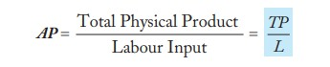

Marginal Product (MP) or Marginal Physical Product (MPP)

It is defined as the change in TP resulting from the employment of an additional unit of a variable factor (labour).

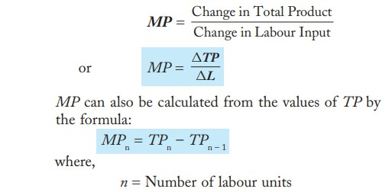

# Law of Variable Proportion

The law of variable proportion is a widely observed law of production which takes place in the short-run. In the short-run, production can be increased by using more of the variable factor. The law is applicable to all sectors of an economy.

The law of variable proportion states that as we employ more and more units of a variable input, keeping other inputs fixed, the total product increases at increasing rate in the beginning then increases at diminishing rate and finally starts falling.

Three Phases of Production

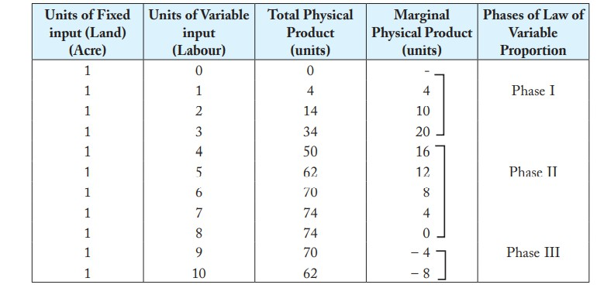

The three phases can be identified by inspecting the behaviour of MP of variable input in the above table. MP of variable input rises up to 3 units. This is phase I in which TP increases at an increasing rate. From 4th unit to 8th unit of variable input, MP falls but remains positive. This is phase II in which TP increases at a decreasing rate. MP of variable input becomes negative from 10th unit. This is phase III in which TP starts falling. These three phases of the short-run law of production are graphically illustrated by the relationship between TP and MP curves.

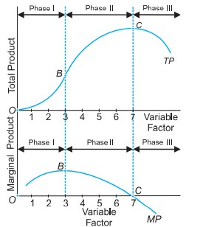

Phase I. Phase of Increasing Returns

It goes from the origin to the point where the MP curve is maximum (i.e., from origin to point B). In this phase, TP curve is increasing at an increasing rate. MP curve rises and reaches a

maximum. A rational producer will not operate in this phase because the producer can always expand through phase I. It is a non-economic range.

Phase II. Phase of Diminishing Returns

It is the most important phase out of the three phases. Phase II of production ranges from the point where MP curve is maximum to the point where the MP curve is zero (i.e., from point B to C). MP curve is positive but declining. TP curve increases at a decreasing rate and reaches a maximum. A rational producer will always operate in this phase. The law of diminishing returns operates in phase II.

Phase III. Phase of Negative Returns

It covers the entire range over which MP curve is negative. In this phase, TP curve falls (after point C). A rational producer will not operate in this phase, even with free labour, because he could increase his output by employing less labour. It is a non-economic and an inefficient phase.

# Economies of scale

Economies of scale refer to the cost advantage experienced by a firm when it increases its level of output. There are two main types of Economies of Scale – they are internal and external. Internal economies of scale refer to benefits that occur within the firm. For example, the firm may be able to obtain higher levels of credit due to its size.

By contrast, external economies occur outside of the firm, but inside the industry, that makes them more efficient.

Internal Economies

1. Labour Economies

In large scale operations workers can do more specific tasks. With little training they can become very proficient in their task, this enables greater efficiency. A good example is an assembly line with many different jobs.

1. Technical Economies

Some production processes require high fixed costs e.g. building a large factory. If a car factory was then only used on a small scale, it would be very inefficient to run. By using the factory to full capacity, average costs will be lower.

1. Managerial Economies

If you buy a large quantity, then the average costs will be lower. This is because of lower transport costs and less packaging. This is why supermarkets get lower prices from suppliers than local corner shops.

1. Financial Economies

Some investments are very expensive and perhaps risky. Therefore only a large firm will be able and willing to undertake the necessary investment. E.g. pharmaceutical industry needs to take risks in developing new drugs

1. Marketing economies of scale

There is little point a small firm advertising on a national TV campaign because the return will not cover the high sunk costs

## External Economies

This occurs when firms benefit from the whole industry getting bigger. E.g. firms will benefit from better infrastructure, access to specialized labour and good supply networks.

# Isoquants

* + It is a curve which shows various combinations of two factor inputs which give the same level of output.
  + ISO means equal and QUANT means quantity.
  + It is also called Isoproduct curves and Equal product curves.

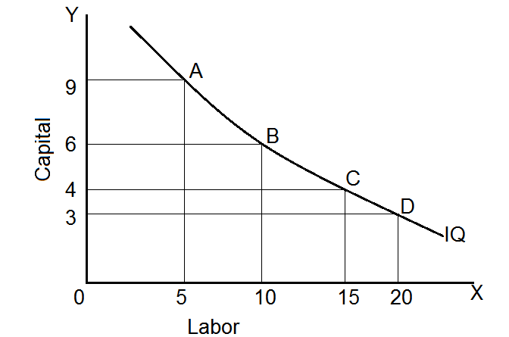

# Properties of Isoquants

1. Isoquants are negatively sloped

An isoquant slopes downwards from left to right. The logic behind this is the principle of diminishing marginal rate of technical substitution. In order to maintain a given output, a reduction in the use of one input must be offset by an increase in the use of another input.

1. Isoquants are convex to the origin

An isoquant must always be convex to the origin. This is because of the operation of the principle of diminishing marginal rate of technical substitution. MRTS is the rate at which marginal unit of an input can be substituted for another input making the level of output remain the same.

The marginal rate of technical substitution (MRTS):

The rate at which one input can be substituted for another along an isoquant is called the marginal rate of technical substitution (MRTS), defined as:

∆K/∆L = MPL/MPK = MRTSL for K

1. Two isoquants cannot cut each other

If they intersect each other, there would be a contradiction and we will get inconsistent results.

1. An isoquant lying above and to the right of another isoquant represents a higher level of output.

This is because of the fact that on the higher isoquant, we have either more units of one factor of production or more units of both the factors.

1. Isoquants need not be parallel

The shape of an isoquant depends upon the marginal rate of technical substitution. Since the rate of substitution between two factors need not necessarily be the same in all the isoquant schedules, they need not be parallel.

# Types of Iso-quant Curves

Linear Iso-quant Curve:

This curve shows the perfect substitutability between the factors of production. This means that any quantity can be produced either employing only capital or only labor or through “n” number of combinations between these two

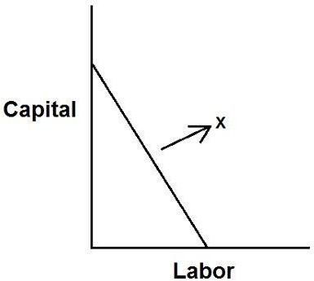

Right Angle Iso-quant Curve:

This is one of the types of iso-quant curves, where there is a strict complementarity with no substitution between the factors of production. According to this, there is only one method of production to produce any one commodity. This curve is also known as Leontief Iso-quant, input-output isoquant and is a right angled curve.

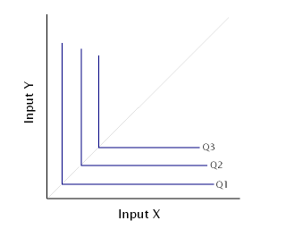

# Isocost line

An isocost line is a graphical representation of various combinations of two factors (labor and capital) which the firm can afford or purchase with a given amount of money or total outlay. Mathematically, an isocost line can be expressed as

C = w L + r K

Where,

C = cost of production

w = price of labor or wages L = units of labor

r = price of capital or interest rate K =units of capital

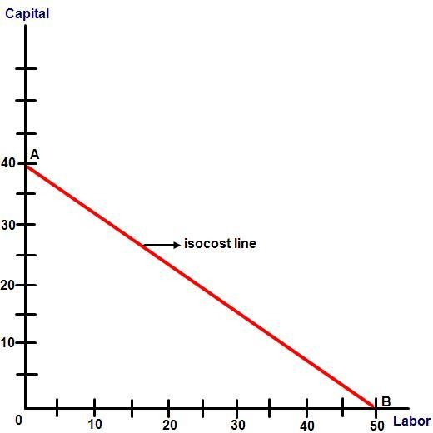

In the given diagram, x-axis represents units of labor and y-axis represents units of capital. Therefore, OB in the figure represents 50 units of labor and OA represents 40 units of capital.

If we join points A and B, we get isocost line for Rs. 200. And, the straight line which joins points A and B will pass through all combinations of labor and capital which the firm can buy with the outlay of Rs 200, if it spends the entire sum on them at the given prices.

This way, an isocost line is also known as price line or outlay line.

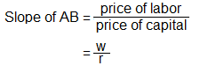

# Shift in Isocost Line

An isocost line may shift due to two reasons. They are

* 1. Change in total outlay to be made by the firm
  2. Change in price of a factor-input Change in total outlay to be made by the firm

When the firm decides to increase the total money to be spent on purchase of inputs while prices of the inputs remain the same, the producer becomes able to afford such combinations of inputs which were initially unattainable to him. This causes isocost line to shift to a new position higher to the initial line.

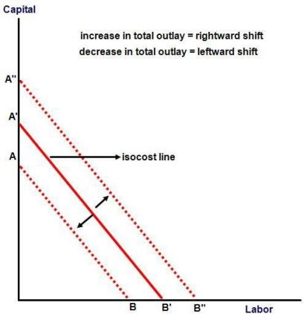

In the above figure, AB is the initial isocost line. When the firm increased its total outlay, the isocost line shifted rightwards to a higher position A’B’ where the producer could purchase combinations of inputs with higher units of labor and capital. Likewise, if the firm reduces its total outlay, the isocost line will shift leftwards to A”B”.

Change in price of a factor-input

Case I: Change in price of labor

Figure: shift in isocost line due to change in price of labor

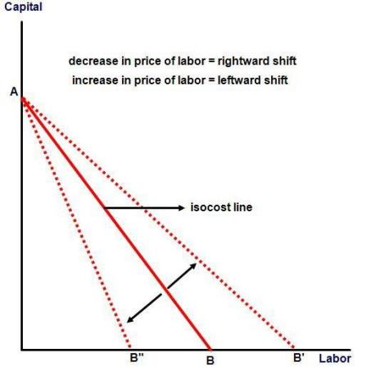

Let us suppose that a firm has total outlay of Rs. 200 and AB is initial isocost line. Let us also suppose that the price of labor was decreased by certain amount, as a result of which the producer became able to purchase more units of labor at the same outlay. However, the producer can’t increase purchasing units of capital as price of capital is constant. Therefore, the position of price line is changed in the x-axis but unchanged in y-axis.

Simply, decrease in price of labor causes anti-clockwise rotation and increase in price of labor causes clockwise rotation.

Case II: Change in price of capital

Figure: shift in isocost line due to change in price of capital

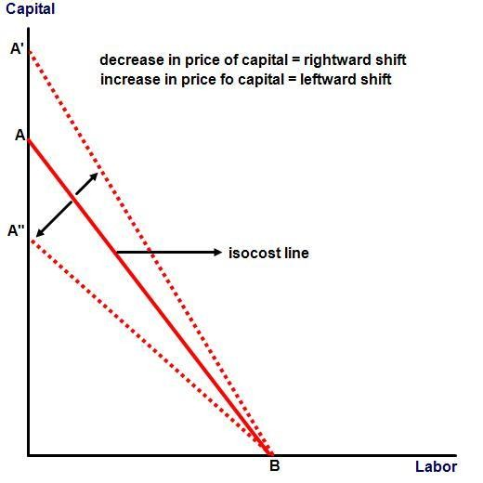

Once again, let us assume that a firm has total outlay of Rs. 200 but this time let us suppose that the price of capital has changed and not of labor.

In this case, the producer will be able to buy more units of capital at same outlay but won’t be able to increase the purchasing units of labor. As a result, the isocost line shifts its position in y-axis and not in x-axis. In the diagram, we can see that isocost line AB shifts to new position A’B as a result of decrease in price of capital. Likewise, the line shifts to A”B as a result of increase in price of capital.

In other words, decrease in price of capital causes clockwise shift in isocost line and increase in price of capital causes anti-clockwise shift.

# Producer’s Equilibrium / Least cost combination

The point of least-cost combination of factors for a given level of output is where the isoquant curve is tangent to an iso-cost line. The iso-cost line GH is tangent to the isoquant 200 at point M. The firm employs the combination of ОС of capital and OL of labour to produce 200 units of output at point M with the given cost-outlay GH. At this point, the firm is minimising its cost for producing 200 units.

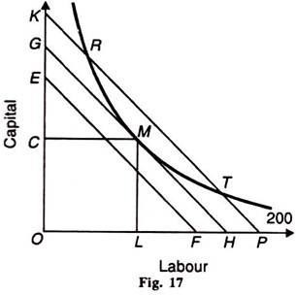

Any other combination on the isoquant 200, such as R or T, is on the higher iso-cost line KP which shows higher cost of production. The iso-cost line EF shows lower cost but

output 200 cannot be attained with it. Therefore, the firm will choose the minimum cost point M which is the least-cost factor combination for producing 200 units of output.

Thus the equilibrium condition

W/r = MPL/MPK = MRTSLK

# Expansion Path

Expansion path is a line or a curve on which every point is an equilibrium point. All these points indicate minimum cost combinations of two factors at various levels of output. Expansion path shows the path on which a rational producer would prefer to increase scale of production in his firm.

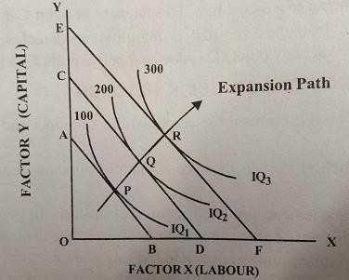

# Technical Progress and its implications

When there is a change in technical progress, the production function will change. Thus production will increase. Technical progress may be embodied and disembodied.

Embodied technical progress:

Improved technology which is attributed to investments in new equipment. New technical changes that are made are embodied in the equipment.

Disembodied technical progress:

Improved technology which results in output increases without investing in new equipment.

# Cobb–Douglas production function

where:

The Cobb–Douglas form was developed and tested against statistical evidence by Charles Cobb and Paul Douglas between 1927–1947; according to Douglas, the functional form itself was developed earlier by Philip Wicksteed.

In its most standard form for production of a single good with two factors, the function is:

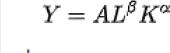

* *Y* = total production
* *L* = [labour](https://en.wikipedia.org/wiki/Labour_(economics)) input
* *K* = [capital](https://en.wikipedia.org/wiki/Capital_(economics)) input (a measure of all machinery, equipment, and buildings; the value of capital input divided by the price of capital)[
* *A* = [total factor productivity](https://en.wikipedia.org/wiki/Total_factor_productivity)
* *α* and *β* are the [output elasticities](https://en.wikipedia.org/wiki/Output_elasticity) of capital and labor, respectively. These values are constants determined by available technology.

Output elasticity measures the responsiveness of output to a change in levels of either labor or capital used in production.

* + *α* + *β* = 1, Constant Returns to scale - meaning that doubling the usage of capital *K* and labor *L* will also double output *Y. Cobb – Douglas production function is a homogenous production function.*
  + *α* + *β* < 1, Returns to scale are decreasing, means that a percentage increase in capital *K* and labor *L* will produce a smaller percentage increase in output *Y*
  + α + β > 1, Returns to scale are increasing, means that a percentage increase in capital K and labor L will produce a larger percentage increase in output Y

# Cost of Production (Concepts)

* Cost is the expenditure incurred y a firm in the production of a commodity.

# Cost Concepts

1. Explicit Cost: It is the expenses actually met y the producer while producing a commodity. (Raw materials)
2. Implicit Cost**:** It is the opportunity cost of the factor services supplied by the firm itself. (Rent)
3. Accounting Costs: This is the monetary outlay for producing a certain good. Accounting costs will include your variable and fixed costs you have to pay.
4. Sunk Costs: These are costs that have been incurred and cannot be recouped. (Adv cost)
5. Social Costs: This is the total cost to society. It includes private costs plus any external costs.
6. Private cost: It is the cost incurred by the producer in the production of a good.
7. External Cost: When a commodity is produced it may cause damages to the environment in the form o fair pollution, water pollution etc.
8. Replacement cost: It is the amount of money required to replace an existing asset with an equally valued or similar asset at the current market price.

# Types of Cost

* + Short run cost: Cost refers to a certain period of time where at least one input is fixed while others are variable. It refers to a certain period of time where at least one input is fixed while others are variable.
  + Long run cost: The long run is a period of time in which all factors of production and costs are variable.

# [Short Run Cost](https://www.geektonight.com/short-run-cost/#what-is-short-run-cost)

The total cost/Short run total cost (SRTC) refers to the actual cost that is incurred by an organisation to produce a given level of output. The Short-Run Total Cost (SRTC) of an organisation consists of two main elements:

Total Fixed Cost (TFC): These costs do not change with the change in output. TFC remains constant even when the output is zero. TFC is represented by a straight line horizontal to the x- axis (output).

Total Variable Cost (TVC): These costs are directly proportional to the output of a firm. This implies that when the output increases, TVC also increases and when the output decreases, TVC decreases as well.

SRTC is obtained by adding the total fixed cost and the total variable cost.

**SRTC = TFC + TVC**

As the TFC remains constant, the changes in SRTC are entirely due to variations in TVC.

Figure depicts the **short run cost curve** of a firm:

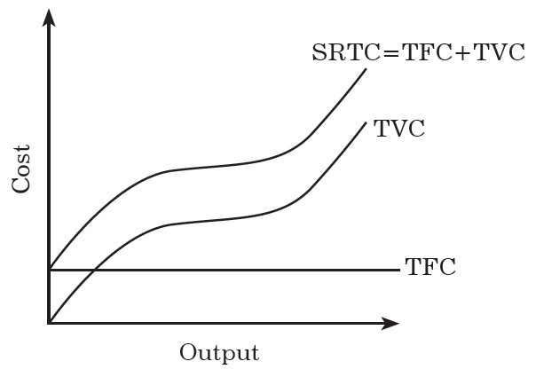

# Short Run Average Cost

The **average cost** is calculated by dividing total cost by the number of units a firm has produced. The short-run average cost (SRAC) of a firm refers to per unit cost of output at different levels of production. To calculate SRAC, short-run total cost is divided by the output.

**SRAC = SRTC/Q = TFC + TVC/Q**

**Where, TFC/Q =Average Fixed Cost (AFC) and**

**TVC/Q =Average Variable Cost (AVC)**

**Therefore, SRAC = AFC + AVC**

SRAC of a firm is U-shaped. It declines in the beginning, reaches to a minimum and starts to rise.

# Short Run Marginal Cost

**Marginal cost** (MC) can be defined as the change in the total cost of a firm divided by the change in the total output. Short-run marginal cost refers to the change in short-run total cost due to a change in the firm’s output.

# Position of short run average and marginal cost curves

The short-run marginal cost (SRMC), short-run average cost (SRAC) and average variable cost (AVC) are U-shaped due to increasing returns in the beginning followed by diminishing returns. SRMC curve intersects SRAC curve and the AVC curve at their lowest points.

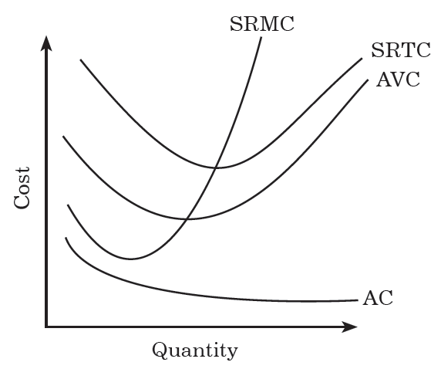

# Long Run Cost

The long run is a period of time in which all factors of production and costs are variable. According to the long run, all inputs are variable. There is no fixed cost.

Long Run Total Costs

Long run total cost refers to the minimum cost of production. It is the least cost of producing a given level of output.

Long Run Average Cost Curve

Long run average cost (LAC) can be defined as the average of the LTC curve or the cost per unit of output in the long run. It is derived from the short run average cost curves.

Long Run Marginal Cost

Long run marginal cost is defined at the additional cost of producing an extra unit of the output in the long-run

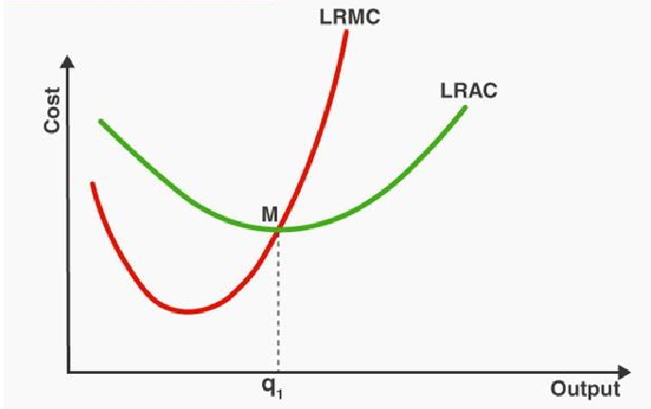

# Revenue

Revenue is the money payment received from the sale of a commodity.

# Concepts

**Total Revenue (TR)**

TR is defined as the total or aggregate of proceeds to the firm from the sale of a commodity.

# Average Revenue (AR)

TR = P.Q where

P = Price

Q = Quantity sold

AR is revenue per unit of output sold. It is obtained by dividing total revenue by the number of units sold.

AR = Total Revenue / Number of units sold

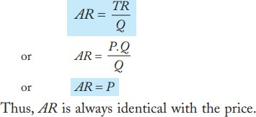

# Marginal Revenue (MR)

MR is addition made to total revenue when one more unit of output is sold.

**MR = TR n - TR n-1 MR = d(TR) / d(Q)**

# Shutdown Point

A shutdown point is a level of operations at which a company experiences no benefit for continuing operations and therefore decides to shut down temporarily—or in some cases permanently. At the shutdown point, there is no economic benefit to continuing production.

A shutdown arises when price or average revenue (AR) falls below average variable cost (AVC) at the profit-maximizing output level. Continued production will incur additional variable costs but will not generate enough revenue to cover them. At the same time, the firm will still have fixed costs to pay, further increasing the losses.

Shutdown point is defined as that point where the market price of the product is equal to the AVC in the short run.

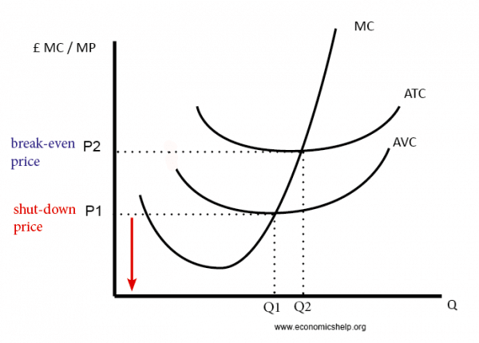

In summary, the shutdown point has the following characteristics:

1. It is the output and price point where a firm is able to just cover its total variable cost.
2. The average variable cost (AVC) is at its minimum point.
3. It is where the marginal cost (MC) curve intercepts the average variable cost (AVC) curve.
4. The firm is indifferent between shutting down and continuing production where losses equal to the total fixed costs are incurred regardless of either decision.

# Break Even Point

* It is method used to study the relationship between TC and TR . The break-even point is the point at which total cost and total revenue are equal, meaning there is no loss or gain for your small business.
* **Breakeven point (BEP)** is used to understand this relationship
* BEP is the point where TC equals to TR. No profit , no loss (zero profit)

**BEP: TC = TR**

**Profit / Loss = TR – TC**

# Profit / Loss = (P x Q) – (TFC + TVC) BEP = TFC / P – AVC

NOTE:

1. At BEP, it is zero profit
2. When no of units sold is lesser than BEP, it is loss
3. When no of units sold is greater than BEP, it is profit

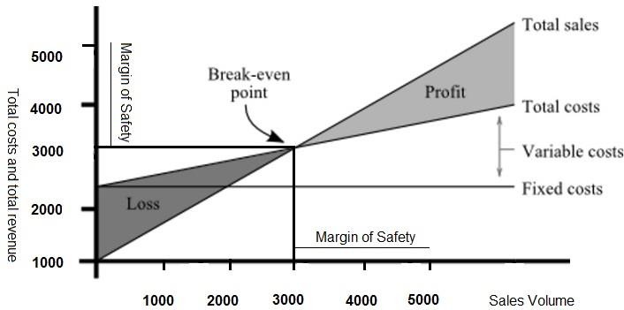

Observations:

TC > TR, it is Loss TC < TR, it is Profit

TC = TR, No Profit , No Loss ( BEP )

# PV Ratio

PV Ratio (Profit Volume Ratio) is the ratio of contribution to sales.

P/V Ratio = Sales – Variable cost/Sales i.e. S – V/S or, P/V Ratio = Fixed Cost + Profit/Sales i.e. F + P/S

Using PV Ratio, we can find BEP

BEP = TFC/ PV Ratio OR TFC * S / S – V

# Margin of Safety (MOS)

* MOS is the sales beyond break – even point. Margin of safety is how much output or sales level can fall before a business reach it’s BEP.

**Margin of Safety = Excess of Sales – BEP**

# Advantages of BEP

* To know the cost revenue relationship
* To plan future business expansion
* To plan future production
* To target sale
* It helps in managerial decision making