Debugging JavaFX code

This document describes debugging tools/tricks for JavaFX applications. The target audience include both the JavaFX compiler developers as well as JavaFX library/sample/test developers. JavaFX compiler supports a number of “hidden” options (options that start with -XD) to support debugging. Most of the -XD options are meant for compiler developers - but a few are useful for library/sample/test developers as well.

AST as XML and -XDtreexsl option

JavaFX compiler, like many other compilers, represents user supplied source code as a ASTs (abstract syntax tree). We can view AST as XML document – and so it can dumped to a file and/or transformed via XSL (XML stylesheets). The compiler option for this is “-Xdtreexsl”. This facility can be used to analyze source code and/or transform source code (compile time aspect oriented programming AOP).

Example:

javafxc -XDtreexsl Main.fx

produces a XML representation of Example.fx's AST under “./treexsl” directory. It is also possible to specify one or more XSL stylesheets to be applied to the XML representation of AST. There are few sample stylesheets under

$OPENJFX/src/share/classes/com/sun/tools/javafx/tree/xml/resources

Example:

javafxc -XDtreexsl=$OPENJFX/src/share/classes/com/sun/tools/javafx/tree/xml/resources/xml2javafx.xsl Main.fx

The above example produces pretty printed JavaFX source code from the XML document. Another example is “bindstat.xsl” which prints how many times given kind of bind construct is used in the source code. You can import xml2javafx.xsl in your own stylesheet and insert your own printlns to produce transformed source code.

The XML document has informnation on symbols (Symbol in compiler source) and types (Type in compiler source). The XSL stylesheet can also access compiler state – make queries like if a Type A is subtype of Type B etc. The XSL stylesheet can access compile state via com.sun.tools.javafx.xml.Compiler class. This is compiler API for XSL stylesheets. This class provides access to symbols, types, command line options and line/colum number information to XSL stylesheets. While XSL can access types and symbols in the input AST document, more specific queries like subtype etc. will need API calls. XSL stylesheets can invoke methods of this class using the namespace URI http://xml.apache.org/xalan/java/com.sun.tools.javafx.tree.xml.Compiler
xml2javafx.xsl example uses the facilities in Compiler class.

-XDdump* options

JavaFX compiler is implemented as various “steps” in which the source JavaFX ASTs are converted to Java ASTs. These Java ASTs are then compiled by back-end embedded Java compiler. [well the Java implemented in back-end is not exact-standard Java – it is java + some extensions like block expressions. So, the transformed Java source can not be compiled by “javac”!]. After type checking (called “attribution” stage), the following steps are applied. You can tell the compiler to dump the pretty-print output of AST to file(s). Each of these “dump” options accepts a directory as option. The compiler writes .fxdump and/or .javadump in the specified directory. The compiler step and associated pretty print dump option is as follows:

-XDdumpattr=<dattr> | Dump pretty print of AST just after attribution (type checking) step.
-XDdumplower=<dlower> | “Lower” step normalizes FX tree before translation. This includes adding explicit type conversions (e.g. for autoboxing, sequence conversions, etc.) and rewriting unary/assignop operations as binary operations.
-XDdumpfill=<dbfunc> | “Fill” step introduces synthectic tree elements need to implement bound functions and bound object literals. If you want to check out how your bound function and/or bound object literal is transformed you may want to dump tree at the end of this step.
-XDdumpinflate=<dltc> | In few cases, JavaFX compiler has to convert function local contexts into classes if need be.  This conversion is needed for local contexts containing local variable binds, on-replace, and some forms of object literal. Also, local context is created for if Pointer.make is called on a  local variable or if interpolation attribute is a local variable. With this dump option, we can view the local classes generated for such cases.
-XDdumpdecompose=<dd> | In “decompose” step, bind expressions are transformed into easily translatable expressions – complex bind expressions are decomposed into simpler ones.
-Xddumpjava=<djd> | Just before submitting transformed Java AST to back-end (modifed) Java compiler, we can dump it to a file using this option. All the other dump options except this one, produce dump files with the extension .fxdump. But, this option produced pretty print dump files with the extension “.javadump”.

Debugging Java code generated by JavaFX compiler

We can instrument a .javadump produced by -XDdumpjava option to add System.out.println() statements. The resultant code can be compiled using javafxc compiler option “-XDmjavac”. Note that the code submitted to back-end compiler is not exactly a standard Java source. It can use extensions like block expressions. To compiler such .javadump files, we can not use the standard Java compiler “javac”.

Example:

javafxc -XDdumpjava=. Main.fx

This produces Main.javadump in the current directory. We can compile that (or edit the file to add debug print statements) using the following command:

javafxc -XDmjavac Main.javadump

Dependency debugging

The important features of JavaFX include “bind” and related facilities like on-replace triggers, on-invalidate triggers. Using bind expressions, user creates “dependency network” among the variables. A bound variable is dependent on one or more bindee variables. Often bugs are because of problems with the dependency network among the variables. In addition to source level variables, JavaFX compiler introduces lots of intermediate synthetic variable (to implement complex bind expressions). Quickly the dependency networks explode so that it becomes very difficult to debug by looking at the source code and/or intrumenting the generated Java code. So, sometimes, it is useful to view the dependency network as a graph. There are two kinds of dependencies – intra-object dependencies and inter-object dependencies. The intra-object dependencies (dependencies b/w instance variables of the same object) are compiled into the source code – i.e, these dependencies are not explicitly maintained in some runtime data structure. But, inter-object dependencies are explicitly maintained in runtime data structures (register/notify mechanism b/w JavaFX objects using runtime data structures). There is a compiler option -XDdumpdepgraph which can be used to dump dependency graph as a .gxl file. GXL – Graph eXchange Language is a XML file format to represent graphs. You may want to refer to http://www.gupro.de/GXL/ for GXL file format specification and other related information. But to view the graphs, you don't know details about GXL file format. You can download a graph viewer software like Graphviz - http://www.graphviz.org/ - Graphviz is available for download for platforms. The native format viewed by Graphviz is “.dot”. User can convert a .gxl file to a .dot file using the command line “gxl2dot” - which comes with Graphviz download.
So, the steps to generate and view (static) dependency graphs are as follows:

javafxc -XDdumpdepgraph=. Person.fx
gxl2dot Person.fx.gxl > Person.dot

After converting the file to .dot format, you can open the graph with Graphviz. Withing Graphviz GUI there is an option to export the graph to internet accessible file formats such .png, .jpg, .svg , .pdf and so on. This way you can export the graph and send it via email/chat.

Simple example source file - Person.fx:

public class Person {
public var name : String;
public var upperCaseName = bind name.toUpperCase();
public var father : Person;
public var mother : Person;
public var fatherName = bind father.name;
public var motherName = bind mother.name;
}
The static dependency graph of the above example source looks as follows:

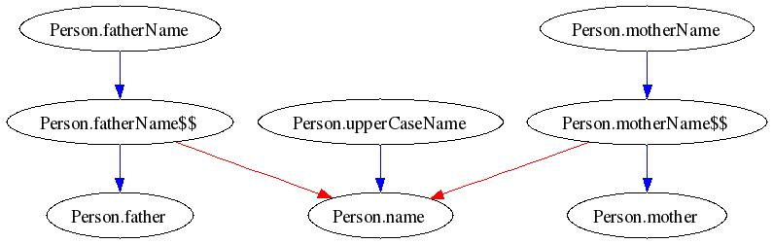
Each node in the above graph is source variable that participates in one or more bind expression. The intra-object dependencies are shown in blue color edges and the intra-object dependencies are shown in red color edges. The intra-object dependencies are really dynamic – i.e., dependent/dependee change in the course of running of the program. There is a private/internal runtime API to dump (inter-object) dependency graph at runtime.
The class com.sun.javafx.runtime.DependentsGraphWriter has many static methods that dump inter-object dependency network from a given FX object in a .gxl file. The above example, “Person.fx” is modified to include the following code:

import com.sun.javafx.runtime.DependentsGraphWriter;
import com.sun.javafx.runtime.FXObject;

function run() {
var p1 = Person { name: "x" };
var p2 = Person { name: "y" };
var p = Person { name: "z", father: p1, mother : p2 };
DependentsGraphWriter.write(p as FXObject, "test.gxl", true);
}

Please refer to the javadoc comments in the DependentsGraphWriter class for detailed information on the various graph “write” methods. The runtime inter-object dependency graph from the above example looks as follows:

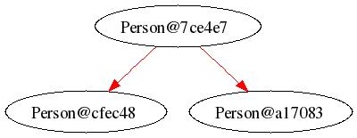
Note that the dependencies are shown only between objects – i.e., there is not variable info in the runtime graph. Also, the static intra-object dependencies are missing in this graph. There is also another way to dump dependency graphs. To use that option, you need to compile your sources (and also the library, compiler runtime and everything on which your code depends on) with the debug compiler option “-XDannobindees”. When source are compiled with this option, the compiler generates a annotation com.sun.javafx.runtime.annotations.JavafxBindees for every variable that is initialized with a bind expression. This is meant to be a debug annotation and so it is not generated by default. There is a private/internal runtime API to dump graphs for Java and JavaFX data structures in the class com.sun.javafx.runtime.FXDOTWriter. When JavaFX is compiled with -XDannobindees option, FXDotWriter uses the debug annotations to generate JavaFX bind dependency edges. Please refer to the javadoc comments in FXDOTWriter for more detailed documentation. If you have not compiled the JavaFX sources with -XDannobindees option, then FXDOTWriter writes only the Java field edges between the objects. The following code is added to Person.fx to use FXDOTWriter.

import com.sun.javafx.runtime.FXDOTWriter;
import com.sun.javafx.runtime.FXObject;

function run() {
var p1 = Person { name: "x" };
var p2 = Person { name: "y" };
var p = Person { name: "z", father: p1, mother : p2 };

println(p.upperCaseName);
println(p.fatherName);
println(p.motherName);

FXDOTWriter.graph("test.dot", p);
}

Steps to produce the dependency graphs are as follows:

javafxc -XDannobindees Person.fx
javafx Person

Graphs produced by FXDOTWriter without and with -XDannobindees option are as follows:
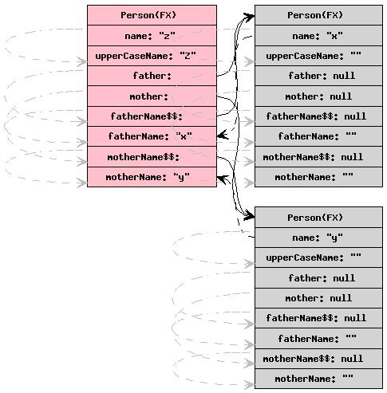
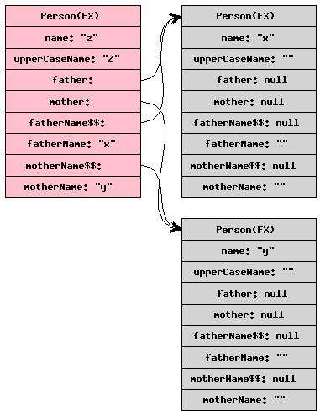

Dynamically tracing JavaFX code

It is possible to dynamically inject tracing code to JavaFX application (or any other Java application) at runtime using BTrace. BTrace ( http://projectkenai.com/projects/btrace ) is a dynamic tracing tool for the Java platform. BTrace injects tracing code into a running application using dynamic bytecode instrumentation and hotswapping loaded classes. This way you can trace code without manually modifying/recompiling your source code. BTrace user guide can be accessed at http://kenai.com/projects/btrace/pages/UserGuide

To use BTrace, a developer writes a tracing script – which is essentially a Java code (with some restrictions) and uses annotations to specify the “places” of interest in the application. There are useful tracing scripts for JavaFX apps under $OPENJFX/buildtools/fxbtrace/btrace_scripts. These BTrace scripts can be compiled using ant makefile $OPENJFX/buildtools/fxbtrace/build.xml. Once compiled, these scripts can be used with JavaFX apps using the script $OPENJFX/buildtools/fxbtrace/bin/fxbtrace.

Steps to use BTrace with JavaFX app:

- Get a copy of BTrace sources using hg clone https://kenai.com/hg/btrace~hg
- define environmental var BTRACE_HOME to directory where btrace repo was cloned.
- Build BTrace using ant makefile $BTRACE_HOME/make/build.xml
- compile all FX BTrace scripts in $OPENJFX/buildtools/fxbtrace/ using ant makefile in this dir using the command : ant -Dbtrace.home=$BTRACE_HOME
- define environmental variable JAVAFX_HOME to be directory where your JavaFX SDK is installed. (by default this is defined as the directory where the compiler repo lives).
- The above compiles all btrace scripts under btrace_scripts to the destination directory $OPENJFX/build/buildtools/fxbtrace/
- $OPENJFX/buildtools/fxbtrace/bin/fxbtrace <compiled-btrace-script.class> <your-fx-main-class> <args>
- For example,
$OPENJFX/buildtools/fxbtrace/bin/fxbtrace $OPENJFX/build/buildtools/fxbtrace/InvalidationTracer.class FXMain
- This produces the trace output file in $OPENJFX/build/buildtools/fxbtrace/InvalidationTracer.class.btrace

You may want to refer to various FX variable tracing scripts under $OPENJFX/buildtools/fxbtrace/btrace_scripts/

