Publish MDM SaaS Events – via Stream Ingestion

  - Problem Stmnt: In MDM SaaS – how to capture the changes to the BE/SE/Relationship and publish them to Flat File?

Step A: Configure the Events for the Supporting Entity in this case.

See below screenshots

B360 - Config the CG_ROLE events:

Select the BE or SE Or RELATIONSHIP asset you are interested in,
in this case its Role and its a Supporting Entity (SE) called CG_ROLE

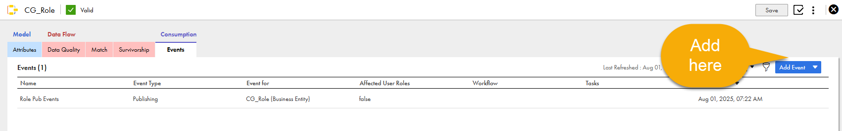

add events you are interested in
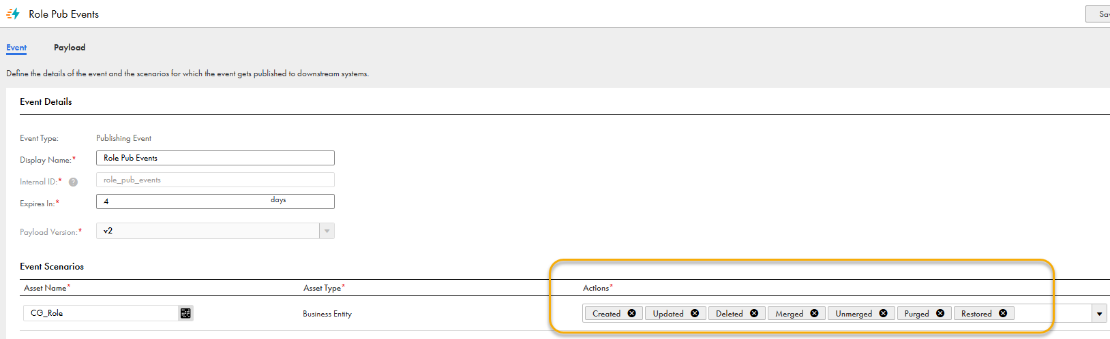

select the payLoad structure – reccommended to select all of the information
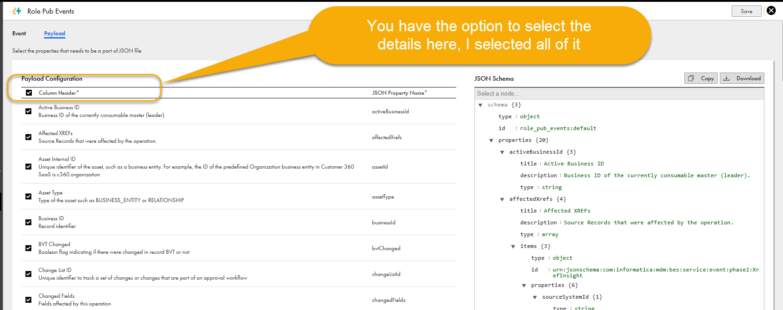

CDI - Config the Task - Streaming Ingestion Task - File:

Log into the CDI and create a new Streaming Ingestion task,
create one as follows
name: az2_streamtask_cgRole2file
S1
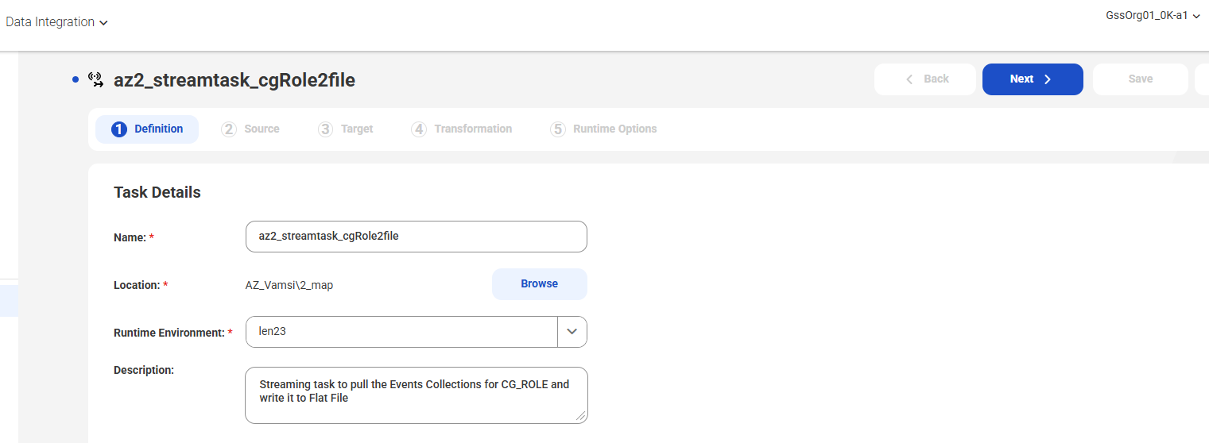
S2
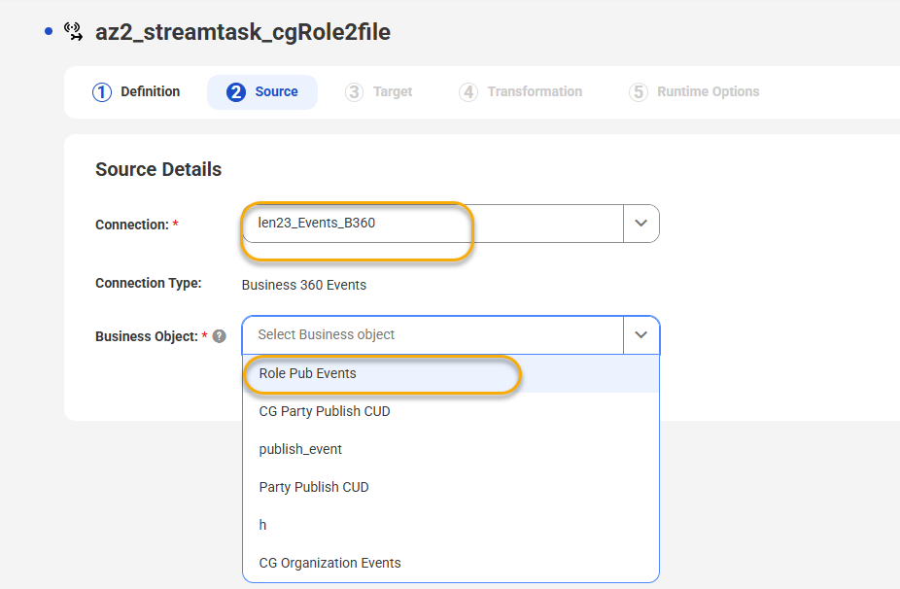
S3
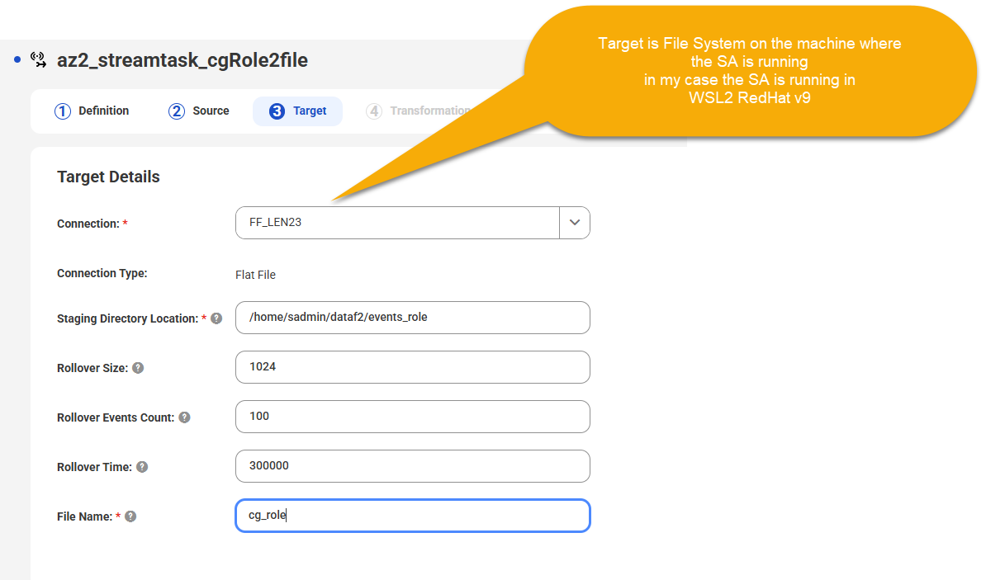
S4
select the msg format
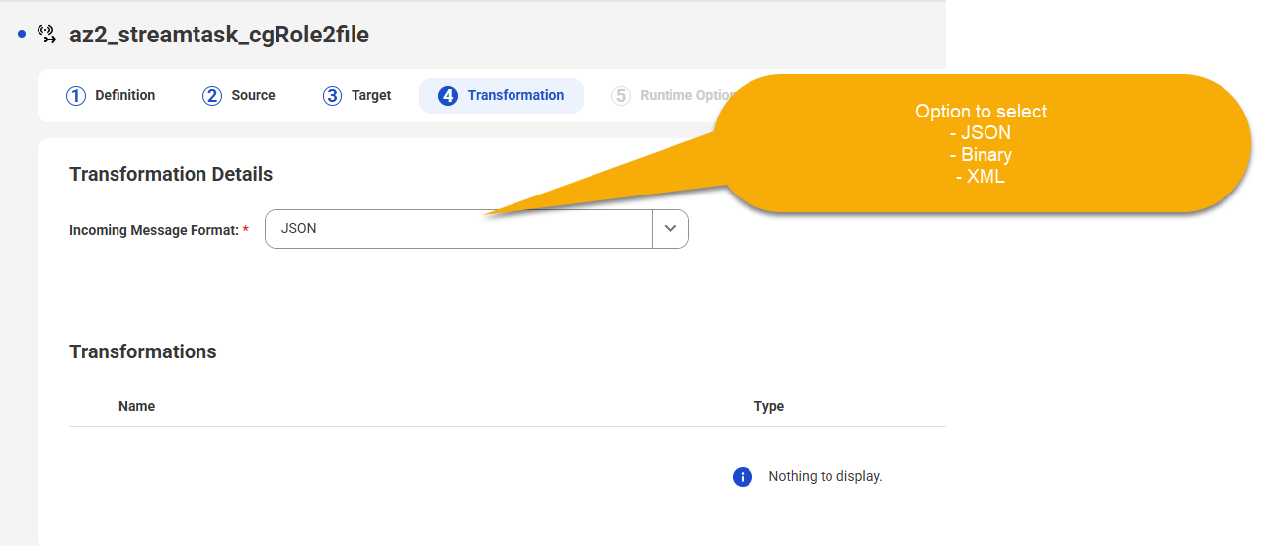

S5
Optionally enable the transformation, for now we can skip it
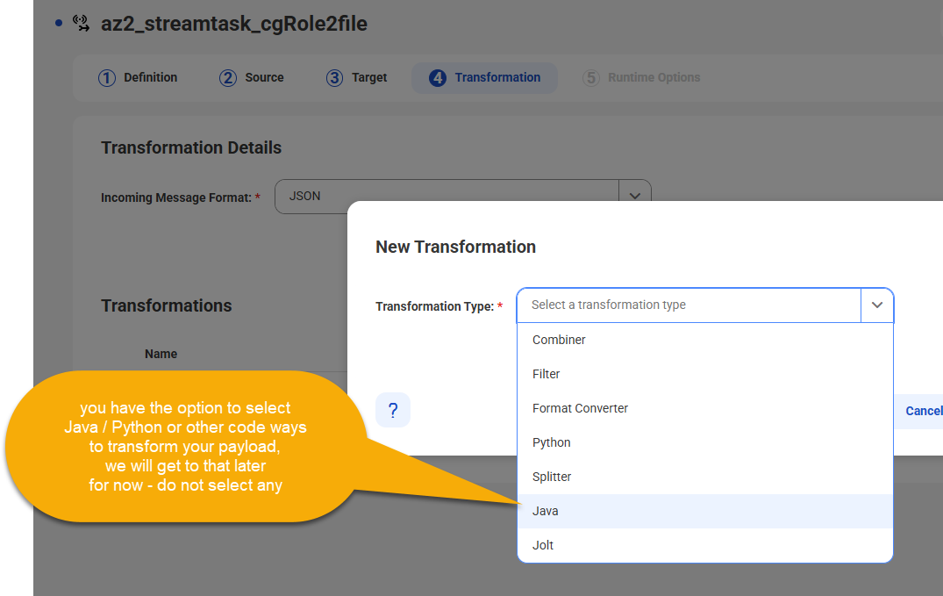

S6
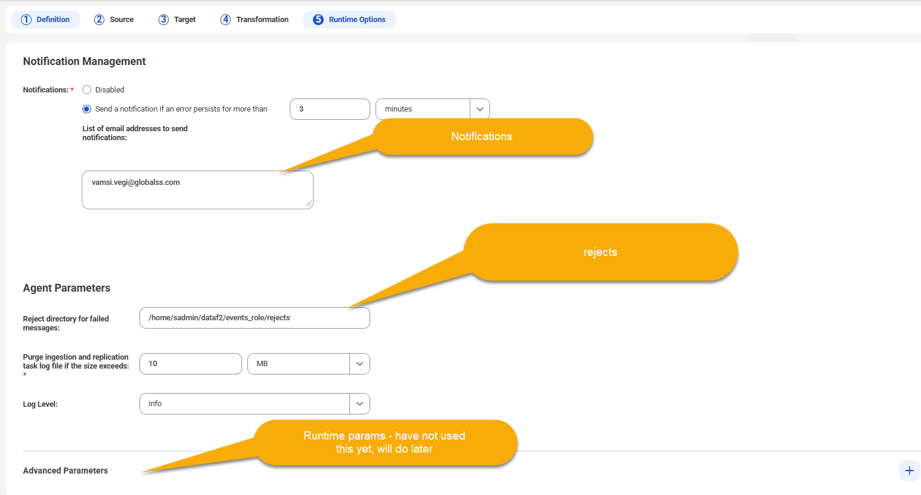

S7
save and deploy
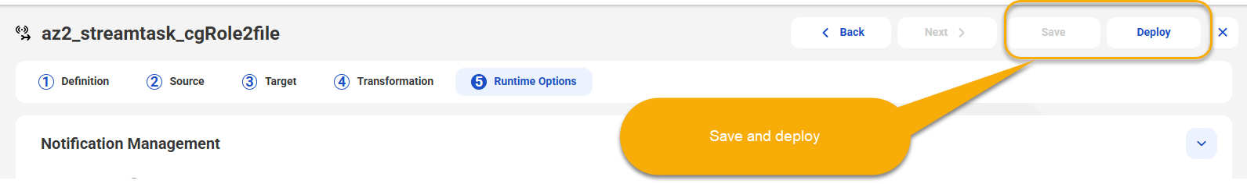

S8

Edit data via BE API – CG_ROLE

Now lets produce some events, but editing data for the CG_ROLE, we will use the REST API and not the MDM SaaS UI for this case
note: the internal id is cg_roles

S1
Login and get the sesssion id
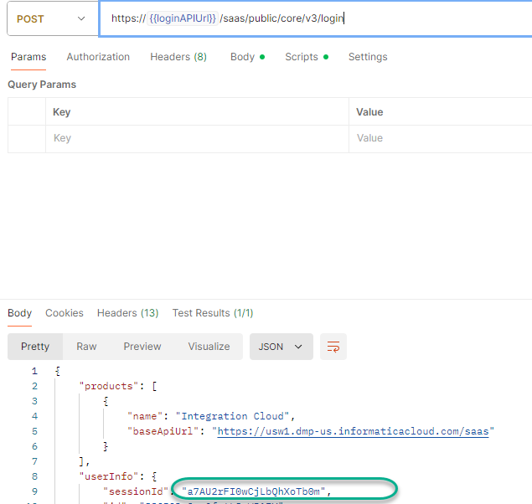

S2
create a record
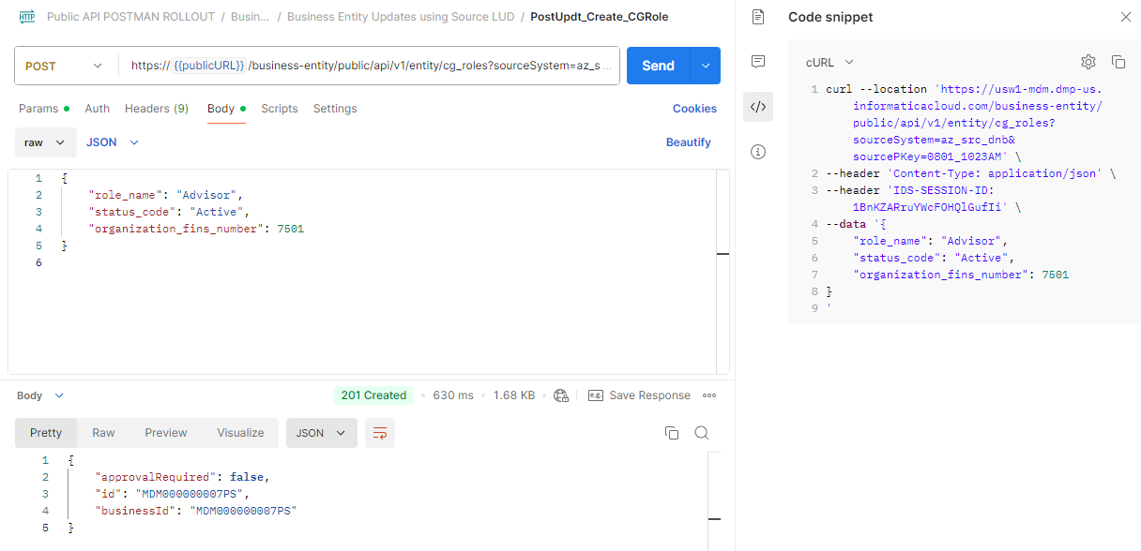

see the event published in the File system
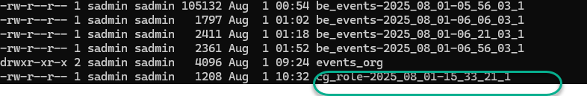

See the event content
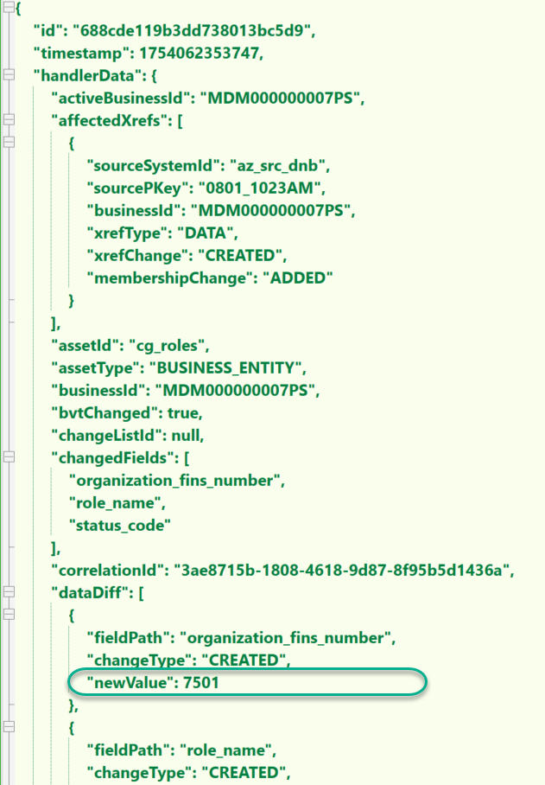

full payload attached here
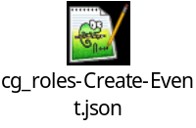

Now lets update it and see the event, see the curl below
curl --location 'https://usw1-mdm.dmp-us.informaticacloud.com/business-entity/public/api/v1/entity/cg_roles?sourceSystem=az_src_dnb&sourcePKey=0801_1023AM' \
--header 'Content-Type: application/json' \
--header 'IDS-SESSION-ID: 1BnKZARruYWcFOHQlGufIi' \
--data '{
"role_name": "Relationship Manager",
"status_code": "Active",
"organization_fins_number": 100001
}
'

changed both the role_name and Org_fins_number

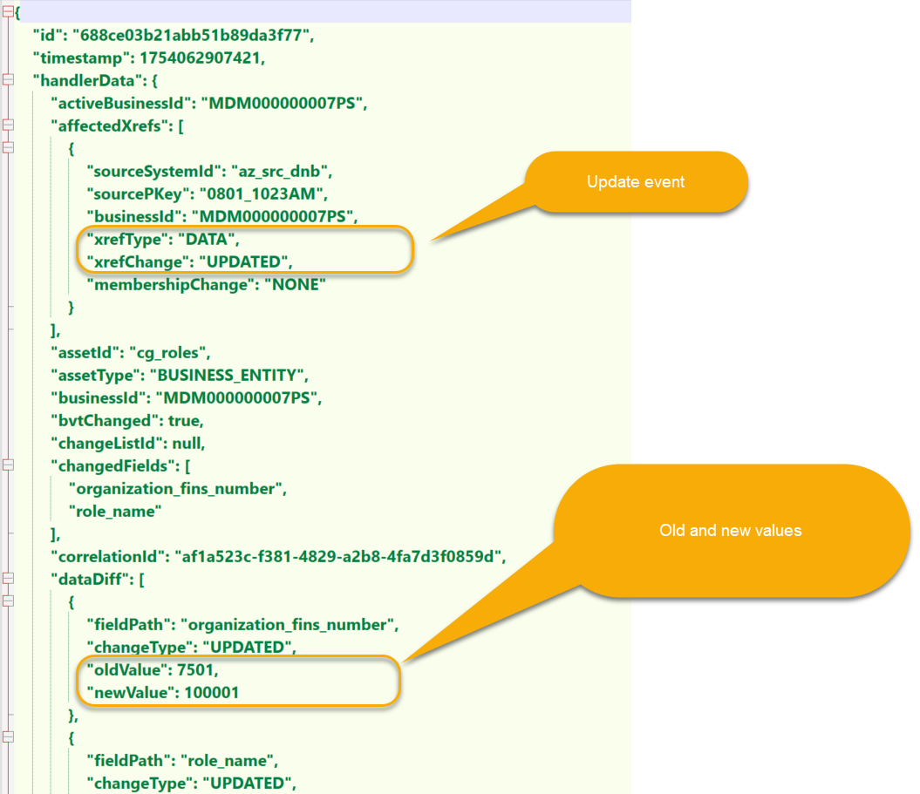

full repsonse payload
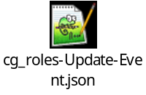

Now lets delete it

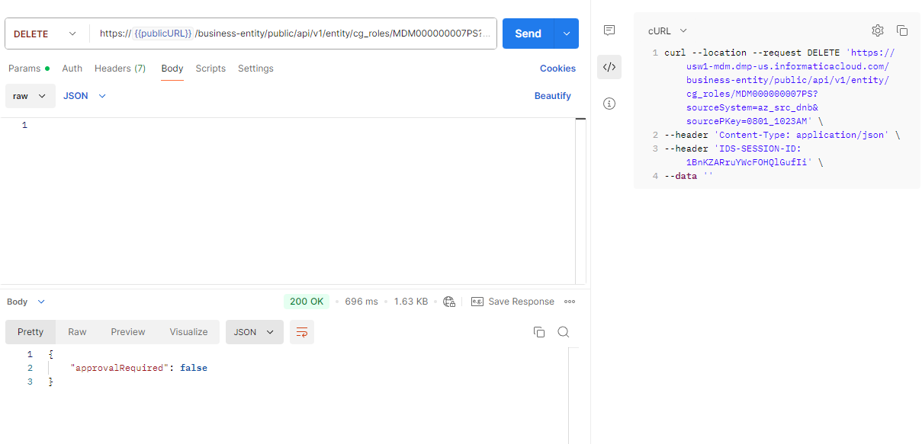

curl is

curl --location --request DELETE 'https://usw1-mdm.dmp-us.informaticacloud.com/business-entity/public/api/v1/entity/cg_roles/MDM000000007PS?sourceSystem=az_src_dnb&sourcePKey=0801_1023AM' \
--header 'Content-Type: application/json' \
--header 'IDS-SESSION-ID: 1BnKZARruYWcFOHQlGufIi' \
--data ''

lets see the event
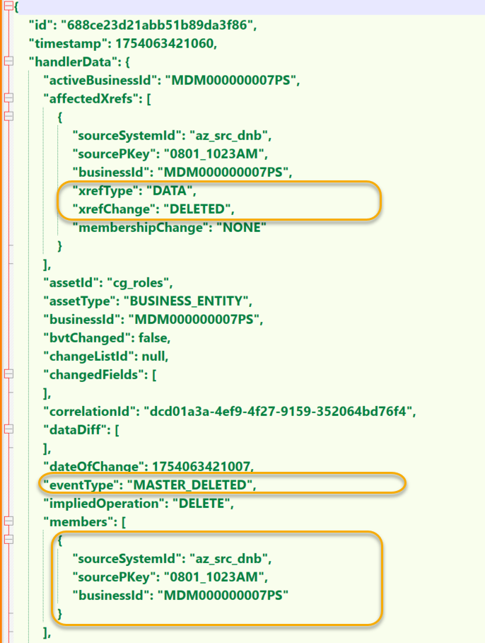

full payLoad is
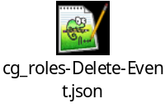

Now lets see how to publish to Kafka

Since I am using the WSL2 on my Laptop (len23) hosting RedHat V9
lets install the apache kafka over there

following the instructions at : https://learn.conduktor.io/kafka/how-to-install-apache-kafka-on-linux/

Install the Kafka software
download from here and move it your linux folder
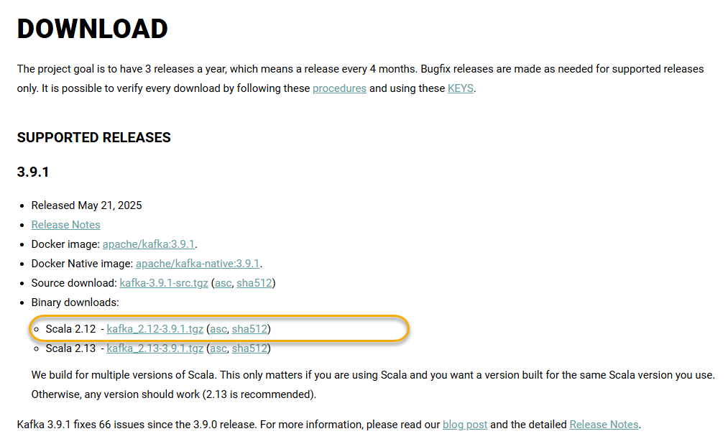

tar -xvf and the contents are as below

first set the java home
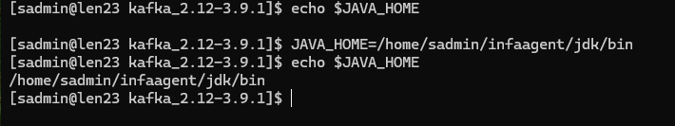

n2

start zookeeper

[sadmin@len23 bin]$ pwd
/home/sadmin/kafka-brokers/kafka_2.12-3.9.1/bin
[sadmin@len23 bin]$ ./zookeeper-server-start.sh
USAGE: ./zookeeper-server-start.sh [-daemon] zookeeper.properties
[sadmin@len23 bin]$ ./zookeeper-server-start.sh ~/kafka-brokers/kafka_2.12-3.9.1/config/zookeeper.properties

n3

Start Apache Kafka broker
Open another Shell window and run the following command from the root of Apache Kafka to start Apache Kafka.

[sadmin@len23 ~]$ cd kafka-brokers/kafka_2.12-3.9.1/bin/
[sadmin@len23 bin]$
[sadmin@len23 bin]$ pwd
/home/sadmin/kafka-brokers/kafka_2.12-3.9.1/bin
[sadmin@len23 bin]$ JAVA_HOME=/home/sadmin/infaagent/jdk/bin
[sadmin@len23 bin]$ echo $JAVA_HOME
/home/sadmin/infaagent/jdk/bin
[sadmin@len23 bin]$ ./kafka-server-start.sh ~/kafka-brokers/kafka_2.12-3.9.1/config/server.properties

N3

lets create a topic

Open another Shell window and run the following command from the root of Apache Kafka to start Apache Kafka.

cd /home/sadmin/kafka-brokers/kafka_2.12-3.9.1/bin
JAVA_HOME=/home/sadmin/infaagent/jdk/bin
echo $JAVA_HOME

[sadmin@len23 bin]$ ./kafka-topics.sh --bootstrap-server localhost:9092 --topic first_topic --create --partitions 3 --replication-factor 1
WARNING: Due to limitations in metric names, topics with a period ('.') or underscore ('_') could collide. To avoid issues it is best to use either, but not both.
Created topic first_topic.

Lets publish a msg

lets see the msg in the consumer

Open another Shell window and run the following command from the root of Apache Kafka to start Apache Kafka.

cd /home/sadmin/kafka-brokers/kafka_2.12-3.9.1/bin
JAVA_HOME=/home/sadmin/infaagent/jdk/bin
echo $JAVA_HOME

./kafka-console-consumer.sh --bootstrap-server localhost:9092 --topic first_topic
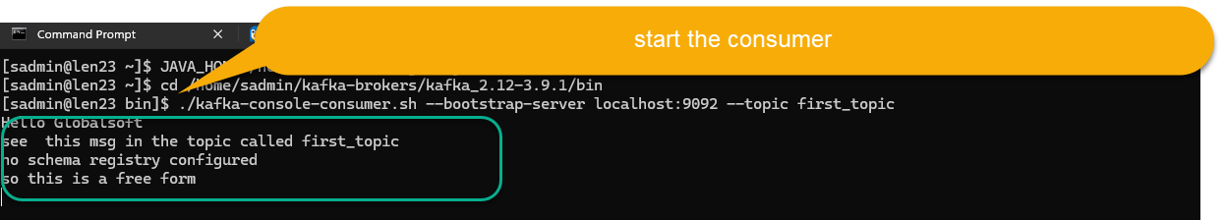

now prep the SA on LEN23 to talk to Kafka

enable kafka for len23
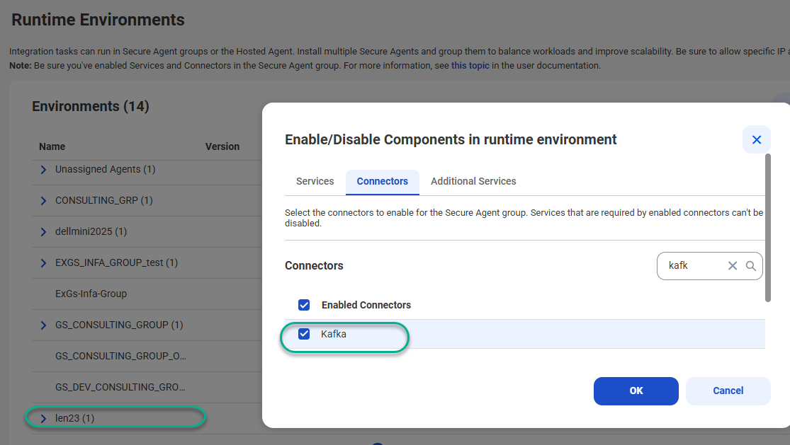

create a connector, in this case len23_kafka
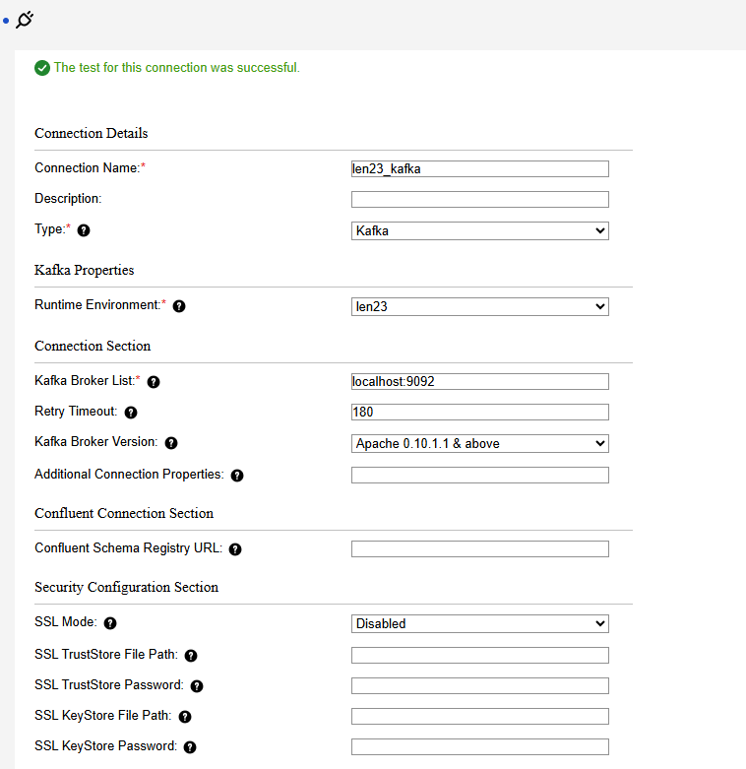

CDI - Config the Task - Streaming Ingestion Task - Kafka:

Log into the CDI and create a new Streaming Ingestion task,
create one as follows
name: az2_streamtask_cgRole2kafka
S1
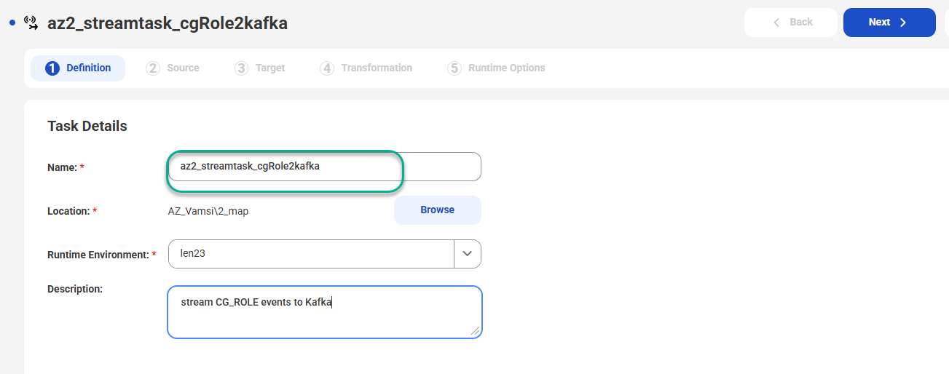
S2
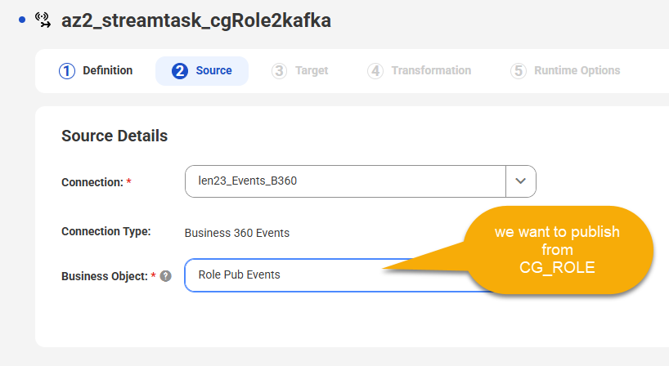
S3
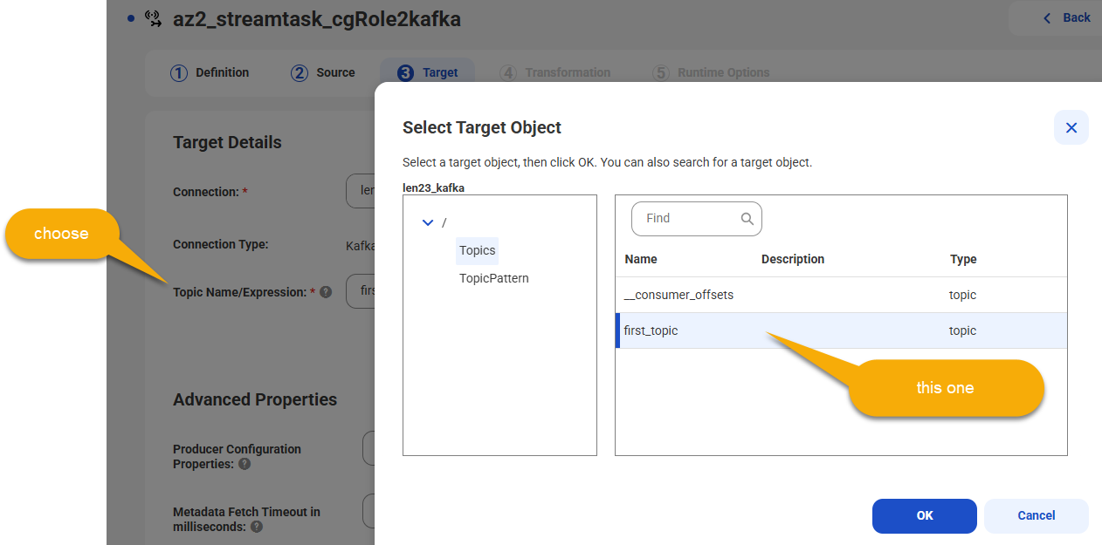
S4

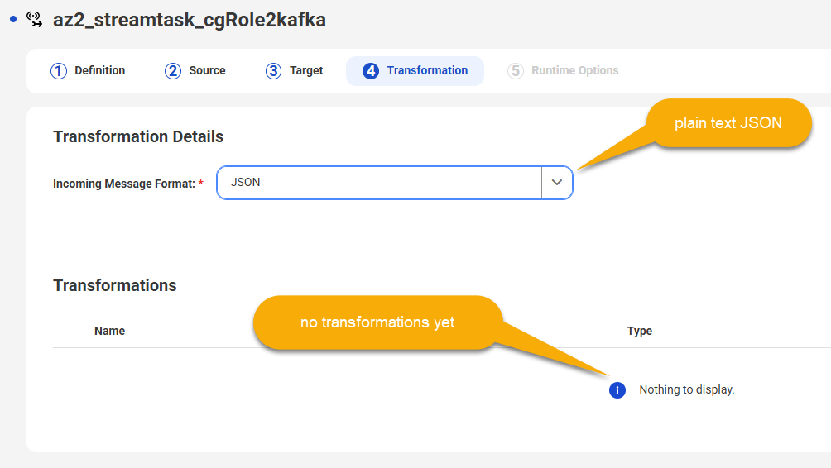
S5
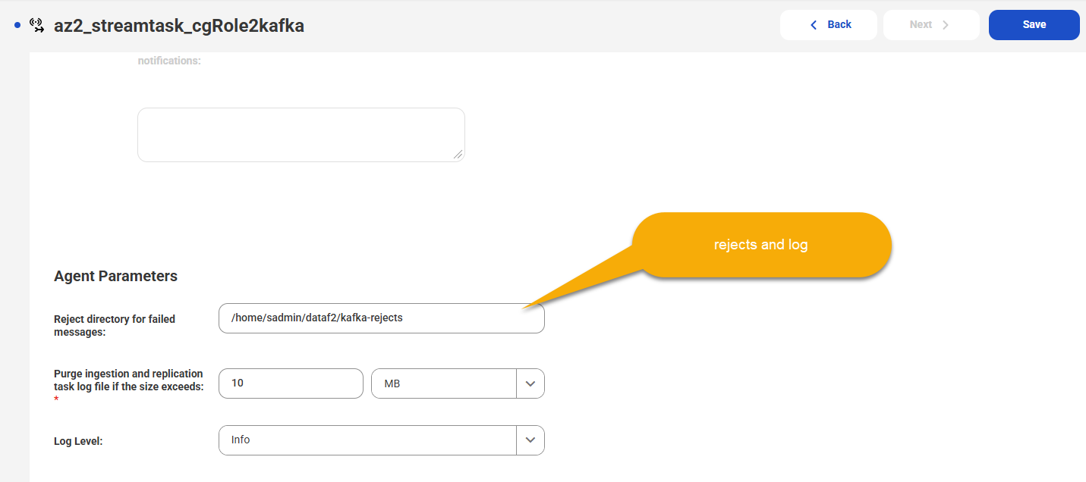
S6
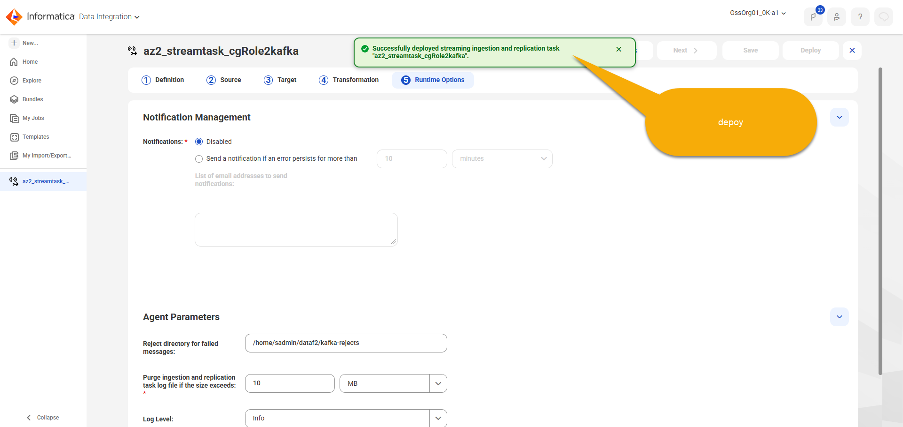
S7

Now lets test it out:create a CG ROLE
S1
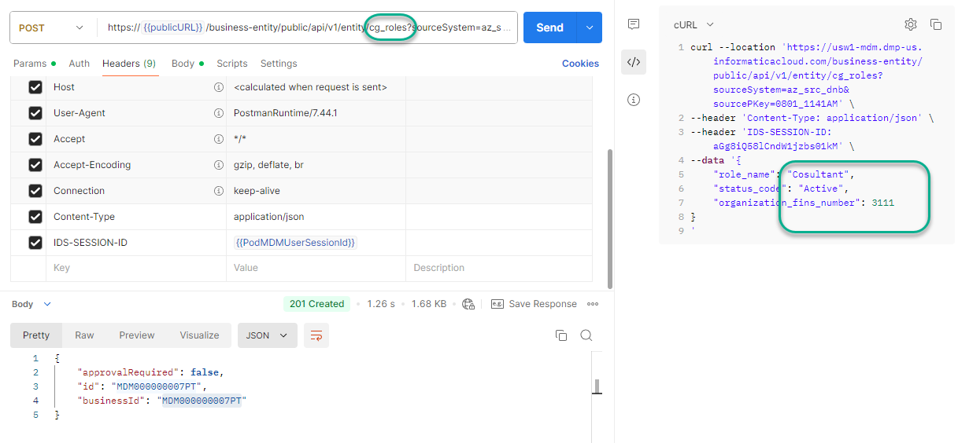
S2
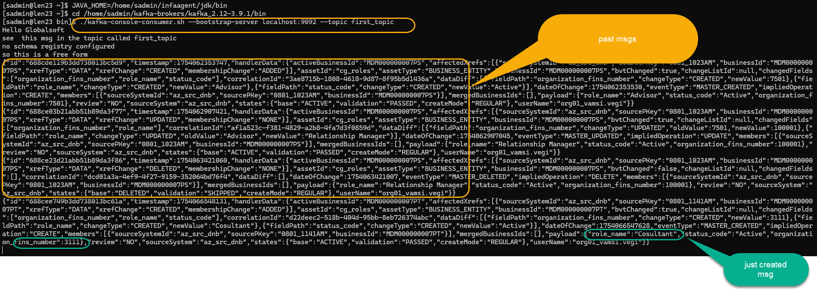

this concludes this POC
for more information reach out
thanks

