  - Subtitle

GetStarted-Postgeres_for_infa_training

Install Postgress from EDB website
Launch the pgAdmin
Username : postgres
Pwd: sanity
You will see default DB and Roles

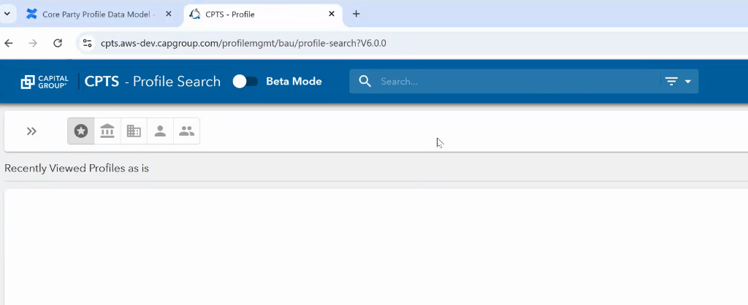

..

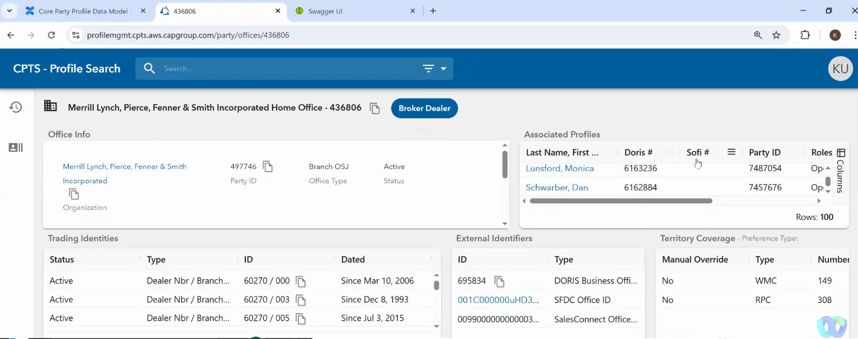

..

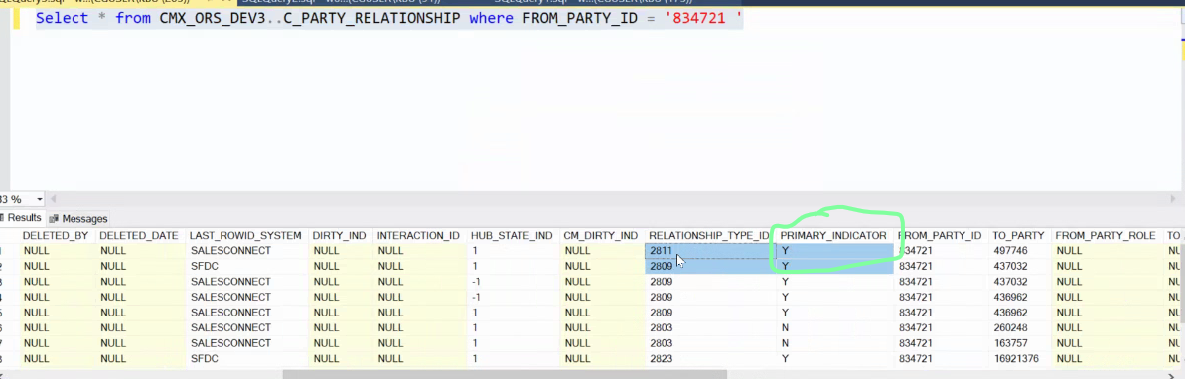

..

Understand the Role

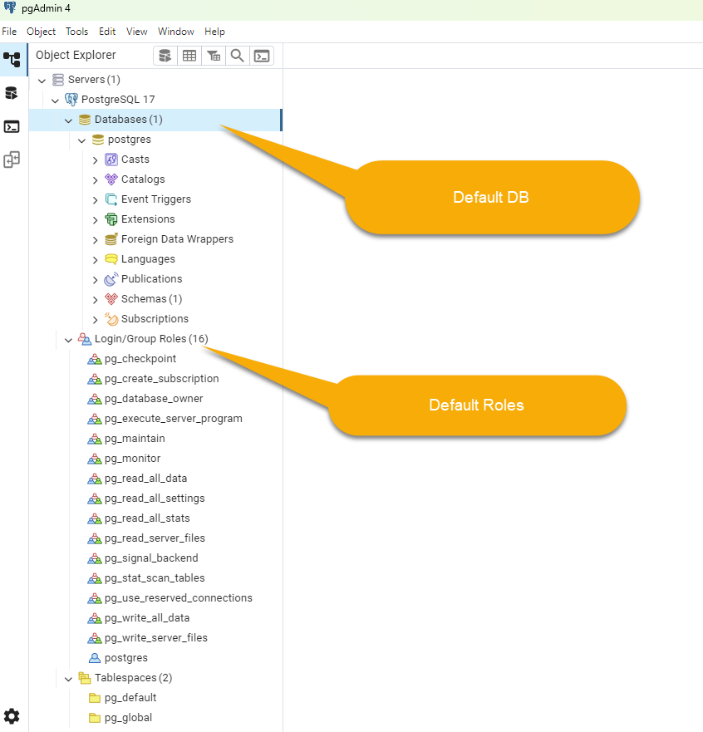

NOTE: pg has a tendency to be case sensitive and therefore, use lower case for all objects, that way you do not have to qualify with double quotes.
The double quote will return an Identifier that is case sensitive
Without it, pg will internally convert all identifiers to lower case

Create a DB called sam_db (lowercase) and no schema.
No schema, we will use public
For some reasons the postgres is trickey, when it comes to
- Creating db & associating an owner
- Logging in as the owner and start issunig DDL and DML
Below are the steps (could be made better, need to read up)
We will use DB Beaver
First : create a conn to database =‘postgres’ user =‘postgres’
And then open SQL file and run as shown

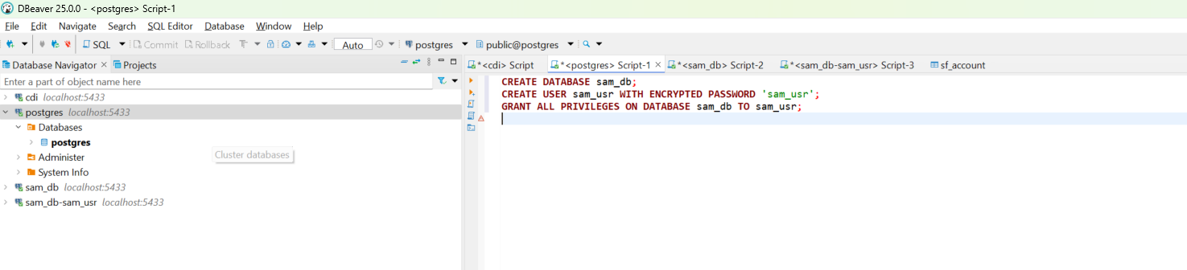

Next : create a conn to database =‘sam_db’ user =‘postgres’
Then issue the below SQLs
# You are now connected to database "sam_db" as user "postgres".
GRANT ALL ON SCHEMA public TO sam_usr;
Next : create a conn to database =‘sam_db’ user =‘sam_usr’
Now create tables etc

IICS – Create Connection
As below
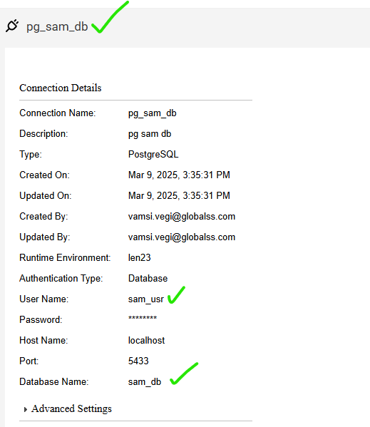

Create a DB called fitch_db (lowercase) and no schema.
Same user name sam_usr
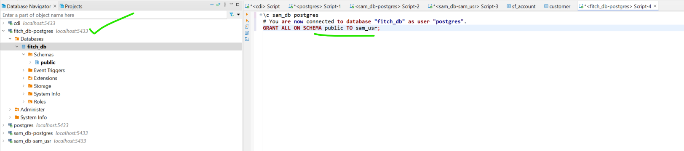

Create a conn on IICS.




