  - Subtitle

GetStarted-Postgeres_for_infa_training

Install Postgress from EDB website
Launch the pgAdmin
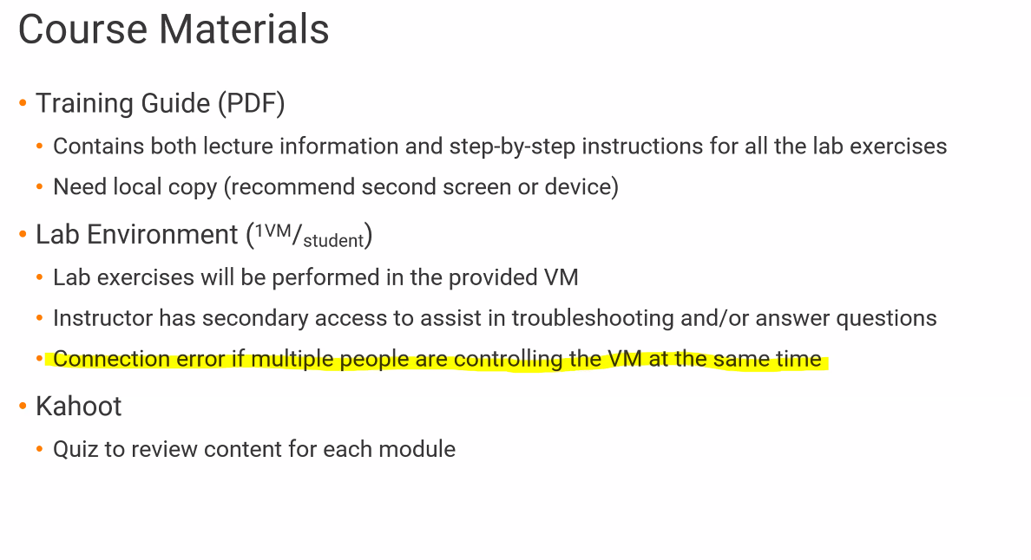

Lab 1
- Launch the provided VM
  - VM link is in the eMail
- Set up MDM App – login as admin (user name pwd in the email)
  - Create first user user: vamsistudent010/Multidomain360
- Login in as student
  - Enable MDM App
  - Download Secure Agent
    - Enable services and connectors
  - Verify run time (take 20 mins to sync up)
  - Create connections
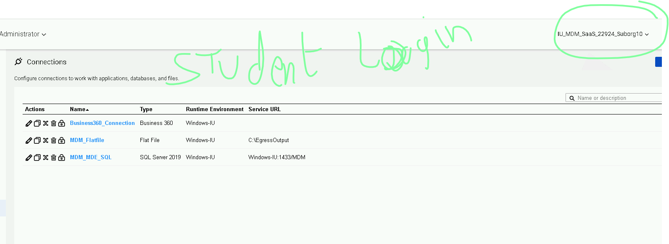
To get certification
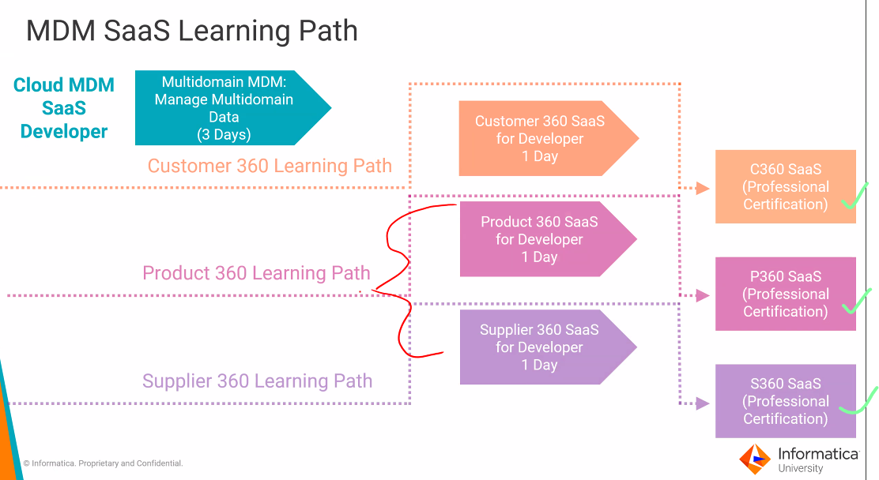

Lab 2
Here will use Multidomain MDM (i.e not C360), therefore it’s a blank data model

