Work Notes: This is a notes on

* set up GitHub – PcktPub Book: Python for finance 2nd ed
* etc

Doc History:

Jan 31st, 2019 : doc created

Contents

Install Anaconda: 1

Getting Started: Create a GitHub project 3

# Install Anaconda:

|  |
| --- |
| see the documentation in lrn-kb dir for   * install and get running using Anaconda |

# Getting Started: Create a GitHub project – Py Finance 2nd ed : YuXing

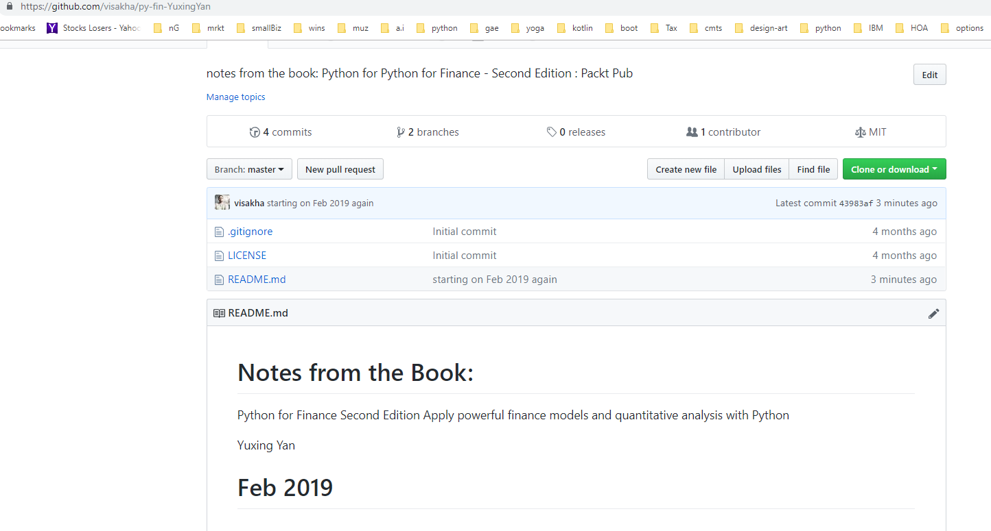

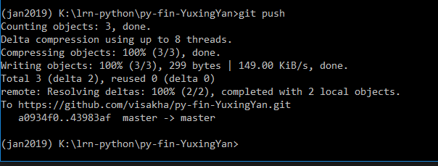

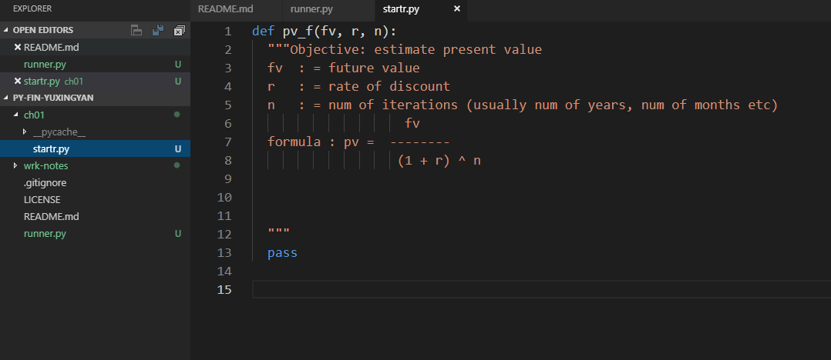

see the definition in cmd

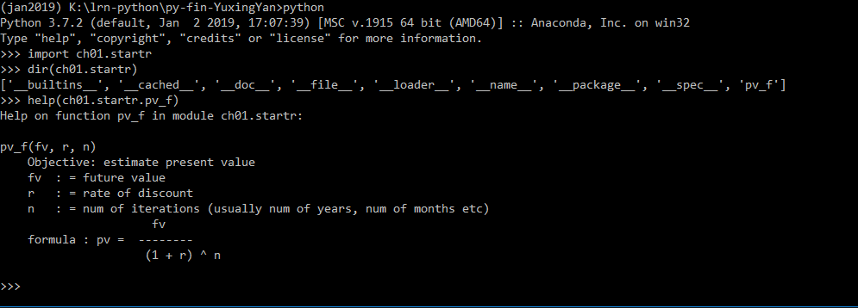

define rr() for re-load in the cmd:

now in the cmd define as below

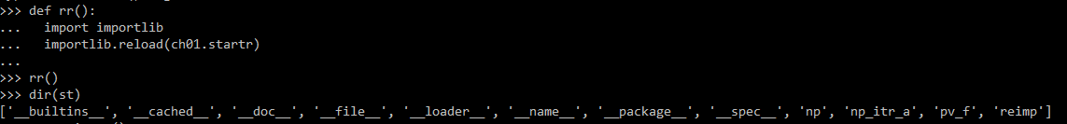

where st is defined as

import ch01.startr as st

Now you can edit the file in vs code and then issue rr() and tun the new code

ex:

