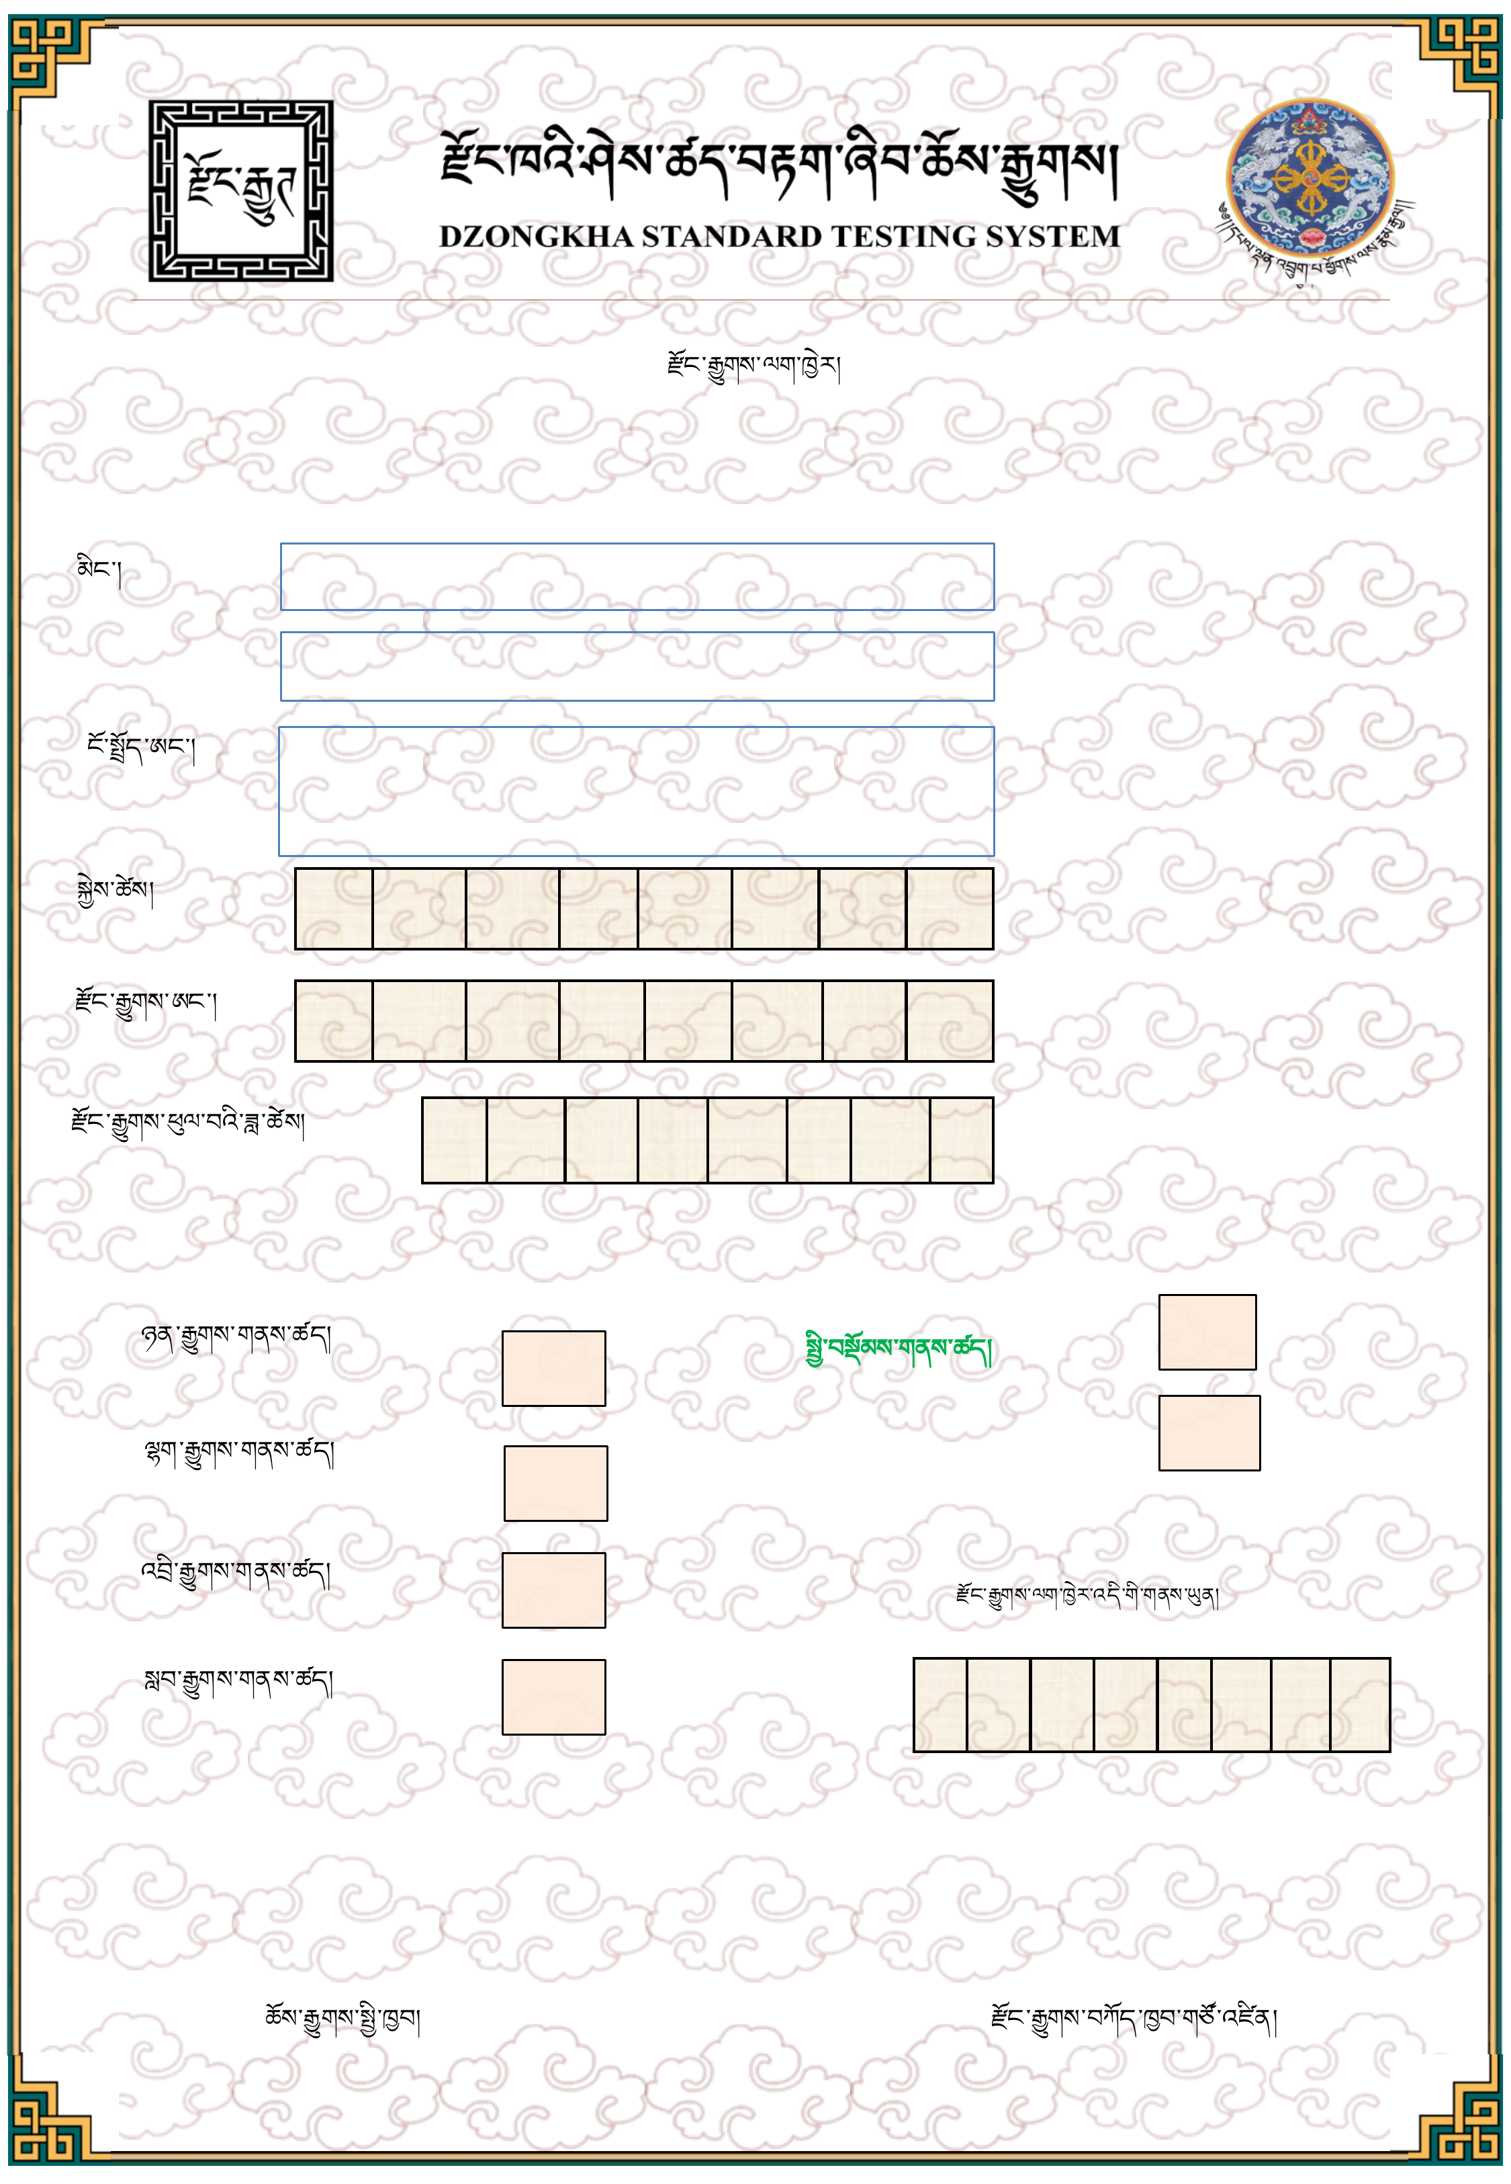
DSTS CERTIFICATE
Name
ID No.
Date of Birth
DSTS No.
Date of Examination
LISTENING
READING
WRITING
SPEAKING
OVERALL LEVEL
This certificate is valid tilL
Chief of Examination
Chief Executive, DSTS
PHOTO
བསོད་ནམས་རིན་ཆེན།
Sonam Rinchen
༡༡༦༠༤༠༠༠༩༣༣
11604000933
༠ ༡ ༡ ༡ ༡ ༩ ༩ ༨
ཀ ༠ ༤ ༠
༣ ༡ ༡ ༢ ༢ ༠ ༢ ༥
༦
༥
༦
༦
༦
6
༢ ༣ ༠ ༡ ༢ ༠ ༢ ༩

