**UART Testbench Architecture**

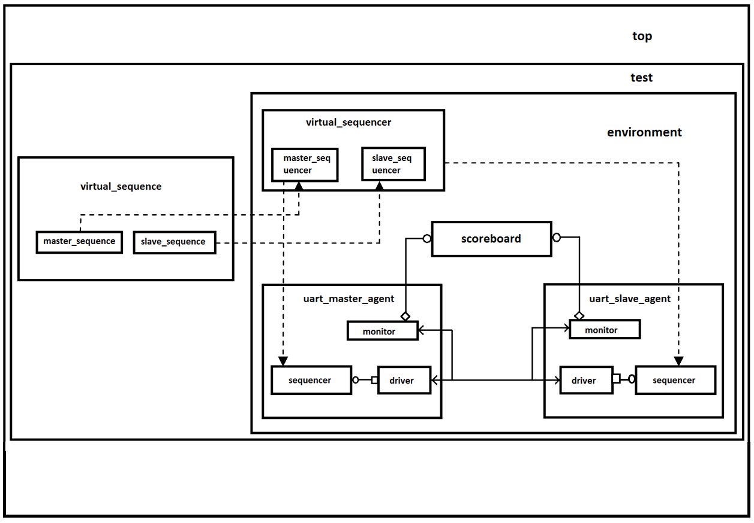

vif

vif

static interface