**Sporty Shoes Ecommerce Website**

Sporty Shoes Ecommerce website allows user to signup and purchase the shoes manufacturing by sporty shoes company. The user interface of the website allows the users to place the multiple orders and view the past orders history. This website has the separate interface for admin where admin can manage list of products (add, delete and view), view the list of users who are signed up and view the purchase history of all users (filtered by date and category).

**Github Link:**

**Tools & Technologies**

This is the home page of the application.

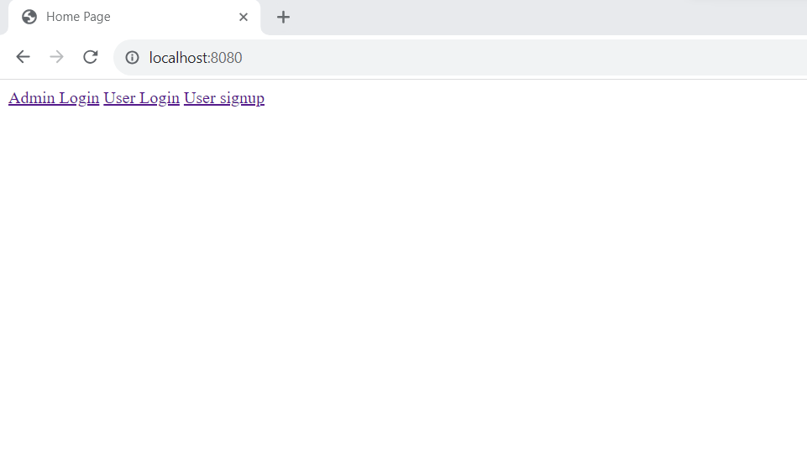

User-signup page asks the user to enter the details for login registration. once the user registration is successful the user will be redirected to login page with the success message.

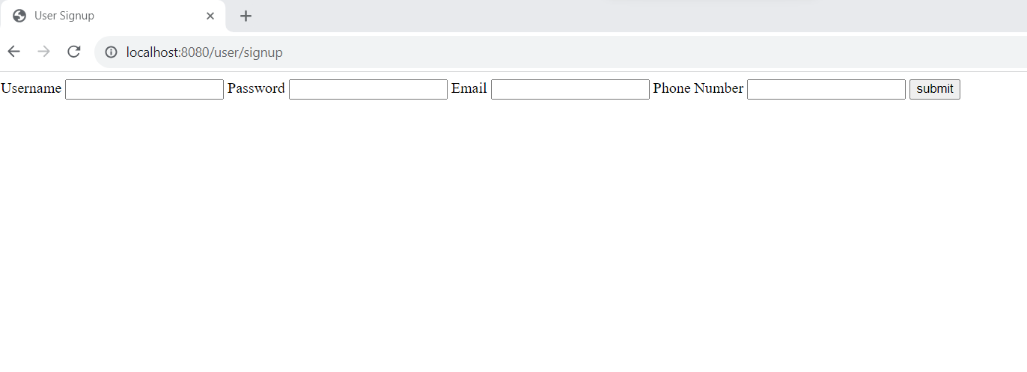

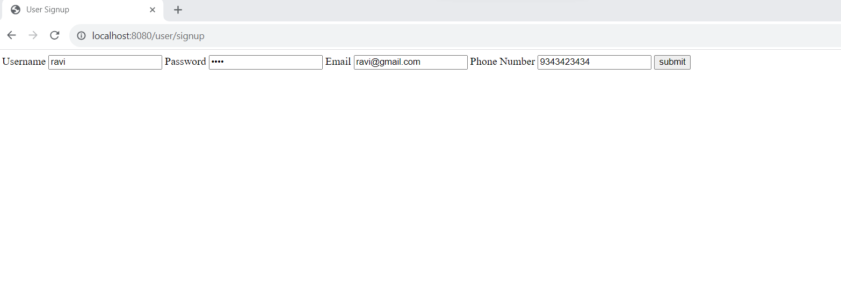

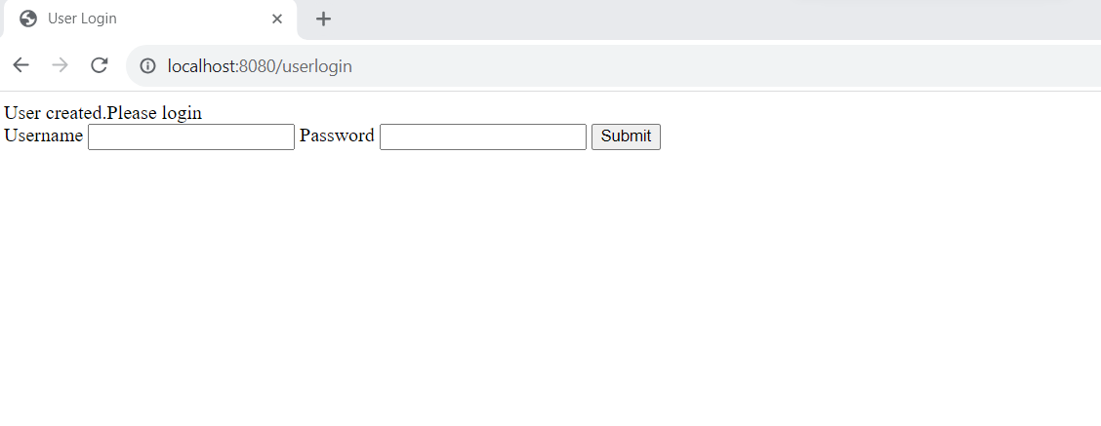

Once the user login successfully the user will be redirected to the cart page to select the items for placing the order. After selecting the require products the user will be redirected to the dummy payment gate page. In payment page user will be listed down with the selected product and asked to enter the card details for the payment. Once the payment is successful the order will be placed and request will be redirected to orders page where the user can use all of their orders.

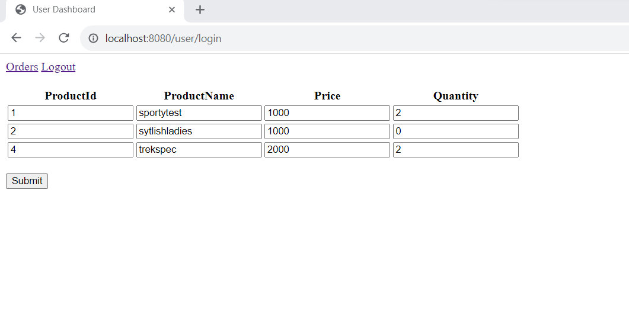

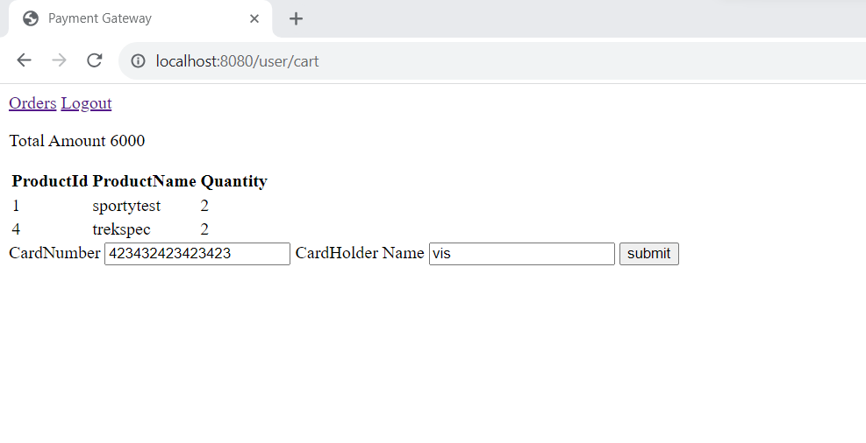

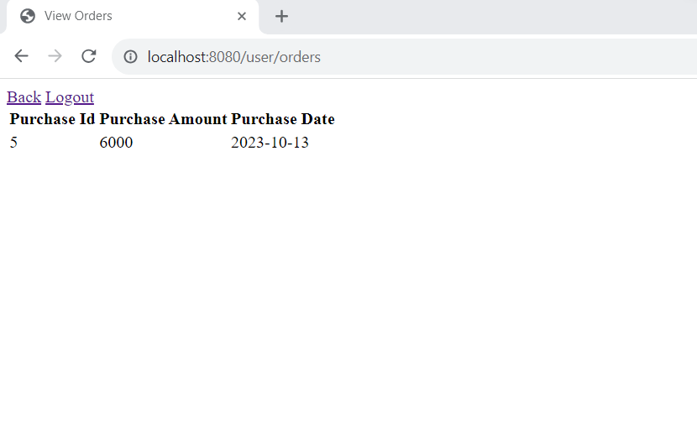

Once the order placed successfully the orders will be stored in purchase table. The purchase table is having one to many relationships with purchase_items table. purchase_items will be having the details items related to each order.

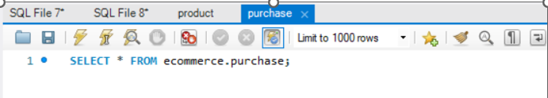

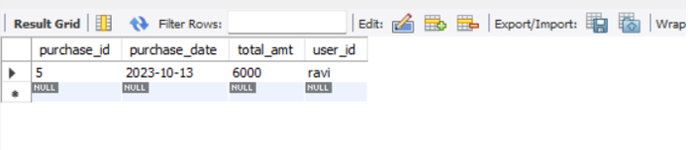

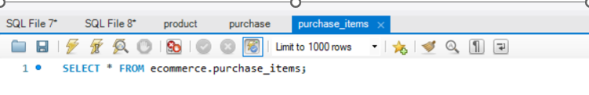

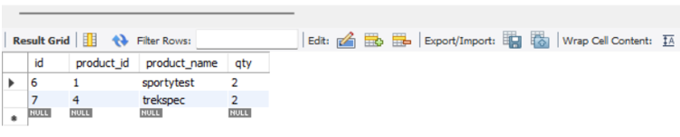

**Admin Functionalities**

Once the admin logins successfully, the request will be redirected to Admin Dashboard page.

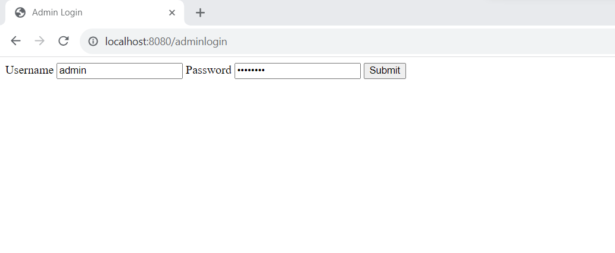

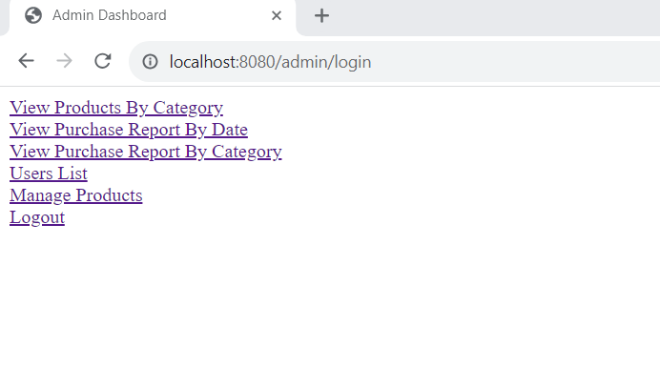

The View Products By Category link allows the user to view products based on selected category.

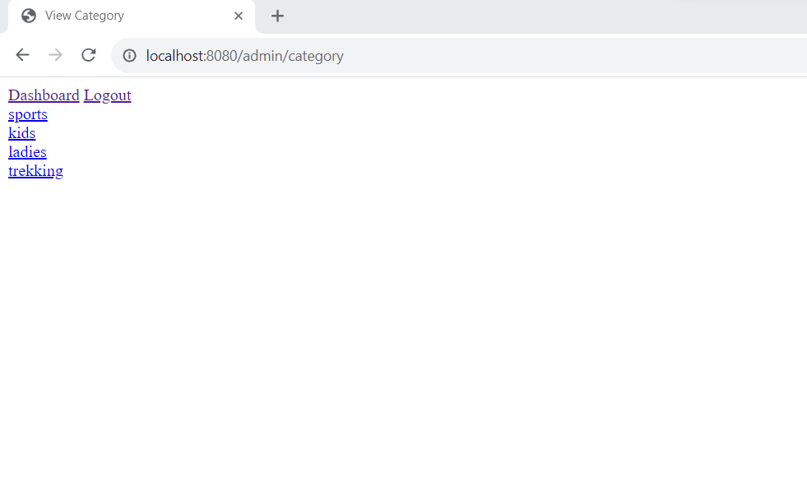

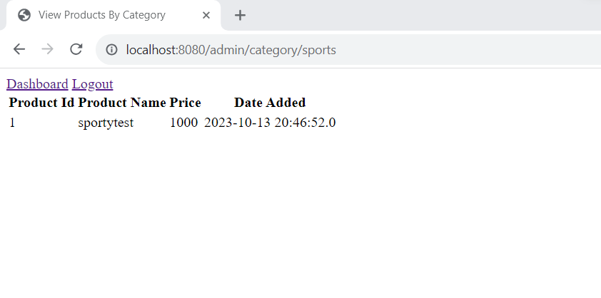

The Users List link in the Dashboard allows the admin to view list of users who are signed up .

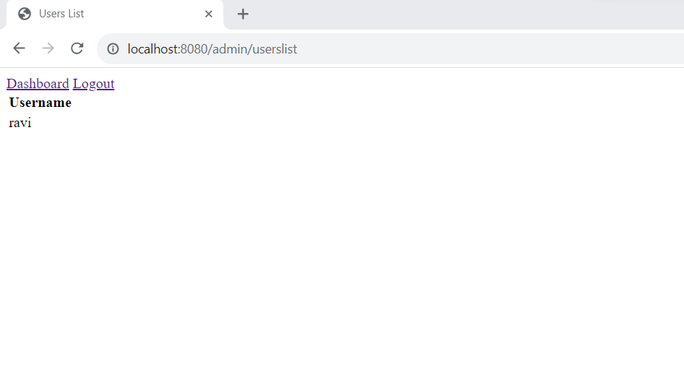

The Manage products link in the Dashboard page allows the user to add, delete or view the products.

**Add Product**

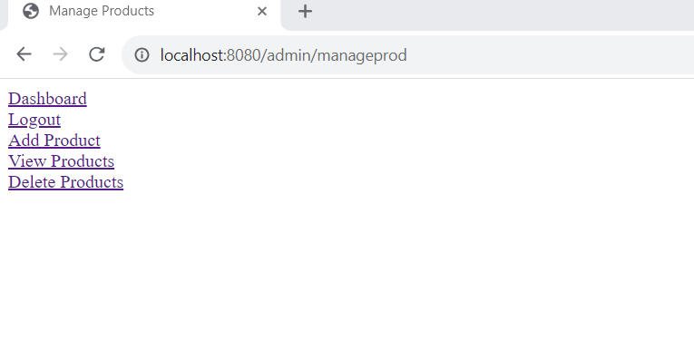

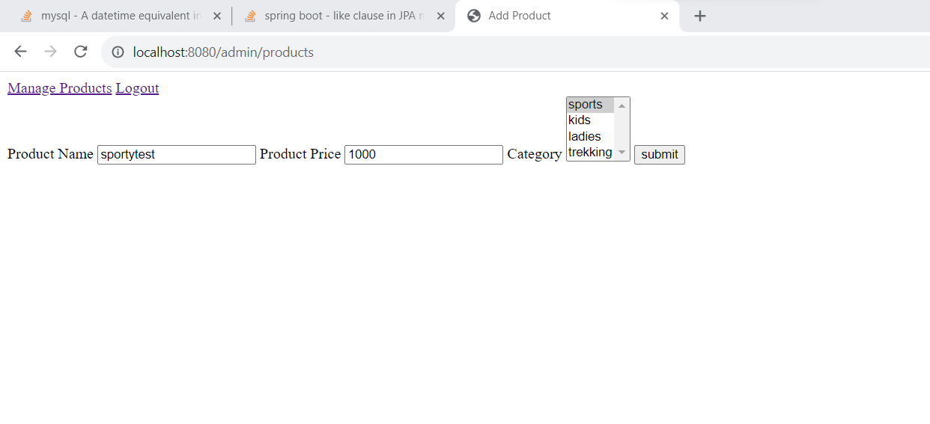

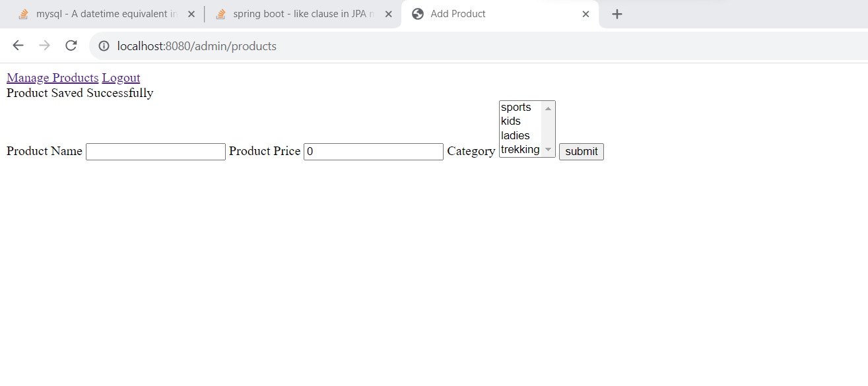

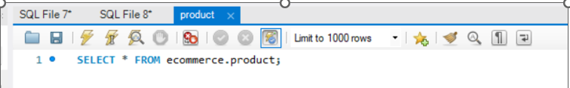

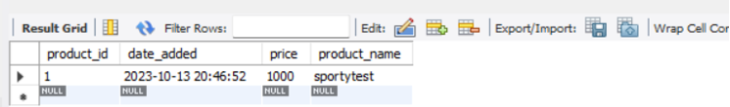

**Delete Product**

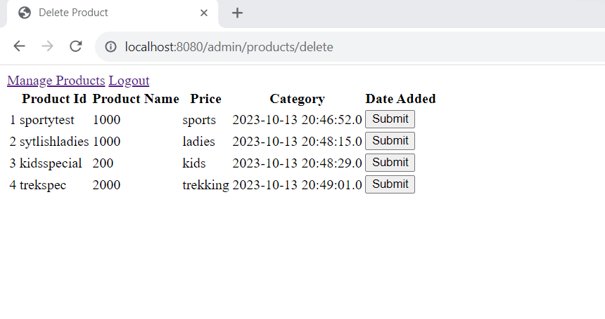

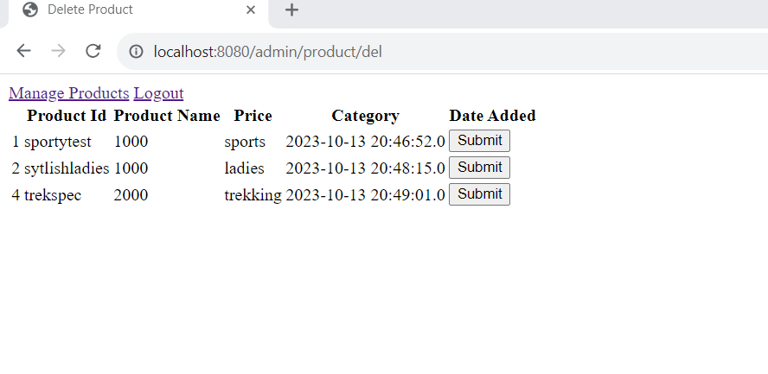

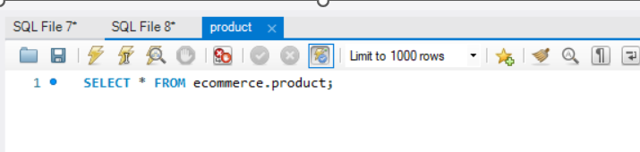

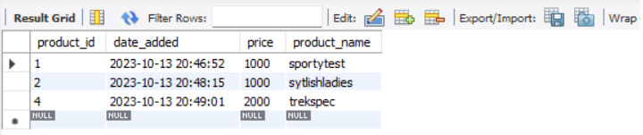

**View Products**

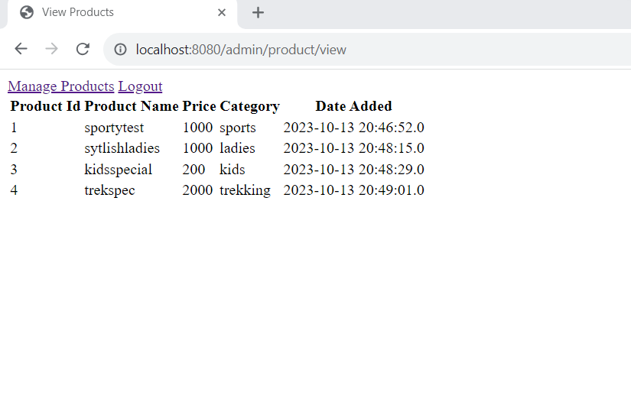

View Purchase Report By Date link in the Dashboard page allows the admin to filter the orders placed by signed up users based on the purchase date.

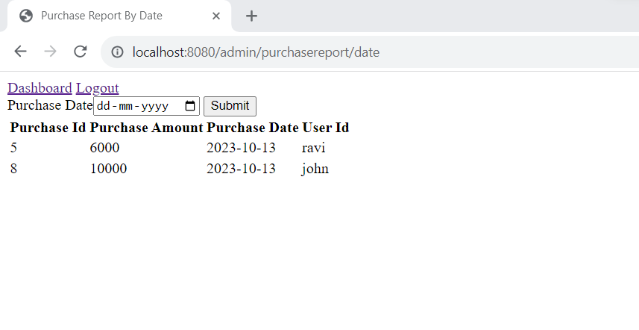

View Purchase Report By Category link in Dashboard page allows the admin to filter the orders placed by signed up users based on the product category.

