**AI Based Diabetes Prediction System**

**Phase 2: Innovation**

In this phase we went a step ahead by choosing an ensemble method to implement the ideas we proposed in the previous phase. We have put our design into innovation by the following steps.

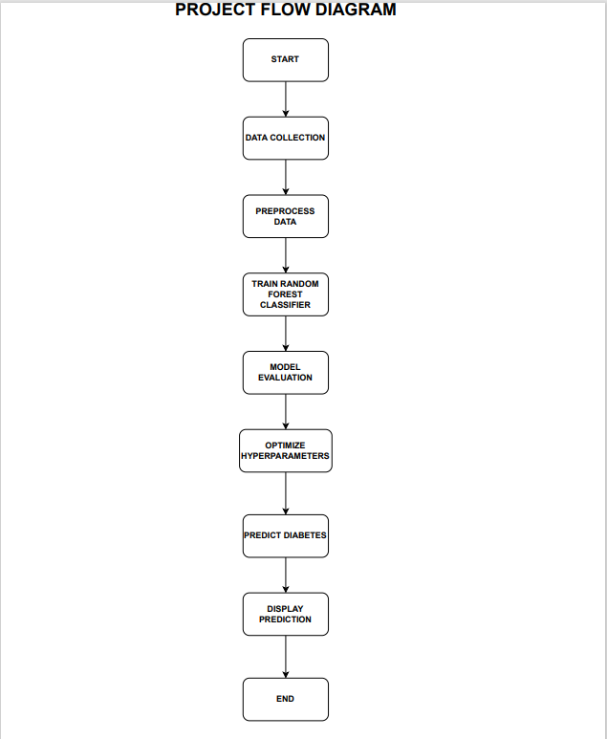

**EXPLANATION:**

**1. Data Collection:**

In the data collection phase, we will gather relevant medical data from various sources. Information such as age, gender, blood pressure, body mass index (BMI), glucose levels, and family history of diabetes may be included in this data. It's critical to make sure the dataset is broad and thorough, reflecting a range of population risk factors and demographics. Because of this diversity, the model will be able to produce predictions that can be applied to a large number of people.

**2. Data Preprocessing:**

To guarantee the quality and appropriateness of the data for training the model, data preparation is an essential step. The tasks are broken out as follows:

**Managing Missing Values:** Medical datasets frequently contain missing values. In order to solve this, we will fill in the missing data points using the proper imputation techniques, such as mean or median imputation.

**Normalization and Standardization:** We will normalize the data to make sure that all features have comparable scales. This procedure stops the model from being dominated by one feature while it is being trained.

**Data division:** The dataset will be split into two sections: around 70% for training and 30% for testing. This allows us to train the model on one subset and evaluate its performance on another, ensuring that the model can generalize well to unseen data.

**3. Train Random Forest Classifier:**

We initialize a Random Forest model with particular hyperparameters in this stage. The number of trees in the forest, the greatest depth at which a tree can be found, and the bare minimum of samples needed in a leaf node are a few examples of these hyperparameters. Next, the training dataset is used to train the model. An effective option for this task is Random Forest, an ensemble learning technique that combines the predictions of several decision trees.

**4. Model Evaluation:**

To assess the model's performance, we use various evaluation metrics. These metrics include:

**Accuracy:** It measures the proportion of correct predictions.

**Precision:** It calculates the ratio of true positive predictions to the total positive predictions.

**Recall:** It computes the ratio of true positive predictions to the total actual positives.

**F1-Score:** It is the harmonic mean of precision and recall, providing a balanced measure of model performance.

Additionally, we use a confusion matrix to summarize true positives, true negatives, false positives, and false negatives, aiding in the interpretation of the model's performance. These metrics help us understand how well the model is at correctly classifying individuals as diabetic or non-diabetic.

**5. Optimize Hyperparameters:**

Despite the robustness of Random Forest, we can improve the model's performance by fine-tuning its hyperparameters. The basic settings for our particular dataset can be discovered by experimenting with various combinations of hyperparameters using methods like grid search or random search.

**6. Predict Diabetes:**

In this step, we gather new patient data, which includes the same features used for training the model. This data should be collected in a manner that mirrors the data format and quality used in the training dataset.

**7. Use the Trained Model to Predict Diabetes:**

The preprocessing steps for the new patient data will be the same as for the training data. We will use the trained Random Forest model to make predictions about the patient's likelihood of having diabetes after preprocessing.

**8. Display Prediction:**

The model's prediction is shown in the last step. This could include a clear indication of whether the patient is at risk for diabetes, as well as any additional information or recommendations based on the prediction.

**9. End:**

The procedure is complete once the prediction is shown, giving patients and healthcare providers useful details for early intervention and preventive measures.