**EC2 Assignment**

**Problem Statement:**

You work for XYZ Corporation. Your corporation wants to launch a new web-based application Using AWS Virtual Machines, configure the resources accordingly for the tasks.

**You are asked to perform the following tasks:**

1. Create an Instance in us-east-1 (N. Virginia) region with an Ubuntu OS and install Nginx for making them web servers.

2. Change the default website with a page displaying the message “Hello World”.

**Problem 1 Solution:** Create an Instance in us-east-1 (N. Virginia) region with an Ubuntu OS and install Nginx for making them web servers.

**Step 1: Go** tothe **“Services” section** & **search** the **“EC2”** service. **Put** the **cursor** over **“EC2”** & **click** on the **“Instances”.**

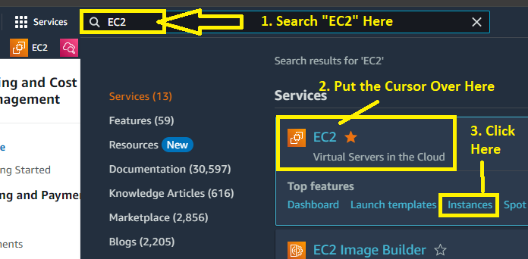

**Step 2: Click** onthe **“Launch Instances”.**

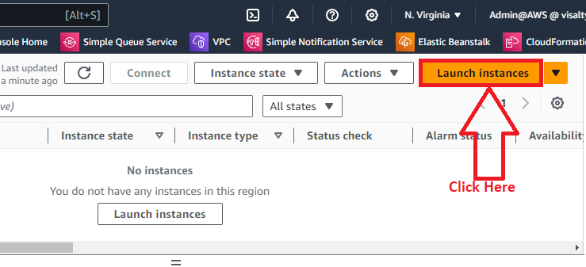

**Step 3: In** the **“Name and tags”** section, **put** the **Name** as “**EC2_NGINX_ASSIGNMENT”.**

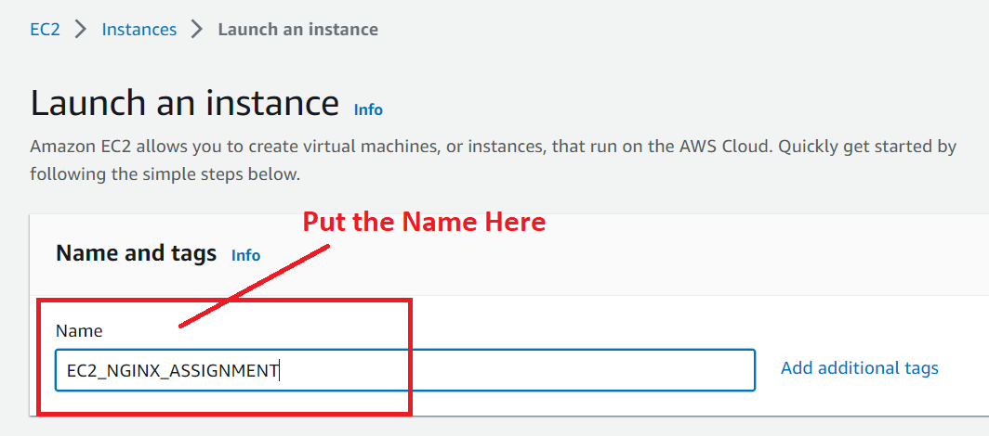

**Step 4: Choose AMI** as **“Ubuntu”.**

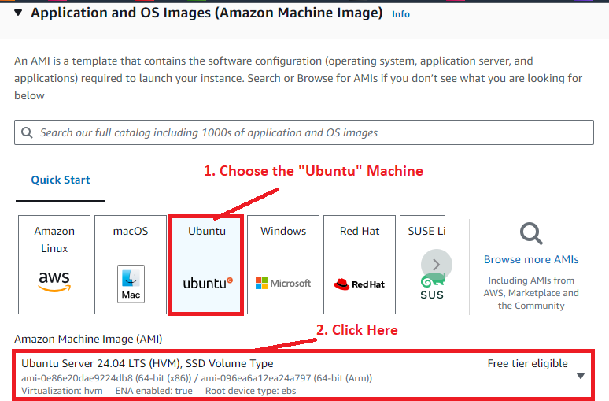

**Step 5: Choose Instance Type** as **“t2.micro”** & **Key pair name** as **“Proceed without a key pair (Not recommended)”.**

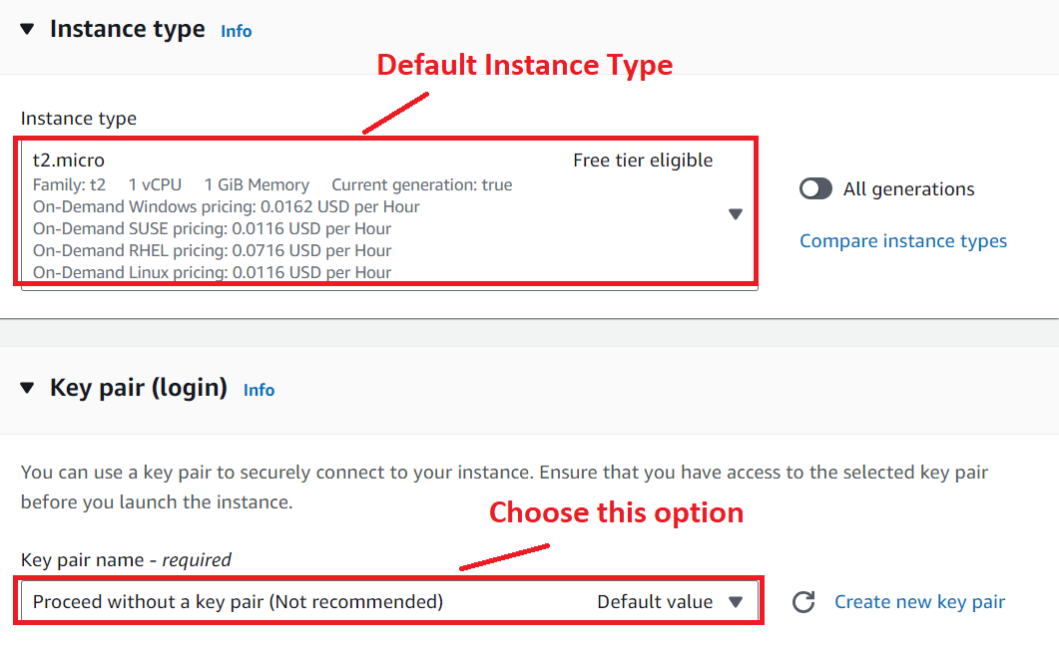

**Step 6: Remain “Network Settings”** as **by default** & **Choose the following options here:**

**Firewall (security groups): -** Create security group

**Allow SSH Traffic from:** Anywhere (0.0.0.0/0)

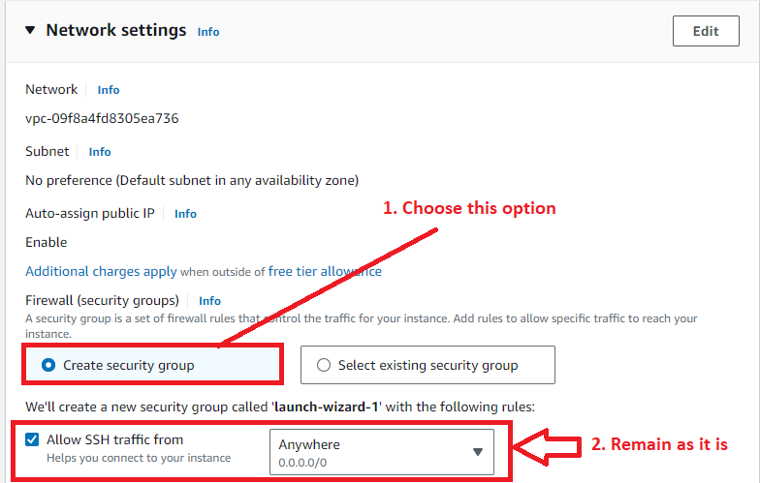

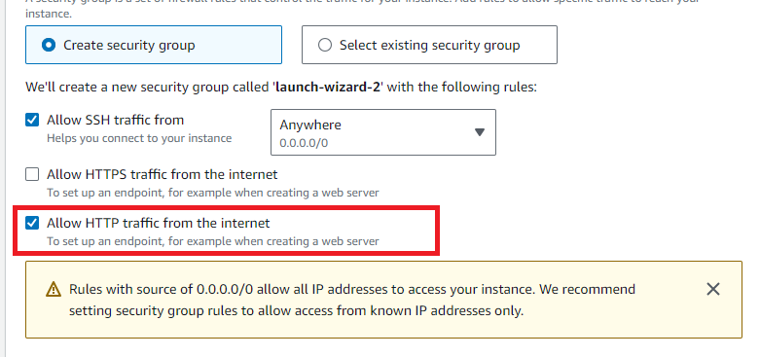

**Step 7: Remain** the **“Configure Storage”** as it is& **click** on the **“Launch Instance”.**

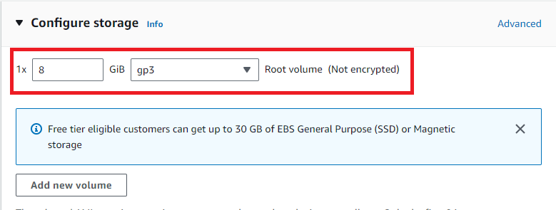

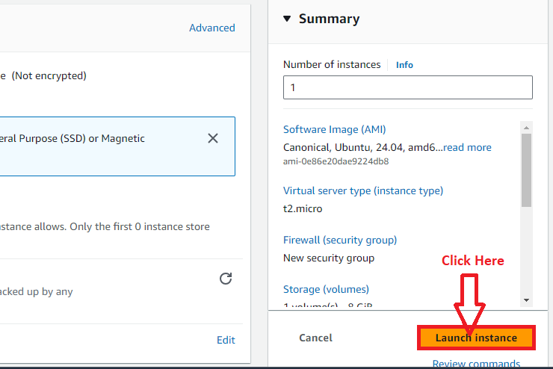

**Step 8: The Instance (EC2_NGINX_ASSIGNMENT)** will be **successfully launched. Click** on the **“Instance Id” starts** from **“I”. (Instance Id: i-0133b75bfd00581b8).**

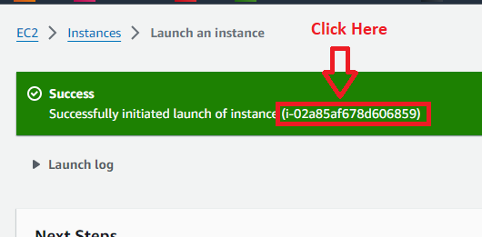

**Step 9: Your instance (EC2_NGINX_ASSIGNMENT)** will be **in** the **“Running” state.**

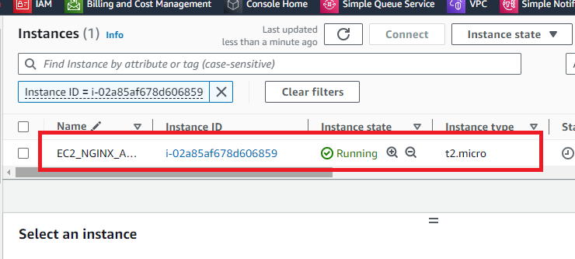

**Step 10: Select** the **Instance (EC2_NGINX_ASSIGNMENT)** & **click** onthe **“Connect”.**

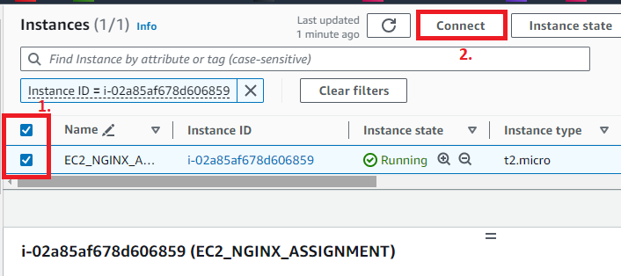

**Step 11: In** the **“EC2 Instance Connect”, click** on the **“Connect”.**

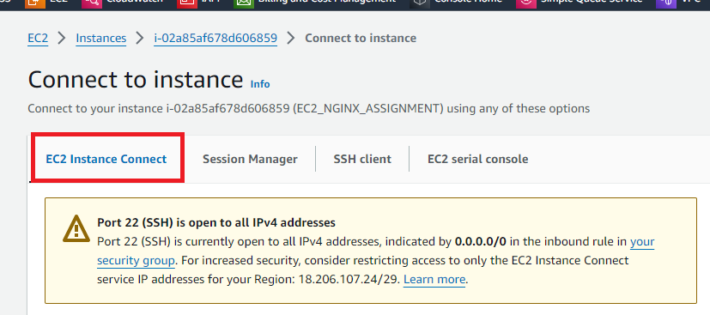

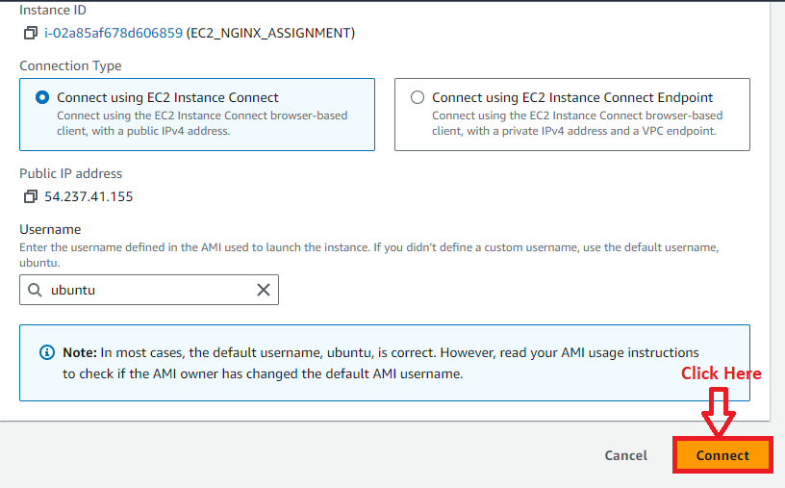

**Step 12: Your Instance (EC2_NGINX_ASSIGNMENT)** will be **successfully connected.**

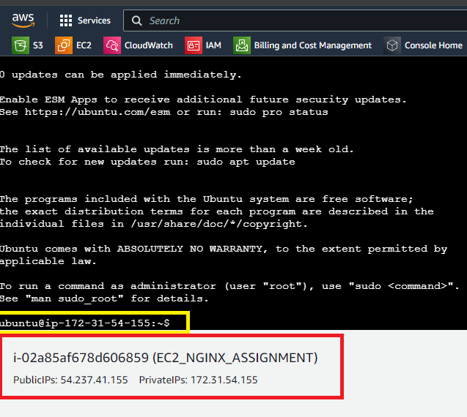

**Step 13: First, we will run** these **two commands** for **installing** the **Nginx. Using first command, we** will **access** the **recent packages, while second command** helps us **installing Nginx** on **Ubuntu.**

**1. sudo apt-get update –** This **command uses** for **updating** the **packages.**

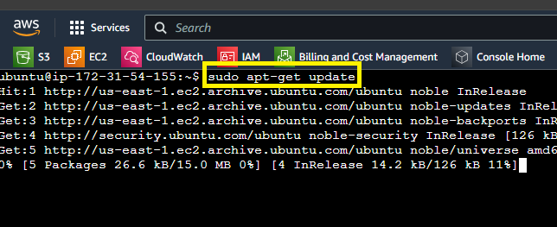

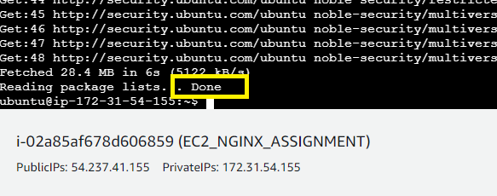

**2. sudo apt-get install nginx –y : This command helps** us **installing** the **NGINX** on the **Ubuntu.**

**It** will be **started installing** the **“NGINX”.**

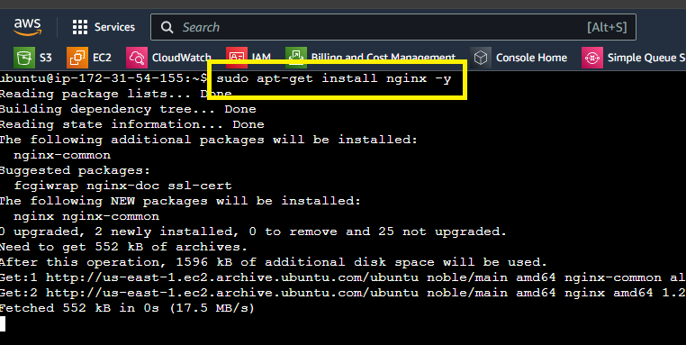

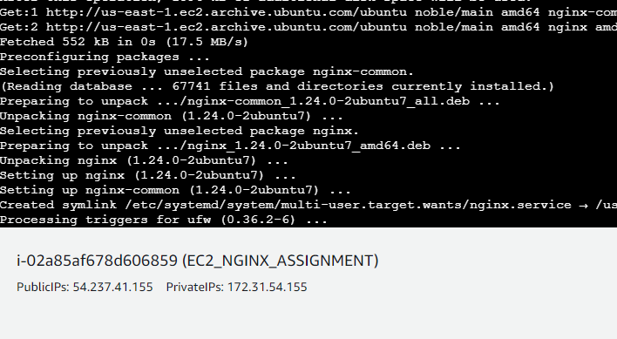

**Step 14: First, we** will **start** the **“NGINX” service using** this **command: sudo systemctl start nginx**

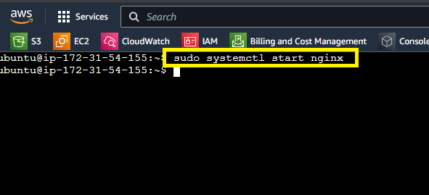

**Step 15: After starting, we** will **enable** the **“NGINX” service using** this **command: sudo systemctl enable nginx**

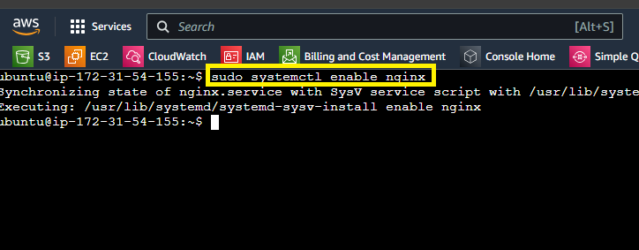

**Step 16: Now, we will check** the **status** of **NGINX** through this **command;**

**sudo systemctl status nginx**

**The “NGINX” status** is **showing** as **“Active”.**

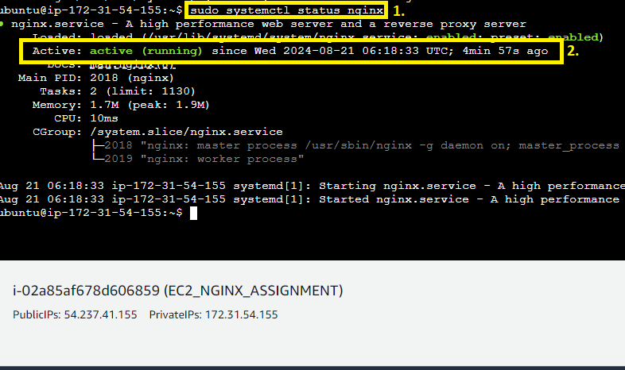

**Step 15: You can** also **check** your **status** via **pasting** the **public IP address (http://54.237.41.155/)** in **the browser address bar.**

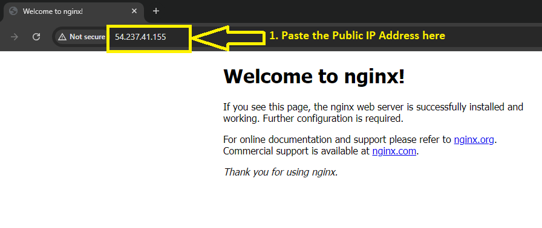

**It’s** a **default web page showing** on the **web browser. In second step, we** will **change** this **web page** to **display** the **“Hello World”** text.

***Problem 2 Solution:*** *Change the default website with a page displaying the message “Hello World”.*

**Step 1: Now, we will access the index.html page through these commands.**

**cd var/www/html –** Change the directory

**ls –** for showing the file in this directory

**sudo chmod -R 777 ./ -** Use this command to change the default permissions & allow the owner to read, write & execute the files, while granting only read and execute permissions to groups and others.

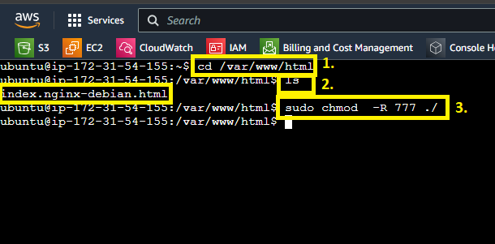

**Step 2: Now, use nano command** to **access** the **index.html file** & **paste** your **html web page content** to **show** the **“Hello World”.**

**a. First, we** will **use** this **command** to **create** the **“index.html”** file.

**sudo nano /var/www/html/index.html**

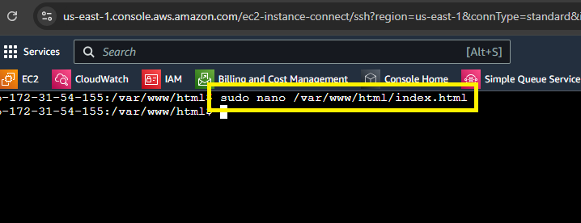

**b. Press “enter”** from the **keyboard & a Nano Editor** will be **displayed** to **you. Paste** the **following code** here:

**<html>**

**<head>**

**<title>Welcome to Nginx Web Server</title>**

**</head>**

**<body>**

**<h1>Hello World</h1>**

**</body>**

**</html>**

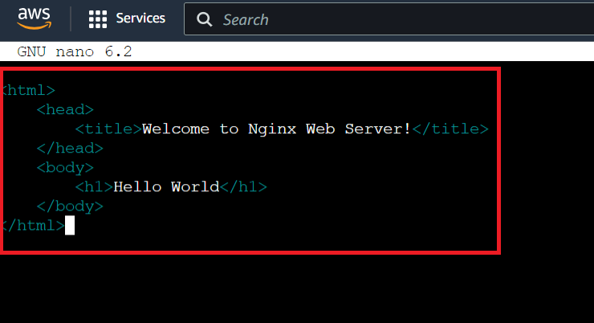

**Press “CTRL+X”** to “**exit”** fromthe **editor.**

**c. Press “Y” from** the **keyboard** to **save** the **content.**

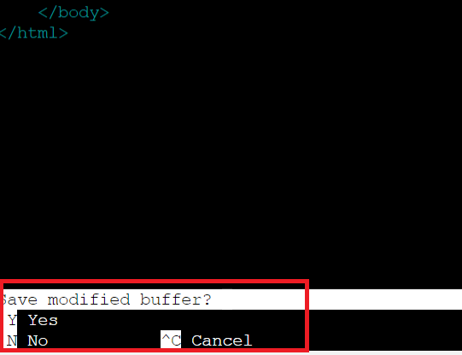

**d. Press “enter”** from the **keyboard.**

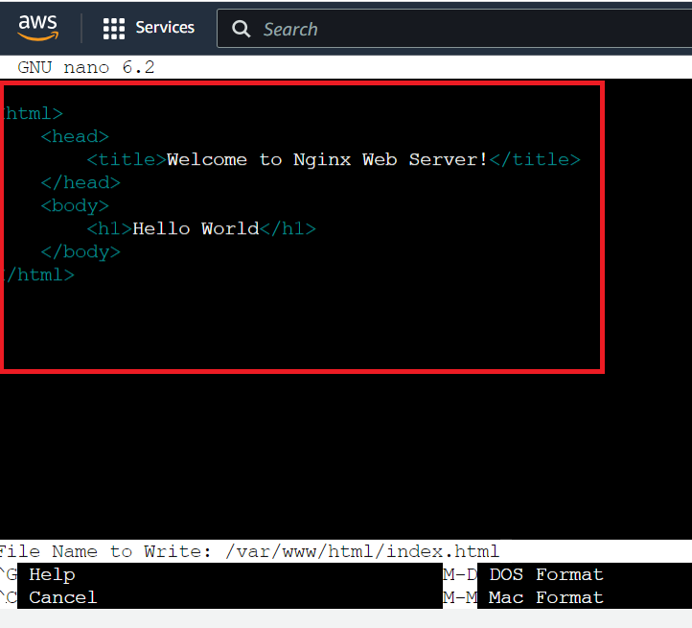

**Step 3: Now, paste** your **“public IP address [http://54.237.41.155/]”** in the **browser address bar again** & **press “enter”** from the **keyboard. Your “Hello World” content** will be **successfully displayed.**

