CORONEL, Lesli Natasha A.; NAVARRO, Joachim Alfonso A.
R2-B09
Development of a Neural Network Program to Classify Research Articles to Their Fields of Study
Dupalco, Luis Patrick E.

I. Critique of Poster Presentation

II. Suggestions for Improvement

III. Appendix
a) Photo of the mentors and mentees in front of the mentees’ poster
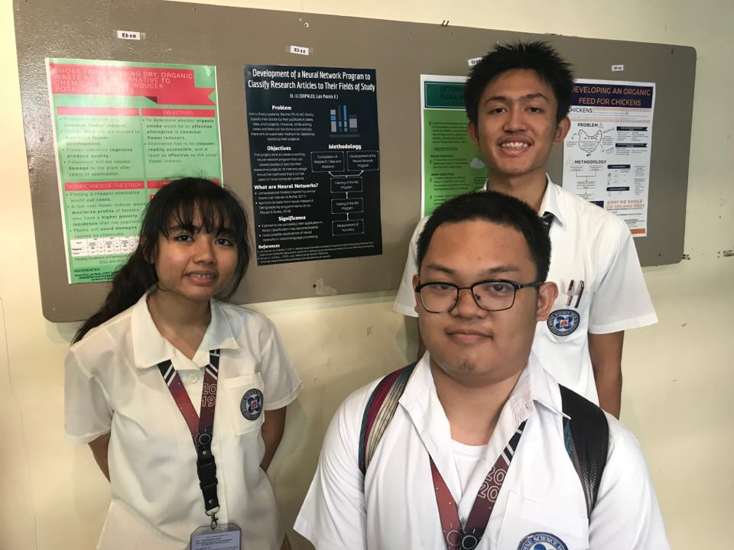
NOTED BY:

_______________________
Luis Patrick E. Dupalco
R1-El11

_______________________
Joachim Alfonso A. Navarro
R2-B09

_______________________
Lesli Natasha A. Coronel
R2-B09

