Musical chords are fundamental to musical harmony and have their own names due to their importance. For most people, accurately identifying or naming musical chords is a difficult task requiring high levels of skill. With this in mind, a neural network that aimed to identify musical chord names from their component notes in real-time was programmed in Python using the Keras framework running on the TensorFlow library. Validation accuracy data was obtained after every training session, and manual MIDI inputs were used to obtain response time data. It was found that the current number of training iterations (2,400) provided an insufficient peak validation accuracy of 5.5%, but showed steadily decreasing values of the loss function. Increasing validation accuracies can be thus expected as the number of training iterations is raised. A left-tailed T-test for one mean was carried out on 30 randomly selected chords from the dataset and showed that the neural network responded significantly faster than the generally accepted standard of 10 milliseconds for real-time use. Further development of the neural network is recommended to increase validation accuracy. Such a neural network may be implemented on devices or software for the purposes of music education.

Process Flowchart
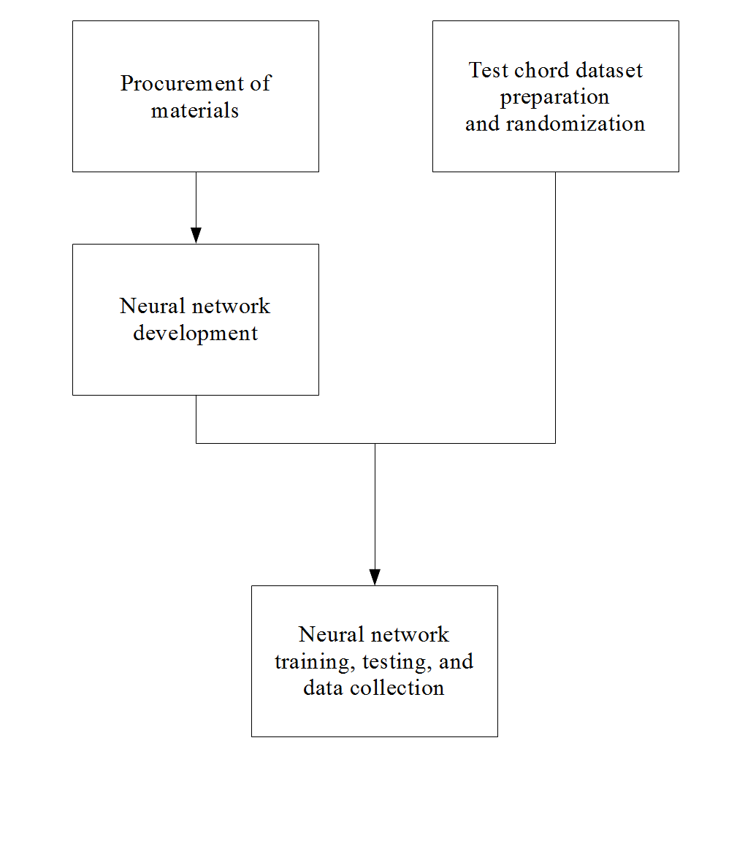

Results of Neural network training, testing, and data collection
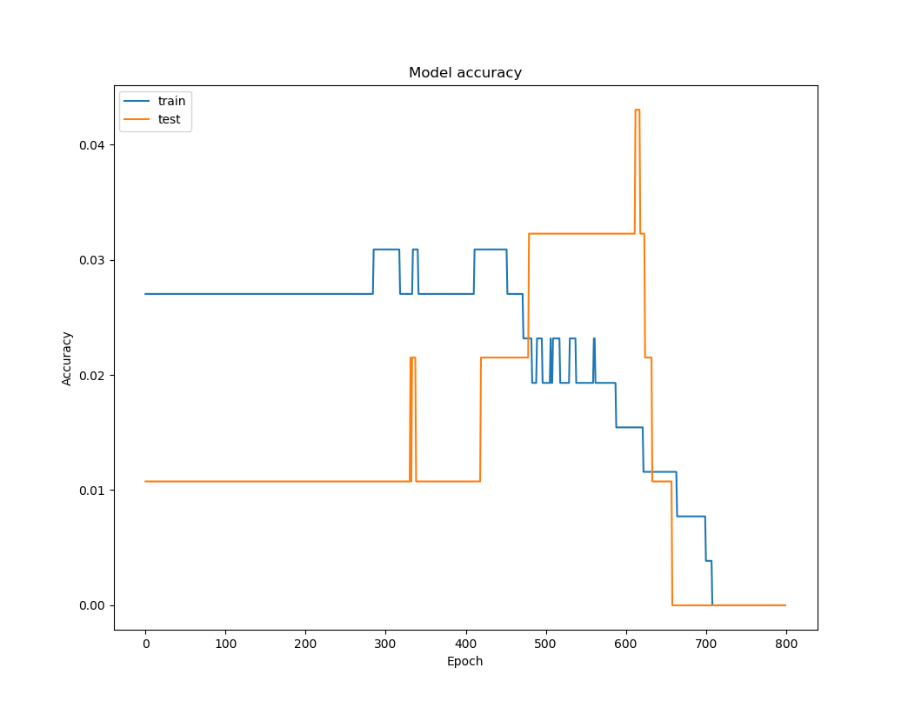
Figure 1. Training and validation accuracies of neural network, epochs 0-800

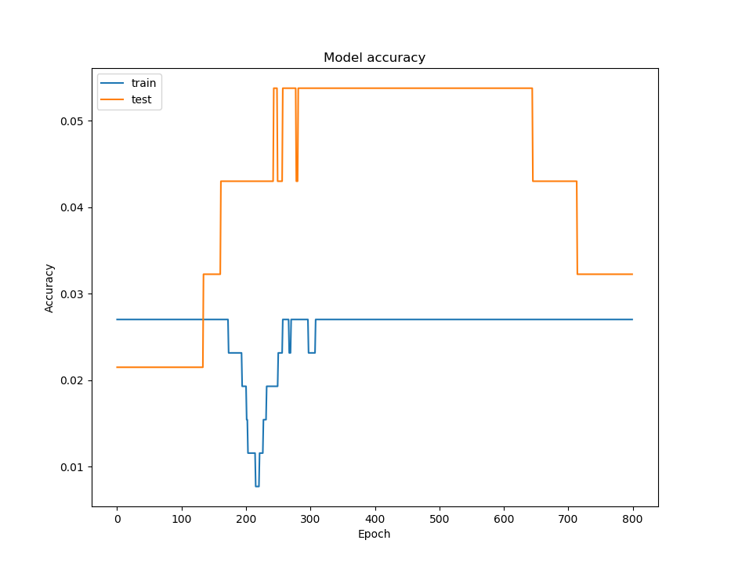
Figure 2. Training and validation accuracies of neural network, epochs 800-1600
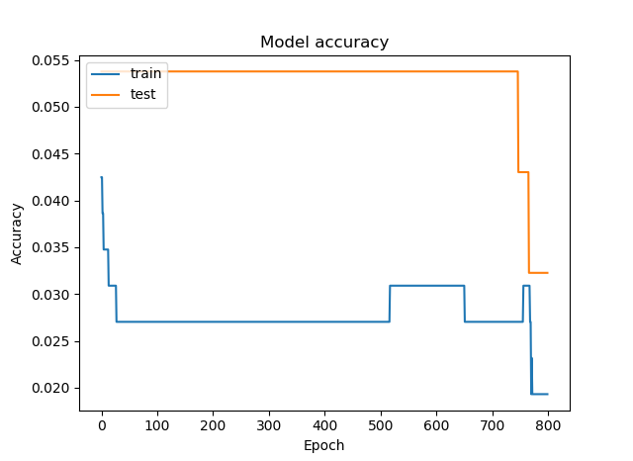
Figure 3. Training and validation accuracies of neural network, epochs 1600-2400

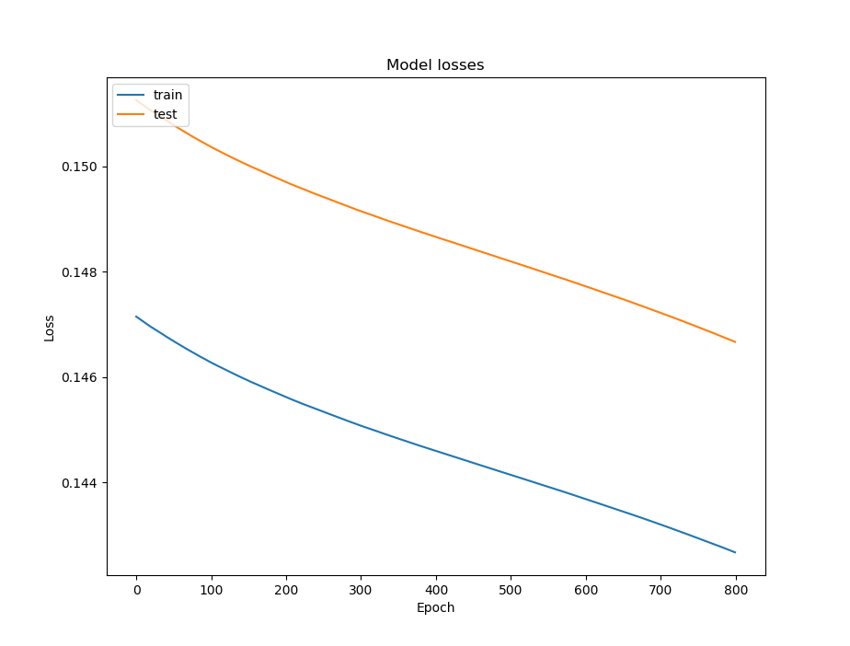
Figure 4. Training and validation losses of neural network, epochs 0-800

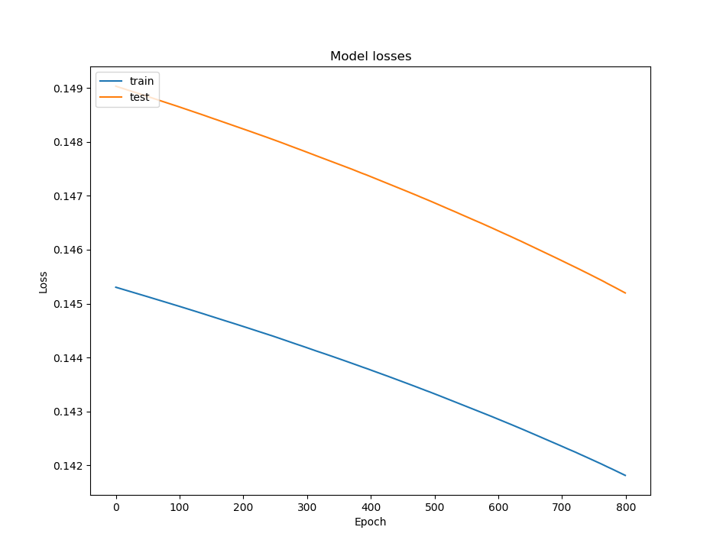
Figure 5. Training and validation losses of neural network, epochs 800-1600

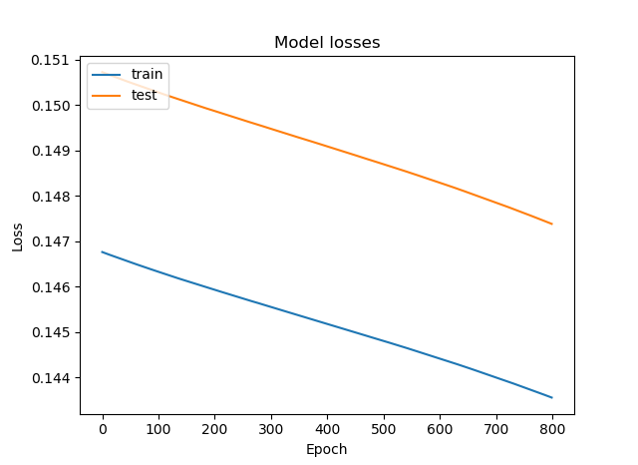
Figure 6. Training and validation losses of neural network, epochs 1600-2400

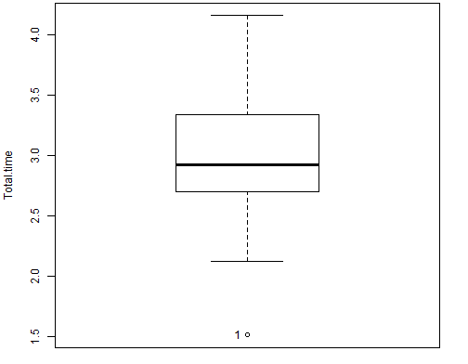
Figure 7. Boxplot of total response times of neural network to MIDI inputs in milliseconds. Note: Null hypothesis is that response time is less than or equal to 10 ms. The program used to make this boxplot does not output units on the y-axis.

