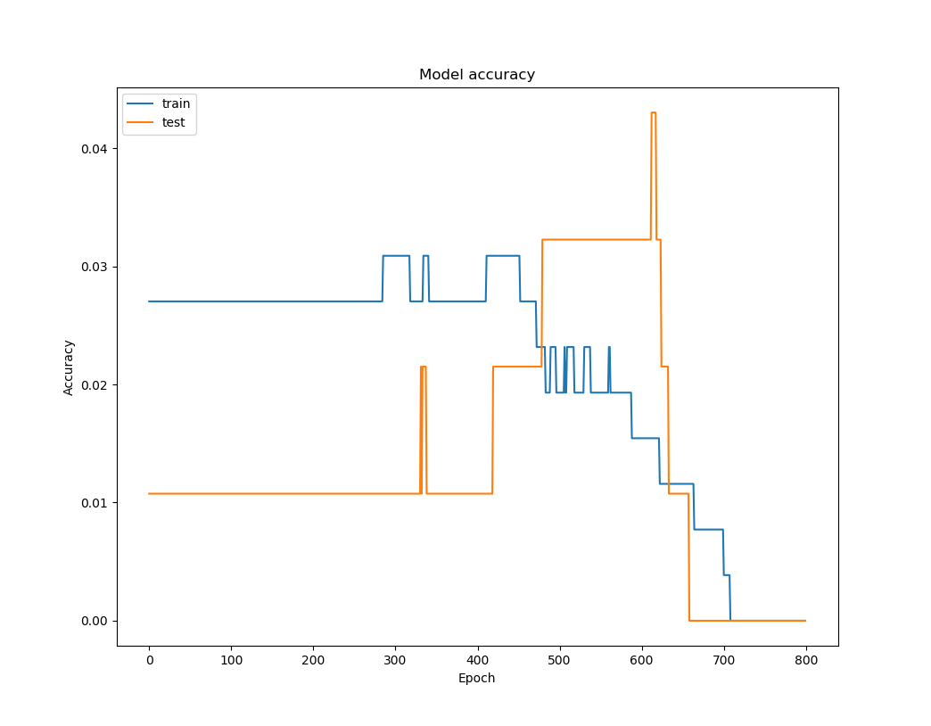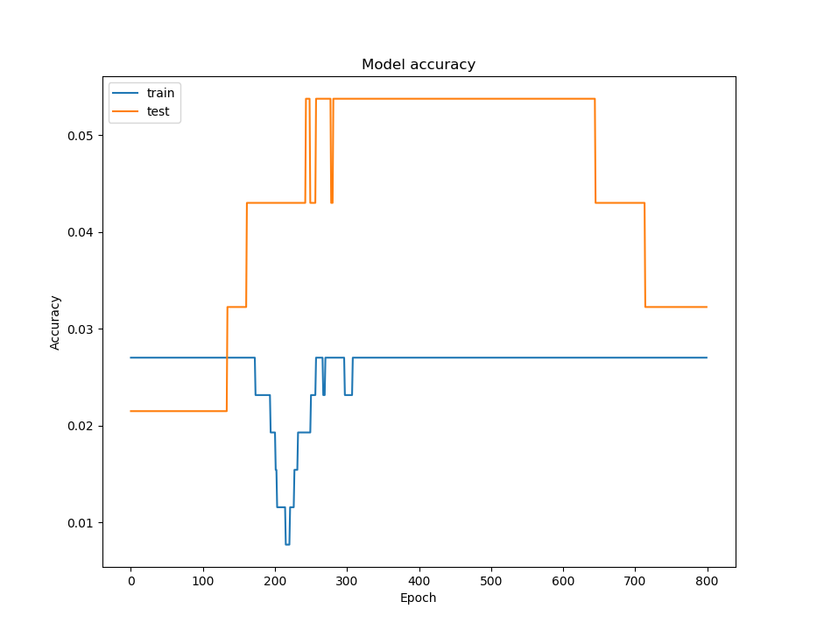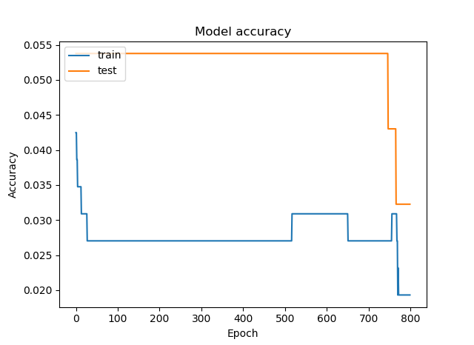

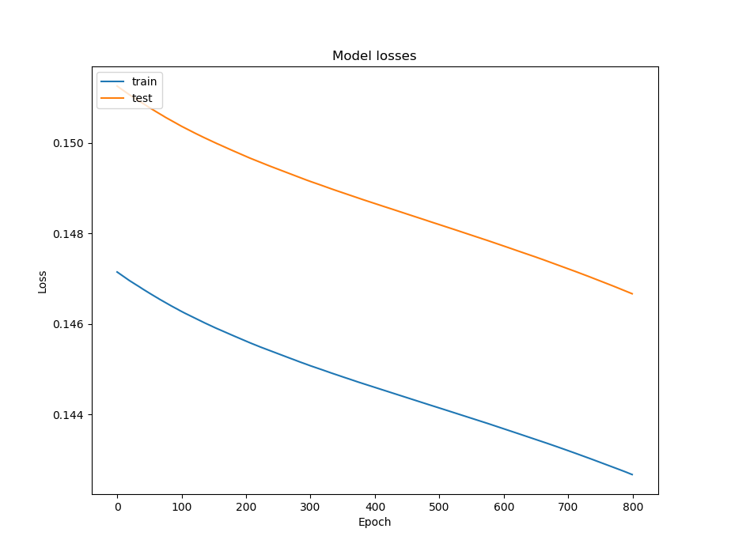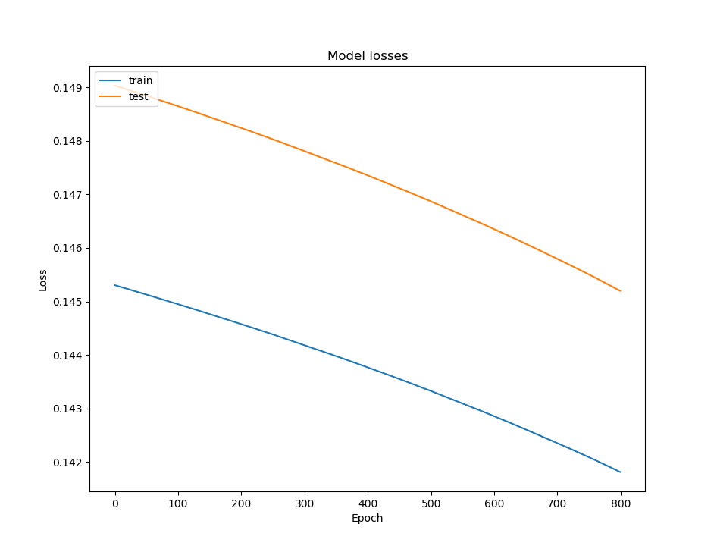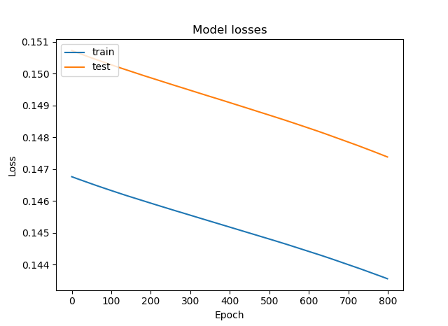*Tables 1.* Training **validation accuracy** of the neural network through **2400 epochs**, in three training sessions of 800 epochs each. **Blue** = Training dataset, **Orange** = Validation dataset

*Tables 1.* Training **losses** of the neural network through **2400 epochs**, in three training sessions of 800 epochs each. **Blue** = Training dataset, **Orange** = Validation dataset.