<Four hundred word abstract goes here>

Process Flowchart



Result of Process A

Table 1: Rater Preference of Pictures

|  |  |  |  |
| --- | --- | --- | --- |
| Rater | RATING OF PICTURES  (1 = awful, 5 = excellent) | | |
| Picture A  (Scenery) | Picture B  (Lolcat) | Picture C  (Fractal) |
| 1 |  |  |  |
| 2 |  |  |  |

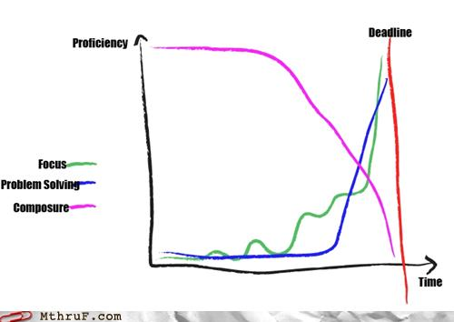

Figure 1: Graphs go here.