First Name MI. Surname

First Name MI. Surname

First Name MI. Surname

April 2015

Project Title Goes Here and Must Be In

Garamond, 24-Point Typeface,

Inverted Triangle

Philippine Science High School

Main Campus

Submitted to the Faculty of the  
Philippine Science High School – Main Campus  
in partial fulfillment of the requirements for  
Science and Technology Research 2

April 2015

Project Title Goes Here and Must Be In

Times New Roman, 16 points

Inverted Triangle

by

First Name MI. Surname

First Name MI. Surname

First Name MI. Surname

ABSTRACT

State the research goals here. What is this project all about? Should be in paragraph form, double line-space, using Times New Roman, 12 point typeface. Should not exceed 250 words or one (1) page. If in excess, typeface may be reduced to 10 points, or line-space set to 1.5.

Explain the purpose (the real-life problem) of the project, and how it is addressed by the researchers.

How was this project done? State relevant methodologies and research design (variables, replication and controls, and data gathering procedures).

State the results. Explain briefly important observations, and what they imply.

State conclusion, and if the objectives are covered.

State the significance of the project.

Approval Sheet

This research work entitled, “**Your Research Project Title Goes Here**” by First Name MI. Surname, First Name MI. Surname, and First Name MI. Surname, presented to the Faculty of the Philippine Science High School – Main Campus in partial fulfillment of the requirements in Science and Technology Research 2, is hereby accepted.

|  |  |
| --- | --- |
|  |  |
|  | Name of Research Adviser Here  Research Adviser |

Acknowledgements

Indicate your gratitude here. Keep it wholesome, and do not exceed one page.

Table of Contents

|  |  |
| --- | --- |
|  | **Page** |

Approval Sheet i

Acknowledgements ii

Table of Contents iii

List of Tables v

List of Figures vi

Introduction 1

Background of the Study 1

Objectives of the Study 1

Significance of the Study 1

Scope and Limitations 1

Literature Review 2

Topic 1 2

Sub-Topic 1.1 2

Methodology 3

Process Flowchart 3

Process 1 3

Process 2 3

Results and Discussion 4

Result of Process A 4

Summary and Conclusion 5

Recommendations 6

Bibliography 7

Appendix A’s Title Goes Here 8

Sample Source Code 9

List of Tables

|  |  |  |
| --- | --- | --- |
| **Table** | **Title** | **Page** |
| 1 | Label or Caption Goes Here | 1023 |

List of Figures

|  |  |  |
| --- | --- | --- |
| **Figure** | **Title** | **Page** |
| 1 | Label or Caption Goes Here | 1023 |

Introduction

Background of the Study

Insert BGotS Here

Objectives of the Study

Insert Objectives Here

Significance of the Study

Insert SotS Here

Scope and Limitations

Insert S&L Here

Literature Review

Topic 1

Discuss Topic 1 Here

To make it easier to generate the Table of Contents, whenever you add a new topic or sub-topic, highlight the topic heading and (in Microsoft Office 2010, 2013, and probably 2007) go to the **References** tab, and select **Add Text**. Choose **Level 2** (for topics) or **Level 3** (for sub-topics).

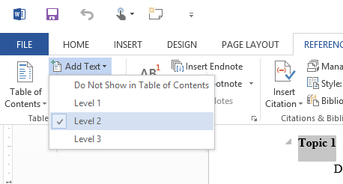

Figure 1: Setting a text entry to appear in the Table of Contents

Sub-Topic 1.1

Discuss Sub-Topic 1.1 Here, If Applicable

Methodology

Process Flowchart



Process 1

Discuss Process 1 Here

Any enumerations in bullet form should be single-line space, except in some instances. For example:

* A list should have at least five (5) items. Otherwise, use a straight sentence.
* If there are many lines per bullet, put in a blank line-space between entries.
* Third item to pad this example
* Fourth item
* Last item to make this worthwhile

Like so.

Process 2

Discuss Process 2 Here

Results and Discussion

Result of Process A

Table 1: Rater Preference of Pictures

|  |  |  |  |
| --- | --- | --- | --- |
| Rater | RATING OF PICTURES  (1 = awful, 5 = excellent) | | |
| Picture A  (Scenery) | Picture B  (Lolcat) | Picture C  (Fractal) |
| 1 |  |  |  |
| 2 |  |  |  |

Discuss Table 1 Here

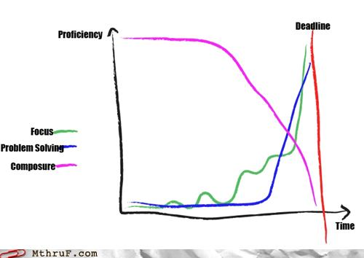

Figure 2: Graphs go here.

Summary and Conclusion

Summarize key results. Note the most important results and related to the objectives of the study.

Draw a conclusion based on the results. State if the project was successful or otherwise.

Recommendations

Recommendations Go Here

Bibliography

Surname, G. M. (1985). *Title of work goes here: A subtitle*. City: Publisher.

Surname, G. M., & OtherSurname, F. N. (2011). Title of article. *Title of journal, volume(issue)*. Retrieved from http://someurl.goeshe.re/file.xyz

APPENDIX A

Appendix A’s Title Goes Here

Full data tables, letters of consent, or statistical test stuff go into one of a multitude of appendices.

APPENDIX B

Sample Source Code

If the project has program code, use the following style and format.

# Quicksort implemented in Python 2.x

# Always preface your source code with some comments describing the code

def Quicksort(Array):

# Check if we need to terminate recursion

if len(Array) <= 1:

return Array

else:

# Get pivot point from first element in Array

Pivot = Array.pop(0)

# Split Array into Left and Right arrays

Left = []

Right = []

for I in Array:

if I < Pivot:

Left.append(I)

else:

Right.append(I)

# Recurse, concatenate, and return the array

return Quicksort(Left) + [Pivot] + Quicksort(Right)