Running Title of the Project: Should not Exceed 250 Characters

Mark Louie D. Lopez (Student 1), Mc Jervis S. Villaruel (Student 2),

Donna Salve C. Hipolito (Student 3), and Rose Mary B. Butaran (Research adviser)

Philippine Science High School – Main Campus, Department of Science and Technology, Agham Road, Diliman, Quezon City, 1101, Philippines

**ABSTRACT**

**Abstract should occupy page 2 of the manuscript and written in one paragraph not to exceed 300 words. It should summarize the background and scope of the work, the principal results, and note the implications of these results or main conclusions. References and acronyms should be avoided. Since the abstract will be published separately by indexing services, it should concisely capture the basic content of the paper and be understandable without the text. Text. The text starts on page 3. It includes the introduction, materials and methods used, results and discussion, and conclusion. They may be written as headings of separate sections or as an integrated text with appropriate headings suitable to the discipline. Headings and subheadings should be aligned to the left of the page and set in bold face and italics.**

INTRODUCTION

Title page (page 1) includes the title, running head, name of each author, addresses, and key words. The title should not exceed 250 characters, without active verbs, abbreviations, and punctuation marks. Avoid waste words such as “Studies on,” “Investigations on,” and “Observations on.” They are useless for indexing purposes. Main title-subtitle arrangement with Roman numeral, hanging title using a colon, and “question” titles are not acceptable. The running head should have no more than 50 characters and spaces. It is an abridged title suitable at the top of the printed page. Write the full name of each author. Give the full postal address, phone number, and e-mail address of the corresponding author to whom inquiries regarding the paper should be directed. On the bottom of the page, list up to six key words that reflect the content of the paper arranged alphabetically.

An Introduction should describe the paper’s background and provide the rationale for the present study. Cite only those references that will provide the most relevant background rather than an exhaustive review of the topic.

METHODOLOGY

*Subheading for procedure 1*

Methods should be described concisely and clearly to allow experiments to be repeated. For commonly used methods, a simple reference is sufficient. Avoid references that are not readily accessible.

RESULTS

*Subheading for result 1*

In Results, present data in only one of the following: text, table, or figure. Results should preferably have no more than five illustrations (tables and/or figures). Do not use tables or figures to present data that can be more concisely stated in the text. Discussion should interpret results in relation to previously published work. Do not repeat results or reiterate the introduction.

**Table 1.** Type each table on a separate sheet. Never use vertical lines to separate columns. Prepare tables so that compared data read down, not across. Columns that show no significant variations should be omitted. Do not use tables for word lists. Titles should be clear, and column headings should be brief with units of measurements in parenthesis. Symbols and abbreviations should be defined below the table. Indicate table footnotes with a, b, c, etc. Do not present the same data in both graphical and tabular form. Tables should be self-explanatory or understandable without reference to the text.

|  |  |  |  |
| --- | --- | --- | --- |
| Criteria | A | B | C |
| 1 | 1 ± 0.01 | 1 ± 0.01 | 1 ± 0.01 |
| 2 | 1 ± 0.01 | 1 ± 0.01 | 1 ± 0.01 |
| 3 | 1 ± 0.01 | 1 ± 0.01 | 1 ± 0.01 |
| 4 | 1 ± 0.01 | 1 ± 0.01 | 1 ± 0.01 |

DISCUSSION

Discussion should incorporate summary of conclusions. Literature citations should be selective, not to exceed 30 references for a research paper.

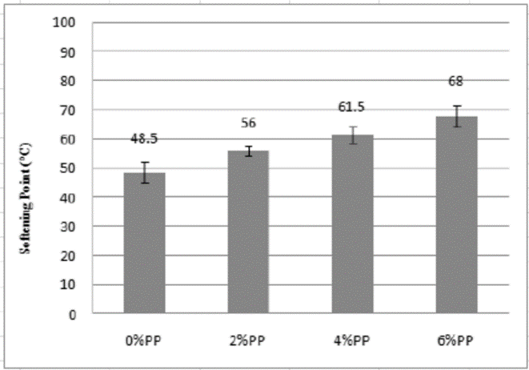

**Figure 1.** Each figure should have a legend or caption typed on a separate sheet and should be self-explanatory. Figure legends should be in lowercase print-type, except for the first letter of first word. Abbreviations and symbols on figures should be defined in the legend. Figures include line drawings, photographs, and computer plots. They should be clear. Magnification of figures if needed should be given by scale. The size should not exceed a full manuscript page. Glossy prints of photographs should be sent mounted on regular bond paper, with lettering about 3 mm high. Write lightly with a soft pencil on the back or margin of figures, or use self-adhesive label, indicating the figure number and name of lead author. For guidance in the preparation of figures and manuscripts in general, authors are urged to refer to a good style manual, such as Robert Day’s How to write and publish a scientific paper, 4th ed. (1994) or The Chicago Manual of Style, 14th ed. (1993).

Avoid citing gray literature or references not accessible through indexes or obtainable via regular library channels. Cite references in the text as follows: single author, White (1998) or (White 1998); two authors, White & Gray (1998) or (White & Gray 1998); more than two authors, Green et al. (1998) or (Green et al. 1998). Cite multiple references in chronological order (e.g., White & Gray 1990, Green 1992, Brown 1994, 1996). Do not cite unpublished work. Note that most of the abstract, methods, and results will be in the past tense, whereas most of the introduction, some of the discussion, and all conclusions will be in the present tense.

ACKNOWLEDGEMENT

Acknowledgments should be brief and are placed under a separate heading immediately before References. Acknowledge any financial support for the work being published and personal assistance.

REFERENCES

Journal Articles MATTHEWS RE. 1982. Classification and nomenclature of viruses. Intervirology 17 (1):1-199. MOJICA ERE. 2007. Copper oxide as mediator for the amperometric determination of hydrogen peroxide. Philipp J Sci 136(1): 25-32.

Book DAY RA. 1995. How to write and publish a scientific paper, 4th ed. Cambridge: Cambridge University Press. 223p.

Portion of Book HIRANO S. 1996. Chitin biotechnology applications. In: Biotechnology Annual Review Vol. 2. El-Grevery MR ed. Amsterdam: Elsevier. p. 237-258.

Theses and Dissertation ALOSTA H. 2002. Effects of linolei, oleic and stearic acids on the anaerobic fermentation of glucose. [MS thesis]. Stillwater, Oklahoma: Oklahoma State University. 212p. (Available at the OSU Library)

Paper from Proceedings PANTASTICO EB, MENDOZA DB. 1988. Climatic constraints to rice production in the Philippines. In: Cardenas A. editor. Climate and Rice Production. Proceedings of a Symposium on the Agrometeorology of the Rice Crop at the 27th meeting of the World Meteorological Organization; 1987 April 8-14; Los Banos, Laguna, Philippines: International Rice Research Institute. p. 107-119.

Organization as Author [AOAC] Association of Official Analytical Chemists. 1984. Official Methods of Analysis, 14th ed. Washington, DC: Association of Official Analytical Chemists, Inc. 1042p.

Patent PAULETTE T. 1998. Pigments manufactured from minerals. Can Patent 2, 186, 964.

Electronic References To direct to the whole website: http://www.usda.org. For a web document: Retrieved from http://www.usda.org on 16 June 2002 (date of retrieval)

Personal communication should appear only in text parenthetically with the names of persons who supplied the information. They should not be listed in the References section.