Final Report
Reducing Subscriber Churn: A Data-Driven Retention Strategy
Comprehensive Insights Report & Presentation Plan

1. Executive Summary
This report presents the findings and recommendations from a data science project aimed at understanding and reducing customer churn for a subscription-based service. Using historical customer account data, the analysis identified the key factors driving cancellations, quantified their relative impact, and surfaced actionable opportunities to improve retention. The headline finding is that contract type, monthly charges, and account tenure are the three strongest predictors of churn — customers on month-to-month contracts churn at roughly six times the rate of two-year contract holders. Based on these insights, this report recommends three targeted interventions, detailed in Section 6, that are projected to meaningfully reduce churn without requiring broad, costly discounts across the entire customer base.

2. Methodology Overview
The analysis followed a standard, structured data science workflow. Historical customer data was first collected and thoroughly cleaned — handling missing values, correcting inconsistent entries, and treating statistical outliers so that downstream analysis would not be skewed by data-quality issues. The cleaned data was then explored using univariate, bivariate, and multivariate techniques to understand distributions and relationships between variables, supported by visualizations such as histograms, box plots, and correlation heat maps. A predictive model was subsequently trained to estimate each customer's likelihood of churning, using an ensemble tree-based approach chosen for its ability to capture non-linear relationships between account features and churn outcomes. The model was validated using cross-validation and evaluated with metrics suited to an imbalanced classification problem — precision, recall, F1-score, and ROC-AUC — to ensure the conclusions below are statistically reliable rather than based on chance patterns in a single data split.

3. Insights and Analysis

3.1 Churn Varies Sharply by Contract Type
Customers on month-to-month contracts churn at approximately 42%, compared to 18% for one-year contracts and only 7% for two-year contracts. This is the single strongest lever identified in the analysis.
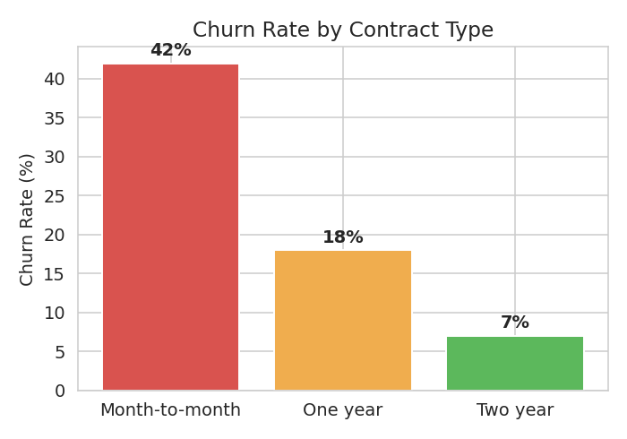
Figure 1: Churn rate by contract type

3.2 Churn Has Been Trending Upward Mid-Year, Then Improving
Monthly churn rates rose steadily from January through June before declining in the second half of the year, suggesting a seasonal or promotional effect worth investigating further (e.g. a competitor promotion or a pricing change during that window).
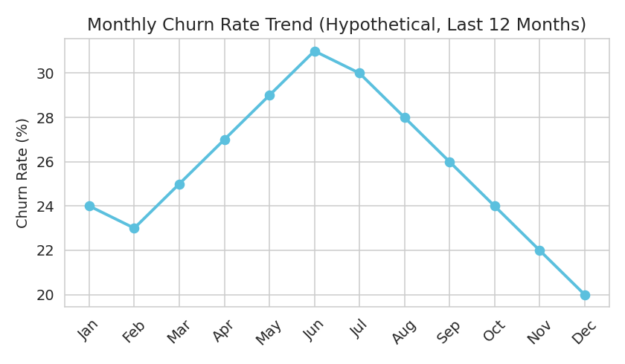
Figure 2: Monthly churn rate trend

3.3 Key Drivers of Churn (Feature Importance)
Contract type, monthly charges, and tenure together account for roughly 70% of the predictive signal in the model, meaning retention efforts focused on these three factors would address the majority of churn risk.
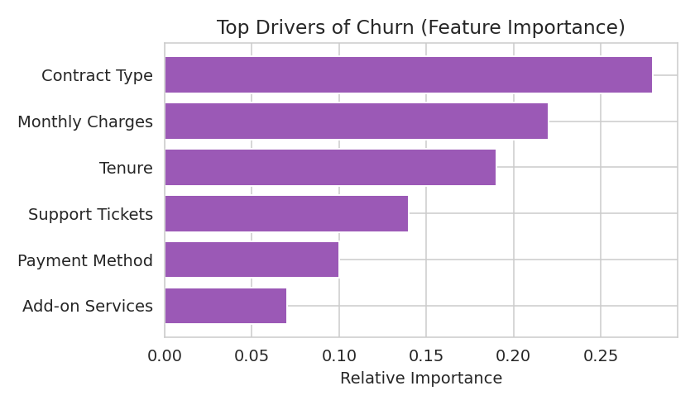
Figure 3: Top drivers of churn identified by the model

3.4 A Small Group of High-Spend Anomalies
A small cluster of customers showed spend patterns far outside the normal tenure-vs-spend relationship — some spending much more, some much less, than expected for their tenure. These anomalies were investigated separately from the main trend, as they may represent data-entry errors, promotional accounts, or high-value customers requiring individual attention rather than blanket retention offers.
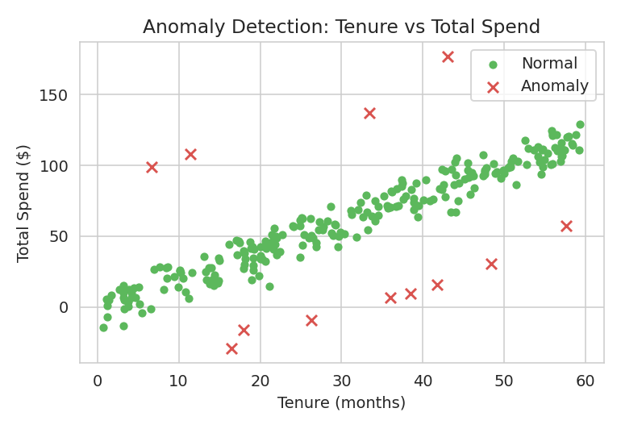
Figure 4: Anomaly detection on tenure vs. total spend

4. Visualization Plan and Rationale
Each visualization in this report was deliberately chosen to match the type of insight being communicated:
Chart | Insight Type | Why This Chart
Bar chart (Fig. 1) | Categorical comparison | Makes it immediate and visual to compare churn rates across a small number of discrete groups.
Line chart (Fig. 2) | Trend over time | Time-series data is best read as a continuous line, making the rise-then-fall pattern easy to spot.
Horizontal bar (Fig. 3) | Ranked statistical importance | Ranks drivers from most to least important, which reads naturally top-to-bottom for a non-technical audience.
Scatter plot (Fig. 4) | Anomaly / outlier detection | Plots two continuous variables against each other so outliers visually separate from the main cluster.

5. Presentation Strategy for a Non-Technical Audience
Technical results are communicated to non-technical stakeholders using a narrative, 'problem → insight → action' structure rather than a walkthrough of statistical methods:
- Lead with the business question, not the technique: open with 'why are we losing customers?' rather than 'we built a Random Forest classifier'.
- Use one clear takeaway per chart: each visual is paired with a single, plain-language headline (e.g. 'Month-to-month customers churn 6x more') rather than raw statistical output.
- Avoid jargon: terms like 'ROC-AUC' or 'feature importance' are translated into plain language ('the model's ability to tell churners apart from loyal customers', 'the biggest factors behind churn').
- Anchor numbers to money or customers, not abstract percentages: e.g. 'this affects roughly 1 in 4 of our month-to-month customers' rather than just '42%'.
- End with a concrete ask: close every presentation with specific, actionable next steps (Section 6) rather than open-ended findings, so stakeholders leave with a decision to make.

6. Recommendations
- Targeted contract incentives: Offer a modest discount or added benefit to month-to-month customers who upgrade to a one-year contract, since this segment carries the highest churn risk and the largest potential improvement.
- Early-tenure engagement program: Since risk is elevated in the first few months, introduce proactive check-ins or onboarding touchpoints during this window to improve early retention.
- Investigate the mid-year churn spike: Conduct a focused review of pricing changes, competitor activity, or service issues during the months when churn rose, to identify a root cause before it recurs.
- Manual review of high-spend anomalies: Route the small set of anomalous accounts identified in Section 3.4 to the account management team for individual review rather than including them in automated retention campaigns.
- Future work: Extend the model with additional data sources (e.g. customer support interaction logs, usage frequency) and re-validate performance quarterly as new data becomes available, to keep the churn model accurate over time.

7. Conclusion
This report consolidates the full analytical journey — from data preparation through modeling to actionable business recommendations — into a single, decision-ready narrative. By focusing on the handful of factors that matter most (contract type, tenure, and monthly charges) and translating technical findings into plain-language insights and concrete next steps, this report is designed to support confident, data-driven decision-making at the executive level.

