Week 1 Task Report
Data Acquisition, Cleaning, and Preprocessing

1. Objective
The objective of this task is to demonstrate the ability to acquire a publicly available dataset, perform data cleaning, and preprocess the data using Python. This report documents the complete process of handling missing values, outliers, and erroneous entries to prepare the dataset for further analysis.

2. Dataset Used
Dataset: Titanic Passenger Dataset (a well-known, publicly available dataset describing passengers aboard the RMS Titanic, including demographic details and survival outcome).
Source: Public GitHub repository (datasciencedojo/datasets), originally derived from the Titanic competition dataset.
For this exercise, a sample of 100 passenger records with 12 original columns (PassengerId, Survived, Pclass, Name, Sex, Age, SibSp, Parch, Ticket, Fare, Cabin, Embarked) was used.

3. Data Acquisition
The dataset was acquired directly as a CSV file and loaded into a pandas DataFrame using Python:
import pandas as pd
df = pd.read_csv("titanic.csv")
print(df.shape)
print(df.head())
This gave an initial DataFrame of shape (100, 12), confirming that the data was read correctly.

4. Initial Data Exploration
Before cleaning, the structure and quality of the data were explored using .info(), .describe(), and a missing-value check:
print(df.info())
print(df.describe(include="all"))
print(df.isnull().sum())
This exploration revealed three columns with missing data: Age (22% missing), Cabin (80% missing), and Embarked (1% missing). The chart below visualizes the missing-value percentages found in this step.
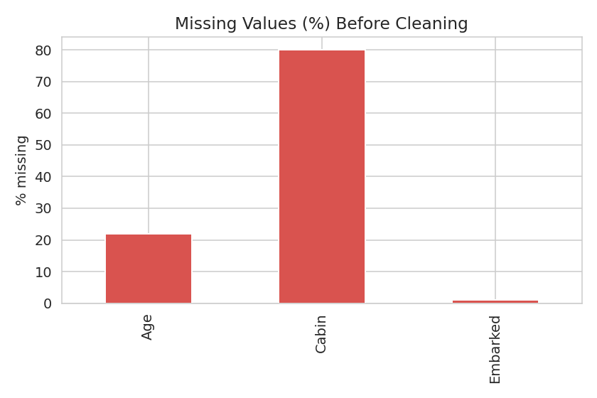
Figure 1: Percentage of missing values per column before cleaning

5. Handling Missing Values
- Age (22% missing): Filled using the median age, since median is robust to outliers and preserves the overall distribution better than the mean.
- Embarked (1% missing): Filled using the mode (most frequently occurring port, 'S'), an appropriate strategy for a categorical column with very few missing entries.
- Cabin (80% missing): Too sparse to reliably impute. Instead of guessing values, the column was dropped and replaced with a new binary feature, 'HasCabin' (1 if a cabin number was recorded, 0 otherwise), which still preserves useful signal.
df["Age"] = df["Age"].fillna(df["Age"].median())
df["Embarked"] = df["Embarked"].fillna(df["Embarked"].mode()[0])
df["HasCabin"] = df["Cabin"].notnull().astype(int)
df.drop(columns=["Cabin"], inplace=True)
After this step, the dataset had zero missing values remaining.

6. Outlier Detection and Treatment
Outliers in the 'Fare' column were identified using the Interquartile Range (IQR) method, a standard statistical technique:
Q1 = df["Fare"].quantile(0.25)
Q3 = df["Fare"].quantile(0.75)
IQR = Q3 - Q1
lower = Q1 - 1.5 * IQR
upper = Q3 + 1.5 * IQR
df["Fare"] = df["Fare"].clip(lower, upper)
9 outlier values were found in the Fare column (very high-priced first-class tickets). Rather than deleting these rows (which would lose other valid information about those passengers), the outlier values were capped at the upper/lower IQR bounds — a technique called winsorization. The box plots below show the Fare distribution before and after this treatment.
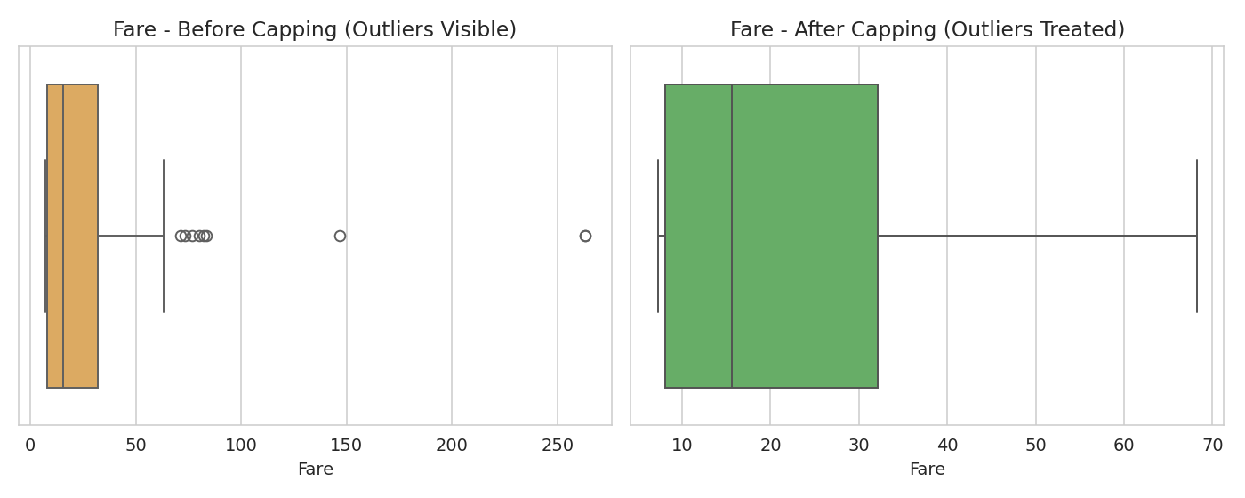
Figure 2: Fare distribution before (left) and after (right) outlier capping

7. Checking for Erroneous / Inconsistent Entries
The dataset was also checked for logically invalid values, such as negative ages, negative fares, and duplicate rows. No negative values or duplicate records were found in this dataset, confirming that beyond missing values and outliers, the raw data was internally consistent.

8. Feature Engineering and Preprocessing
- Title extraction: A 'Title' feature (Mr, Mrs, Miss, Master, etc.) was extracted from the Name column, since a passenger's title carries useful social/age information.
- FamilySize: Created by summing SibSp (siblings/spouses aboard) + Parch (parents/children aboard) + 1, giving a single feature representing family size.
- Categorical encoding: 'Sex' was label-encoded (male=0, female=1) and 'Embarked' was one-hot encoded into three binary columns (Embarked_C, Embarked_Q, Embarked_S), since machine learning models require numeric input.
df["Title"] = df["Name"].str.extract(r",\s*([^\.]*)\.")
df["FamilySize"] = df["SibSp"] + df["Parch"] + 1
df["Sex_encoded"] = df["Sex"].map({"male": 0, "female": 1})
df = pd.get_dummies(df, columns=["Embarked"], prefix="Embarked")
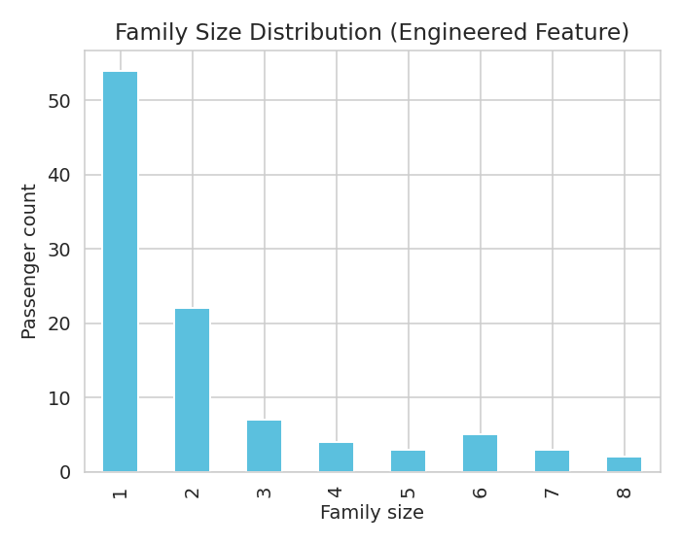
Figure 3: Distribution of the engineered 'FamilySize' feature
After preprocessing, the final cleaned dataset had 100 rows and 17 columns, with no missing values, treated outliers, and additional engineered features ready for further analysis or modeling.

9. Challenges Faced and How They Were Overcome
- High missingness in Cabin: Imputing 80% missing values would have introduced too much noise. Solution: converted it into a simple presence/absence binary feature instead of guessing actual cabin numbers.
- Choosing an imputation strategy for Age: Mean imputation can be distorted by outliers; median was chosen instead as a more robust central-tendency measure.
- Deciding how to treat Fare outliers: Deleting outlier rows would reduce the sample size and remove otherwise-valid passenger information. Capping (winsorization) was used instead to reduce the outliers' influence while retaining all records.
- Extracting a clean 'Title' from free-text names: Names had inconsistent punctuation and bracketed nicknames; a regular expression was used to reliably isolate the title portion.

10. Impact of Preprocessing on Subsequent Analyses
These preprocessing decisions directly affect any downstream analysis or machine-learning model built on this data:
- Removing missing values prevents errors or biased results when training statistical/ML models, most of which cannot handle NaN values natively.
- Capping outliers in Fare reduces the risk that a few extremely high ticket prices dominate distance-based algorithms (e.g., KNN, linear regression) or skew summary statistics.
- Encoding categorical variables (Sex, Embarked) makes the dataset usable by machine learning algorithms, which generally require numeric input.
- Engineered features (Title, FamilySize, HasCabin) can improve model performance by capturing patterns (e.g., social status, travelling alone vs. with family) that were not directly available in the raw columns.
Overall, careful cleaning and preprocessing ensures that any future analysis — whether descriptive statistics, visualization, or predictive modeling — is based on accurate, consistent, and well-structured data rather than being distorted by missing values, outliers, or noisy raw fields.

11. Methodology & Strategy
Beyond this week's cleaning task, the broader data science project will follow a standard five-stage pipeline. The strategy for each stage is outlined below and illustrated in the flowchart.
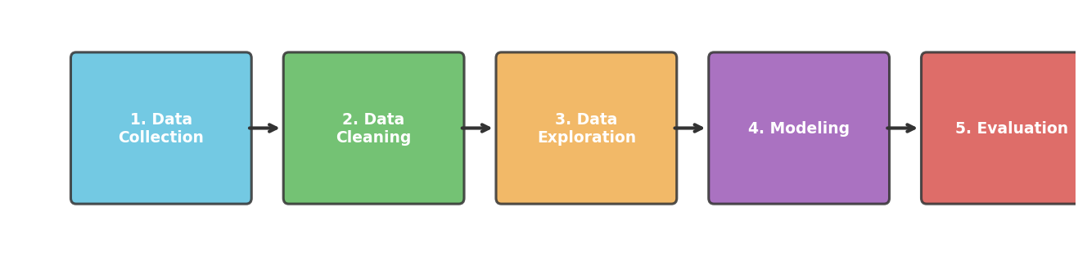
Figure 4: Overall data science process flowchart
- Data Collection: Acquire a relevant, publicly available dataset from a reliable source (e.g. GitHub, Kaggle, UCI repository) and load it into a structured format (pandas DataFrame).
- Data Cleaning: Explore the dataset's structure and quality; handle missing values, outliers, duplicates, and inconsistent entries using column-appropriate techniques (as demonstrated in Sections 4-8 of this report).
- Data Exploration: Perform exploratory data analysis (EDA) using summary statistics and visualizations (histograms, box plots, correlation heatmaps) to uncover patterns and relationships between variables.
- Modeling: Select and train appropriate machine learning models based on the problem type (classification/regression), split data into train/test sets, and tune hyperparameters.
- Evaluation: Assess model performance using suitable metrics (accuracy, precision/recall, RMSE, etc.), interpret results, and iterate on the approach if needed.

12. Timeline & Tools
The project work is planned across roughly 30-35 hours, allocated as follows:
Stage | Est. Hours | Key Tools
Data Collection & Understanding | 4-5 hrs | pandas, requests
Data Cleaning & Preprocessing | 8-9 hrs | pandas, numpy
Exploratory Data Analysis | 7-8 hrs | matplotlib, seaborn
Modeling | 8-9 hrs | scikit-learn
Evaluation & Reporting | 4-5 hrs | scikit-learn, Word/Docx

Python libraries expected to be used across the project:
- pandas — data loading, cleaning, and manipulation
- numpy — numerical operations
- matplotlib & seaborn — data visualization
- scikit-learn — preprocessing utilities, model building, and evaluation metrics

13. Expected Outcomes & Challenges
Expected outcomes: A clean, well-structured dataset; clear visual insights from exploration; a working baseline model; and a documented, reproducible workflow that can be extended in later stages.
- Challenge: Inconsistent or missing data across sources → Mitigation: apply systematic, column-appropriate cleaning strategies and document every assumption made (as done in Section 9 of this report).
- Challenge: Outliers or skewed distributions affecting model performance → Mitigation: detect outliers statistically (IQR method) and treat them via capping rather than blind deletion.
- Challenge: Limited time (30-35 hours) across all stages → Mitigation: time-box each stage per the timeline above and prioritize core deliverables first.
- Challenge: Choosing the right model/metrics → Mitigation: start with a simple, interpretable baseline model before trying more complex approaches.

14. Conclusion
This task successfully demonstrated the full data preparation pipeline: acquiring a real public dataset, exploring its structure and quality, systematically handling missing values using column-appropriate strategies, detecting and treating outliers using the IQR method, checking for erroneous/duplicate entries, and engineering new features while encoding categorical variables for downstream use. The resulting cleaned dataset (titanic_cleaned.csv) is now ready for exploratory data analysis or machine learning tasks.

