Assignment 3
Select two LLMs (Large Language Models) that are mostly used for supporting code generation in programming.
Ans) I will be choosing ChatGPT o-3 mini high and Gemini 2.0 Flash


VS 

In each of the selected LLMs, provide prompts to generate the implementation of the ‘Rod Cutting Problem’ in your chosen programming language using three algorithmic approaches (their pseudo algorithms are enclosed). The same prompt must be used to two LLMs for each algorithm.
Ans) The Prompt I used in both the LLM’s is :"Implement the Rod Cutting Problem in Python using the three algorithmic approaches shown in the attached image which has the pseudo code for all the three Algorithms."

  - For each code generated by each LLM for three algorithms:
  - 1) Ensure that the generated codes correctly represent the three different algorithms.
  - 2) Review the correctness by testing the code with the sample data below
  - 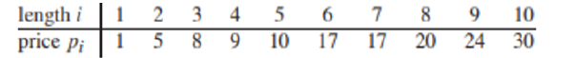

Your tests involve :
- Entering a number as input for n, the size of the rod, (n = 1..10).
- Measuring actual execution times of the code to evaluate the performance difference among the three algorithms.
- Measuring the number of recursive calls (algorithms 1 & 2) or the number of iterations (algorithm 3).
Repeat the above process five times using different values of n: 2, 4, 6, 8, and 10.
- Measure the lines of code
- Measure the asymptotic complexity(O)
I have implemented a total of six separate code files—three from ChatGPT (Algo 1, Algo 2, and Algo 3) and three from Gemini (Algo 1, Algo 2, and Algo 3). I intentionally kept each algorithm in a separate and distinct code file to ensure precise measurement of execution time and to accurately count the number of lines of code for each implementation.
ALGORITHM 1 (Recursive Approach (Brute-Force) Rod Cutting Using ChatGPT:
import time

# Global counter for recursive calls
recursive_calls = 0

def rod_cutting_recursive(prices, n):
global recursive_calls
recursive_calls += 1
if n == 0:
return 0
max_revenue = 0
for i in range(1, n + 1):
max_revenue = max(max_revenue, prices[i - 1] + rod_cutting_recursive(prices, n - i))
return max_revenue

prices = [1, 5, 8, 9, 10, 17, 17, 20, 24, 30]
test_lengths = [2, 4, 6, 8, 10]

print("Recursive Approach (Brute-Force) Rod Cutting using ChatGPT")
for n in test_lengths:
recursive_calls = 0 # reset counter for each test
start_time = time.perf_counter()
revenue = rod_cutting_recursive(prices, n)
end_time = time.perf_counter()
print(f"Rod length: {n} | Maximum revenue: {revenue} | Recursive calls: {recursive_calls} | Execution time: {end_time - start_time:.8f} seconds")

OUTPUT:
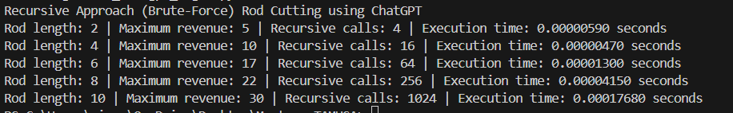
Lines of Code: 21
Asymptotic Complexity: O(2^n)

ALGORITHM 2 Memoized Cut Rod using ChatGPT:
import time

# Global counter for recursive calls in memoized approach
memo_calls = 0

def rod_cutting_memo(prices, n, memo):
global memo_calls
memo_calls += 1
if n == 0:
return 0
if n in memo:
return memo[n]
max_revenue = 0
for i in range(1, n + 1):
max_revenue = max(max_revenue, prices[i - 1] + rod_cutting_memo(prices, n - i, memo))
memo[n] = max_revenue
return max_revenue

prices = [1, 5, 8, 9, 10, 17, 17, 20, 24, 30]
test_lengths = [2, 4, 6, 8, 10]

print("Memoized Cut Rod using ChatGPT")
for n in test_lengths:
memo_calls = 0 # reset counter for each test
memo = {} # reset memo for each test case
start_time = time.perf_counter()
revenue = rod_cutting_memo(prices, n, memo)
end_time = time.perf_counter()
print(f"Rod length: {n} | Maximum revenue: {revenue} | Recursive calls: {memo_calls} | Execution time: {end_time - start_time:.8f} seconds")
Lines of Code: 24 , Asympotitic Complexity: O(n^2)
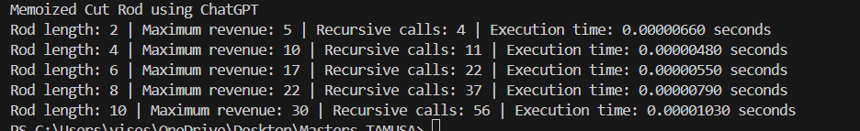
ALGORITHM 3 Bottom-Up Rod Cutting using ChatGPT:

import time

def rod_cutting_bottom_up(prices, n):
iterations = 0 # local counter for loop iterations
dp = [0] * (n + 1)
for j in range(1, n + 1):
max_revenue = 0
for i in range(1, j + 1):
iterations += 1
max_revenue = max(max_revenue, prices[i - 1] + dp[j - i])
dp[j] = max_revenue
return dp[n], iterations

prices = [1, 5, 8, 9, 10, 17, 17, 20, 24, 30]
test_lengths =[2, 4, 6, 8, 10]

print("Bottom-Up Rod Cutting using ChatGPT")
for n in test_lengths:
start_time = time.perf_counter()
revenue, iterations = rod_cutting_bottom_up(prices, n)
end_time = time.perf_counter()
print(f"Rod length: {n} | Maximum revenue: {revenue} | Iterations: {iterations} | Execution time: {end_time - start_time:.8f} seconds")

Lines of Code: 19 , Asympotitic Complexity: O(n^2)

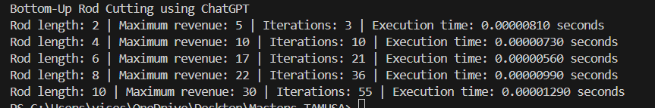

ALGORITHM 1 (Recursive Approach (Brute-Force) Rod Cutting Using Gemini:
import time

prices = [1, 5, 8, 9, 10, 17, 17, 20, 24, 30]
n_values = [2, 4, 6, 8, 10]

def recursive_rod_cut(prices, n):
calls = [0]
def _recursive_rod_cut(prices, n, calls):
calls[0] += 1
if n == 0:
return 0
max_revenue = -float('inf')
for i in range(1, n + 1):
max_revenue = max(max_revenue, prices[i - 1] + _recursive_rod_cut(prices, n - i, calls))
return max_revenue

start_time = time.perf_counter()
revenue = _recursive_rod_cut(prices, n, calls)
end_time = time.perf_counter()
execution_time = end_time - start_time
return revenue, calls[0], execution_time

print("Recursive Approach (Brute-Force) Rod Cutting Gemini 2.0 Flash:")
for n in n_values:
revenue, calls, execution_time = recursive_rod_cut(prices, n)
print(f"Rod length: {n} | Maximum revenue: {revenue} | Recursive calls: {calls} | Execution time: {execution_time:.8f} seconds")

Lines of Code: 22, Asymptotic Complexity: O(2^n)
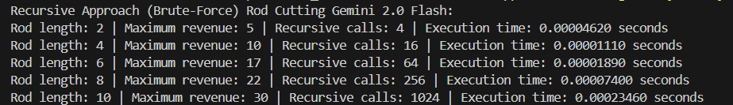

ALGORITHM 2 Memoized Cut Rod using Gemini:
# Code 2: Memoized (top-down) implementation of the Rod Cutting problem.
import time
prices = [1, 5, 8, 9, 10, 17, 17, 20, 24, 30]
n_values = [2, 4, 6, 8, 10]

def memoized_rod_cut(prices, n):
memo = [-float('inf')] * (n + 1)
calls = [0]
def _memoized_rod_cut_aux(prices, n, memo, calls):
calls[0] += 1
if n == 0:
return 0
if memo[n] >= 0:
return memo[n]
max_revenue = -float('inf')
for i in range(1, n + 1):
max_revenue = max(max_revenue, prices[i - 1] + _memoized_rod_cut_aux(prices, n - i, memo, calls))
memo[n] = max_revenue
return max_revenue

start_time = time.perf_counter()
revenue = _memoized_rod_cut_aux(prices, n, memo, calls)
end_time = time.perf_counter()
execution_time = end_time - start_time
return revenue, calls[0], execution_time

print("Memoized Cut Rod using Gemini 2.0 Flash:")
for n in n_values:
revenue, calls, execution_time = memoized_rod_cut(prices, n)
print(f"Rod length: {n} | Maximum revenue: {revenue} | Recursive calls: {calls} | Execution time: {execution_time:.8f} seconds")
Lines of Code: 26, Asymptotic Complexity: O(n^2)
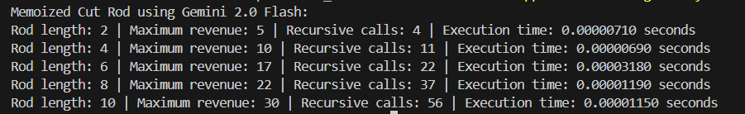

ALGORITHM 3 Bottom-Up Rod Cutting using Gemini:
import time

prices = [1, 5, 8, 9, 10, 17, 17, 20, 24, 30]
n_values = [2, 4, 6, 8, 10]

# Code 3: Bottom-up cut-rod algorithm.
def bottom_up_cut_rod(prices, n):
revenue = [0] * (n + 1)
cuts = [0] * (n + 1)
iterations = 0

start_time = time.perf_counter()
for j in range(1, n + 1):
max_revenue = -float('inf')
for i in range(1, j + 1):
iterations += 1
if max_revenue < prices[i - 1] + revenue[j - i]:
max_revenue = prices[i - 1] + revenue[j - i]
cuts[j] = i
revenue[j] = max_revenue
end_time = time.perf_counter()
execution_time = end_time - start_time

def get_cuts(cuts, n):
cut_list = []
while n > 0:
cut_list.append(cuts[n])
n = n - cuts[n]
return cut_list

return revenue[n], iterations, execution_time
print("Bottom-Up Rod Cutting using Gemini 2.0 Flash")
for n in n_values:
revenue, iterations, execution_time = bottom_up_cut_rod(prices, n)
print(f"Rod length: {n} | Maximum revenue: {revenue} | Iterations: {iterations} | Execution time: {execution_time:.8f} seconds")
Lines of Code: 29 , Asympotitic Complexity: O(n^2)
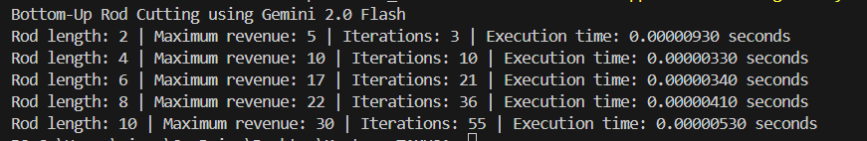
CHATGPT GEMINI

Algorithm 1 (Recursive Approach
(Brute-Force) Rod Cutting.

