Algorithm 1 using ChatGPT (DP):
import time
import random

def fractional_knapsack(weights, values, W):
n = len(values)
ratio = [(values[i] / weights[i], weights[i], values[i], i) for i in range(n)]
ratio.sort(reverse=True)

max_value = 0.0
selected_items = []
start_time = time.perf_counter()

for r, wt, val, idx in ratio:
if W == 0:
break
if wt <= W:
max_value += val
selected_items.append((idx, 1)) # full item
W -= wt
else:
fraction = W / wt
max_value += val * fraction
selected_items.append((idx, fraction)) # partial item
break

end_time = time.perf_counter()
exec_time = end_time - start_time

return max_value, selected_items, exec_time

# --- TEST CASES ---
test_cases = [
{
"name": "Test Case 1",
"weights": [10, 20, 30],
"values": [60, 100, 120],
"capacity": 50
},
{
"name": "Test Case 2",
"weights": [1, 2, 3, 5],
"values": [6, 11, 12, 14],
"capacity": 10
},
{
"name": "Random 100 Items",
"weights": [random.randint(1, 150) for _ in range(100)],
"values": [],
"capacity": 500
}
]

# Generate increasing values for weights in test case 3
test_cases[2]["values"] = [w + random.randint(1, 10) * 3 for w in test_cases[2]["weights"]]

for test in test_cases:
max_val, items, runtime = fractional_knapsack(test["weights"], test["values"], test["capacity"])
print(f"\n{test['name']} (Fractional Knapsack Greedy)")
print(f"Max Value: {max_val:.2f}")
print(f"Selected Items (index, fraction): {items}")
print(f"Execution Time: {runtime:.12f} seconds")

OUTPUT:
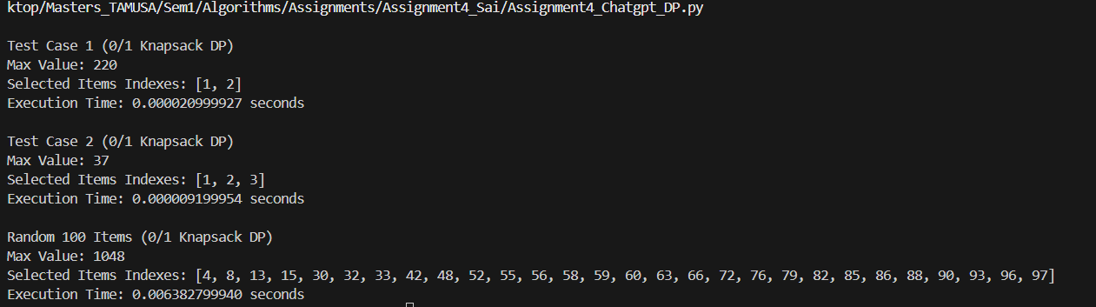

Algorithm 2 using ChatGPT (Greedy Approach):

import time
import random

def fractional_knapsack(weights, values, W):
n = len(values)
ratio = [(values[i] / weights[i], weights[i], values[i], i) for i in range(n)]
ratio.sort(reverse=True)

max_value = 0.0
selected_items = []
start_time = time.perf_counter()

for r, wt, val, idx in ratio:
if W == 0:
break
if wt <= W:
max_value += val
selected_items.append((idx, 1)) # full item
W -= wt
else:
fraction = W / wt
max_value += val * fraction
selected_items.append((idx, fraction)) # partial item
break

end_time = time.perf_counter()
exec_time = end_time - start_time

return max_value, selected_items, exec_time

# --- TEST CASES ---
test_cases = [
{
"name": "Test Case 1",
"weights": [10, 20, 30],
"values": [60, 100, 120],
"capacity": 50
},
{
"name": "Test Case 2",
"weights": [1, 2, 3, 5],
"values": [6, 11, 12, 14],
"capacity": 10
},
{
"name": "Random 100 Items",
"weights": [random.randint(1, 150) for _ in range(100)],
"values": [],
"capacity": 500
}
]

# Generate increasing values for weights in test case 3
test_cases[2]["values"] = [w + random.randint(1, 10) * 3 for w in test_cases[2]["weights"]]

for test in test_cases:
max_val, items, runtime = fractional_knapsack(test["weights"], test["values"], test["capacity"])
print(f"\n{test['name']} (Fractional Knapsack Greedy)")
print(f"Max Value: {max_val:.2f}")
print(f"Selected Items (index, fraction): {items}")
print(f"Execution Time: {runtime:.12f} seconds")

OUTPUT:
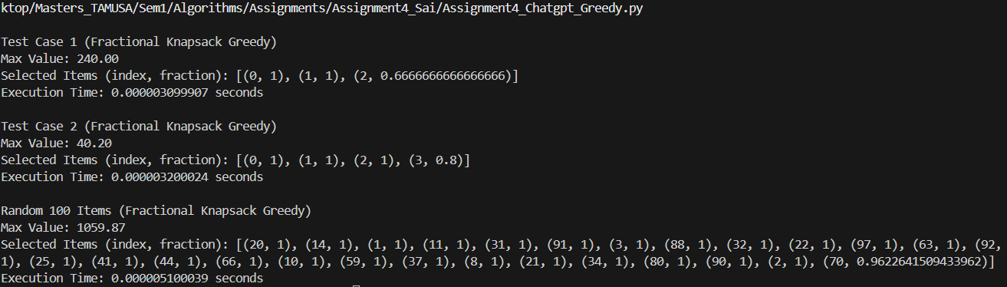

Algorithm1 using Gemini (Dynamic Approach):
import random
import time

def knapsack_01_dp(capacity, weights, values):

n = len(values)
dp = [[0 for _ in range(capacity + 1)] for _ in range(n + 1)]

for i in range(1, n + 1):
for w in range(1, capacity + 1):
if weights[i - 1] > w:
dp[i][w] = dp[i - 1][w]
else:
dp[i][w] = max(
dp[i - 1][w], values[i - 1] + dp[i - 1][w - weights[i - 1]]
)

return dp[n][capacity], dp

def get_selected_items_01(capacity, weights, values, dp):
"""
Finds the items included in the knapsack.

Args:
capacity: The maximum weight capacity of the knapsack.
weights: A list of the weights of the items.
values: A list of the values of the items.
dp: The DP table calculated by knapsack_01_dp.

Returns:
A list of the indices of the selected items.
"""

n = len(values)
w = capacity
selected_items = []

for i in range(n, 0, -1):
if i > 0 and dp[i][w] != dp[i - 1][w]: # Check if item was included
selected_items.append(i - 1)
w -= weights[i - 1]

return selected_items

def measure_execution_time(func, *args, number=10):
"""
Measures the execution time of a function using time.perf_counter().

Args:
func: The function to measure.
*args: The arguments to pass to the function.
number: The number of times to execute the function.

Returns:
The average execution time in seconds.
"""
start_time = time.perf_counter()
for _ in range(number):
func(*args)
end_time = time.perf_counter()
return (end_time - start_time) / number

# Test cases
test_cases = [
{
"name": "Test Case 1",
"weights": [10, 20, 30],
"values": [60, 100, 120],
"capacity": 50,
},
{
"name": "Test Case 2",
"weights": [1, 2, 3, 5],
"values": [6, 11, 12, 14],
"capacity": 10,
},
{
"name": "Random 100 Items",
"weights": [random.randint(1, 150) for _ in range(100)],
"values": [],
"capacity": 500,
},
]

# Run tests for 0/1 Knapsack
print("--- 0/1 Knapsack Tests ---")
for test_case in test_cases:
print(f"\n--- {test_case['name']} ---")

# Generate values for the 100-item test case
if not test_case["values"]:
test_case["values"] = [
w * 3 + random.randint(-5, 20) for w in test_case["weights"]
]
test_case["values"] = [max(1, min(v, 500)) for v in test_case["values"]]

capacity = test_case["capacity"]
weights = test_case["weights"]
values = test_case["values"]

# Measure execution time
execution_time = measure_execution_time(
knapsack_01_dp, capacity, weights, values, number=10
)
print(f"Execution Time: {execution_time:.6f} seconds")

# Run the knapsack algorithm and print results
max_value, dp_table = knapsack_01_dp(capacity, weights, values)
print(f"Maximum value: {max_value}")

selected_items_indices = get_selected_items_01(
capacity, weights, values, dp_table
)
selected_items = [f"Item {i + 1}" for i in selected_items_indices]
print(f"Selected items: {selected_items}")
OUTPUT:
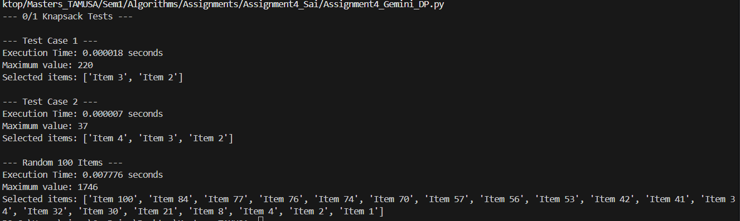

Algorithm2 using Gemini (Greedy Approach):
import random
import time

def fractional_knapsack(capacity, weights, values):
"""
Solves the Fractional Knapsack problem using a greedy approach.
"""

# Calculate value-to-weight ratios
ratios = [(values[i] / weights[i], i) for i in range(len(values))]

# Sort items in descending order of their value-to-weight ratio
ratios.sort(key=lambda x: x[0], reverse=True)

max_value = 0
load = 0
selected_items = [] # To store (item index, fraction taken)

for ratio, index in ratios:
if weights[index] <= capacity - load:
# Take the whole item
max_value += values[index]
load += weights[index]
selected_items.append((index, 1))
else:
# Take a fraction of the item
fraction = (capacity - load) / weights[index]
max_value += values[index] * fraction
load = capacity
selected_items.append((index, fraction))
break # Knapsack is full

return max_value, selected_items

def measure_execution_time(func, *args, number=10):
"""
Measures the execution time of a function using time.perf_counter().
"""

start_time = time.perf_counter()
for _ in range(number):
func(*args)
end_time = time.perf_counter()
return (end_time - start_time) / number

# Test cases
test_cases = [
{
"name": "Test Case 1",
"weights": [10, 20, 30],
"values": [60, 100, 120],
"capacity": 50,
},
{
"name": "Test Case 2",
"weights": [1, 2, 3, 5],
"values": [6, 11, 12, 14],
"capacity": 10,
},
{
"name": "Random 100 Items",
"weights": [random.randint(1, 150) for _ in range(100)],
"values": [],
"capacity": 500,
},
]

# Run tests for Fractional Knapsack
print("--- Fractional Knapsack Tests ---")
for test_case in test_cases:
print(f"\n--- {test_case['name']} ---")

# Generate values for the 100-item test case
if not test_case["values"]:
test_case["values"] = [
w * 3 + random.randint(-5, 20) for w in test_case["weights"]
]
test_case["values"] = [max(1, min(v, 500)) for v in test_case["values"]]

capacity = test_case["capacity"]
weights = test_case["weights"]
values = test_case["values"]

# Measure execution time
execution_time = measure_execution_time(
fractional_knapsack, capacity, weights, values, number=10
)
print(f"Execution Time: {execution_time:.6f} seconds")

# Run the knapsack algorithm and print results
max_value, selected_items = fractional_knapsack(capacity, weights, values)
print(f"Maximum value: {max_value}")
print("Selected items:", end=" ") # Print "Selected items:" once, at the beginning
for index, fraction in selected_items:
print(f"Item {index + 1}: {fraction}", end=" ") # Print items side-by-side
print() # Print a newline at the end of the list
