Assignment 1
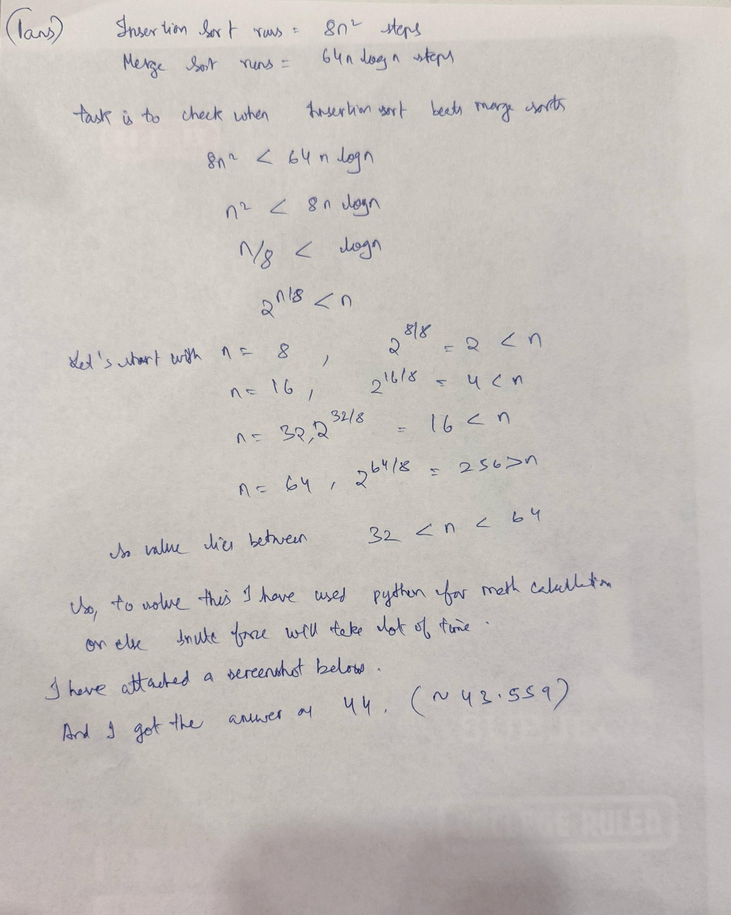
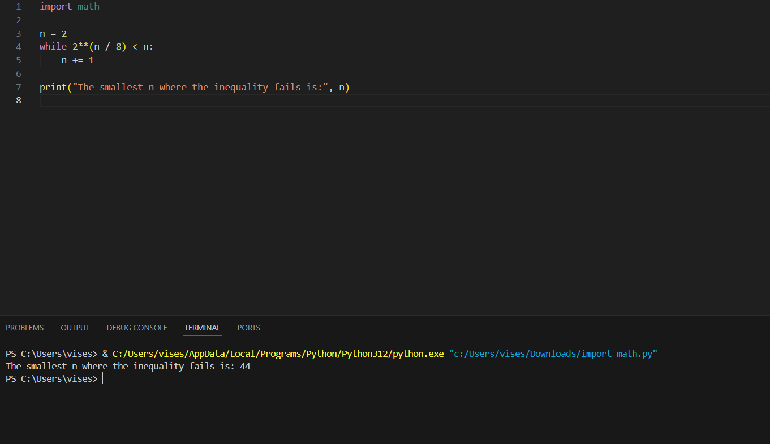

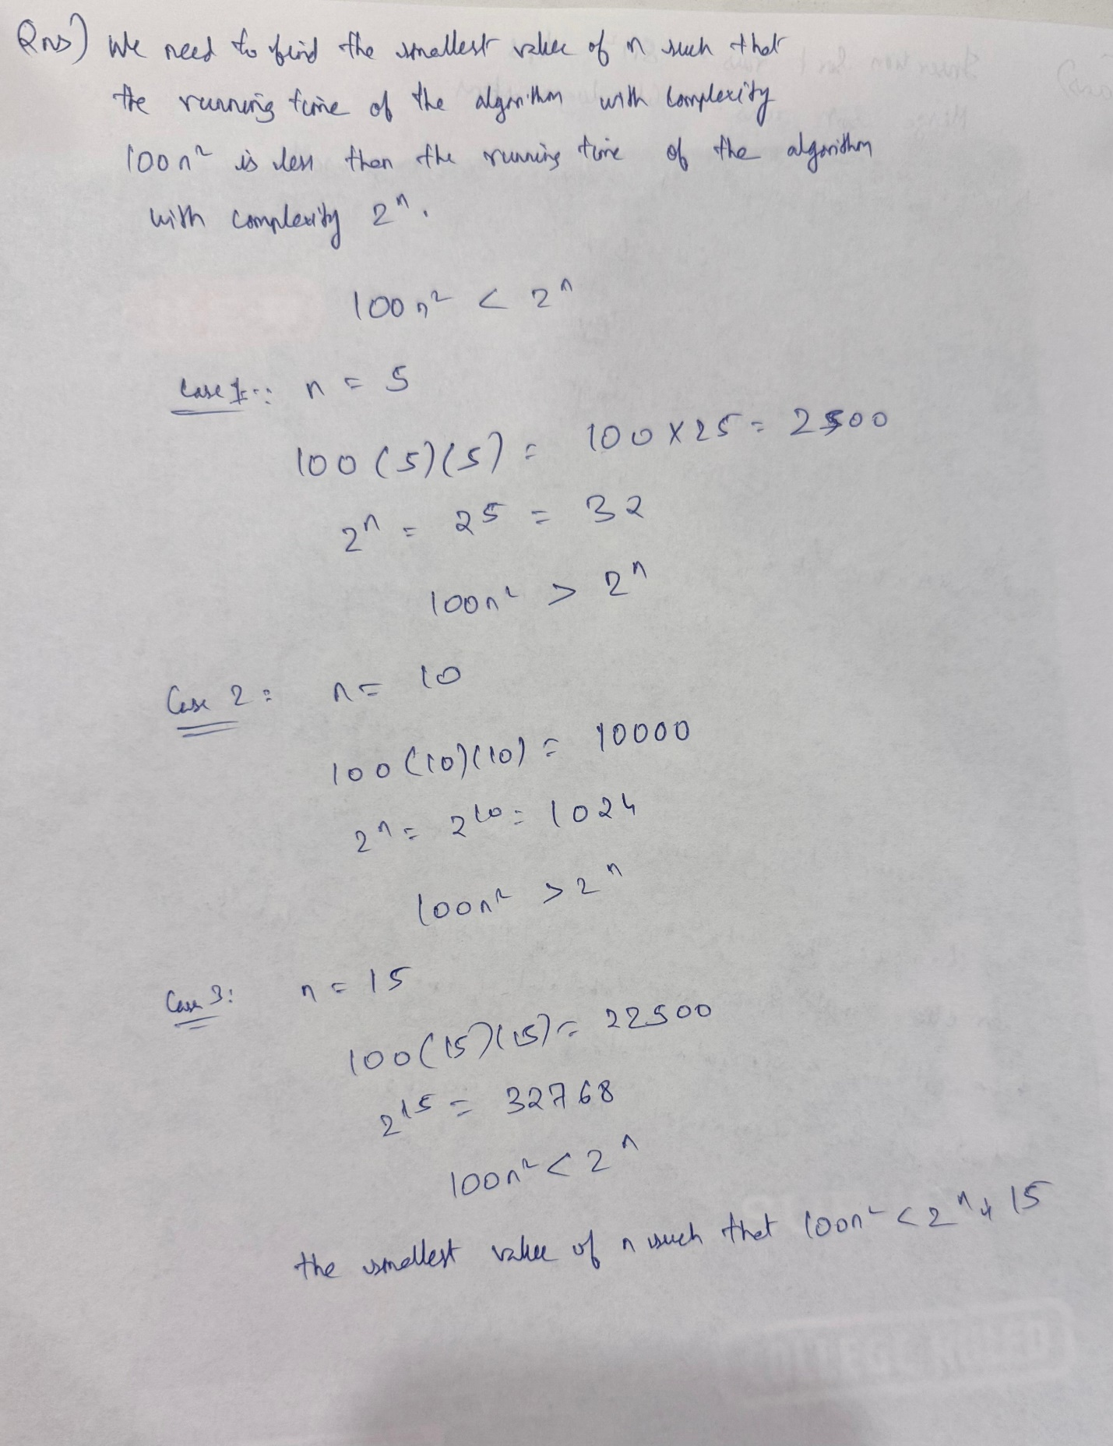

3rd answer
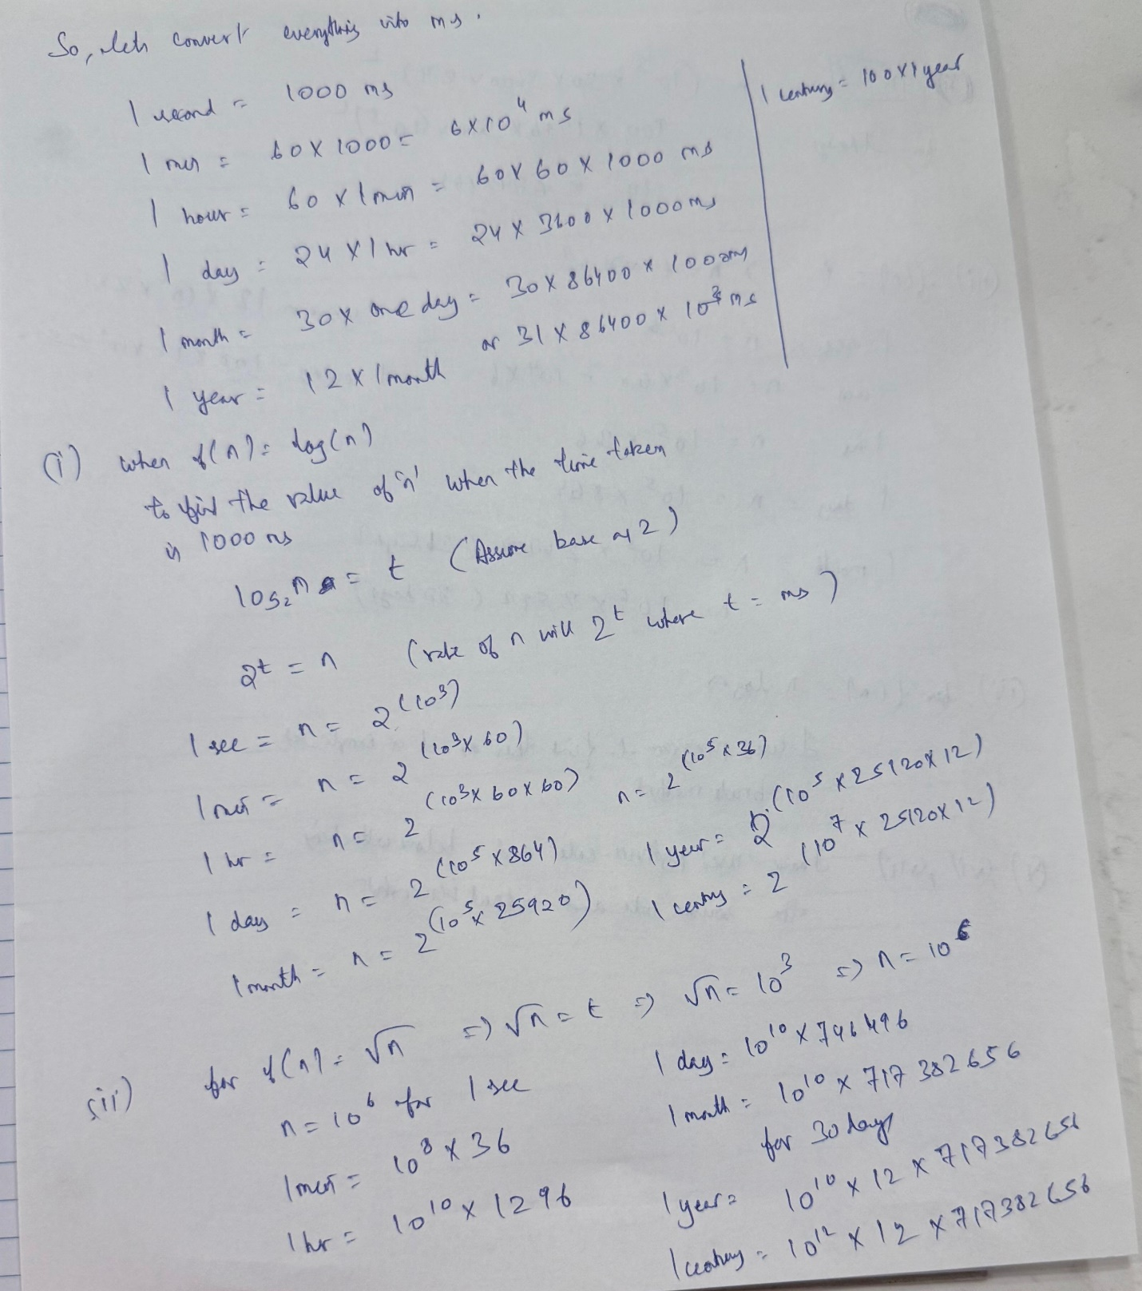
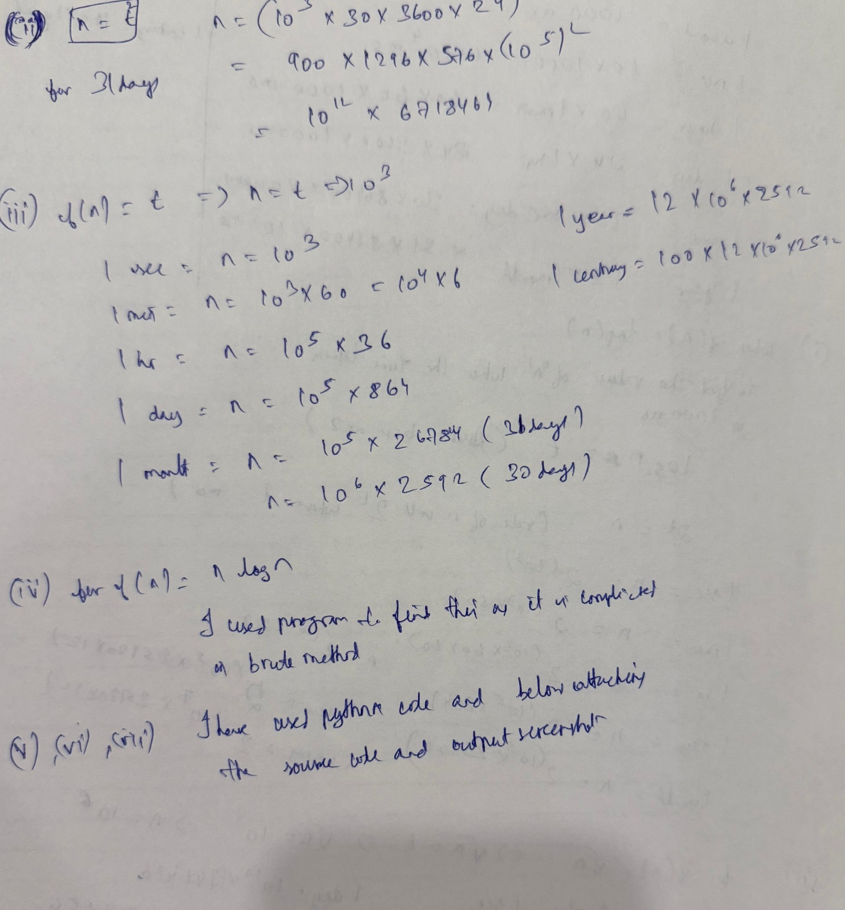

import math

def rootN(time):
x = time ** 0.5
return x

def functionNlogN(time):

low, high = 1, time
while low < high:
mid = (low + high) // 2
if mid * math.log2(mid) < time:
low = mid + 1
else:
high = mid
return low if low * math.log2(low) >= time else low - 1

def functionNsquare(time):
x = time ** 2
return int(x)

def functionNcube(time):
x = time ** (1/3)
return int(x)

def function2powN(time):
if time > 1:
x = math.log2(time)
return int(x)
else:
return 0

def functionNfact(time):
n = 1
fact = 1

limit = 1000
while fact < time and n < limit:
n = n + 1
fact = fact * n
return n-1 if n < limit else "Overflow"

onesec = 1000
onemin = 60 * onesec
onehour = 60 * onemin
oneday = 24 * onehour
onemonth = 30 * oneday
oneyear = 365 * oneday
onecentury = 100 * oneyear

times = [onesec, onemin, onehour, oneday, onemonth, oneyear, onecentury]

print("f(n) = log(n) \t", end="")
for time in times:
print("2 ^ "+str(time) +" ", end="")
print()

print("f(n) = sqrt(n) \t", end="")
for time in times:
print(str(int(rootN(time))) +" ", end="")
print()

print("f(n) = n \t\t", end="")
for time in times:
print(str(time) +" ", end="")
print()

print("f(n) = nlogn \t", end="")
for time in times:
print(str(functionNlogN(time)) +" ", end="")
print()

print("f(n) = n^2 \t\t", end="")
for time in times:
print(str(functionNsquare(time)) +" ", end="")
print()

print("f(n) = n^3 \t\t", end="")
for time in times:
print(str(functionNcube(time)) +" ", end="")
print()

print("f(n) = 2^n \t\t", end="")
for time in times:
print(str(function2powN(time)) +" ", end="")
print()

print("f(n) = n! \t\t", end="")
for time in times:
print(str(functionNfact(time)) +" ", end="")
print()

OUTPUT:
