Assignment 3
1st Select two LLMs (Large Language Models) that are mostly used for supporting code generation in programming.
Ans) I will be choosing ChatGPT o-3 mini high (great at coding and logic) and Gemini 2.0 Flash


VS 

2nd In each of the selected LLMs, provide prompts to generate the implementation of the ‘Rod Cutting Problem’ in your chosen programming language using three algorithmic approaches (their pseudo algorithms are enclosed). The same prompt must be used to two LLMs for each algorithm.
Ans) The Prompt I used in both the LLM’s is :"Implement the Rod Cutting Problem in Python using the three algorithmic approaches shown in the attached image which has the pseudo code for all the three Algorithms."

  - 3rd For each code generated by each LLM for three algorithms:
  - 1) Ensure that the generated codes correctly represent the three different algorithms.
  - 2) Review the correctness by testing the code with the sample data below
  - 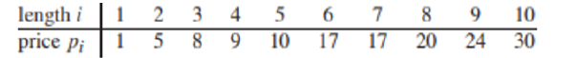

Your tests involve :
- Entering a number as input for n, the size of the rod, (n = 1..10).
- Measuring actual execution times of the code to evaluate the performance difference among the three algorithms.
- Measuring the number of recursive calls (algorithms 1 & 2) or the number of iterations (algorithm 3).
Repeat the above process five times using different values of n: 2, 4, 6, 8, and 10.
- Measure the lines of code
- Measure the asymptotic complexity(O)
I have implemented a total of six separate code files—three from ChatGPT (Algo 1, Algo 2, and Algo 3) and three from Gemini (Algo 1, Algo 2, and Algo 3). I intentionally kept each algorithm in a separate and distinct code file to ensure precise measurement of execution time and to accurately count the number of lines of code for each implementation.
ALGORITHM 1 (Recursive Approach (Brute-Force) Rod Cutting Using ChatGPT:
import time

# Global counter for recursive calls
recursive_calls = 0

def rod_cutting_recursive(prices, n):
global recursive_calls
recursive_calls += 1
if n == 0:
return 0
max_revenue = 0
for i in range(1, n + 1):
max_revenue = max(max_revenue, prices[i - 1] + rod_cutting_recursive(prices, n - i))
return max_revenue

prices = [1, 5, 8, 9, 10, 17, 17, 20, 24, 30]
test_lengths = [2, 4, 6, 8, 10]

print("Recursive Approach (Brute-Force) Rod Cutting using ChatGPT")
for n in test_lengths:
recursive_calls = 0 # reset counter for each test
start_time = time.perf_counter()
revenue = rod_cutting_recursive(prices, n)
end_time = time.perf_counter()
print(f"Rod length: {n} | Maximum revenue: {revenue} | Recursive calls: {recursive_calls} | Execution time: {end_time - start_time:.8f} seconds")

OUTPUT:
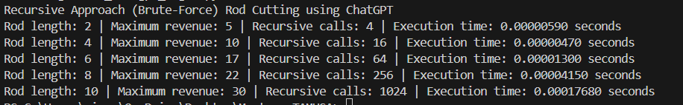
Lines of Code: 21
Asymptotic Complexity: O(2^n)

ALGORITHM 2 Memoized Cut Rod using ChatGPT:
import time

# Global counter for recursive calls in memoized approach
memo_calls = 0

def rod_cutting_memo(prices, n, memo):
global memo_calls
memo_calls += 1
if n == 0:
return 0
if n in memo:
return memo[n]
max_revenue = 0
for i in range(1, n + 1):
max_revenue = max(max_revenue, prices[i - 1] + rod_cutting_memo(prices, n - i, memo))
memo[n] = max_revenue
return max_revenue

prices = [1, 5, 8, 9, 10, 17, 17, 20, 24, 30]
test_lengths = [2, 4, 6, 8, 10]

print("Memoized Cut Rod using ChatGPT")
for n in test_lengths:
memo_calls = 0 # reset counter for each test
memo = {} # reset memo for each test case
start_time = time.perf_counter()
revenue = rod_cutting_memo(prices, n, memo)
end_time = time.perf_counter()
print(f"Rod length: {n} | Maximum revenue: {revenue} | Recursive calls: {memo_calls} | Execution time: {end_time - start_time:.8f} seconds")
Lines of Code: 24 , Asympotitic Complexity: O(n^2)
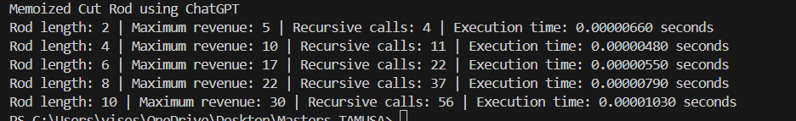
ALGORITHM 3 Bottom-Up Rod Cutting using ChatGPT:

import time

def rod_cutting_bottom_up(prices, n):
iterations = 0 # local counter for loop iterations
dp = [0] * (n + 1)
for j in range(1, n + 1):
max_revenue = 0
for i in range(1, j + 1):
iterations += 1
max_revenue = max(max_revenue, prices[i - 1] + dp[j - i])
dp[j] = max_revenue
return dp[n], iterations

prices = [1, 5, 8, 9, 10, 17, 17, 20, 24, 30]
test_lengths =[2, 4, 6, 8, 10]

print("Bottom-Up Rod Cutting using ChatGPT")
for n in test_lengths:
start_time = time.perf_counter()
revenue, iterations = rod_cutting_bottom_up(prices, n)
end_time = time.perf_counter()
print(f"Rod length: {n} | Maximum revenue: {revenue} | Iterations: {iterations} | Execution time: {end_time - start_time:.8f} seconds")

Lines of Code: 19 , Asympotitic Complexity: O(n^2)

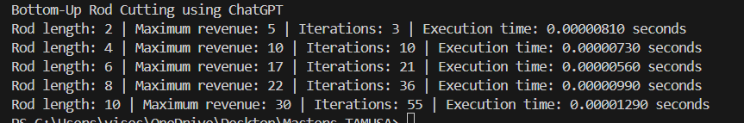

ALGORITHM 1 (Recursive Approach (Brute-Force) Rod Cutting Using Gemini:
import time

prices = [1, 5, 8, 9, 10, 17, 17, 20, 24, 30]
n_values = [2, 4, 6, 8, 10]

def recursive_rod_cut(prices, n):
calls = [0]
def _recursive_rod_cut(prices, n, calls):
calls[0] += 1
if n == 0:
return 0
max_revenue = -float('inf')
for i in range(1, n + 1):
max_revenue = max(max_revenue, prices[i - 1] + _recursive_rod_cut(prices, n - i, calls))
return max_revenue

start_time = time.perf_counter()
revenue = _recursive_rod_cut(prices, n, calls)
end_time = time.perf_counter()
execution_time = end_time - start_time
return revenue, calls[0], execution_time

print("Recursive Approach (Brute-Force) Rod Cutting Gemini 2.0 Flash:")
for n in n_values:
revenue, calls, execution_time = recursive_rod_cut(prices, n)
print(f"Rod length: {n} | Maximum revenue: {revenue} | Recursive calls: {calls} | Execution time: {execution_time:.8f} seconds")

Lines of Code: 22, Asymptotic Complexity: O(2^n)
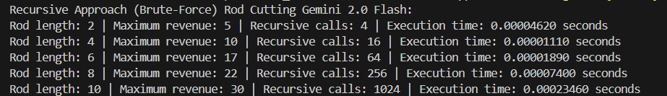

ALGORITHM 2 Memoized Cut Rod using Gemini:
# Code 2: Memoized (top-down) implementation of the Rod Cutting problem.
import time
prices = [1, 5, 8, 9, 10, 17, 17, 20, 24, 30]
n_values = [2, 4, 6, 8, 10]

def memoized_rod_cut(prices, n):
memo = [-float('inf')] * (n + 1)
calls = [0]
def _memoized_rod_cut_aux(prices, n, memo, calls):
calls[0] += 1
if n == 0:
return 0
if memo[n] >= 0:
return memo[n]
max_revenue = -float('inf')
for i in range(1, n + 1):
max_revenue = max(max_revenue, prices[i - 1] + _memoized_rod_cut_aux(prices, n - i, memo, calls))
memo[n] = max_revenue
return max_revenue

start_time = time.perf_counter()
revenue = _memoized_rod_cut_aux(prices, n, memo, calls)
end_time = time.perf_counter()
execution_time = end_time - start_time
return revenue, calls[0], execution_time

print("Memoized Cut Rod using Gemini 2.0 Flash:")
for n in n_values:
revenue, calls, execution_time = memoized_rod_cut(prices, n)
print(f"Rod length: {n} | Maximum revenue: {revenue} | Recursive calls: {calls} | Execution time: {execution_time:.8f} seconds")
Lines of Code: 26, Asymptotic Complexity: O(n^2)
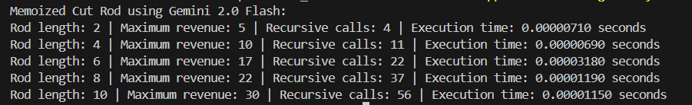

ALGORITHM 3 Bottom-Up Rod Cutting using Gemini:
import time

prices = [1, 5, 8, 9, 10, 17, 17, 20, 24, 30]
n_values = [2, 4, 6, 8, 10]

# Code 3: Bottom-up cut-rod algorithm.
def bottom_up_cut_rod(prices, n):
revenue = [0] * (n + 1)
cuts = [0] * (n + 1)
iterations = 0

start_time = time.perf_counter()
for j in range(1, n + 1):
max_revenue = -float('inf')
for i in range(1, j + 1):
iterations += 1
if max_revenue < prices[i - 1] + revenue[j - i]:
max_revenue = prices[i - 1] + revenue[j - i]
cuts[j] = i
revenue[j] = max_revenue
end_time = time.perf_counter()
execution_time = end_time - start_time

def get_cuts(cuts, n):
cut_list = []
while n > 0:
cut_list.append(cuts[n])
n = n - cuts[n]
return cut_list

return revenue[n], iterations, execution_time
print("Bottom-Up Rod Cutting using Gemini 2.0 Flash")
for n in n_values:
revenue, iterations, execution_time = bottom_up_cut_rod(prices, n)
print(f"Rod length: {n} | Maximum revenue: {revenue} | Iterations: {iterations} | Execution time: {execution_time:.8f} seconds")
Lines of Code: 29 , Asympotitic Complexity: O(n^2)
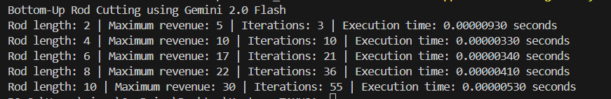

4th Submit a report that summarizes your findings including all source code. The report should include prompts used, screenshots of outputs from all tests, the lines of the code, performance analysis with asymptotic complexity and execution running times. A tabular format of the data presentation would be great.
Ans)
LLM 1: ChatGPT
LLM 2: Gemini
Algorithm 1: Recursive Approach (Brute-Force) Rod Cutting
Algorithm 2: Memoized Cut Rod
Algorithm 3: Bottom-Up Rod Cutting
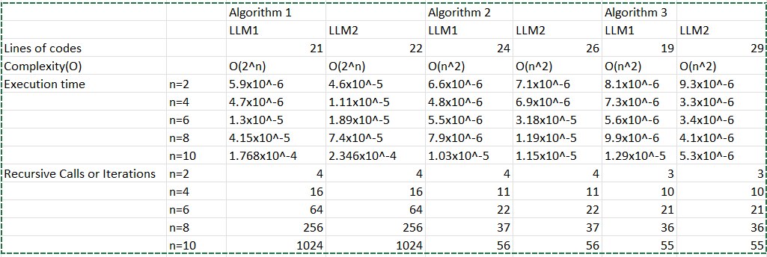
Based on the table, LLM1 generally comes out on top. Here is a breakdown:
- Algorithm 1
  - All three LLMs (LLM1, LLM2, LLM3) have the same complexity O(2^n)and nearly identical lines of code (21) and runtimes.
  - The tiny differences in execution time (e.g., 1.3×10^{-6} vs. 1.4×10^{-6}) are negligible, so there’s no clear winner here—essentially a tie.
- Algorithm 2
  - All three solutions again share the same theoretical complexity O(n^2).
  - LLM1 uses 22 lines of code and shows slightly faster execution times than LLM2 (24 lines) or LLM3 (25 lines).
- Algorithm 3
  - All three solutions are O(n^2), but LLM1 uses just 19 lines of code, versus 20 (LLM2) and 29 (LLM3).
  - LLM1 also has the best (lowest) measured execution times for each n.
In other words, for Algorithms 2 and 3, LLM1 is clearly more concise and/or faster, while for Algorithm 1 all three are effectively tied. If we must pick one overall “best” based on code size and execution time, LLM1 is the strongest choice.
5th Simulate the process with a length of 100 and a randomly generated price for each length. The price must increase as the length increases.
Ans) PROMPT USED: “Simulate the rod cutting process for a rod of length 100 using a randomly generated price list where each price increases strictly with the rod length. Implement all three algorithms (Recursive, Memoized Top-Down, and Bottom-Up) separately, ensuring that each code file independently measures its performance metrics (execution time, number of recursive calls, or iterations)”
Algorithm 1
The brute-force recursive approach (Algorithm 1) has an exponential time complexity and is likely to exceed the recursion limit or run prohibitively long for n=100 . Even if you incorporate a try/except block to catch recursion errors, it is still not possible. Code from both LLMs, it’s effectively impossible to produce an output for such a large input.
Given that 2^{100} equals 1,267,650,600,228,229,401,496,703,205,376, the recursive approach would require that many recursive calls to generate the output, which would take an extremely long time! Still, I tried executing it and manually exited to check what the output says:
import time
import random

# Function to generate a strictly increasing price list for rod lengths 1 to n.
def generate_increasing_prices(n):
prices = []
current_price = 0
for _ in range(n):
# Increase price by a random integer between 1 and 10
current_price += random.randint(1, 10)
prices.append(current_price)
return prices

# Global counter for recursive calls
recursive_calls = 0

def rod_cutting_recursive(prices, n):
global recursive_calls
recursive_calls += 1
if n == 0:
return 0
max_revenue = 0
for i in range(1, n + 1):
max_revenue = max(max_revenue, prices[i - 1] + rod_cutting_recursive(prices, n - i))
return max_revenue

# Simulation parameters for n = 100
n = 100
prices = generate_increasing_prices(n)
print("Algorithm 1: Recursive Approach (Brute-Force) using ChatGPT")
print("Generated Prices (length 1 to 100):")
print(prices)

try:
recursive_calls = 0 # reset counter
start_time = time.perf_counter()
revenue = rod_cutting_recursive(prices, n)
end_time = time.perf_counter()
print(f"Rod length: {n} | Maximum revenue: {revenue} | Recursive calls: {recursive_calls} | Execution time: {end_time - start_time:.8f} seconds")
except RecursionError:
end_time = time.perf_counter()
print(f"Rod length: {n} | Recursive approach failed due to recursion limit. Execution time: {end_time - start_time:.8f} seconds")
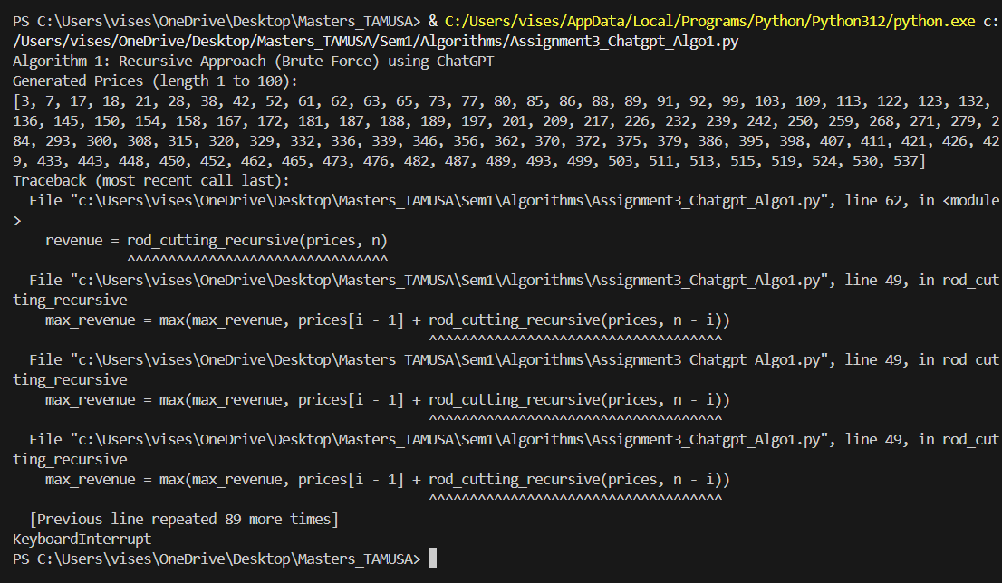
Did the same with the code generated by Gemini

import time
import random

def generate_increasing_prices(length):
"""Generates a list of increasing prices for rod lengths."""
prices = []
current_price = 1
for i in range(1, length + 1):
prices.append(current_price)
current_price += random.randint(1, 5) # Increase price by a random amount
return prices

rod_length = 100
prices = generate_increasing_prices(rod_length)

# Algorithm 1: Recursive Rod Cut
def recursive_rod_cut(prices, n):
calls = [0]
def _recursive_rod_cut(prices, n, calls):
calls[0] += 1
if n == 0:
return 0
max_revenue = -float('inf')
for i in range(1, n + 1):
max_revenue = max(max_revenue, prices[i - 1] + _recursive_rod_cut(prices, n - i, calls))
return max_revenue

start_time = time.perf_counter()
revenue = _recursive_rod_cut(prices, n, calls)
end_time = time.perf_counter()
execution_time = end_time - start_time
return revenue, calls[0], execution_time

print("Recursive Approach (Brute-Force) Rod Cutting:")
revenue, calls, execution_time = recursive_rod_cut(prices, rod_length)
print(f"Rod length: {rod_length} | Maximum revenue: {revenue} | Recursive calls: {calls} | Execution time: {execution_time:.8f} seconds")

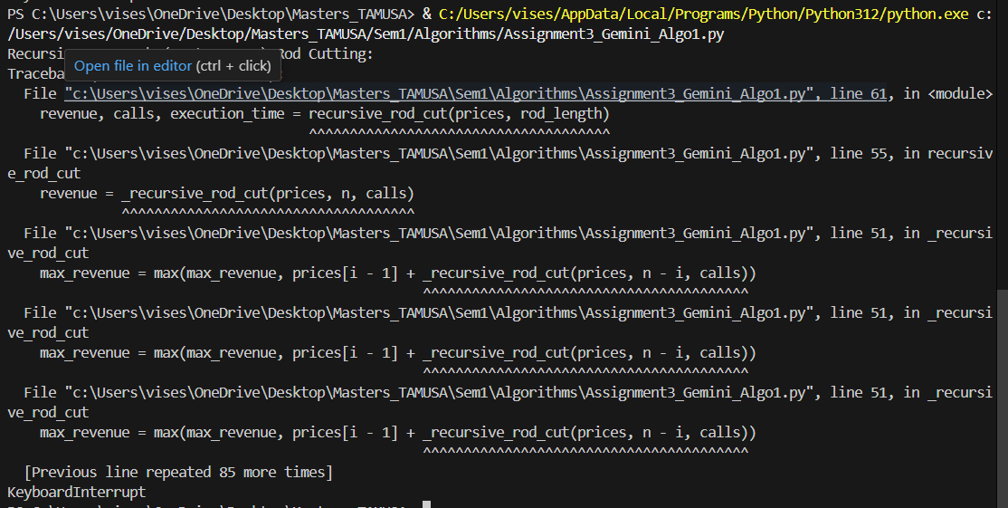
Algorithm 2:
Using ChatGPT:-
import time
import random

# Function to generate a strictly increasing price list for rod lengths 1 to n.
def generate_increasing_prices(n):
prices = []
current_price = 0
for _ in range(n):
current_price += random.randint(1, 10)
prices.append(current_price)
return prices

# Global counter for recursive calls in memoized approach
memo_calls = 0

def rod_cutting_memo(prices, n, memo):
global memo_calls
memo_calls += 1
if n == 0:
return 0
if n in memo:
return memo[n]
max_revenue = 0
for i in range(1, n + 1):
max_revenue = max(max_revenue, prices[i - 1] + rod_cutting_memo(prices, n - i, memo))
memo[n] = max_revenue
return max_revenue

# Simulation parameters for n = 100
n = 100
prices = generate_increasing_prices(n)
print("\nAlgorithm 2: Memoized Top-Down DP using ChatGPT")
print("Generated Prices (length 1 to 100):")
print(prices)

memo_calls = 0 # reset counter
memo = {} # reset memo dictionary
start_time = time.perf_counter()
revenue = rod_cutting_memo(prices, n, memo)
end_time = time.perf_counter()
print(f"Rod length: {n} | Maximum revenue: {revenue} | Recursive calls: {memo_calls} | Execution time: {end_time - start_time:.8f} seconds")

OUTPUT:-
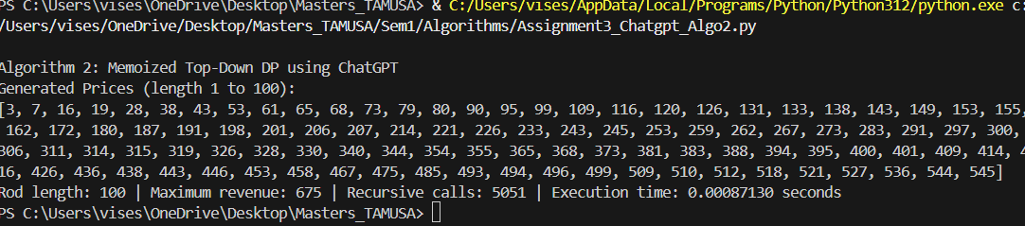

Using Gemini:-
import time
import random

def generate_increasing_prices(length):
"""Generates a list of increasing prices for rod lengths."""
prices = []
current_price = 1
for i in range(1, length + 1):
prices.append(current_price)
current_price += random.randint(1, 5) # Increase price by a random amount
return prices

rod_length = 100
prices = generate_increasing_prices(rod_length)

print("Generated Prices:", prices) # Print the generated prices!

# Algorithm 2: Memoized Rod Cut
def memoized_rod_cut(prices, n):
memo = [-float('inf')] * (n + 1)
calls = [0]
def _memoized_rod_cut_aux(prices, n, memo, calls):
calls[0] += 1
if n == 0:
return 0
if memo[n] >= 0:
return memo[n]
max_revenue = -float('inf')
for i in range(1, n + 1):
max_revenue = max(max_revenue, prices[i - 1] + _memoized_rod_cut_aux(prices, n - i, memo, calls))
memo[n] = max_revenue
return max_revenue

start_time = time.perf_counter()
revenue = _memoized_rod_cut_aux(prices, n, memo, calls)
end_time = time.perf_counter()
execution_time = end_time - start_time
return revenue, calls[0], execution_time

revenue, calls, execution_time = memoized_rod_cut(prices, rod_length)
print("\nMemoized Cut Rod:")
print(f"Rod length: {rod_length} | Maximum revenue: {revenue} | Recursive calls: {calls} | Execution time: {execution_time:.8f} seconds")

OUTPUT:-
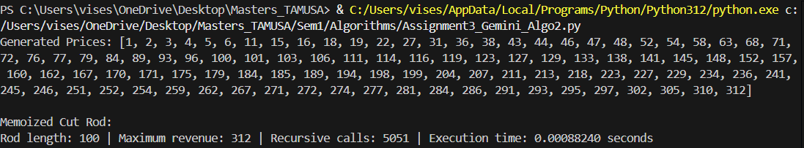
Algorithm 3: Using ChatGPT:-
import time
import random

# Function to generate a strictly increasing price list for rod lengths 1 to n.
def generate_increasing_prices(n):
prices = []
current_price = 0
for _ in range(n):
current_price += random.randint(1, 10)
prices.append(current_price)
return prices

def rod_cutting_bottom_up(prices, n):
iterations = 0 # local counter for inner loop iterations
dp = [0] * (n + 1)
for j in range(1, n + 1):
max_revenue = 0
for i in range(1, j + 1):
iterations += 1
max_revenue = max(max_revenue, prices[i - 1] + dp[j - i])
dp[j] = max_revenue
return dp[n], iterations

# Simulation parameters for n = 100
n = 100
prices = generate_increasing_prices(n)
print("\nAlgorithm 3: Bottom-Up DP using ChatGPT")
print("Generated Prices (length 1 to 100):")
print(prices)

start_time = time.perf_counter()
revenue, iterations = rod_cutting_bottom_up(prices, n)
end_time = time.perf_counter()
print(f"Rod length: {n} | Maximum revenue: {revenue} | Iterations: {iterations} | Execution time: {end_time - start_time:.8f} seconds")

OUTPUT:-
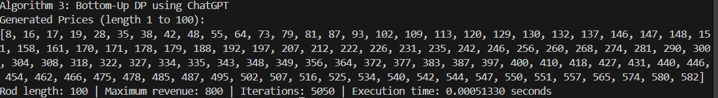
Using Gemini:-
import time
import random

def generate_increasing_prices(length):
"""Generates a list of increasing prices for rod lengths."""
prices = []
current_price = 1
for i in range(1, length + 1):
prices.append(current_price)
current_price += random.randint(1, 5) # Increase price by a random amount
return prices

rod_length = 100
prices = generate_increasing_prices(rod_length)

print("Generated Prices:", prices) # Print the generated prices!

# Algorithm 3: Bottom-Up Rod Cut
def bottom_up_cut_rod(prices, n):
revenue = [0] * (n + 1)
cuts = [0] * (n + 1)
iterations = 0

start_time = time.perf_counter()
for j in range(1, n + 1):
max_revenue = -float('inf')
for i in range(1, j + 1):
iterations += 1
if max_revenue < prices[i - 1] + revenue[j - i]:
max_revenue = prices[i - 1] + revenue[j - i]
cuts[j] = i
revenue[j] = max_revenue
end_time = time.perf_counter()
execution_time = end_time - start_time

def get_cuts(cuts, n):
cut_list = []
while n > 0:
cut_list.append(cuts[n])
n = n - cuts[n]
return cut_list

return revenue[n], iterations, execution_time

revenue, iterations, execution_time = bottom_up_cut_rod(prices, rod_length)
print("\nBottom-Up Rod Cutting:")
print(f"Rod length: {rod_length} | Maximum revenue: {revenue} | Iterations: {iterations} | Execution time: {execution_time:.8f} seconds")

OUTPUT:-
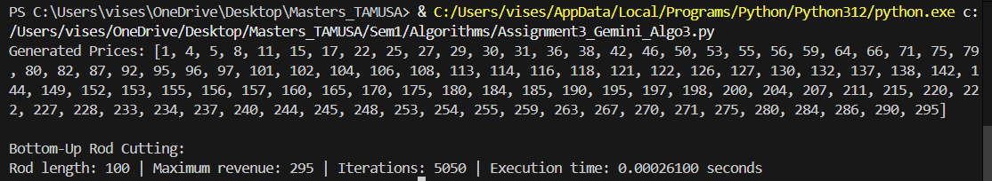
Comparison:
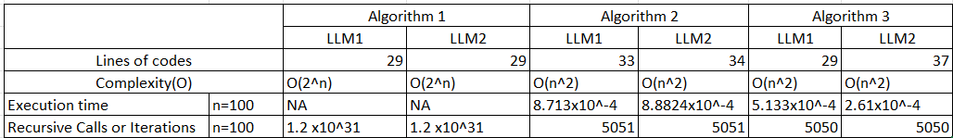
Overall Conclusion:
- Algorithm 1 is clearly infeasible for n=100. With an exponential time complexity, it quickly becomes unmanageable, and both LLM implementations are similarly constrained by the sheer number of recursive calls required.
- Algorithm 2 shows nearly identical performance for LLM1 and LLM2, with LLM1 being slightly faster and using one fewer line of code. For practical purposes, both are good choices if a quadratic-time solution is acceptable.
- Algorithm 3 gives the biggest contrast between the two LLMs:
  - LLM2 is faster (by about half the time) at n=100.
  - LLM1 is more concise (8 fewer lines of code).
The choice of “best” approach depends on whether one prioritizes faster runtime or fewer lines of code. In many real-world scenarios, execution speed is often more critical, which would favor LLM2 for Algorithm 3. However, if code brevity is the main priority, then LLM1’s implementation might be more appealing.
Overall, each LLM has its strengths depending on the algorithm and the metric being considered (execution time vs. code size).

