Assignment 4

1st Select two LLMs (Large Language Models) that are mostly used for supporting code generation in programming.

Ans) I will be choosing ChatGPT o-3 mini high (great at coding and logic) and Gemini 2.0 Flash


VS 

2nd In each of the selected LLMs, provide prompts to generate the implementation of the two Knapsack problems in your chosen programming language (their pseudo algorithms are enclosed). The same prompt must be used to two LLMs for each algorithm.
Ans) Prompt: “Write a Python program to solve the Knapsack Problem using (1) 0/1 Knapsack Dynamic Programming and (2) Fractional Knapsack Greedy Strategy. The program should accept a list of items with weights and values, a max weight W, and return the maximum value possible and the list of items selected.”

  - 3rd For each code generated by each LLM for two algorithms:
  - a) Ensure that the codes generated correctly represent the two different algorithms.
  - b) Review the correctness by testing the code with the sample data below to fill a knapsack with a max weight capacity of W.

  - Items: A, B, C Their weight: weight[i] = {10, 20, 30} Their values: val[i] = {60, 100, 120} Max weight capacity of W = 50
  - Items: A, B, C, D Their weight: weight[i] = {1, 2, 3, 5} Their values: val[i] = {6, 11, 12, 14} Max weight capacity of W = 10
  - Your test involves specifying the number of items, their weights and values, and the maximum capacity that the knapsack can carry, but the code implementation should follow the given pseudocode below.

I have implemented a total of four separate code files—two from ChatGPT (Algo 1, Algo 2) and two from Gemini (Algo 1, Algo 2). I intentionally kept each algorithm in a separate and distinct code file to ensure precise measurement of execution time and to accurately count the number of lines of code for each implementation.

ALGORITHM 1 (Dynamic Programming Approach) Using ChatGPT:
import time

def knapsack_01(weights, values, W):
n = len(weights)
dp = [[0] * (W + 1) for _ in range(n + 1)]

for i in range(1, n + 1):
for w in range(W + 1):
if weights[i-1] <= w:
dp[i][w] = max(dp[i-1][w], dp[i-1][w - weights[i-1]] + values[i-1])
else:
dp[i][w] = dp[i-1][w]

res = dp[n][W]
w = W
items = []
for i in range(n, 0, -1):
if res <= 0:
break
if res != dp[i-1][w]:
items.append(i-1)
res -= values[i-1]
w -= weights[i-1]

return dp[n][W], items

# Problem 1
w1, v1, cap1 = [10, 20, 30], [60, 100, 120], 50
start_time = time.perf_counter()
val1, items1 = knapsack_01(w1, v1, cap1)
print("=== 0/1 Knapsack - Problem 1 ===")
print("Maximum Value:", val1)
for i in items1:
print(f"Item {i}: weight={w1[i]}, value={v1[i]}")

# Problem 2
w2, v2, cap2 = [1, 2, 3, 5], [6, 11, 12, 14], 10
val2, items2 = knapsack_01(w2, v2, cap2)
end_time = time.perf_counter()
print("\n=== 0/1 Knapsack - Problem 2 ===")
print("Maximum Value:", val2)
for i in items2:
print(f"Item {i}: weight={w2[i]}, value={v2[i]}")

print(f"Execution time using ChatGPT (Dynamic Programming Approach) : {end_time - start_time:.8f} seconds")

OUTPUT:
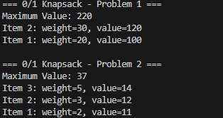
Lines of Code: 32
Asymptotic Complexity: O(nW)

ALGORITHM 2 (Greedy Approach) using ChatGPT:
import time

def knapsack_fractional(weights, values, W):
index = list(range(len(weights)))
ratio = [v/w for v, w in zip(values, weights)]
index.sort(key=lambda i: ratio[i], reverse=True)

max_value = 0
items = []

for i in index:
if weights[i] <= W:
W -= weights[i]
max_value += values[i]
items.append((i, 1))
else:
frac = W / weights[i]
max_value += values[i] * frac
items.append((i, frac))
break

return max_value, items

# Problem 1
w1, v1, cap1 = [10, 20, 30], [60, 100, 120], 50
start_time = time.perf_counter()
val1, items1 = knapsack_fractional(w1, v1, cap1)
print("\n=== Fractional Knapsack - Problem 1 ===")
print("Maximum Value:", val1)
for i, frac in items1:
print(f"Item {i}: {frac:.2f} of (weight={w1[i]}, value={v1[i]})")

# Problem 2
w2, v2, cap2 = [1, 2, 3, 5], [6, 11, 12, 14], 10
val2, items2 = knapsack_fractional(w2, v2, cap2)
end_time = time.perf_counter()
print("\n=== Fractional Knapsack - Problem 2 ===")
print("Maximum Value:", val2)
for i, frac in items2:
print(f"Item {i}: {frac:.2f} of (weight={w2[i]}, value={v2[i]})")
print(f"Execution time using ChatGPT (Greedy Approach): {end_time - start_time:.8f} seconds")
Lines of Code: 28 , Asympotitic Complexity: O(nlogn)
OUTPUT:-
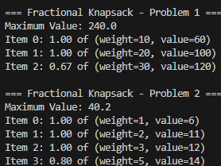

ALGORITHM 1 (Dynamic Programming) Using Gemini:
import time

def knapsack_01_dp(items, max_weight):
n = len(items)
# Initialize a table to store the maximum values for different weights and items
dp_table = [[0 for _ in range(max_weight + 1)] for _ in range(n + 1)]

# Build the dp_table in a bottom-up manner
for i in range(1, n + 1):
for w in range(1, max_weight + 1):
if items[i - 1][1] > w: # If the current item's weight is greater than the current weight
dp_table[i][w] = dp_table[i - 1][w]
else: # Otherwise, take the maximum of including or not including the item
dp_table[i][w] = max(dp_table[i - 1][w], items[i - 1][2] + dp_table[i - 1][w - items[i - 1][1]])

# Backtrack to find the items included in the knapsack
included_items = []
w = max_weight
for i in range(n, 0, -1):
if dp_table[i][w] != dp_table[i - 1][w]:
included_items.append(items[i - 1][0])
w -= items[i - 1][1]

return dp_table[n][max_weight], included_items

# Test Cases for 0/1 Knapsack
items1 = [("A", 10, 60), ("B", 20, 100), ("C", 30, 120)]
max_weight1 = 50

items2 = [("A", 1, 6), ("B", 2, 11), ("C", 3, 12), ("D", 5, 14)]
max_weight2 = 10

# Run test cases and print results
start_time = time.perf_counter()
max_value1, selected_items1 = knapsack_01_dp(items1, max_weight1)
print("0/1 Knapsack Test Case 1:")
print("Maximum value:", max_value1)
print("Included items:", selected_items1)

max_value2, selected_items2 = knapsack_01_dp(items2, max_weight2)
end_time = time.perf_counter()
print("\n0/1 Knapsack Test Case 2:")
print("Maximum value:", max_value2)
print("Included items:", selected_items2)

print(f"Execution time using Gemini (Dynamic Programming Approach): {end_time - start_time:.8f} seconds")

Lines of Code: 29, Asymptotic Complexity: O(nW)
OUTPUT:-
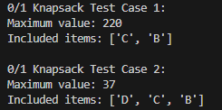

ALGORITHM 2 (Greedy Approach) using Gemini:
import time

def fractional_knapsack(items, max_weight):
# Calculate value-to-weight ratio for each item
value_per_weight = [(item[0], item[2] / item[1], item[1], item[2]) for item in items]

# Sort items in descending order of value-to-weight ratio
value_per_weight.sort(key=lambda x: x[1], reverse=True)

total_value = 0
knapsack_items = []
remaining_weight = max_weight

for item_name, _, item_weight, item_value in value_per_weight:
if item_weight <= remaining_weight:
# Take the whole item
total_value += item_value
remaining_weight -= item_weight
knapsack_items.append((item_name, 1))
else:
# Take a fraction of the item
fraction = remaining_weight / item_weight
total_value += item_value * fraction
knapsack_items.append((item_name, fraction))
break # Knapsack is full

return total_value, knapsack_items

# Test Cases for Fractional Knapsack
items1 = [("A", 10, 60), ("B", 20, 100), ("C", 30, 120)]
max_weight1 = 50

items2 = [("A", 1, 6), ("B", 2, 11), ("C", 3, 12), ("D", 5, 14)]
max_weight2 = 10

# Run test cases and print results
start_time = time.perf_counter()
max_value1, selected_items1 = fractional_knapsack(items1, max_weight1)
print("Fractional Knapsack Test Case 1:")
print("Maximum value:", max_value1)
print("Included items:", selected_items1)

max_value2, selected_items2 = fractional_knapsack(items2, max_weight2)
end_time = time.perf_counter()
print("\nFractional Knapsack Test Case 2:")
print("Maximum value:", max_value2)
print("Included items:", selected_items2)
print(f"Execution time using ChatGPT (Greedy Approach): {end_time - start_time:.8f} seconds")
Lines of Code: 29, Asymptotic Complexity: O(nlogn)
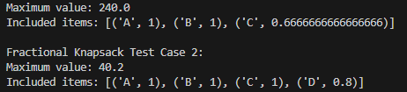
c) Once the correctness is checked from b), now simulate the process with 100 items and randomly generated weights ranging from 1 to 150 and values ranging from $1 to $500 for a max weight capacity of W = 500. The value must increase as the weight increases.
d) Each output should display the maximum value to fill a knapsack along with the list of items added to the knapsack.
e) Also measure/compare the actual execution times of the generated code and asymptotic complexities of both algorithms to evaluate their performance difference.

I have implemented c,d,e in four different codes just like above 2 algorithms from ChatGPT and 2 Algorithms from Gemini:

ALGORITHM 1 (Dynamic Programming Approach) Using ChatGPT:
import random
import time

# Generate 100 items with weights sorted and values strictly increasing

weights = sorted(random.randint(1, 150) for _ in range(100))

values = []
prev_value = 0
for w in weights:
min_value = max(prev_value + 1, w + 1)
value = min_value + random.randint(0, 100)
values.append(value)
prev_value = value

def knapsack_01(weights, values, W):
n = len(weights)
dp = [[0] * (W + 1) for _ in range(n + 1)]
for i in range(1, n + 1):
for w in range(W + 1):
if weights[i - 1] <= w:
dp[i][w] = max(dp[i - 1][w], dp[i - 1][w - weights[i - 1]] + values[i - 1])
else:
dp[i][w] = dp[i - 1][w]

res = dp[n][W]
w = W
items = []
for i in range(n, 0, -1):
if res <= 0:
break
if res != dp[i - 1][w]:
items.append(i - 1)
res -= values[i - 1]
w -= weights[i - 1]

return dp[n][W], items

if __name__ == "__main__":
capacity = 500
start_time = time.perf_counter()
max_val, selected = knapsack_01(weights, values, capacity)
end_time = time.perf_counter()

print("=== 0/1 Knapsack (DP) — Fixed Capacity ===")
print("Maximum Value:", max_val)

total_weight = sum(weights[i] for i in selected)
print("Total Weight Used:", total_weight)

print("Selected Items (index, weight, value):")
for i in selected:
print(f"Item {i}: weight={weights[i]}, value={values[i]}")
print(f"Execution time using ChatGPT (Dynamic Programming Approach) : {end_time - start_time:.8f} seconds")

OUTPUT:-
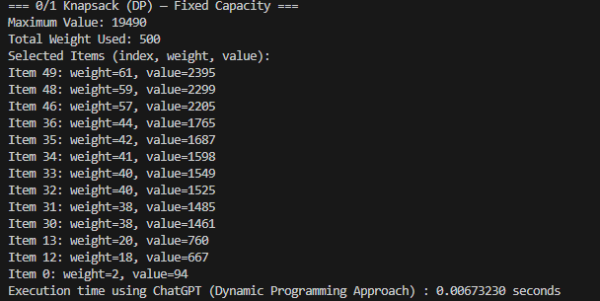

ALGORITHM 2 (Greedy Approach) using ChatGPT:
import random
import time
# Generate 100 items with weights sorted and values strictly increasing
random.seed(42)
weights = sorted(random.randint(1, 150) for _ in range(100))

values = []
prev_value = 0
for w in weights:
min_value = max(prev_value + 1, w + 1)
value = min_value + random.randint(0, 100)
values.append(value)
prev_value = value

def knapsack_fractional(weights, values, W):
index = list(range(len(weights)))
ratio = [v / w for v, w in zip(values, weights)]
index.sort(key=lambda i: ratio[i], reverse=True)

max_value = 0
items = []

for i in index:
if weights[i] <= W:
W -= weights[i]
max_value += values[i]
items.append((i, 1))
else:
frac = W / weights[i]
max_value += values[i] * frac
items.append((i, frac))
break

return max_value, items

if __name__ == "__main__":
capacity = 500
start_time = time.perf_counter()
max_val, selected = knapsack_fractional(weights, values, capacity)
end_time = time.perf_counter()

print("=== Fractional Knapsack (Greedy) ===")
print("Maximum Value:", round(max_val, 2))
print("Selected Items (index, fraction, weight, value):")
for i, frac in selected:
print(f"Item {i}: {frac:.2f} of (weight={weights[i]}, value={values[i]})")
print(f"Execution time using ChatGPT (Greedy Approach): {end_time - start_time:.8f} seconds")

OUTPUT:-
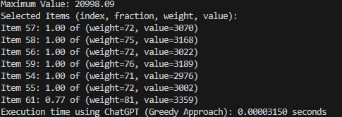

ALGORITHM 1 (Dynamic Programming) Using Gemini:
import random
import time

def knapsack_01_dp_large(items, max_weight):
"""
Solves the 0/1 Knapsack problem using dynamic programming for a larger number of items.

Args:
items: A list of tuples, where each tuple is (item_name, weight, value).
max_weight: The maximum weight the knapsack can hold.

Returns:
A tuple containing:
- The maximum total value that can be put in the knapsack.
- A list of tuples, where each tuple is (item_name, weight, value).
- The execution time of the algorithm.
"""

n = len(items)
dp_table = [[0 for _ in range(max_weight + 1)] for _ in range(n + 1)]

for i in range(1, n + 1):
for w in range(1, max_weight + 1):
if items[i - 1][1] > w:
dp_table[i][w] = dp_table[i - 1][w]
else:
dp_table[i][w] = max(dp_table[i - 1][w], items[i - 1][2] + dp_table[i - 1][w - items[i - 1][1]])

included_items = []
w = max_weight
for i in range(n, 0, -1):
if dp_table[i][w] != dp_table[i - 1][w]:
included_items.append(items[i - 1])
w -= items[i - 1][1]

return dp_table[n][max_weight], included_items

# Generate 100 items with strictly increasing weights and values
def generate_items_01(n=100, max_weight=150, max_value=500):
items = []
weights = sorted(random.sample(range(1, max_weight + 1), n)) # Unique sorted weights
values = []
current_value = random.randint(1, max_value // (2 * n)) # Start with a small random value
for i in range(n):
current_value += random.randint(1, max_value // n) # Ensure value increases
values.append(current_value)

for i in range(n):
items.append((f"Item{i + 1}", weights[i], values[i]))
return items

# Test Case with 100 items
items_large_01 = generate_items_01()
max_weight_large_01 = 500

# Run and print results for 0/1 Knapsack
start_time = time.perf_counter() # Moved start time here
max_value_01, selected_items_01 = knapsack_01_dp_large(items_large_01, max_weight_large_01)
end_time = time.perf_counter() # Moved end time here
print("0/1 Knapsack with 100 items:")
print("Maximum value:", max_value_01)
print("Items added to knapsack:")
for item in selected_items_01:
print(f"Item {item[0]}: 1.00 of (weight={item[1]}, value={item[2]})")
print(f"Execution time using Gemini (Dynamic Programming Approach): {end_time - start_time:.8f} seconds")

OUTPUT:-
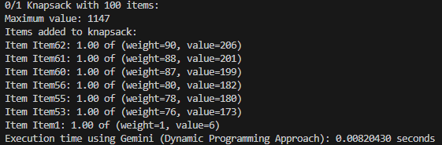

ALGORITHM 2 (Greedy Approach) using Gemini:
import random
import time

def fractional_knapsack_large(items, max_weight):

value_per_weight = [(item[0], item[2] / item[1], item[1], item[2]) for item in items]
value_per_weight.sort(key=lambda x: x[1], reverse=True)

total_value = 0
knapsack_items = []
remaining_weight = max_weight

for item_name, _, item_weight, item_value in value_per_weight:
if item_weight <= remaining_weight:
total_value += item_value
remaining_weight -= item_weight
knapsack_items.append((item_name, 1, item_weight, item_value))
else:
fraction = remaining_weight / item_weight
total_value += item_value * fraction
knapsack_items.append((item_name, fraction, item_weight, item_value))
break

return total_value, knapsack_items

# Generate 100 items with strictly increasing weights and values
def generate_items_fractional(n=100, max_weight=150, max_value=500):
items = []
weights = sorted(random.sample(range(1, max_weight + 1), n)) # Unique sorted weights
values = []
current_value = random.randint(1, max_value // (2 * n)) # Start with a small random value
for i in range(n):
current_value += random.randint(1, max_value // n) # Ensure value increases
values.append(current_value)

for i in range(n):
items.append((f"Item{i + 1}", weights[i], values[i]))
return items

# Test Case with 100 items
items_large_fractional = generate_items_fractional()
max_weight_large_fractional = 500

# Run and print results for Fractional Knapsack
start_time = time.perf_counter() # Moved start time here
max_value_fractional, selected_items_fractional = fractional_knapsack_large(
items_large_fractional, max_weight_large_fractional
)
end_time = time.perf_counter() # Moved end time here
print("\nFractional Knapsack with 100 items:")
print("Maximum value:", max_value_fractional)
print("Items added to knapsack:")
for item in selected_items_fractional:
print(f"Item {item[0]}: {item[1]:.2f} of (weight={item[2]}, value={item[3]})")
print(f"Execution time using ChatGPT (Greedy Approach): {end_time - start_time:.8f} seconds")

OUTPUT:-
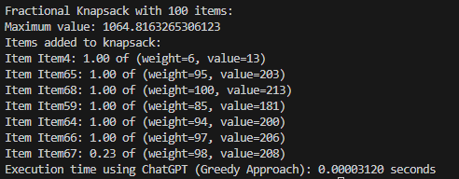

4th Submit a report that summarizes your findings including all source code. The report should include prompts used, screenshots of outputs from all tests, and performance analysis with asymptotic complexity and execution running times. A tabular format of the data presentation would be great.

Comparative Analysis of Dynamic Programming and Greedy Approaches (ChatGPT vs Gemini)
In this Assignment, I implemented and compared the 0/1 Knapsack problem using Dynamic Programming (DP) and the Fractional Knapsack problem using a Greedy Algorithm, with separate solutions generated by both ChatGPT and Gemini. The comparison focuses on time complexity, code structure, and execution performance for small test cases and a large dataset of 100 items.
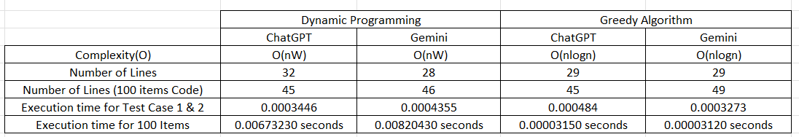

Time Complexity:
Both models correctly implemented algorithms with expected theoretical complexities:
- The Dynamic Programming approach follows a time complexity of O(nW), where n is the number of items and W is the knapsack capacity.
- The Greedy Algorithm (for the fractional variant) has a time complexity of O(n log n) due to the sorting step based on value-to-weight ratio.
These complexities align with the standard formulations of the knapsack problems and were consistent across both tools.

Code Structure Comparison:
When comparing the number of lines of code, I observed that Gemini produced slightly more compact overall structures. For example, Gemini’s DP solution used 28 top-level lines compared to ChatGPT’s 32. However, when it came to logic-specific lines (in the 100-item code), ChatGPT’s DP version was slightly shorter (45 lines) than Gemini’s (46 lines). For the Greedy approach, both had 29 structural lines, but Gemini’s implementation had a slightly longer code (49 lines vs. 45).
These differences suggest that Gemini tends to optimize for brevity in structure, while ChatGPT focuses more on code readability and clear step-by-step logic.

Execution Time Analysis:
The most significant difference came from execution time benchmarks:
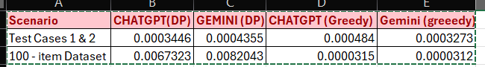
- Dynamic Programming: ChatGPT’s solution consistently outperformed Gemini’s, particularly on the full 100-item dataset, where it was approximately 1.5 milliseconds faster. This indicates better optimization in memory and loop efficiency.
- Greedy Algorithm: Both models delivered excellent performance, with Gemini having a slight edge in execution speed. However, the difference was only a few microseconds, making it insignificant in practical applications.

Conclusion:
Both ChatGPT and Gemini successfully implemented efficient and correct solutions. However:
- ChatGPT is more efficient for DP-based problems, offering better performance on large inputs.
- Gemini excels in fractional/greedy scenarios, providing slightly faster outputs with a bit more logic.
- Greedy solutions are significantly more performant in execution, though they trade off optimality for speed.
These results show that while both models are reliable, choosing between them may depend on the problem type (DP vs Greedy) and whether we prioritize readability, performance, or brevity in code.

