SQL CUBES ASSIGNMENT
1)What was the COST of the items sold in the Fayetteville store of Dillard’s?
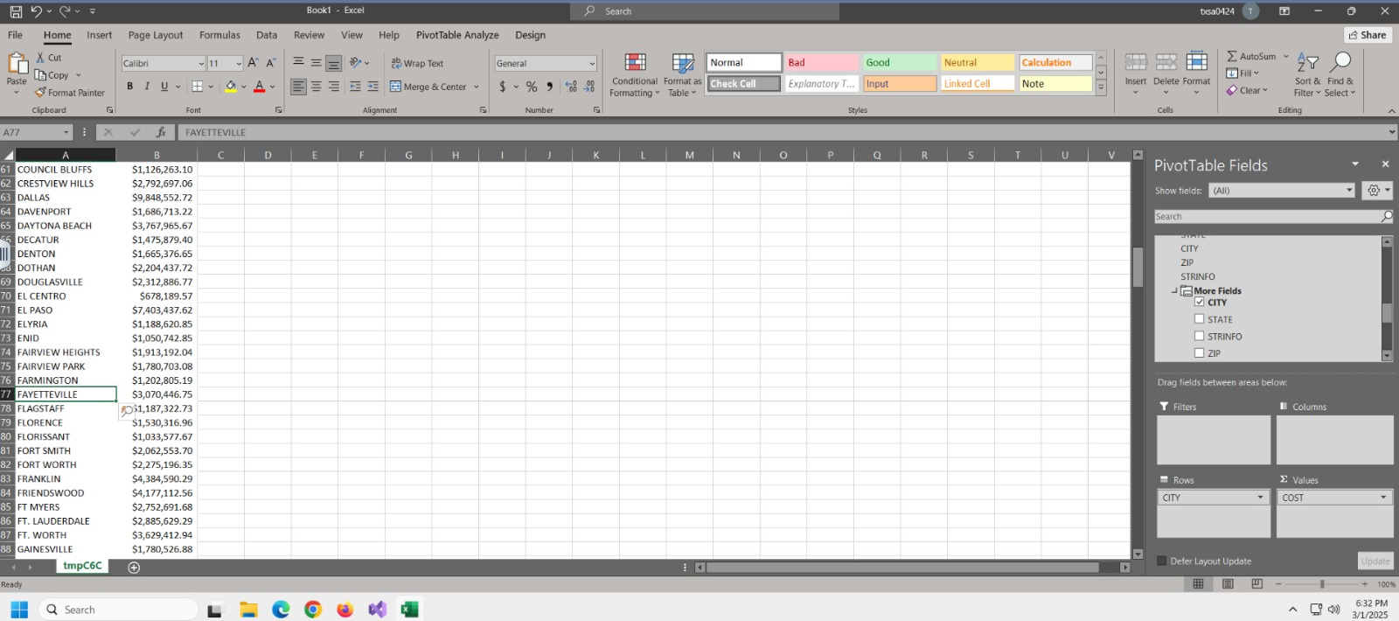

2) What is the AMT (amount) of items sold at Little Rock stores?
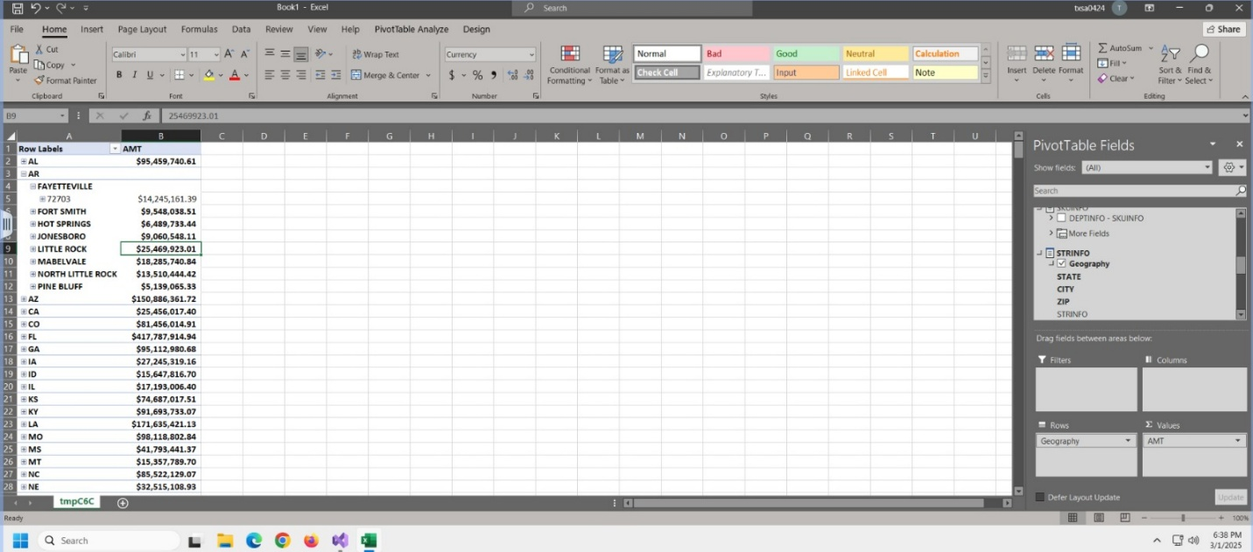

3) What is the amount of items sold in the Fayetteville store in Quarter 3 of the year 2004?

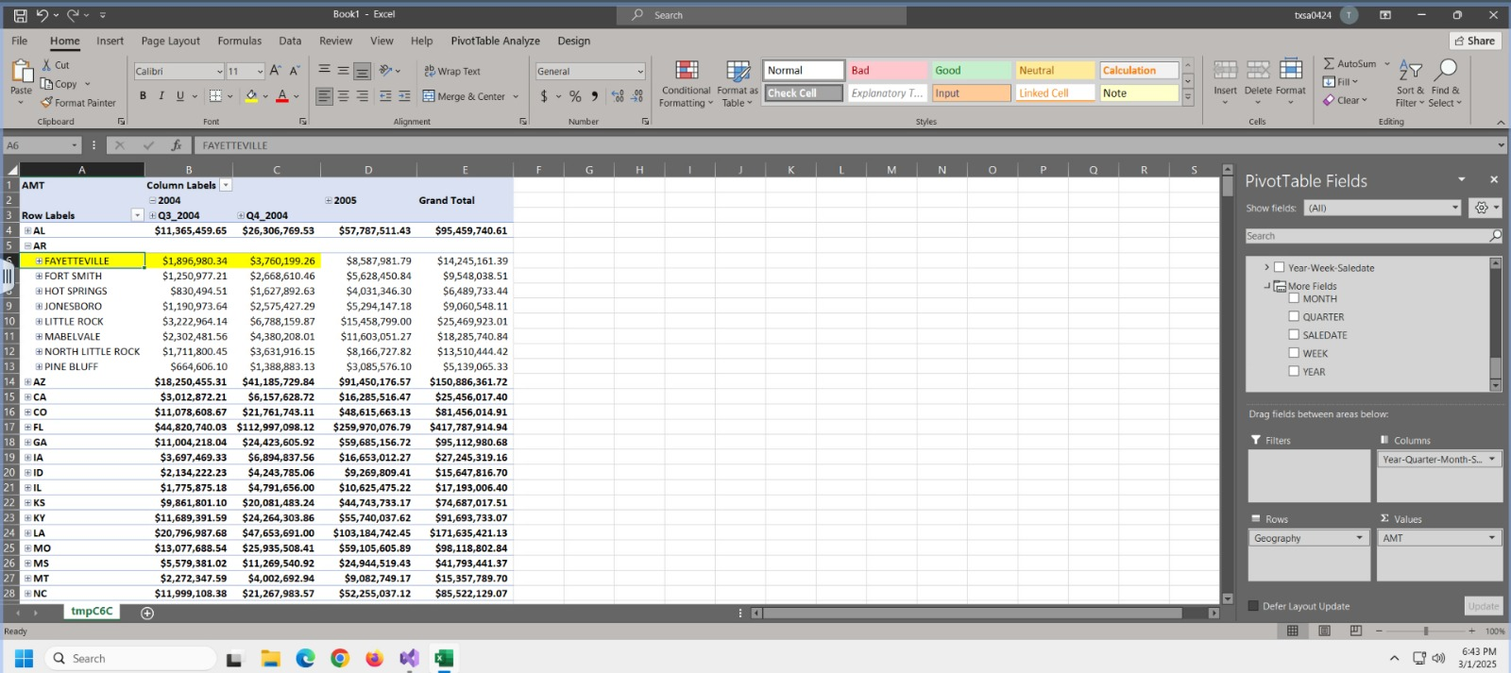
4) What is the amount of items sold by Clavin K in the Fayetteville store in Quarter 3 of the year 2004?
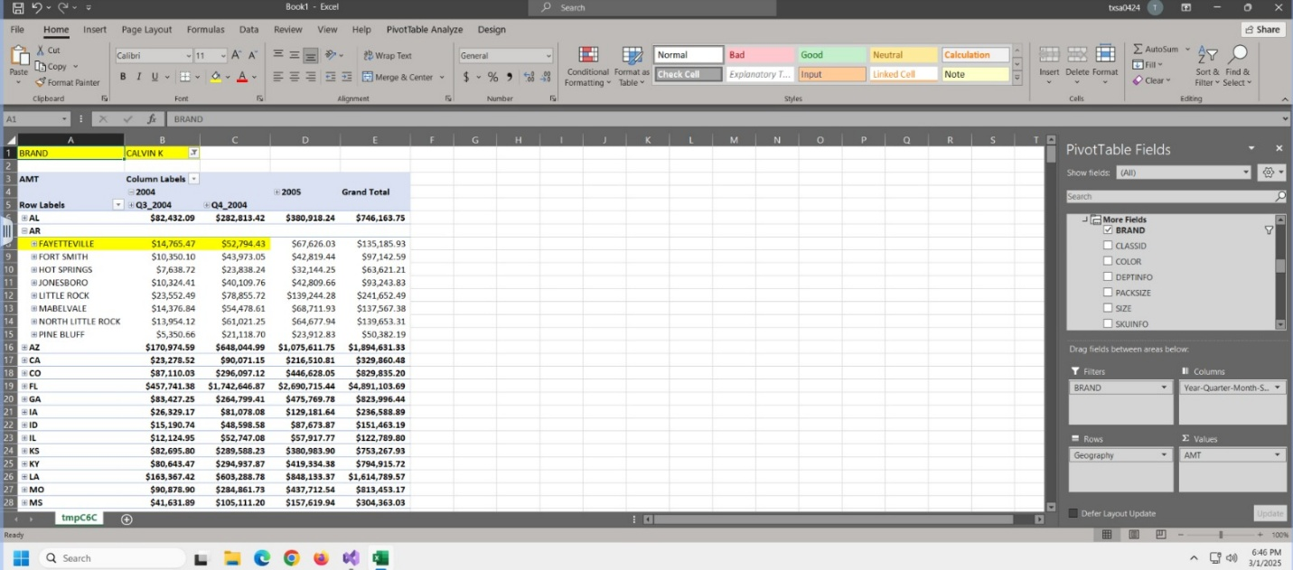

5) What is the profit margin for the store Fayetteville?
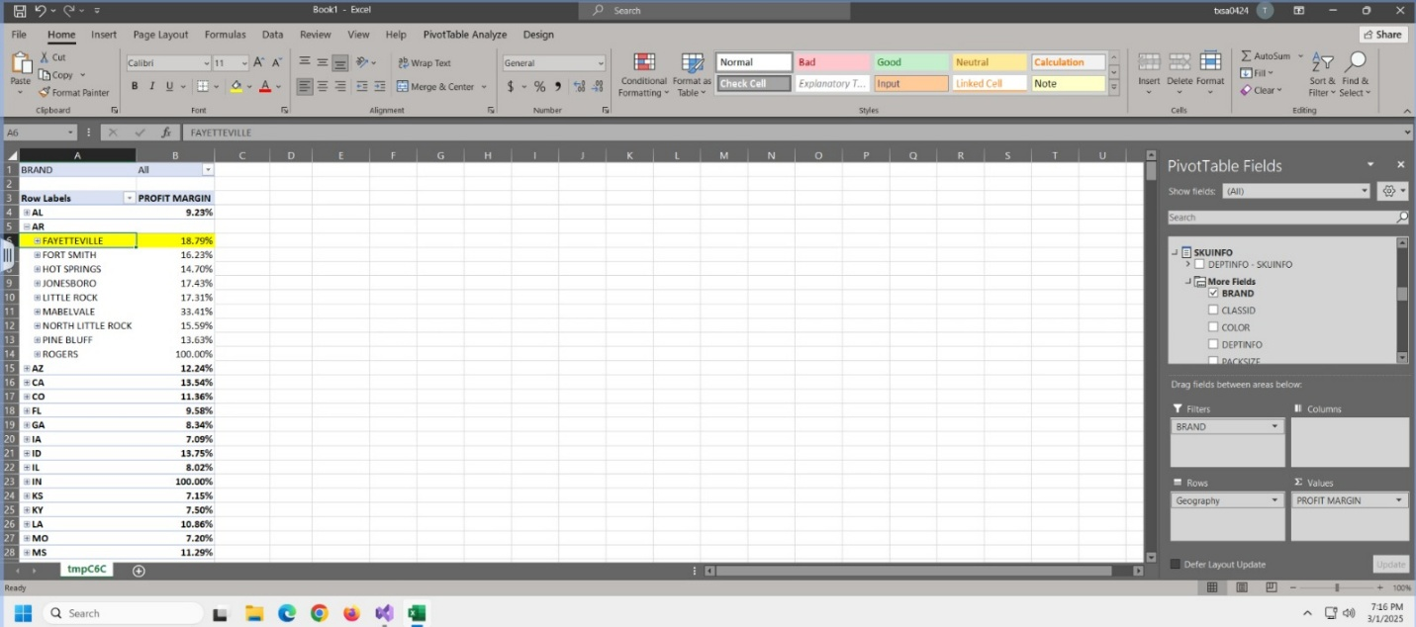

6) What is the profit margin for Fayetteville for brand Adidas A?

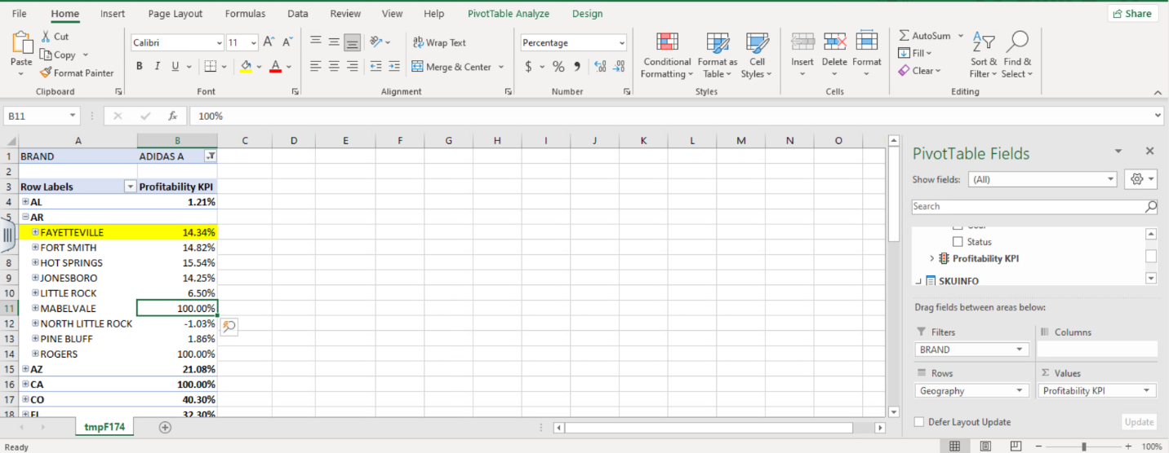

7) What is the AMT (amount) of items sold at Little Rock stores?
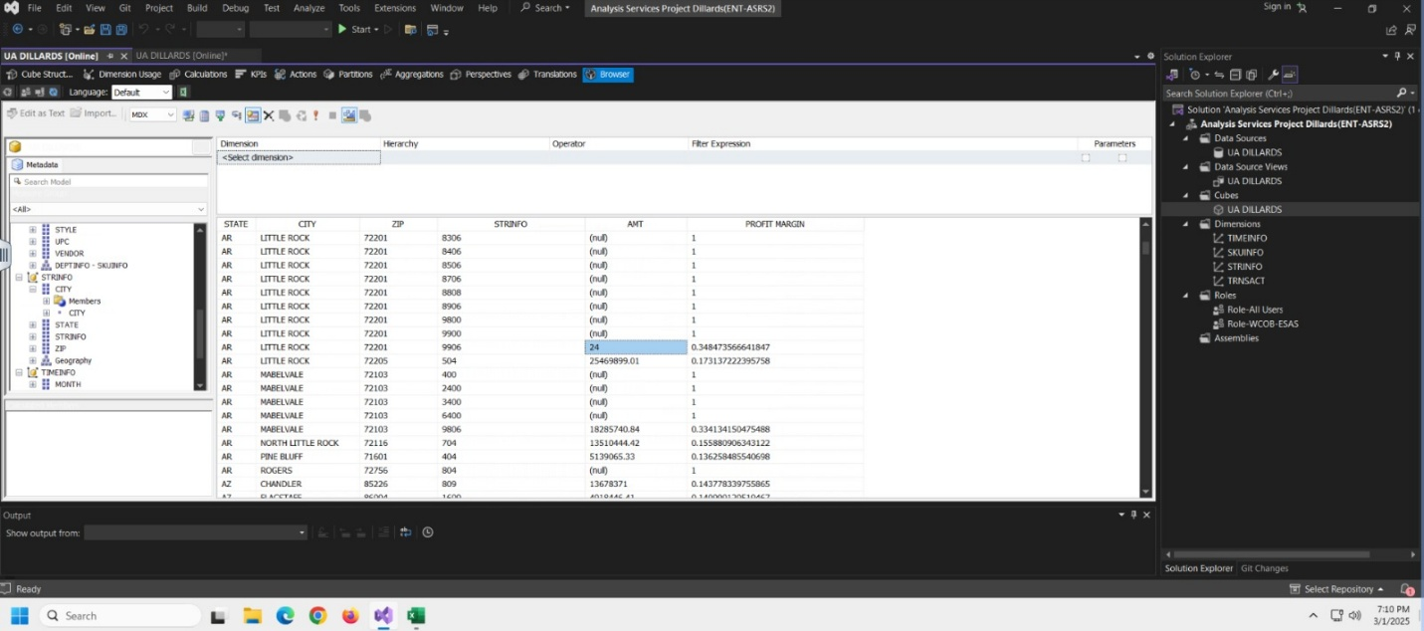
8) What is the amount of items sold in the Fayetteville store in Quarter 3 of the year 2004?
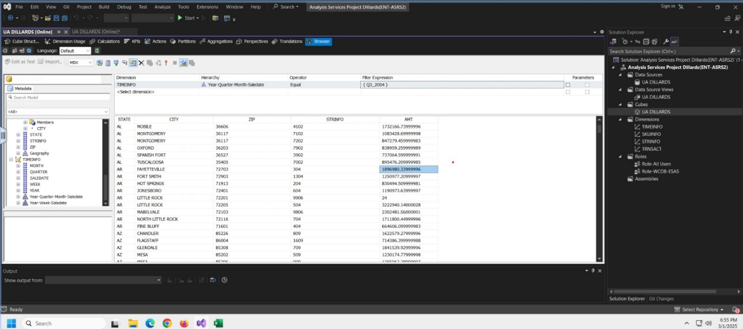

9) What is the amount of items sold in the Fayetteville store in Quarter 3 of the year 2004 for brand Calvin K?
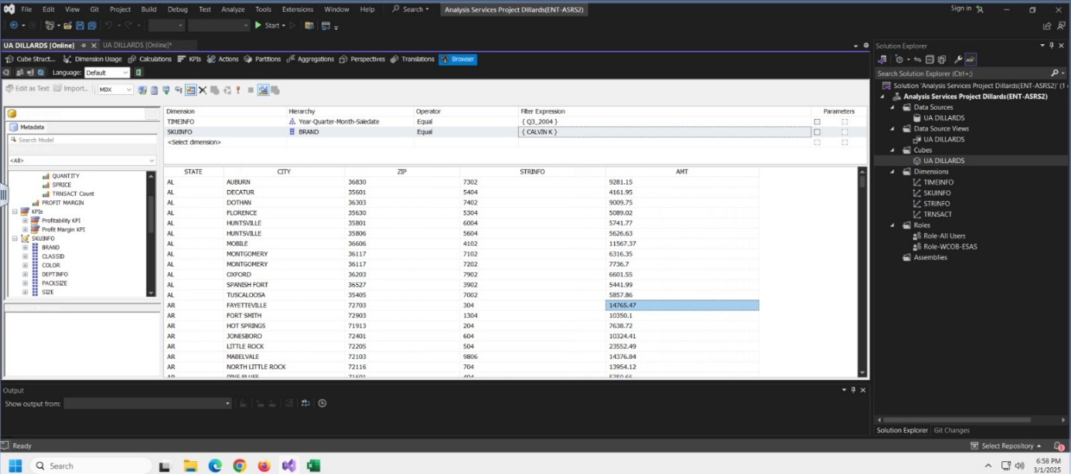
10) What is the profit margin for Fayetteville store?
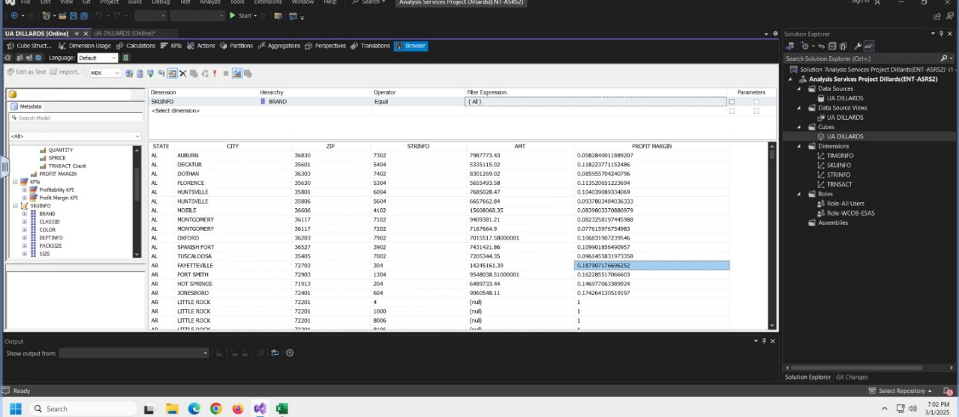

11)What is the profit margin for Fayetteville store for Calvin K?


